

NMI P 105
Pattern Approval Specifications for the
Graduation of Analogue Scales
First edition — May 1976 (Document 105)
First edition, first revision — May 1979 (Document 105)
First edition, second revision — November 1980 (Document 105)
First edition, third revision — August 1988 (Document 105)
First edition, fourth revision — June 2001 (renamed NSC P 105)
First edition, fifth revision — July 2004 (renamed NMI P 105)
Bradfield Road, Lindfield, NSW 2070
PO Box 264, Lindfield, NSW 2070
Telephone: (61 2) 8467 3600
Facsimile: (61 2) 8467 3610
Web page: http://www.measurement.gov.au
© Commonwealth of Australia 1976
CONTENTS
1. Form of Scale Marks 1
2. Arrangement of Scale Marks 1
3. Numbering of Scale Marks 1
4. Recommended Numbering Arrangements 1
4.1 First Alternative 1
4.2 Second Alternative 2
4.3 Third Alternative 2

1. Form of Scale Marks
Scale marks shall be made up of lines of the same thickness and the thickness shall be constant and shall be between one-tenth and one-quarter the width of a scale spacing without being less then 0.2 mm.
The length of the shortest lines shall not be less than the width of a scale spacing.

2. Arrangement of Scale Marks
Three recommended arrangements for graduated scales are as follows, where n is any positive or negative whole number or zero:
- style A (top), numerical value of graduation, d, is 1×10^{n};
- style B (middle) numerical value of graduation, d, is 2×10^{n};
- style C (bottom) numerical value of graduation, d, is 5×10^{n}.
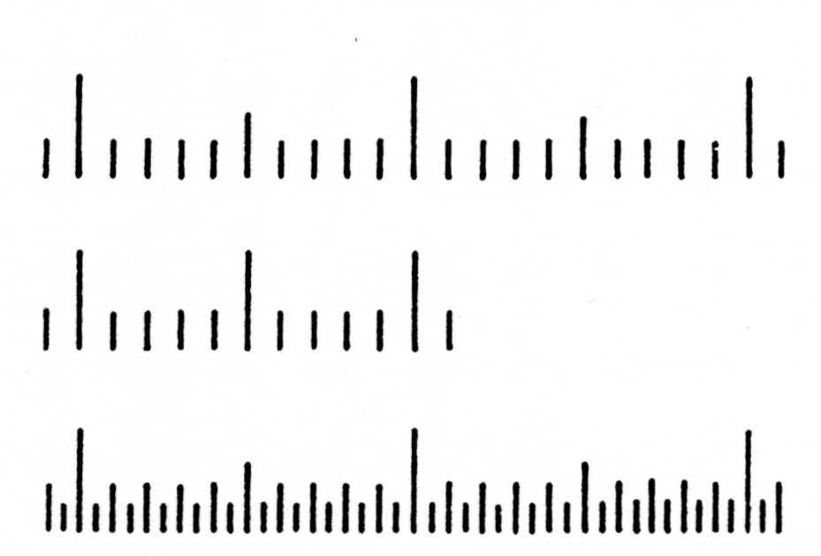
Special consideration will be given to alternative arrangements if space or other restrictions prevent the recommended arrangements being met.

3. Numbering of Scale Marks
- The actual or apparent height of numbers shall be not less then L/330, without being less than 2 mm, where L is the reading distance.
- The width of a number measured parallel to the base of the scale shall be less than the distance between two consecutive numbered scale marks.
- The decimal marker on numbers less than unity shall be preceded by a zero digit.
- The decimal marker shall be a point with a diameter of 1.5 times the thickness of the lines forming adjacent digits; the point shall be on the base line of the digits or at mid-height.
- Digits of the number shall be horizontally aligned except on fan-shaped dials.
- Vulgar fractions are not acceptable.
- A comma or similar mark shall not be marked between third and fourth digits of a number.

4. Recommended Numbering Arrangements

4.1 First Alternative
Style A (d = 1×10^{n}) where N is an integral multiple of 10d.
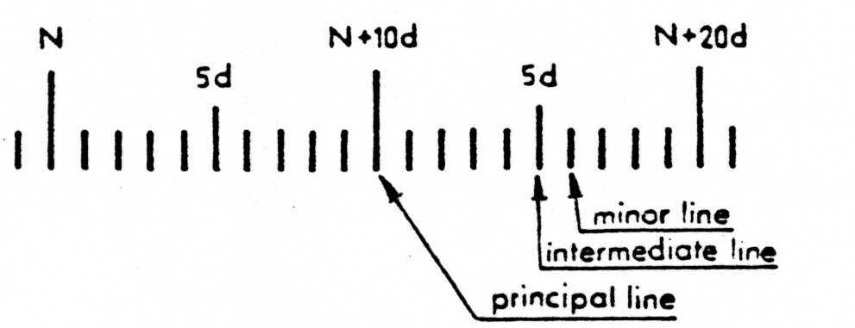
Style B (d = 2×10^{n}) where N is an integral multiple of 10d.
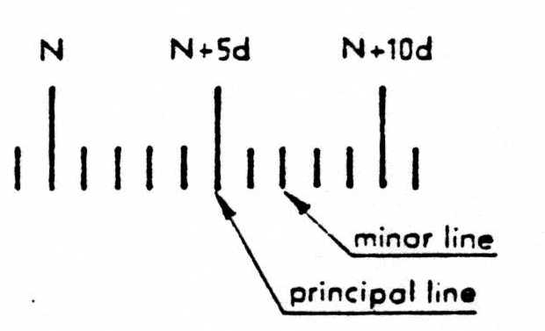
Style C (d = 5×10^{n}) where N is an integral multiple of 20d.
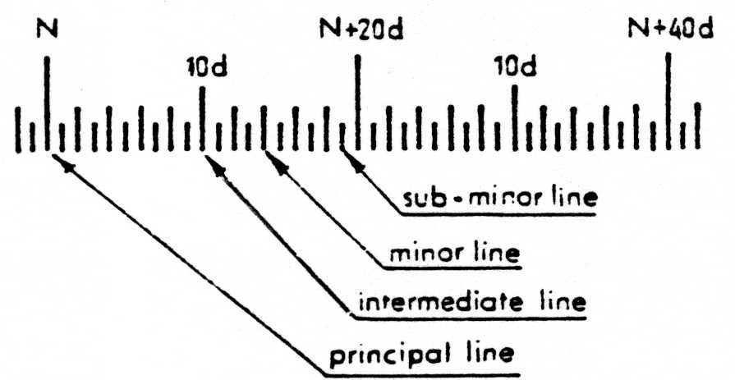

4.2 Second Alternative
All minor graduation lines (except sub-minor lines) may be numbered incrementally from the preceding principal line, as follows:
(a) style A – 1d, 2 d, 3 d etc up to 9 d;
(b) style B – 1d, 2d, 3d, 4 d; and
(c) style C – 2d, 4d, 6d etc up to 18 d.

4.3 Third Alternative
All graduation lines (except sub-minor lines) may be numbered progressively from zero at 1, 5 or 10 graduation intervals.

