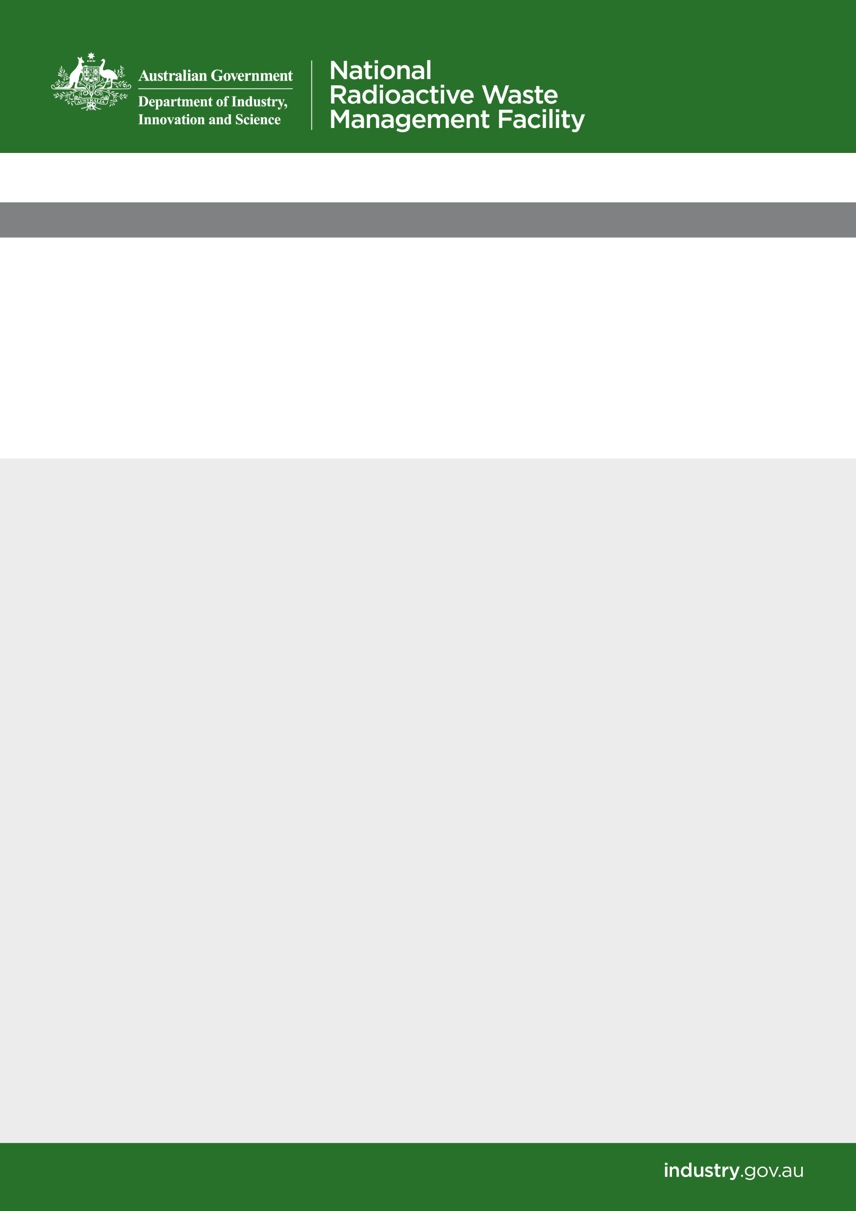

# Minutes

## Kimba *Thursday 3 May 2018*

### Economic Working Group

**Economic Woking Group**

Thursday 3 May 2018

Location: DIIS office Kimba

|  |  |  |
| --- | --- | --- |
| **Time** | **Item** | **Lead** |
| Coffee and Tea available on arrival | | |
| 0830-0835 | Welcome |  |
| 0835-0845 | Housekeeping   * Introduction * Apologies * Overview of the meeting agenda | Chair |
| 0845-0900 | Processes for the working group   * Contracts * Processes * Confidentiality agreements * Expectations of members * Outcomes * Reporting to KCC | DIIS |
| 0900-0915 | Approving Kimba Area School ANSTO education experience Lucas Heights   * STEM opportunities for students | Working Group |
| 0915-1030 | **Identifying Economic needs in line with a Radioactive Waste Facility being built at Kimba**   * Summarise todays activities and objective * Structure of meetings to mid July 2018 and delivering a response to the KCC * Listing Community benefits package | Chair to introduce  Working Group to discuss |
| 1030-1100 | Morning Tea | |
| 1100-1200 | Continued session   * **Identifying Economic needs in line with a Radioactive Waste Facility being built at Kimba** * Structuring an approach to a Community benefits package * Assigning funding to services and infrastructure needs * Identifying Flow on effects to the Kimba Community * What about regional impacts | Working Group to discuss |
| 1200-1220 | Summarise todays activities   * Next steps * Identify agenda topics for next meeting | Chair |
| 1220-1230 | Next meeting  Other business | Chair |
| 1230 – 1300 | Lunch | |

Attendees:

|  |  |
| --- | --- |
| David Schmidt (Chair) | Heather Baldock |
| Christine Lehmann | Deb Larwood |
| Dean Johnson | Pat Beinke |
| Laura Fitzgerald | Charlie Milton |

Apologies:

No apologies

Other Attendees:

|  |  |
| --- | --- |
| **Name** | **Organisation** |
| Bruce Wilson | DIIS NRWMF – Principal Adviser |
| Clayton Harris | DIIS NRWMF – Community Consultation |
| Maree Barford | DIIS NRWMF – Community Liaison Officer |
| Ian Carter | DIIS NRWMF – Community Consultation |
| Nicholas Clifford-Hordacre | DIIS NRWMF – Community Consultation |

|  |  |
| --- | --- |
| **Action Items** | **Status** |
| **Action 1:**  The department to follow up with Kimba and ANSTO concerning Kimba school trip to ANSTO and report back to the EWG on the outcome.  **Action 2**: The department to contact James Rusk of AECOM and invite him to speak at the next KEWG meeting.  **Action 3**: The department to follow up on the upskilling of workers in Kimba for job opportunities that the facility may bring.  **Action 4:**  The department to contact Peta Ashworth and invite her to speak at a future meeting.  **Action 5:** In the case that the facility goes ahead that the facility commits to using local medical services for any work related medical needs.  **Action 6:**  Favourable points be taken from Kimba Council’s letter to the Minister and moved into the project proposal list.  **Action 7:**  The department to find a federal aged care representative to speak to the KEWG.  **Action 8:**  The department to assist the KEWG in constructing a plan detailing project proposals.  **Action 9:**  Department to source some expert assistance to cost the project proposals to inform feasibility of each proposal for the KEWG.  **Action 10**: The KEWG members to provide input into the proposal list and consolidate before the next meeting on 16 May 2018. | In Progress  Completed  In Progress  In Progress  In Progress  In Progress  In Progress  In Progress  In Progress  In Progress |

*Meeting opened 8.30am*

ANSTO school trip

* School kids from Kimba have been offered the opportunity to visit ANSTO for 5 days to learn about the research and development that happens at ANSTO. While in Sydney they will also have the opportunity to visit Sydney Harbour and the Australian Museum. The trip is funded by the department.
* Before the trip ANSTO will visit Kimba and provide a presentation to school children in years 9-12. Students can then make an informed decision and choose whether they are interested in attending or not.
* All committee members support the trip going ahead. Support should be kept confidential until approved by the school and department.

**ACTION 1:** The department to follow up with Kimba and ANSTO concerning Kimba school trip to ANSTO and report back to the EWG on the outcome.

Potential jobs as a result of the facility

* AECOM has released a list of potential services that will be needed if the facility goes ahead e.g. fuel, accommodation, meals, earthmoving etc.
* The committee requests an AECOM representative attend the next meeting to speak about job opportunities.
* The committee also requests Peta Ashworth to speak to them about various opportunities that come along with the facility.
* The committee would like to know what proportion of the build money will be allocated to each profession. Which professions will benefit the most?
* Once known, The KEWG can begin to identify community members to assist in these roles, if extra workers are needed it is preferred that they are sourced from Cleave and surrounding areas for economic benefit of the region.
* Committee members have mentioned that the department has previously discussed up-skilling opportunities for Kimba workers.

**ACTION 2**: The department to contact James Rusk of AECOM and invite him to speak at the next KEWG meeting.

**ACTION 3:** The department to follow up on the upskilling of workers in Kimba for job opportunities that the facility may bring.

**ACTION 4:** The department to contact Peta Ashworth and invite her to speak at a future meeting.

Proposals for Kimba

* The KEWG has expressed the need for a permanent doctor in Kimba.
* The position is an on call 24/7 position and it is hard one to keep filled, therefore hiring two doctors at the same time may be a more attractive option as they can share the work.
* It was moved by the committee that the facility should commit to using local doctors for all medical services (occupational health checks etc.).
* It was suggested by various committee that the aged care facilities in Kimba be extended, there is a long waiting list.
* One member mentioned that disabled access in the aged care facilities needs to be addressed.
* A committee member suggested that science and technology programmes would enable children in Kimba to have a choice in returning to Kimba to work at the facility after university. Access to programmes such as graduate programmes, scholarships etc. will help them to be adequately trained.
* The committee was in agreeance that Kimba would benefit from better mobile and internet coverage.
* The committee questioned whether the professionally managed investment fund generate at least $1 million per year after taxes and fees.
* The council have put forward a letter to the Minister with 5 dot point proposals. The committee did not endorse the entire letter but are satisfied with what the council have put forward.

**Conflict of Interest:** Mayor Johnson and Ms Larwood declared a conflict of interest with discussions on the council letter addressed to the Minister. The letter detailed Kimba Council list of services and infrastructure associated with a radioactive waste management facility. Mayor Johnson and Ms Larwood excused themselves from the discussion.

**ACTION 5:** the department to follow a motion from the KEWG. In the case that the facility goes ahead that the facility commits to using local medical services for any work related medical needs.

**ACTION 6:** Favourable points be taken from Kimba Council’s letter to the Minister and moved into the project proposal list.

**ACTION 7:** The department to find a federal aged care representative to speak to the KEWG.

Presenting economic benefits of the facility to other committees and the community

* KEWG to produce a plan and timeline on paper of proposals detailing the benefit to the community and what is needed from the government.
* Members expressed that any funding coming from the government should be put towards population increase and new jobs within the area.
* One member suggested that the 10 million dollars should be given to the rate payers as they are a major support to the community.
* One member questioned will there be funds generated from the storage of waste at the facility?

**ACTION 8**: The department to assist the KEWG in constructing a plan detailing proposals.

**ACTION 9:** Department to source some expert assistance to cost the project proposals to inform feasibility of each proposal for the KEWG.

Proposal list

**ACTION 10:** The KEWG members to provide input into the proposal list and consolidate before the next meeting on 16 May 2018.

Other business

* A committee member had tabled data from the Regional Development Australia Whyalla Eyre Peninsula (RDAWEP) Annual Report 2016-2017, 2015-2016 relevant to Kimba.

Source: <http://www.rdawep.org.au/wp-content/uploads/2016/02/RDAWEP-Annual-Report-16-17.pdf>

*Meeting closed 1:30pm*