Stocktake of government programs supporting collaboration and innovation precincts in Australia
As an addendum to the Statement of Principles for Australian Innovation Precincts, this resource lists Australian Government and state and territory government programs and activities which support innovation precincts and industry-research collaboration.
While not definitive, the stocktake demonstrates that the Australian Government is providing substantial support for education, research, industry development, innovation and regional development. It also shows that state and territory governments are playing an important role in supporting innovation precinct development and industry-research collaboration. The Australian Government acknowledges that state and territory governments also play a key role in supporting innovation precinct development through hospital and infrastructure spending, land use planning, business engagement and facilitation, and regulating Crown land.
This stocktake was developed in consultation with Australian government departments and agencies and state and territory governments.

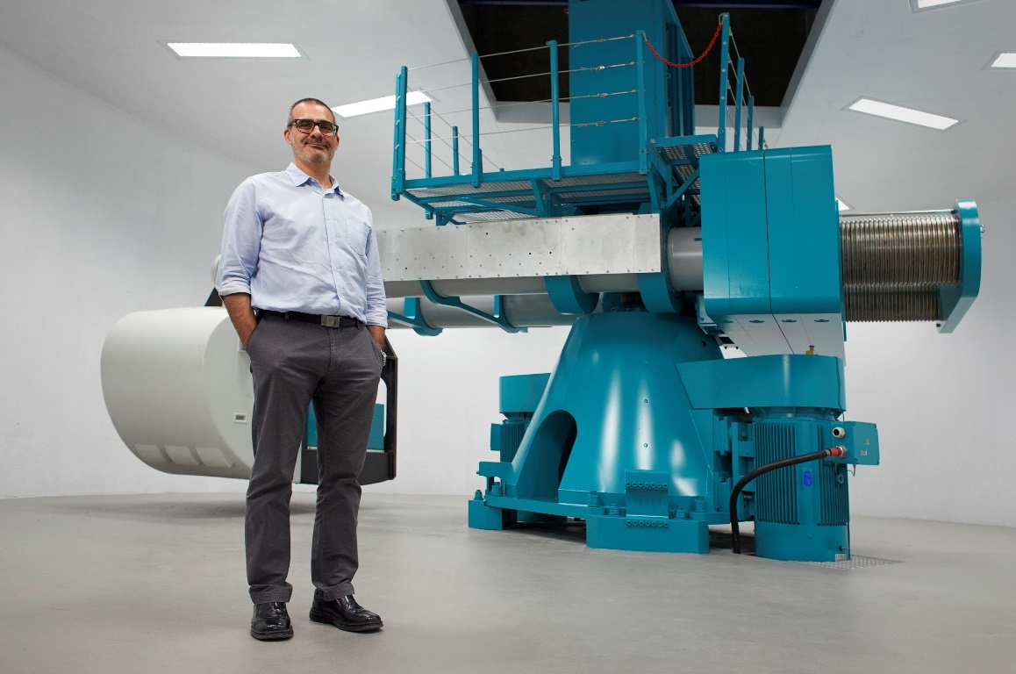 | 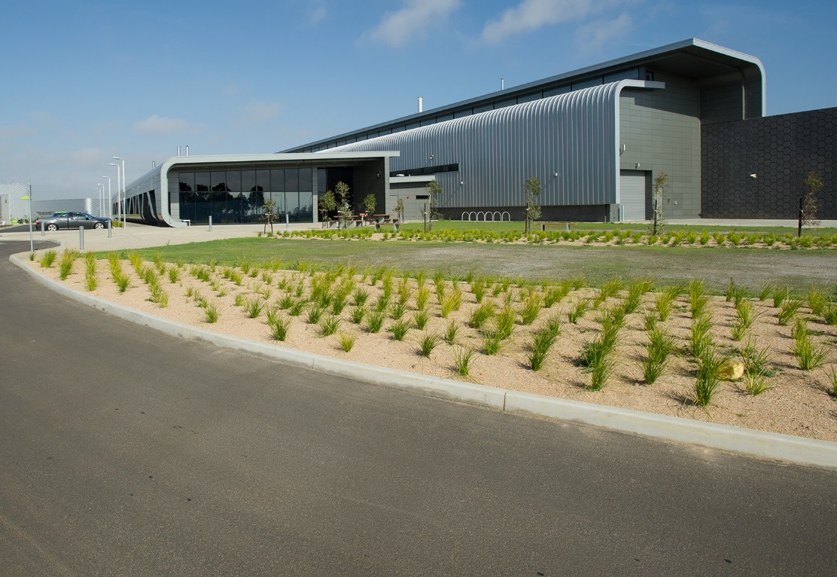
Caption: National Geotechnical Centrifuge Facility (Source: The University of Western Australia) | Caption: Carbon Nexus, Deakin University Waurn Ponds Campus (Source: Deakin University)

Initiative and Australian Government Agency | Funding | Programme aims
 |  | Strategic coordination and direction setting | Physical precinct creation, enhancement, and expansion | Encouraging education, VET and research sector actors to collaborate | Encouraging industry sector actors to collaborate | Supporting incubators and accelerators | Supporting start-ups | Description
Australian Research Council
Engagement and Impact Assessment | N/A |  |  |  |  |  |  | Examines how universities are translating their research into economic, social and other benefits and encourage greater collaboration between universities, industries and other end-users of research.
Linkage Program
Centres of Excellence Scheme | $81.2 million (2018) |  |  |  |  |  |  | Supports innovative and transformational research of international standing, the training and development of the next generation of researchers, and the building of human capacity to support research and industry in the future.
Industrial Transformation Research Program | $39.0 million (2018) |  |  |  |  |  |  | Encourages and supports university-based researchers and industry to work together to find solutions to a range of issues facing Australian industries.
Linkage Infrastructure, Equipment and Facilities Scheme | $32.7 million (2018) |  |  |  |  |  |  | Supports collaborative arrangements across organisations to develop resources, top-quality research, mentoring, training, expertise and knowledge. Partners may be drawn from industry and are required to contribute cash and/or in-kind or other material resources.
Linkage Projects Scheme | $75.0 million (2017) |  |  |  |  |  |  | Promotes collaboration and research partnerships between key stakeholders in research and innovation including higher education institutions, government, business, industry and end-users.
CSIRO
CSIRO Innovation Fund | $200 million |  |  |  |  |  |  | Invests in start-up and spin off companies, and SMEs engaged in the translation of research generated in the publicly funded research sector.
CSIRO ON Accelerator | $20 million over four years from 2016-2020 |  |  |  |  |  |  | Helps all Australian researchers develop the entrepreneurial mindset and skills necessary to drive commercial outcomes from their science and technology.
CSIRO SME Connect | $5.6 million over two years |  |  |  |  |  |  | Links Australian businesses with researchers, facilitating and enabling innovation-driven partnerships through funding, support and resources.
Department of Education and Training
Academic Centres of Cyber Security Excellence | $1.9 million over four years |  |  |  |  |  |  | Builds Australia’s capability in cyber security through encouraging more students to study cyber security, increasing the number of highly skilled post-graduates, and supporting research addressing key challenges.
Australian Mathematical Sciences Institute National Research Internships Program | $28.2 million over four years |  |  |  |  |  |  | Supports industry-based training of PhD research students, with a focus on women in Science, Technology, Engineering and Mathematics (STEM). APR.Intern delivers the program on behalf of the Department of Education and Training.
Higher Education Research Block Grants | $1.92 billion (2018) |  |  |  |  |  |  | Supports Higher Degree by Research (HDR) students' knowledge transfer and research commercialisation activities. The Grants also provide systemic support. Funds can be used on any research activity (except for stipends for HDR students), including knowledge transfer and research commercialisation.
National Collaborative Research Infrastructure Strategy - Operational Funding | $150 million per annum ongoing (indexed) |  |  |  |  |  |  | Provides funding for the operations of world class research infrastructure.
NCRIS - Research Infrastructure Investment Plan | $1.9 billion over 12 years from 2017–2018 |  |  |  |  |  |  | Supports the upgrade and enhancement of national research infrastructure facilities in response to the 2016 National Research Infrastructure Roadmap.
Department of Health
Biomedical Translation Fund | $250 million (at least matched with private capital) |  |  |  |  |  |  | Makes venture capital investments in promising biomedical innovations with commercialisation potential in Australia.
Medical Research Future Fund | $2.0 billion in disbursements in the first six years to 2021-22 |  |  |  |  |  |  | Provides grants of financial assistance to support health and medical research and innovation, with the objective of improving the health and wellbeing of Australians.
Department of Industry, Innovation and Science
Advanced Manufacturing Fund | $100 million |  |  |  |  |  |  | Encourages further research and investment in emerging engineers and scientists, provides facilities to test new products and develops business capability to ensure advanced manufacturing businesses are world‑leaders in competitive global markets.
Advanced Manufacturing Early Stage Research Fund | $4 million |  |  |  |  |  |  | Funds the Advanced Manufacturing Growth Centre to support small scale and pilot research projects in advanced manufacturing.
Australia-China Science and Research Fund – Joint Research Centres | Up to $1 million per grant for over 3 years |  |  |  |  |  |  | Links Australian and Chinese research institutions to build research capacity, maximise the application and commercialisation of research outcomes, and boost collaboration between researchers and industry.
Australia-India Strategic Research Fund – Collaborative Research Projects | Up to $500 000 per grant for over 3 years |  |  |  |  |  |  | Links Australian and Indian research institutions, as well as industry and/or other end-user partners, to build research capacity and maximise the application and commercialisation of research outcomes.
Business Research and Innovation Initiative | $25.5 million (over the forwards) |  |  |  |  |  |  | Engages Australian innovative start-ups and SMEs to provide innovative solutions to problems in public policy and service delivery.

Initiative and Australian Government Agency | Funding | Programme aims
 |  | Strategic coordination and direction setting | Physical precinct creation, enhancement, and expansion | Encouraging education, VET and research sector actors to collaborate | Encouraging industry sector actors to collaborate | Supporting incubators and accelerators | Supporting start-ups | Description
Entrepreneurs’ Programme (EP) $482 million (2017-18 to 2020-21)
EP – Accelerating Commercialisation | (included in EP) |  |  |  |  |  |  | Helps businesses, entrepreneurs and researchers to commercialise novel products, services and processes.
EP – Incubator Support | (included in EP) |  |  |  |  |  |  | Assists new and existing Incubators to improve the prospects of Australian start-ups achieving commercial success through helping them to develop their business capabilities.
EP – Innovation Connections | (included in EP) |  |  |  |  |  |  | Provides businesses with access to expert technology advice to address technology and knowledge gaps, and collaborate with the research sector in developing new ideas with commercial potential.
Cooperative Research Centres (CRC) Program | $710 million ((2017-18 to 2020-21) |  |  |  |  |  |  | Supports industry-led and outcome-focused collaborative research partnerships between industry, researchers and the community. The CRC Program has two streams: CRCs and CRC Projects. CRC Projects must have SME participants, creating a new pathway for SMEs to engage in collaborative research.
Global Innovation Strategy –  Global Connections Fund | $4.9 million |  |  |  |  |  |  | Provides initial funding support specifically to promote Australian researchers and SMEs undertake global researcher-SME collaborations.
Global Innovation Strategy –  Global Innovation Linkages | $16.5 million |  |  |  |  |  |  | Provides funding to help Australian businesses and researchers to collaborate with global partners on strategically focused, leading-edge research and development projects.
Industry Growth Centres Initiative | N/A |  |  |  |  |  |  | Drives innovation, productivity and competitiveness by focusing on sectors of competitive strength and strategic priority.

Initiative and Australian Government Agency | Funding | Programme aims
 |  | Strategic coordination and direction setting | Physical precinct creation, enhancement, and expansion | Encouraging education, VET and research sector actors to collaborate | Encouraging industry sector actors to collaborate | Supporting incubators and accelerators | Supporting start-ups | Description
Department of Infrastructure, Regional Development and Cities
Building Better Regions Fund | $641.6 million |  |  |  |  |  |  | Boost economic growth in key regional areas, which may include funding infrastructure that can contribute to the creation and expansion of innovation precincts.  However, precinct creation and expansion is not a core aim of these programs.
Regional Growth Fund | $272.2 million
Regional Jobs and Investment Packages | $222.3 million
Regional Development Australia | $75.3 million |  |  |  |  |  |  | Draws together all levels of government to enhance the development of Australia's regions.
City Deals | N/A |  |  |  |  |  |  | Draws together the three levels of government, the community and private enterprise to create place-based partnerships.
Smart Cities and Suburbs Program | $50 million |  |  |  |  |  |  | Provides funding to support projects that apply innovative technology-based solutions to urban challenges to improve the liveability, productivity and sustainability of Australian cities, suburbs and towns.
National Medical Health Research Council
Advanced Health Research and Translation Centres | N/A |  |  |  |  |  |  | Encourages leadership in health research and translation in Australia by recognising leading centres of collaboration that excel in health and medical research, and the translation of evidence into excellent patient care, and demonstrate a strong research and translation focus in the education of health professionals, at an international level.
Boosting Dementia Research Initiative | $200 million (2014-2019) |  |  |  |  |  |  | Provides funding to boost dementia research with: $150 million to urgently scale up dementia research, and $50 million for an NHMRC National Institute for Dementia Research.
Centres of Research Excellence | $39.9 million  (2018) |  |  |  |  |  |  | Provides support for teams of researchers to pursue collaborative research and develop capacity in clinical, population health and health services research.
Development Grants | $15.0 million  (2018) |  |  |  |  |  |  | Supports health and medical research at the proof-of-concept stage that specifically drives towards a commercial outcome within a foreseeable timeframe.
Equipment Grants | $5.7 million  (2018) |  |  |  |  |  |  | Provides funding annually to NHMRC approved Administering Institutions to facilitate the procurement of equipment designed to support high quality health and medical research.
Independent Research Institute Infrastructure Support Scheme | $30 million per annum |  |  |  |  |  |  | Provides funding annually for overhead infrastructure costs to NHMRC approved Administering Institutions that are independent medical research institutes.
Partnership Centres Initiative | $7.6 million  (2018) |  |  |  |  |  |  | Brings teams of researchers and decision-makers together to create better health services and health by collaborative work on priority themes determined by the needs of the health and health care systems.
Partnership Projects | $3.9 million  (2018) |  |  |  |  |  |  | Provides funding and support to create new opportunities for researchers and policy makers to work together to define research questions, undertake research, interpret the findings and implement the findings into policy and practice.
Department of Defence
Centre for Defence Industry Capability | $44.1 million (2018-19) |  |  |  |  |  |  | Provides advisers to help businesses navigate the defence market, provide specialist advice on improving competitiveness and accessing global markets, and facilitate connections with other businesses and Defence. CDIC also links Australian innovators and researchers to the Defence Innovation Hub and the Next Generation Technologies Fund.
Defence Innovation Hub | $640 million to June 2026 |  |  |  |  |  |  | Invests in maturing and further developing technologies that have moved from the early science stages into the engineering and development stages of the innovation process. Proposals must align with one of six capability streams.
Next Generation Technologies Fund | $730 million (next decade to June 2026) |  |  |  |  |  |  | Focuses on fundamental research and development of future game-changing concepts that can be further matured and realised into military capability through the Defence Innovation Hub.

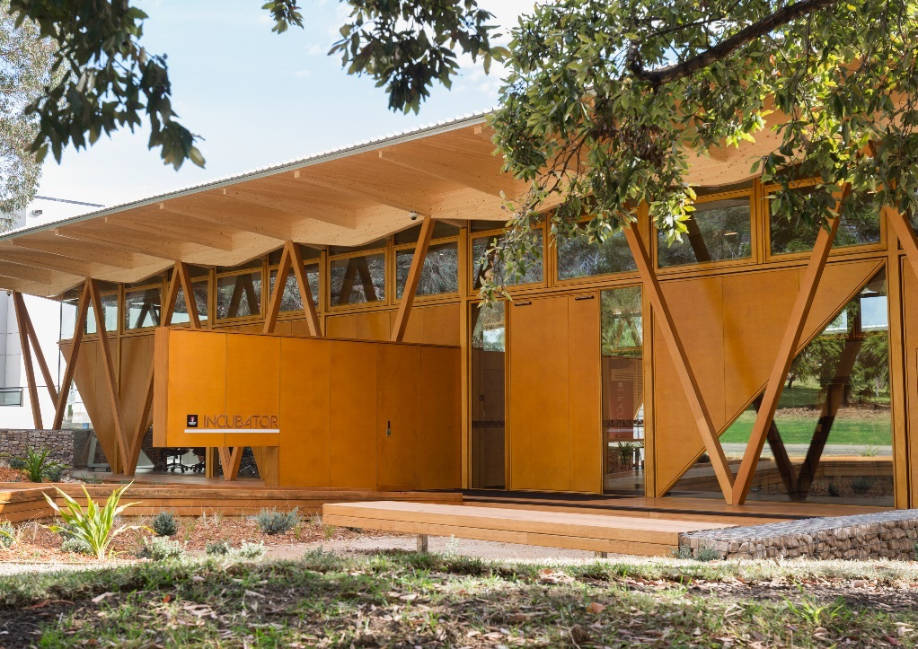 | 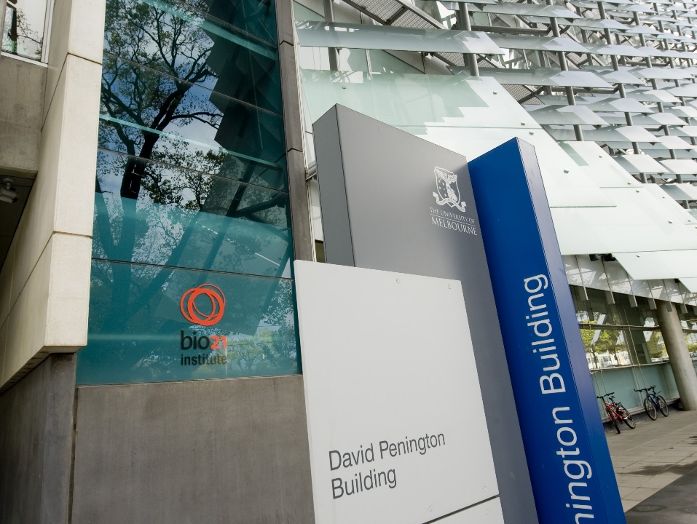
Caption: Macquarie University Incubator, Macquarie Park Innovation District | Caption: Bio21 Institute, David Penington Building, The University of Melbourne
State and Initiative | Funding |  | Programme aims
 |  |  | Strategic coordination and direction setting | Physical precinct creation, enhancement, and expansion | Encouraging education, VET and research sector actors to collaborate |  | Encouraging industry sector actors to collaborate | Supporting incubators and accelerators | Supporting start-ups |  | Description
Australian Capital Territory
CAN Drive – Automated Vehicle Trial | $750 000 |  |  |  |  |  |  |  |  |  |  | Trials driver monitoring technology to improve safety in automated vehicles with Seeing Machines.
Canberra Innovation Network | $1.25 million |  |  |  |  |  |  |  |  |  |  | Connects innovation and entrepreneurship with science and research.
Innovation Connect | $500 000 |  |  |  |  |  |  |  |  |  |  | Helps Canberra-based businesses develop innovative products and services.
Renewable Energy Innovation Fund | $12 million |  |  |  |  |  |  |  |  |  |  | Supports Canberra-based renewable energy business and attract new ventures.
Renewables Innovation Hub |  |  |  |  |  |  |  |  |  |  |  | Brings together start-ups and pioneering organisations to develop the ACT’s renewable energy and cleantech sectors.
New South Wales
Boosting Business Innovation Programme, including TechVouchers | $18 million |  |  |  |  |  |  |  |  |  |  | Funds research organisations to establish new innovation spaces and activities to give small businesses better access to researchers.
Jobs for NSW | $190 million |  |  |  |  |  |  |  |  |  |  | Provides grants, loans and loan guarantees to help innovative businesses scale and create new jobs.
Jobs for NSW – Sydney Startup Hub |  |  |  |  |  |  |  |  |  |  |  | Draws together leading incubators and accelerators in a high-density start-up cluster in the CBD.
Jobs for NSW Cluster Pilot Program |  |  |  |  |  |  |  |  |  |  |  | Creates stronger links between organisations to develop networks and boost economic development.
Knowledge Hubs |  |  |  |  |  |  |  |  |  |  |  | Brings together businesses, research organisations and industry associations in key sectors to share information and direct research through collaborative projects.
Sydney School of Entrepreneurship (SSE) |  |  |  |  |  |  |  |  |  |  |  | Provides NSW’s entrepreneurs with access to entrepreneurial training, mentoring and support.
Northern Territory
Business Innovation Support Initiative | $1 million |  |  |  |  |  | ■ |  | ■ |  |  | Helps NT businesses undertake R&D which could lead to new products, processes or services, including collaborating with researchers.
Queensland
Advance Queensland | $650 million | ■ |  | ■ |  | ■ | ■ | ■ | ■ |  |  | Supports programs that drive innovation, build on Queensland’s natural advantages, and help raise its profile as an attractive investment destination.
Advance Queensland Commercialisation Partnership Program |  |  |  |  |  | ■ | ■ | ■ | ■ |  |  | Places innovators in Chinese incubators to collaborate with global expertise, access top facilities and accelerate commercial outcomes.
Advance Queensland Industry Accelerator Program |  |  |  |  |  |  |  | ■ | ■ |  |  | Pairs potential start-ups and SMEs with accelerators offering relevant industry partners and capacity to successfully deliver an industry-focused program in Queensland. The accelerators tap into local talent to fast track ideas into commercially viable products, services and business models.
Advance Queensland Innovation Partnerships |  | ■ |  |  |  | ■ | ■ |  |  |  |  | Positions Queensland as a global innovation hub with grants to Queensland research organisations to collaborate on research projects with industry.
Advance Queensland Knowledge Transfer Program |  |  |  |  |  | ■ | ■ |  |  |  |  | Builds collaboration between universities and small business by bringing on a university graduate to work on an innovative project.
Advancing Regional Innovation Program |  | ■ |  | ■ |  | ■ | ■ |  |  |  |  | Encourages innovation across Queensland and supports local economies to create regional jobs.
Advance Queensland Small Business Innovation Research Program |  |  |  |  |  | ■ | ■ |  | ■ |  |  | Provides commercial opportunities to innovators while solving Queensland Government challenges.
The Precinct |  |  |  | ■ |  | ■ | ■ | ■ | ■ |  |  | Brings together Queensland start-ups, incubators, investors and mentors under the one roof in Brisbane's Fortitude Valley,
South Australia
GigCity Adelaide | $7.6 million |  |  |  |  |  |  |  |  |  |  | Connects innovation precincts and co-working spaces with affordable gigabit-speed internet.
Lot Fourteen | $476 million |  |  | ■ |  | ■ | ■ | ■ | ■ |  |  | Supports Renewal SA’s development of Lot Fourteen, an innovation district, to create high-value jobs and industries and help secure South Australia’s future.
Tonsley | $253 million |  |  | ■ |  | ■ | ■ | ■ | ■ |  |  | Supports Renewal SA’s development of Tonsley into a vibrant, dynamic community of businesses that will shape a knowledge-based industrial future together.
Tasmania
Enterprize Tasmania | $2.5 million |  |  |  |  |  |  |  |  |  |  | Operates start-up hubs in Hobart and Launceston to facilitate engagement between education, start-ups, investors, commercial partners and an accelerator program.
Launceston IoT & Smart City | $200 000 |  |  |  |  |  |  |  |  |  |  | Collaborates to roll out a city wide Internet of Things (IoT) network and encourage local start-ups and schools to develop IoT solutions through workshops and training.
Greater Launceston Transformation Project | $2.5 million |  |  |  |  |  |  |  |  |  |  | Delivers smart city analytics for better educational outcomes, new 3D virtual city modelling tools for city planning processes, an innovation framework and hub, and planning the deployment of smart technology in aged care and smart emergency response systems.
Victoria
Future Industries Fund (FIF)  (funding streams set below) | $200 million |  |  |  |  |  |  |  |  |  |  | Supports six high-growth sectors that have the potential for extraordinary economic growth - to create jobs and attract investment in Victoria.
FIF – Sector Growth Program | $20 million |  |  |  |  |  |  |  |  |  |  | Provides grants of up to $1 million to undertake projects aligned with the Future Industries Sector Strategies that will create new jobs and drive growth, productivity and competitiveness of businesses.
FIF – Future Industries Manufacturing Program | $18 million |  |  |  |  |  |  |  |  |  |  | Provides up to $500 000 in grants for implementation of new manufacturing technologies and processes.
FIF – New Energy Jobs Fund | $20 million |  |  |  |  |  |  |  |  |  |  | Supports projects that create long-term sustainable jobs, increase the uptake of renewable energy generation, reduce greenhouse gas emissions and drive innovation in new energy technologies.
Launch Vic | $60 million |  |  |  |  |  |  |  |  |  |  | Accelerate start-ups to drive new idea and create jobs in Victoria. Launch Vic is an independent agency.
Plan Melbourne - National Employment and Innovation Clusters and Urban Renewal Precincts |  |  |  |  |  |  |  |  |  |  |  | Sets a 35 year strategy for supporting jobs, housing and transport, while building on Melbourne's legacy of distinctiveness, liveability and sustainability.
Arden |  |  |  |  |  |  |  |  |  |  |  | Planning and activation of the Arden precinct in collaboration with the City of Melbourne. The precinct will be a new knowledge and cultural hub leveraging proximity to the Melbourne Biomedical Precinct in Parkville.
Fishermans Bend Employment Precinct (National Employment and Innovation Cluster) | $20.4 million |  |  |  |  |  |  |  |  |  |  | Stimulating economic activity and job creation within the former General Motors Holden site at Fishermans Bend.
La Trobe National Employment and Innovation Cluster |  |  |  |  |  |  |  |  |  |  |  | Working with key stakeholders to increase employment within the cluster, and maximise its innovation potential.
Monash National Employment and Innovation Cluster |  |  |  |  |  |  |  |  |  |  |  | Working closely with key stakeholders, including local governments, Monash University, research institutions, major businesses, representative organisations and the local community, to develop an action plan for the cluster, with the aim of maximising its employment and innovation potential.
Melbourne Biomedical Precinct (Parkville National Employment and Innovation Cluster) |  |  |  |  |  |  |  |  |  |  |  | Working with key stakeholders to support the ongoing growth of high-skill and high-value jobs in the precinct and maximise its innovation potential.
Cremorne (Melbourne TechCity) |  |  |  |  |  |  |  |  |  |  |  | Working with local stakeholders, businesses and education providers to curate this precinct with a focus on digital technologies and Artificial Intelligence.
Brunswick Design Precinct |  |  |  |  |  |  |  |  |  |  |  | Leverages RMIT University’s proposed campus expansion and existing government landholdings for a creative industry hub. RMIT, Moreland City Council and the Victorian Government have signed a Memorandum of Understanding to explore the economic opportunities of the precinct and identify interventions.
Footscray Health and Wellbeing Cluster |  |  |  |  |  |  |  |  |  |  |  | Investing in a health and education hub with significant private sector investment potential and involvement from Victoria University.
Western Australia
Bentley-Curtin Specialised Activity Centre |  |  |  |  |  |  |  |  |  | Investing in a significant employment centre, based around education, innovation, technology and research activities.
Murdoch Health and Knowledge Precinct | $200+ million |  |  |  |  |  |  |  |  | Investing in a mixed-use residential, retail and commercial area centred on a health and education precinct.
Australian Marine Complex and Marine Technology Park |  |  |  |  |  |  |  |  |  | Commits to expanded common use infrastructure with an increased focus on defence industry infrastructure needs and recognising the importance in collaboration between resource sector capacity in industry and research.
Defence and Defence Industries Strategic Plan Including the Defence Science Centre |  |  |  |  |  |  |  |  |  | Sets a new strategy for the defence sector and commits to a Defence Science Centre that will build industry – research collaboration, deliver improved industry focussed education and build the capacity of the Australian Marine Complex at Henderson.
New Industries Fund | $16.78 million over 3 years |  |  |  |  |  |  |  |  | Builds research, innovation and commercialisation capacity.
Industrial Lands Authority |  |  |  |  |  |  |  |  |  | Established to take responsibility for development or expansion of a range of specialised industrial land including the implementation of the Bentley-Curtin Specialised Activity Centre, Australian Marine Complex and other innovation precincts.
Royalties for Regions |  |  |  |  |  |  |  |  |  | Quarantines a portion of mineral royalty income for expanding economic and community capacity in the regions, the source of much of the royalty incomes.
WA Fishing Industry Council | $2 million |  |  |  |  |  |  |  |  | Coordinates across the fishing industry and supports research and collaboration.

