
NITP 8
National Instrument Test Procedures for Milk Tanks
© Commonwealth of Australia 2011
NMI V 14
First edition — December 2004

NITP 8
First edition — December 2011
National Measurement Institute
Bradfield Road, Lindfield, NSW 2070
PO Box 264, Lindfield, NSW 2070
T (61 2) 8467 3600
F (61 2) 8467 3610
W www.measurement.gov.au
Preface
On 30 June 2010 the uniform test procedures (i.e. relevant NMI V documents) were deemed to be national instrument test procedures (NITPs) for the purposes of section 18GG of the National Measurement Act 1960 (Cth).
In 2011 the NITPs were renumbered to better align the numbers with the classes of pattern approval and servicing licensee. As a result this document (NMI V 14) became NITP 8.
The only changes that have been made to the latest edition of this document are it has been rebranded, renumbered, renamed and its cross-references have been updated. In all other respects it is identical with NMI V 14.
NMI’s Chief Metrologist has determined that NITP 8 contains the test procedures for the verification of milk tanks.
CONTENTS
Preface ii
Explanation of Terms iv
1. Scope 1
2. Equipment 1
3. Visual Inspection 1
3.1 Required Data 1
3.2 Characteristics of the Milk Tank 1
3.3 Characteristics of the Dipstick(s) 2
4. Test Procedures 2
4.1 Accuracy 2
4.2 Milk Tank Test Procedures 2
4.3 Test Procedure for the Strength of the Bridge 4
4.4 Additional Tests 4
4.5 Stamping 4
5. Suggested Sequence for Testing 4
Appendix A. Test Report 4
Appendix B. Datum Level Marks 7
Appendix C. Examples of Recommended Scale Marks 8
Appendix D. Application of the Roman Level in Inspection of Milk Tanks 9
Appendix E. Free Drainage Check 12
Appendix F. Method of Reading the Dipstick 13

Explanation of Terms
For explanations of other terms see General Information for Test Procedures.
Adjustment
Alteration of the measurement parameters to bring the instrument within the allowable MPEs for an instrument in use.
Calibration
The set of operations that (under specified conditions) establishes the relationship between the indicated or nominal value of an instrument and the corresponding known value of the measured quantity.
Certification
The examination of an instrument by a certifier (the holder, or an employee of the holder, of a servicing licence) in order to mark the instrument indicating that it conforms with the relevant test procedures.
- Initial certification is the certification of a new instrument by a certifier, which does not bear a verification or certification mark and has never been verified or certified before.
- Subsequent certification is any certification of an instrument by a certifier because the mark is no longer valid due to such reasons as:
- repairs or adjustments have been made that affect metrological performance; or
- the mark has been defaced or removed.
In-service Inspection
The examination of an instrument by an inspector or certifier to check that:
- the verification or certification mark is valid; and
- the errors do not exceed the MPEs permitted for in-service inspection.
In-service inspection does not permit the instrument to be marked with a verification or certification mark.
Verification
The examination of an instrument by an inspector in order to mark the instrument indicating that it conforms with the relevant test procedures.
- Initial verification is the verification of a new instrument by an inspector, which does not bear a verification or certification mark and has never been verified or certified before.
- Subsequent verification is any verification of an instrument by an inspector because the mark is no longer valid due to such reasons as:
- repairs or adjustments have been made that affect metrological performance; or
- the mark has been defaced or removed.
- Re-verification is the examination of an instrument by an inspector to check that:
- the verification or certification mark is valid; and
- the instrument has not been modified in any way since verification or certification;
in order to mark the instrument indicating that it conforms with the relevant test procedures.

Scope
NITP 8 describes the test procedures for the verification, certification and in-service inspection of fixed milk tanks to ensure that they measure to within the maximum permissible errors specified in the National Measurement Regulations and that they comply with the certificate of approval.
Certificates of approval are based on
NMI M 4. Pattern Approval Specifications for Milk Tanks. Refer to NMI M 4 for all metrological and technical requirements. All milk tanks must comply with the relevant Trade Measurement Act and Regulations.
These test procedures apply to all tanks used to measure, by means of a linear measuring device, the volume of milk contained in the tank. The tanks may also be used to measure other food products.
Reference should also be made to NMI M 4 for metrological and technical requirements of levelling devices.
These test procedures supersede Test Procedure No 6. Farm Milk Tanks, first edition, May 1990, found in Inspectors Handbook No 5.

Equipment
- Certificate of approval.
- Appropriate reference standard of measurement to deliver measured quantities of water i.e. a master meter calibrated for water.
- A supply of water, appropriate hoses and connections.
- Current Regulation 13 or Regulation 80 certificates for all reference standards of measurement. Uncertainties must be in accordance with the National Measurement Regulations and not greater than one-third of the maximum permissible error of the tank being tested. Consult the licensing authority for more information.
- Test report (see Appendix A).

Visual Inspection
Visually inspect the milk tank and record details of the required data and characteristics of the tank on the test report.

Required Data
- Test report reference number.
- Date of test.
- Type of test: verification, certification or in-service inspection (for in-service inspection ensure that the verification/
certification mark is in place).
- Name of owner/user.
- Address of owner/user.
- Name of contact on premises.
- Address where the milk tank is located.
- Description of milk tank.
- Manufacturer.
- Model.
- Milk tank serial number.
- Certificate of approval number.
- Maximum capacity and the verification scale interval.
- The verification or certification mark (only required for re-verification and in-service inspection).

Characteristics of the Milk Tank
- Does the milk tank comply with its certificate of approval?
- Is the milk tank being used in an appropriate manner?
- Are all mandatory descriptive markings clearly and permanently marked on a data plate that is fixed to the milk tank?
- Is the milk tank complete, un-damaged and in a clean and operational condition?
- Are the legs or supports of the milk tank firmly in contact with the surface on which the tank stands?
- Is there a mandatory notice for a level indicating device fitted to the milk tank?
- Is the level indicating device rigidly attached to the milk tank and un-damaged?
Note: Some tanks are exempt from the need for a level indicating device (see NMI M 4).
- Are the datum level marks clear and easily identified (see Appendix B)?
- Are all removable fittings, such as dipstick, outlet control devices and agitator blade(s), marked with the model and serial number of the milk tank?

Characteristics of the Dipstick(s)
    - Have there been any unauthorised repairs or alterations to the dipstick or the dipstick socket(s)?
    - Is any new or replacement dipstick of metal, rectangular in section, not less than 25 mm nor more than 30 mm wide, and not less than 5 mm thick?
    - Does the dipstick have a matt finish?
    - Are all markings, numbering and scale intervals are in accordance with those shown in Appendix C?
    - Does the manufacturer’s name and serial number marked on the dipstick agree with those shown on the data plate?
    - Is the distance between the centerlines of any two adjacent scale marks less than 1.5 mm?
    - Where required, is the datum mark clearly shown on the dipstick?
    - Is the dipstick stamped with an, inspector’s mark or licensee’s mark?
    - Is the dipstick straight and does it hang vertically?
    - Does the dipstick clear the bottom of the tank by at least 5 mm?

Test Procedures
The following series of test procedures determine if the performance of a milk tank meets requirements and whether the tank requires adjustment or service.
The procedures include tests to determine that the leveling device(s) is installed and functioning correctly.
Each test procedure is explained as a discrete test. However some tests may be combined to expedite the testing procedure. A suggested sequence for testing is shown in clause 5.

Accuracy
The method of verifying the accuracy of a milk tank consists of delivering measured quantities of water into the tank to correspond with selected scale marks on the linear measuring device and reading it in the prescribed manner.

Maximum Permissible Error
The maximum permissible error for (re)verification and (re)certification shall be ±1 scale interval for all scale intervals on the linear measuring device or as specified in the certificate of approval.

Level Sensitivity
The distance moved by the level indicator from its central position is at least equal to the change in the liquid level on the dipstick.

Level Accuracy using Datum Level Marks
The liquid level in both sight glasses shall be equal when the two sight glasses are held together.

Milk Tank Test Procedures
Tests for the veracity of the level device(s) should be conducted prior to testing the milk tank for accuracy.

Test Procedure for a Replacement Level Indicating Device
If a replacement level indicating device has been fitted to a stamped milk tank or to a milk tank rejected for a faulty level indicating device only, the following procedure is recommended.
Milk Tanks with Internal Datum Level Marks
- Fill the tank with water to the lowest scale mark.
- Measure with a trammel the distance between the water level and each datum level mark. They should coincide; if they do not coincide, the tank is not level.
- If necessary, adjust the leg height to level the tank.
Note: This adjustment is not a duty of an inspector but may be done if the inspector so wishes, provided s/he first obtains authority to do so from the owner of the milk tank.
- With the tank level, check that the level indicating device is correct.
Milk Tanks with External Datum Level Marks
If the tank has external datum level marks, check the level indicating device by using a Roman level instead of the trammel.

Procedure for Testing Level Indicating Devices
The following procedures relate to the sensitivity and the accuracy of the level indicating devices.
These tests should be conducted prior to testing the milk tank for accuracy.

Test for Sensitivity
- Ensure that the adjustable legs fitted to the tank are free to turn on the adjusting thread.
- Adjust the legs of the tank so that the level indicating device is centrally located.
- Fill the tank to any suitable scale mark on the dipstick and then tilting the tank along the horizontal axis.
- As an additional check tilt the tank along the transverse axis.

Test for Accuracy Using Datum Level Marks
- Adjust the legs of the tank so that the level indicator is centrally located.
- Fill the Roman level with water and ensure that it is free of air bubbles.
- Compare the datum level marks by using the Roman level (see Appendix D).

Procedure for Milk Tank Accuracy
- Wet the tank thoroughly by flushing the sides of the tank with water.
- Drain the tank with the outlet valve open for one minute after the continuous flow of water has ceased.
- Close the outlet valve and check that there are no residual pools of water remaining in the tank.
- Ensure that the tank drains freely to the outlet (see Appendix E).
- Deliver a measured quantity of water into the tank to lowest scale mark on the linear measuring device.
- Read the dipstick in the manner described in Appendix F.
- Record the reading.
- Repeat steps 5 to 7 for:
- at least three intermediate scale marks which are approximately evenly spaced; one of the marks should coincide with the level mark on the linear measuring device; and
- the highest scale mark.

Datum Mark Check

External Datum Marks
- If the tank has external datum marks, check that the water level coincides with the datum mark on the dipstick and the tank datum level marks, by using a Roman level.
- Record result.

Internal Datum Marks
- If the tank has internal datum level marks, check that the water level coincides with the datum level marks on the dipstick and the tank datum level marks.
- Record result.
- Recheck that there are no leaks from the valve.
- Drain the tank.
- With the tank empty, recheck that level indicating device(s) is centrally located.

Test Procedure for the Strength of the Bridge
The dipstick reading shall not change by more than 0.5 of a scale division.
- Fill the tank to a scale mark and apply a static load of 100 kg to any position on the bridge.
- Repeat step 1 for several different positions on the bridge.
- Record the result.

Additional Tests
Apply any additional tests required by the certificate of approval.

Stamping
If the instrument is correct, stamp the dipstick and the milk tank with the inspector’s mark and the date mark.
If the instrument is not correct reject it and obliterate any inspector’s mark or licensee’s mark that the instrument bears.

Suggested Sequence for Testing
- Check the certificate of approval for any additional tests required. Make provision for including these tests in the testing sequence.
- Visually inspect the instruments and devices and make a note of their metrological characteristics:
- level indicating devices;
- dipstick(s);
- milk tank;
- any other characteristics.
- Conduct a free drainage test (Appendix E).
- Test any level indicating device for:
- sensitivity;
- accuracy.
- Conduct the volume test for the prescribed.
- Check the datum marks.
- Carry out the test for bridge strength.
- Conduct any additional tests that are required to complete the testing, including if necessary any additional testing required by the certificate/s of approval.
- Carry out anything else you need to do to complete the procedure. This may include:
- obliterating verification, certification and control marks from the milk tank; and
- stamping the milk tank (for more information on stamping see
General Information for Test Procedures).
Appendix A. Test Report
Appendix A contains a test report on which to record the results.
Although the format of the test report may vary according to the individual needs and requirements of trade measurement authorities and licensees, the following test report contains the minimum amount of information that must be recorded.
If the certificate of approval requires additional tests, attach pages that record the results of these tests.
Number each page of the test report in the style shown at the top of each page.
Test Report for Milk Tanks
Test report reference number Date of test
Type of test (tick one) □ Verification □ Certification □ In-service inspection
For in-service inspection record the verification/certification mark
Name of owner/user
Address of owner/user
Name of contact on premises
Address where the instrument is located
Description of instrument
Manufacturer
Model
Serial number
Certificate of approval number
Maximum capacity
Scale mark value (L)
Characteristics of the Milk Tank (clause 3.2)
Are all mandatory markings permanently fixed on the milk tank and any removable fittings in the prescribed location(s)? | yes/no
Is the milk tank complete, un-damaged and in a clean and operational condition? | yes/no
Are the legs/supports of the tank firmly in contact with the surface on which the tank stands? | yes/no
Are the datum level marks clear and easily identified? | yes/no
Is the mandatory notice for a level indicating device fitted? | yes/no/na
Is the level indicating device rigidly attached and not damaged? | yes/no/na
Characteristics of the Dipstick(s) (clause 3.3)
Have there been any unauthorised repairs or alterations to the dipstick or the dipstick socket(s)? | yes/no
Is any new or replacement dipstick of metal, rectangular in section, not less than  25 mm nor more than 30 mm wide, and not less than 5 mm thick? | yes/no/na
Does the dipstick have a matt finish? | yes/no
Are all markings, numbering and scale intervals in accordance with Appendix C? | yes/no
Does the manufacturer’s name and serial number marked on the dipstick agree with those shown on the data plate? | yes/no
Is the distance between the centerlines of any two adjacent scale marks >1.5 mm? | yes/no
Is the datum mark clearly shown on the dipstick where required? | yes/no/na
Is the dipstick stamped with the, inspector’s mark or the licensee’s mark? | yes/no
Is the dipstick straight and does it hang vertically? | yes/no
Does the dipstick clear the bottom of the tank by at least 5 mm? | yes/no
Other Characteristics
Is the agitator securely mounted? | yes/no/na
Unless the tank is designed otherwise, is the agitator(s) in the tank? | yes/no/na
Milk Tank Test Results (clause 4.2)
Free drainage (Appendix E) |  | □ Pass □ Fail
Level indicating device  (clause 4.2.5) | Sensitivity | □ Pass □ Fail
Level indicating device  (clause 4.2.5) | Accuracy | □ Pass □ Fail
Volume check (clause 4.2.6) | Reading
Lowest mark |  | □ Pass □ Fail
First intermediate mark |  | □ Pass □ Fail
Second intermediate mark |  | □ Pass □ Fail
Third intermediate mark |  | □ Pass □ Fail
Highest mark (max capacity) |  | □ Pass □ Fail
Datum mark check |  | □ Pass □ Fail
Bridge strength |  | □ Pass □ Fail
Additional Tests (clause 4.4)
□ Pass □ Fail
□ Pass □ Fail
□ Pass □ Fail
Signed Print name
Comments

Appendix B. Datum Level Marks
Datum level marks may consist of one centre punch mark or two; centre punch marks approximately 100 mm apart and shall be located on tanks as follows:
Circular in Plan
At three places approximately evenly spaced around the tank.
Rectangular in Plan
At four places, each place being near a corner of the tank.
Provided that:
- if the tank has an open top, the datum level marks are on the internal surface of the tank at a level corresponding to the capacity of the tank (on some older tanks the datum marks may be found at about half capacity); or
- if the tank has an integral closed top, the datum level marks:
  - are on the external surface of the tank accessible for checking with a Roman level; and
  - correspond with a line marked ‘level mark’ or ‘datum mark’ engraved on the back of the dipstick; or
- if the tank is horizontal cylindrical, the datum level marks:
  - are on the external surfaces of the tank at the widest horizontal cross section accessible for checking with a Roman level; and
  - correspond with a line marked ‘level mark’ or ‘datum mark’ engraved on the back of the dipstick.
Appendix C. Examples of Recommended Scale Marks

Appendix D. Application of the Roman Level
in Inspection of Milk Tanks
The Level
Roman levels apply the hydrostatic principle that the surface of a liquid is level. A Roman level suitable for checking tanks is comprised of 3 to 5 m of flexible tubing of 10 to 15 mm bore with a plain glass tube approximately 15 cm long inserted in each end. Clear plastic tubing is preferable and should not be of smaller bore because of difficulty with air bubbles. The glass tube enables a good meniscus to be obtained.
Methods of Use
When filled with water, a Roman level can compare levels inside or outside a tank without filling the tank with water. Before carrying out such a measurement the levels in the tubes should be compared as shown in Figure 1 to ensure that the tubing is completely filled. A difference in levels indicates the presence of air bubbles or a blockage.
Figure 2 shows how a Roman level may be used to check the level of a tank with external level marks. Similarly it may be used to check the level of a tank with internal marks without filling the tank with water, or to check the capacity mark on the linear measuring device of a tank with either internal or external level marks. It may also be used to check for bridge distortion or wear in a dipstick socket.
Figure 3 shows how a Roman level is used to check the capacity mark on the dipstick of a tank with external level marks when the tank is full of water. In this case the tube is completely filled by first overfilling the tank by a few litres and then siphoning back to the capacity mark through the Roman level.

Figure 1. The liquid level in both sight glasses should be equal
when the two sight glasses are held together

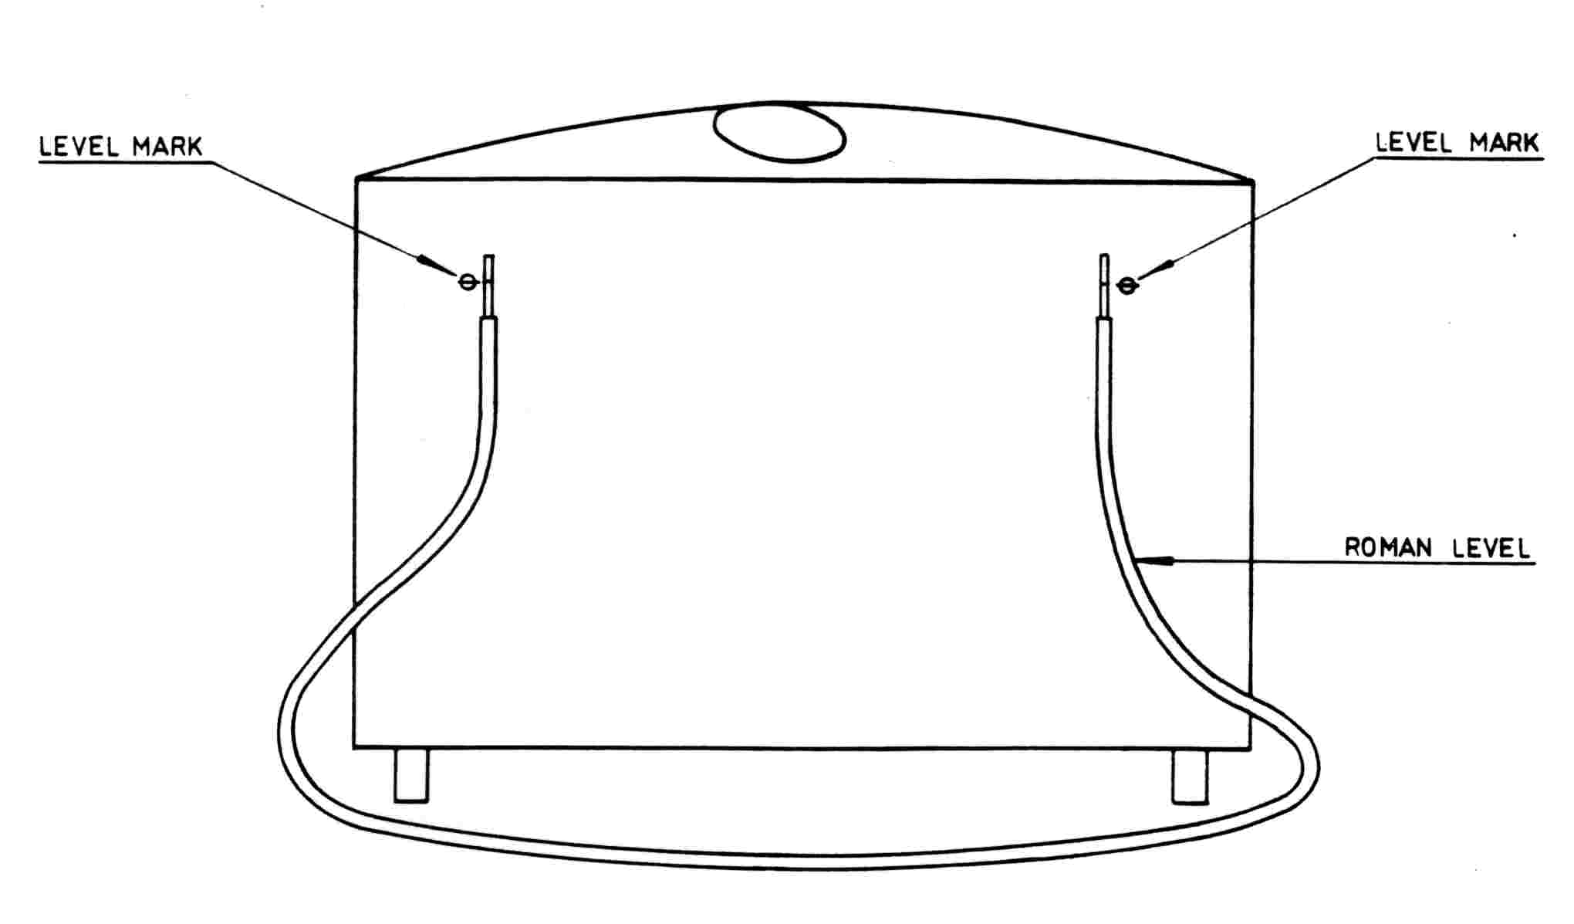
Figure 2. A Roman level being used to check the level of a tank with external level marks
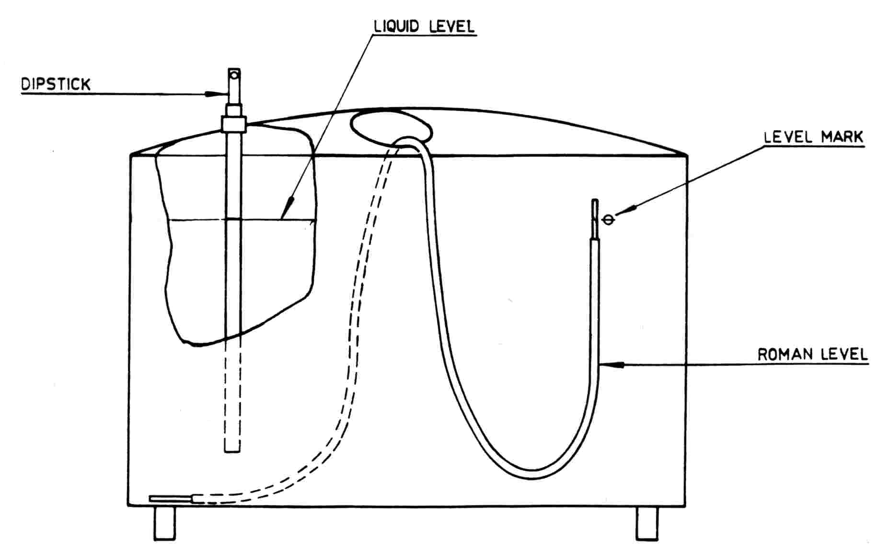
Figure 3. A Roman level being used to check the capacity mark on the dipstick
of a tank with external level marks
Appendix E. Free Drainage Check
The ability to drain freely is checked in the following manner:
  - Level the tank.
  - Flush the tank with water to wet the surface thoroughly and allow it to drain for 4 min.
  - Close the outlet valve and deliver 40 L of water into the tank. Open the outlet valve and allow the tank to drain under gravity for 1 min, and then close the outlet valve.
  - Place a container under the outlet valve.
  - Open the outlet valve and collect the drainage over a period of 4 min.
The volume of water collected should not exceed 160 mL.
Appendix F. Method of Reading the Dipstick
To ensure that correct and reproducible readings are obtained when using a milk tank dipstick, the following procedure is recommended.
- Ensure that:
  - the dipstick is initially clean and dry;
  - the agitator has been inoperative for sufficient time to allow the surface of the liquid to have settled;
  - any froth on the surface, at the point of entry of the dipstick, has been moved aside.
- Gently insert the dipstick vertically in the prescribed position. Take special care during the last 10 mm of movement to prevent ripples.
- After reaching its correct prescribed position, and while still vertical, gently but promptly remove the dipstick from the liquid.
- Read the indication at the line of demarcation between the wet and dry parts of the dipstick.
- At least at one measurement take several dip readings to ensure the dipstick produces the same reading in whatever position it is placed in the socket(s).

