Australian Space Agency – Candidate information session
Slide one

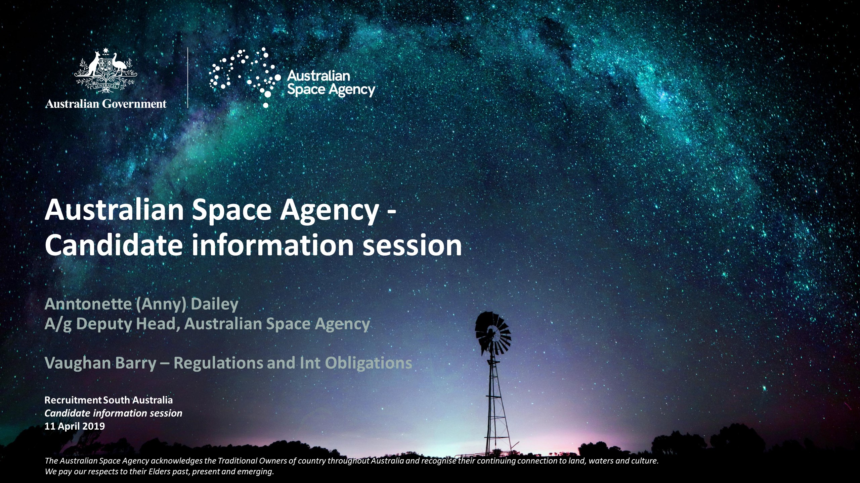

Australian Space Agency - Candidate information session
Anntonette (Anny) Dailey A/g Deputy Head, Australian Space Agency and Vaughan Barry – Regulations and International Obligations
Recruitment South Australia Candidate information session 11 April 2019
The Australian Space Agency acknowledges the Traditional Owners of country throughout Australia and recognise their continuing connection to land, waters and culture. We pay our respects to their Elders past, present and emerging.
The Australian Government is in caretaker and as such, we can only provide advice in line with the Department of Prime Minister and Cabinet’s guidance on Caretaker Conventions.
Slide two
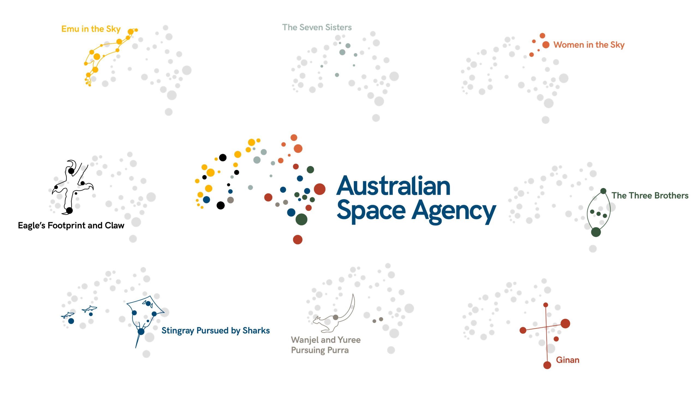

Slide three
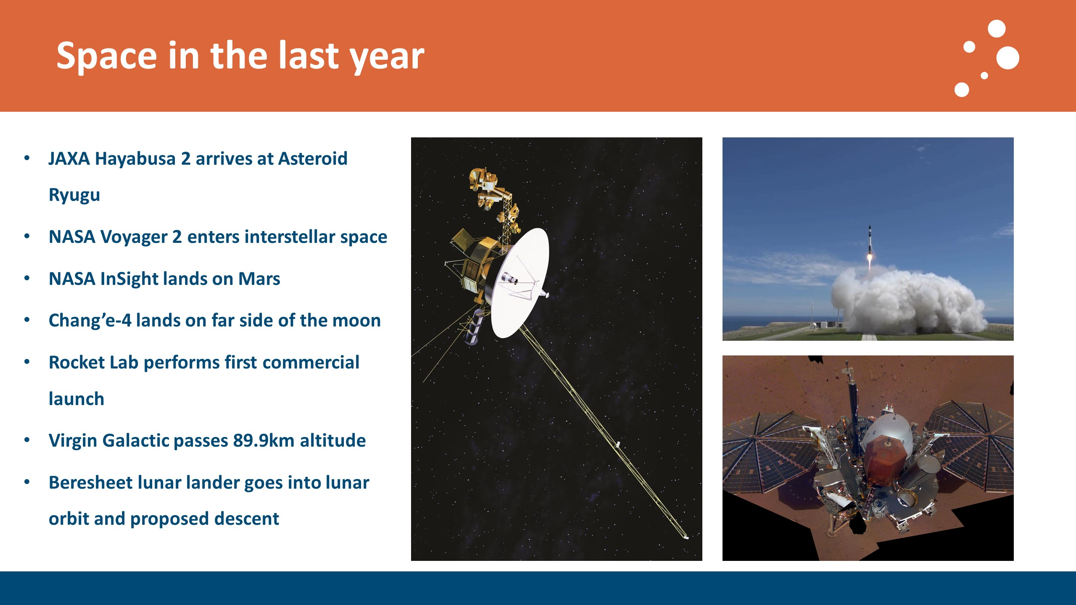

Space in the last year
  - JAXA Hayabusa 2 arrives at Asteroid Ryugu
  - NASA Voyager 2 enters interstellar space
  - NASA InSight lands on Mars
  - Chang’e-4 lands on far side of the moon
  - Rocket Lab performs first commercial launch
  - Virgin Galactic passes 89.9km altitude
  - Beresheet lunar lander goes into lunar orbit and proposed descent
Slide four
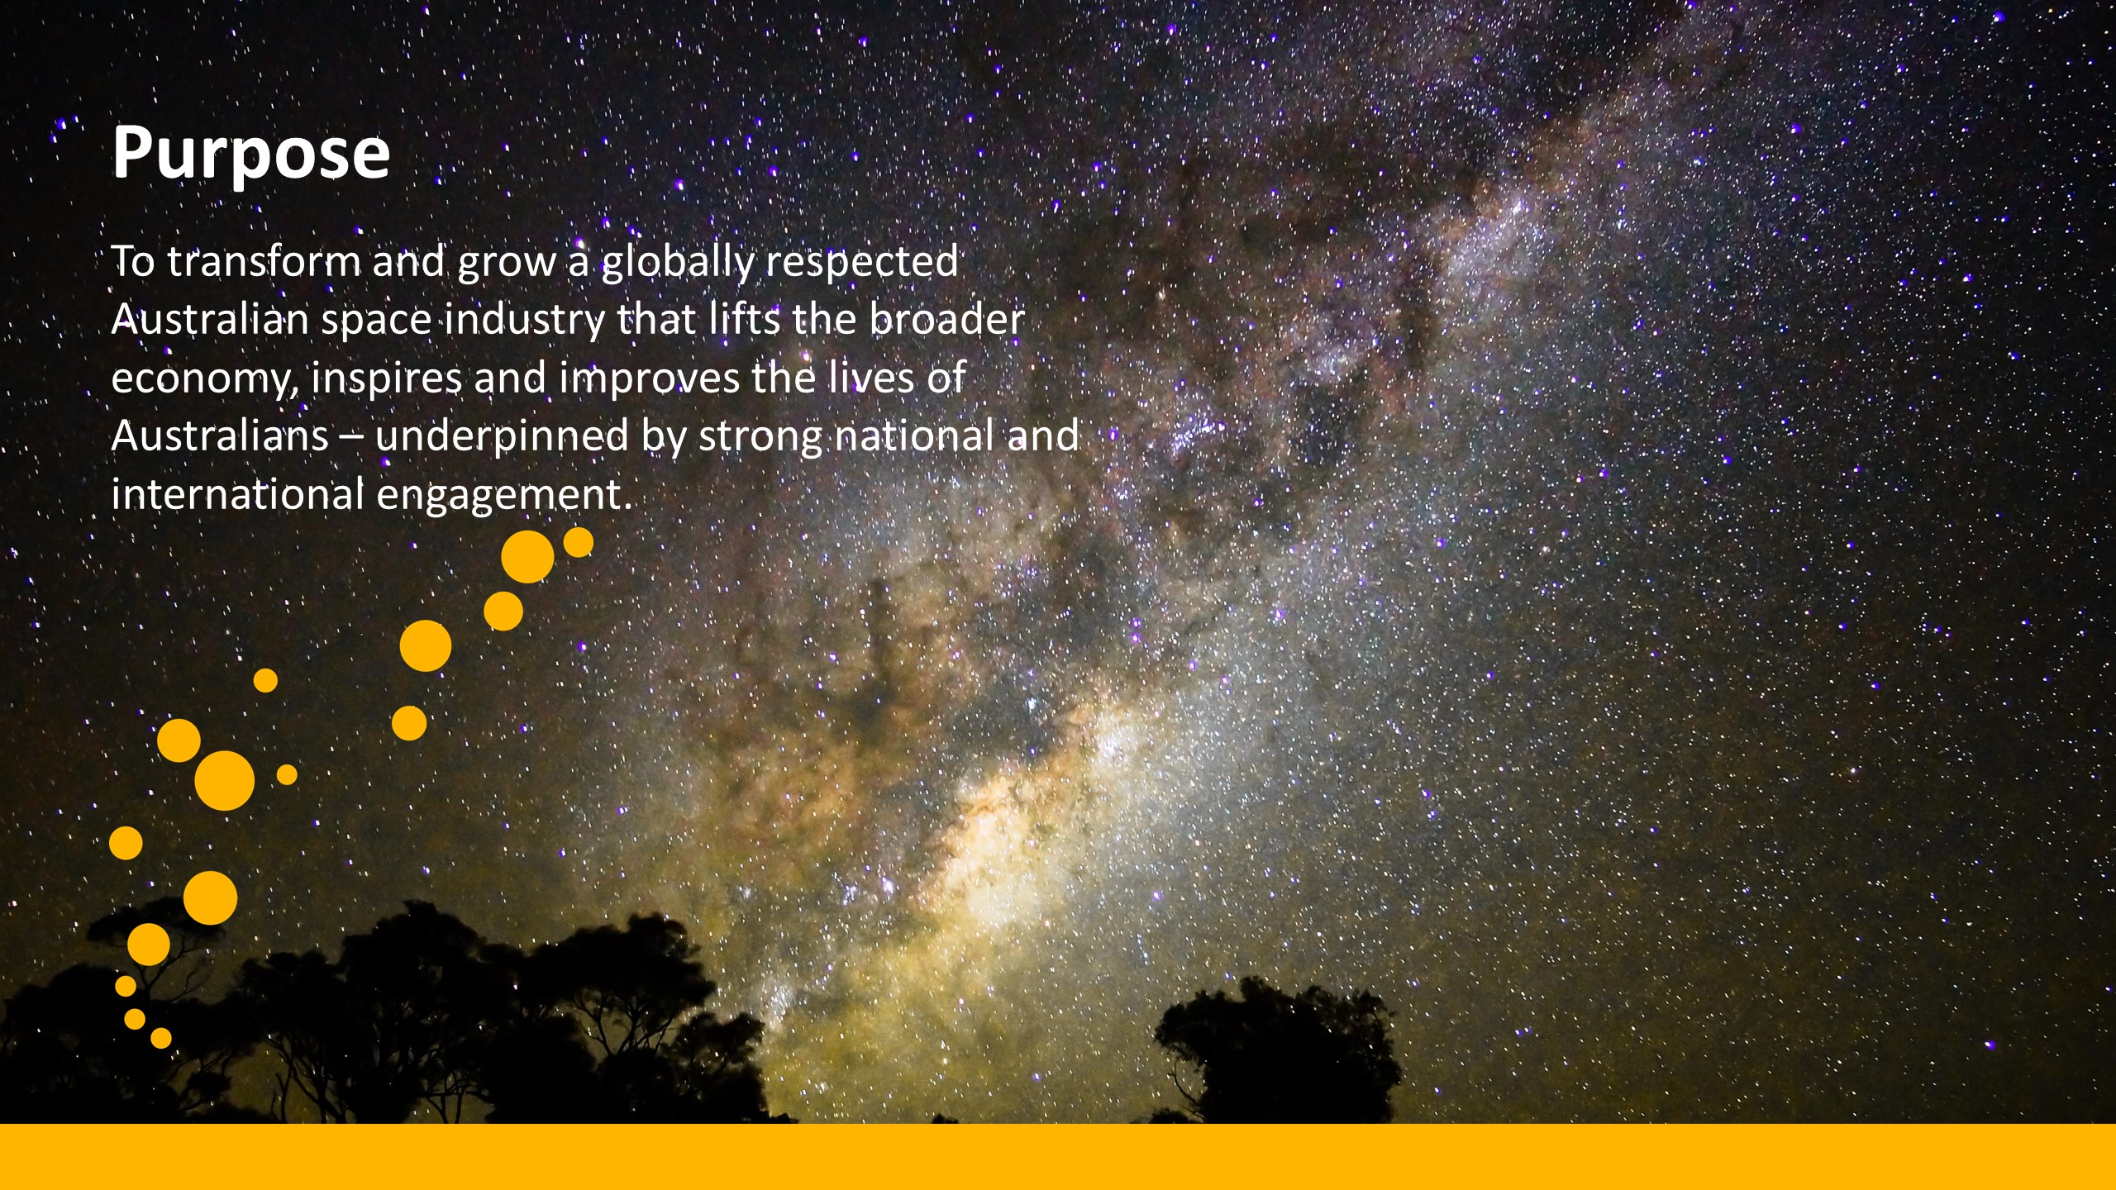

Purpose
To transform and grow a globally respected Australian space industry that lifts the broader economy, inspires and improves the lives of Australians – underpinned by strong national and international engagement.

Slide five
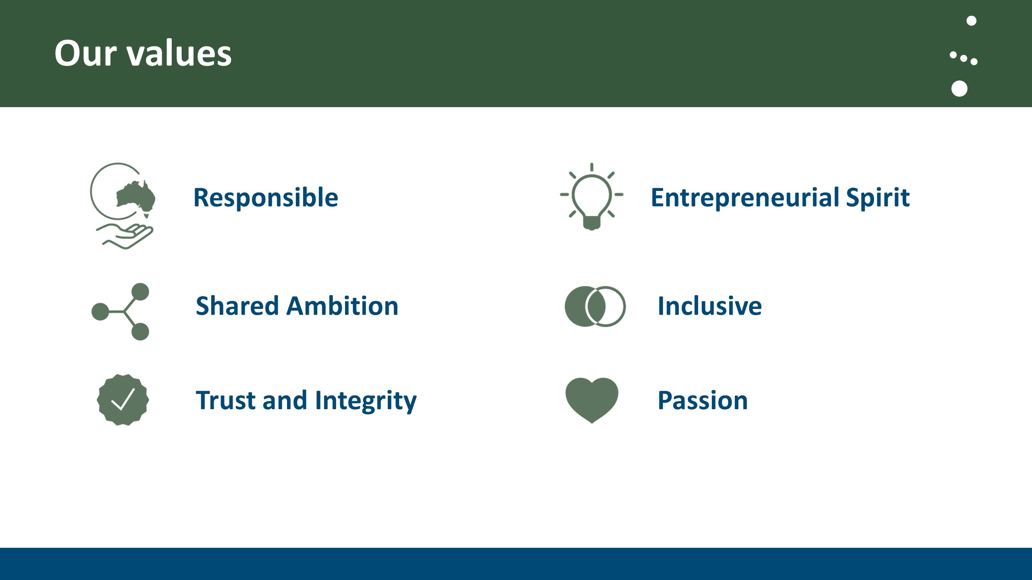

Our values
- Responsible
- Shared vision
- Trust and integrity
- Entrepreneurial spirit
- Inclusive
- Passion

Slide six
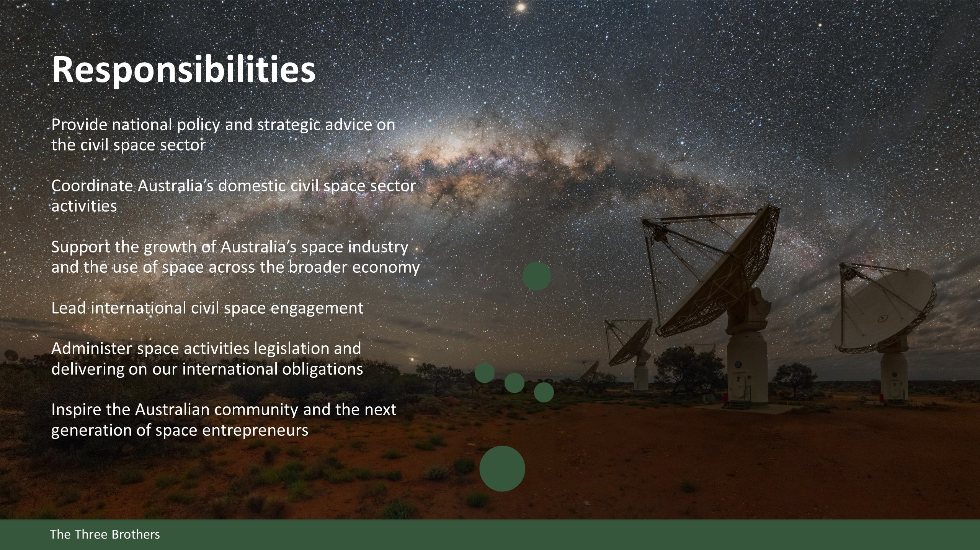

Responsibilities
Provide national policy and strategic advice on the civil space sector
Coordinate Australia’s domestic civil space sector activities
Support the growth of Australia’s space industry and the use of space across the broader economy
Lead international civil space engagement
Administer space activities legislation and delivering on our international obligations
Inspire the Australian community and the next generation of space entrepreneurs
Slide seven
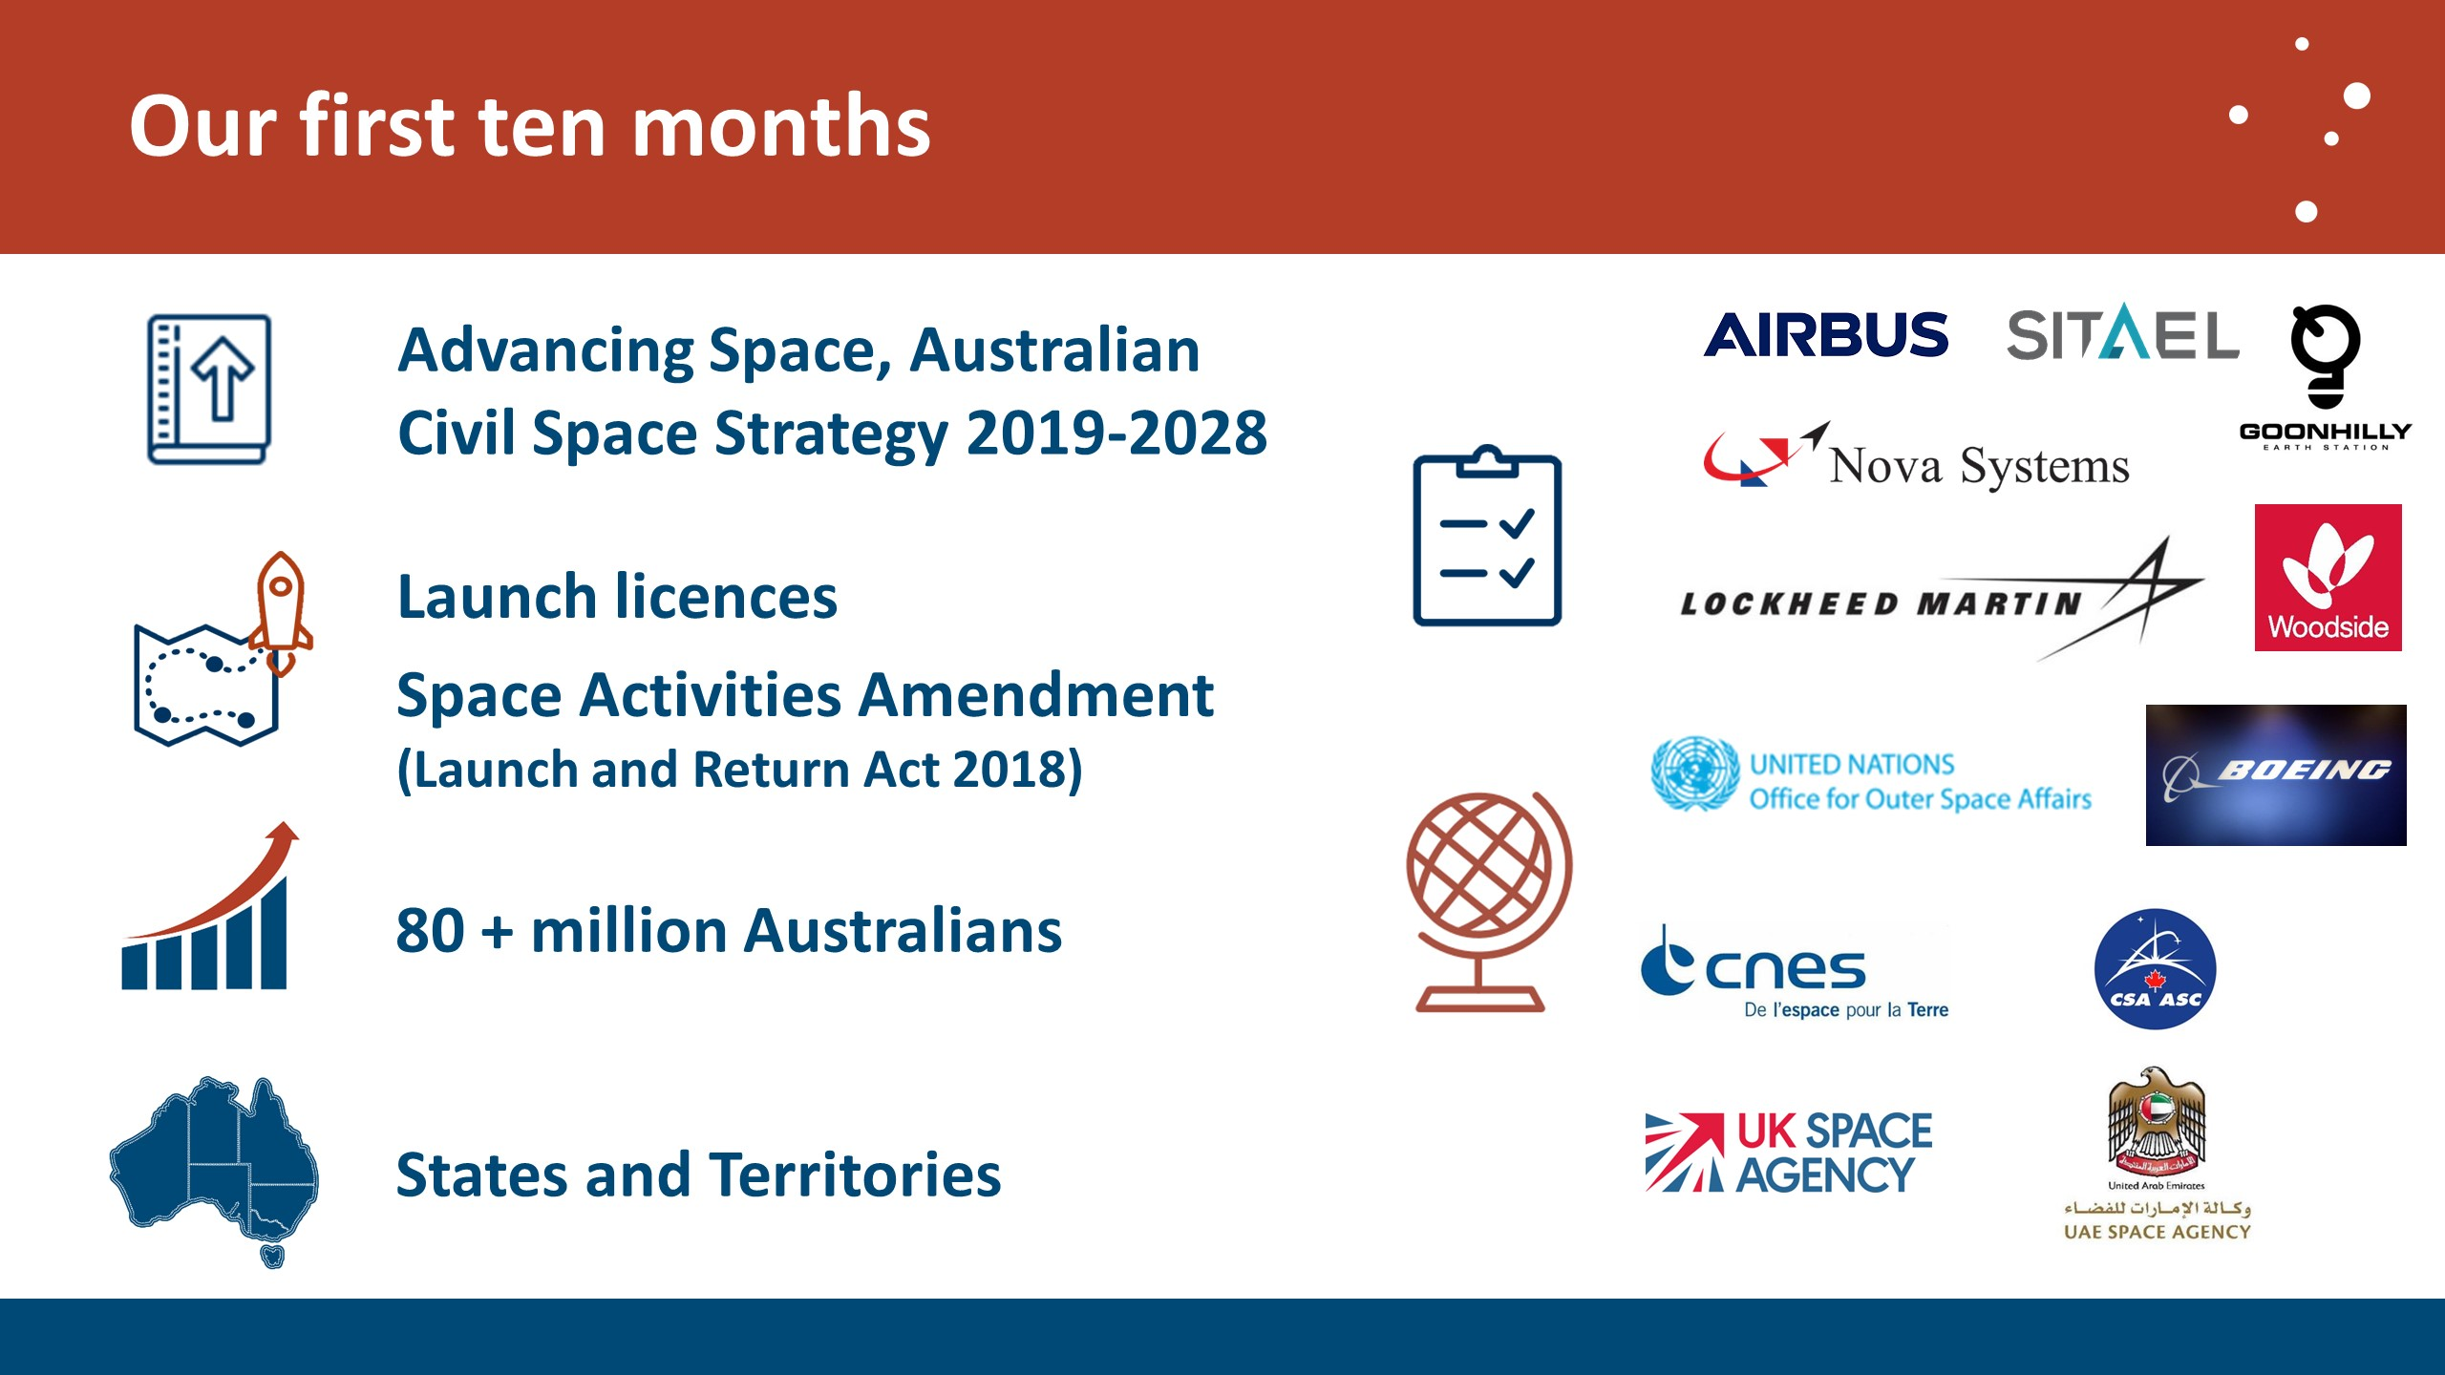

Our first ten months
Advancing Space, Australian Civil Space Strategy 2019-2028
Launch licence Space Activities Amended (Launch and Return Act 2018)
80 + million Australians
States and Territories
Seven Statements of Strategic Intent and Cooperation: Airbus, Sitael, Nova Systems, Lockheed Martin, Goonhilly, Woodside, Boeing
Four Memorandums of Understanding: French, Canadian, United Kingdom and United Arab Emeritus Space Agencies.

Slide eight
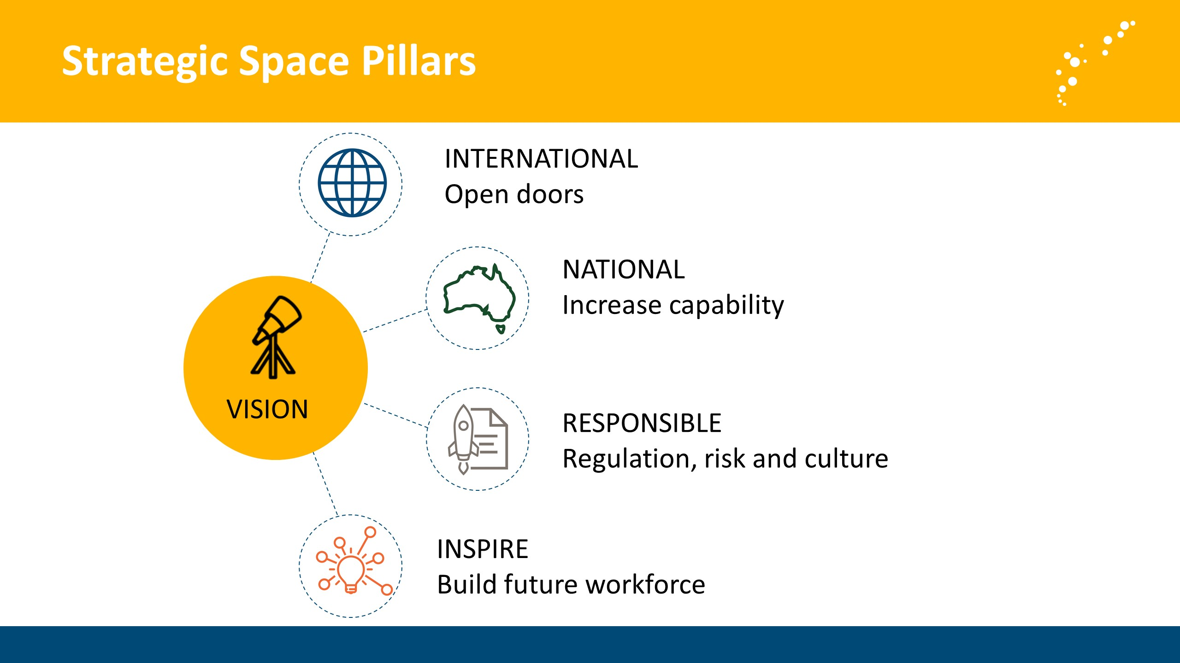

Strategic Space Pillars
- International - Open doors
- National – Increase capability
- Responsible – Regulation, risk and culture
- Inspire – Build future workforce

Slide nine
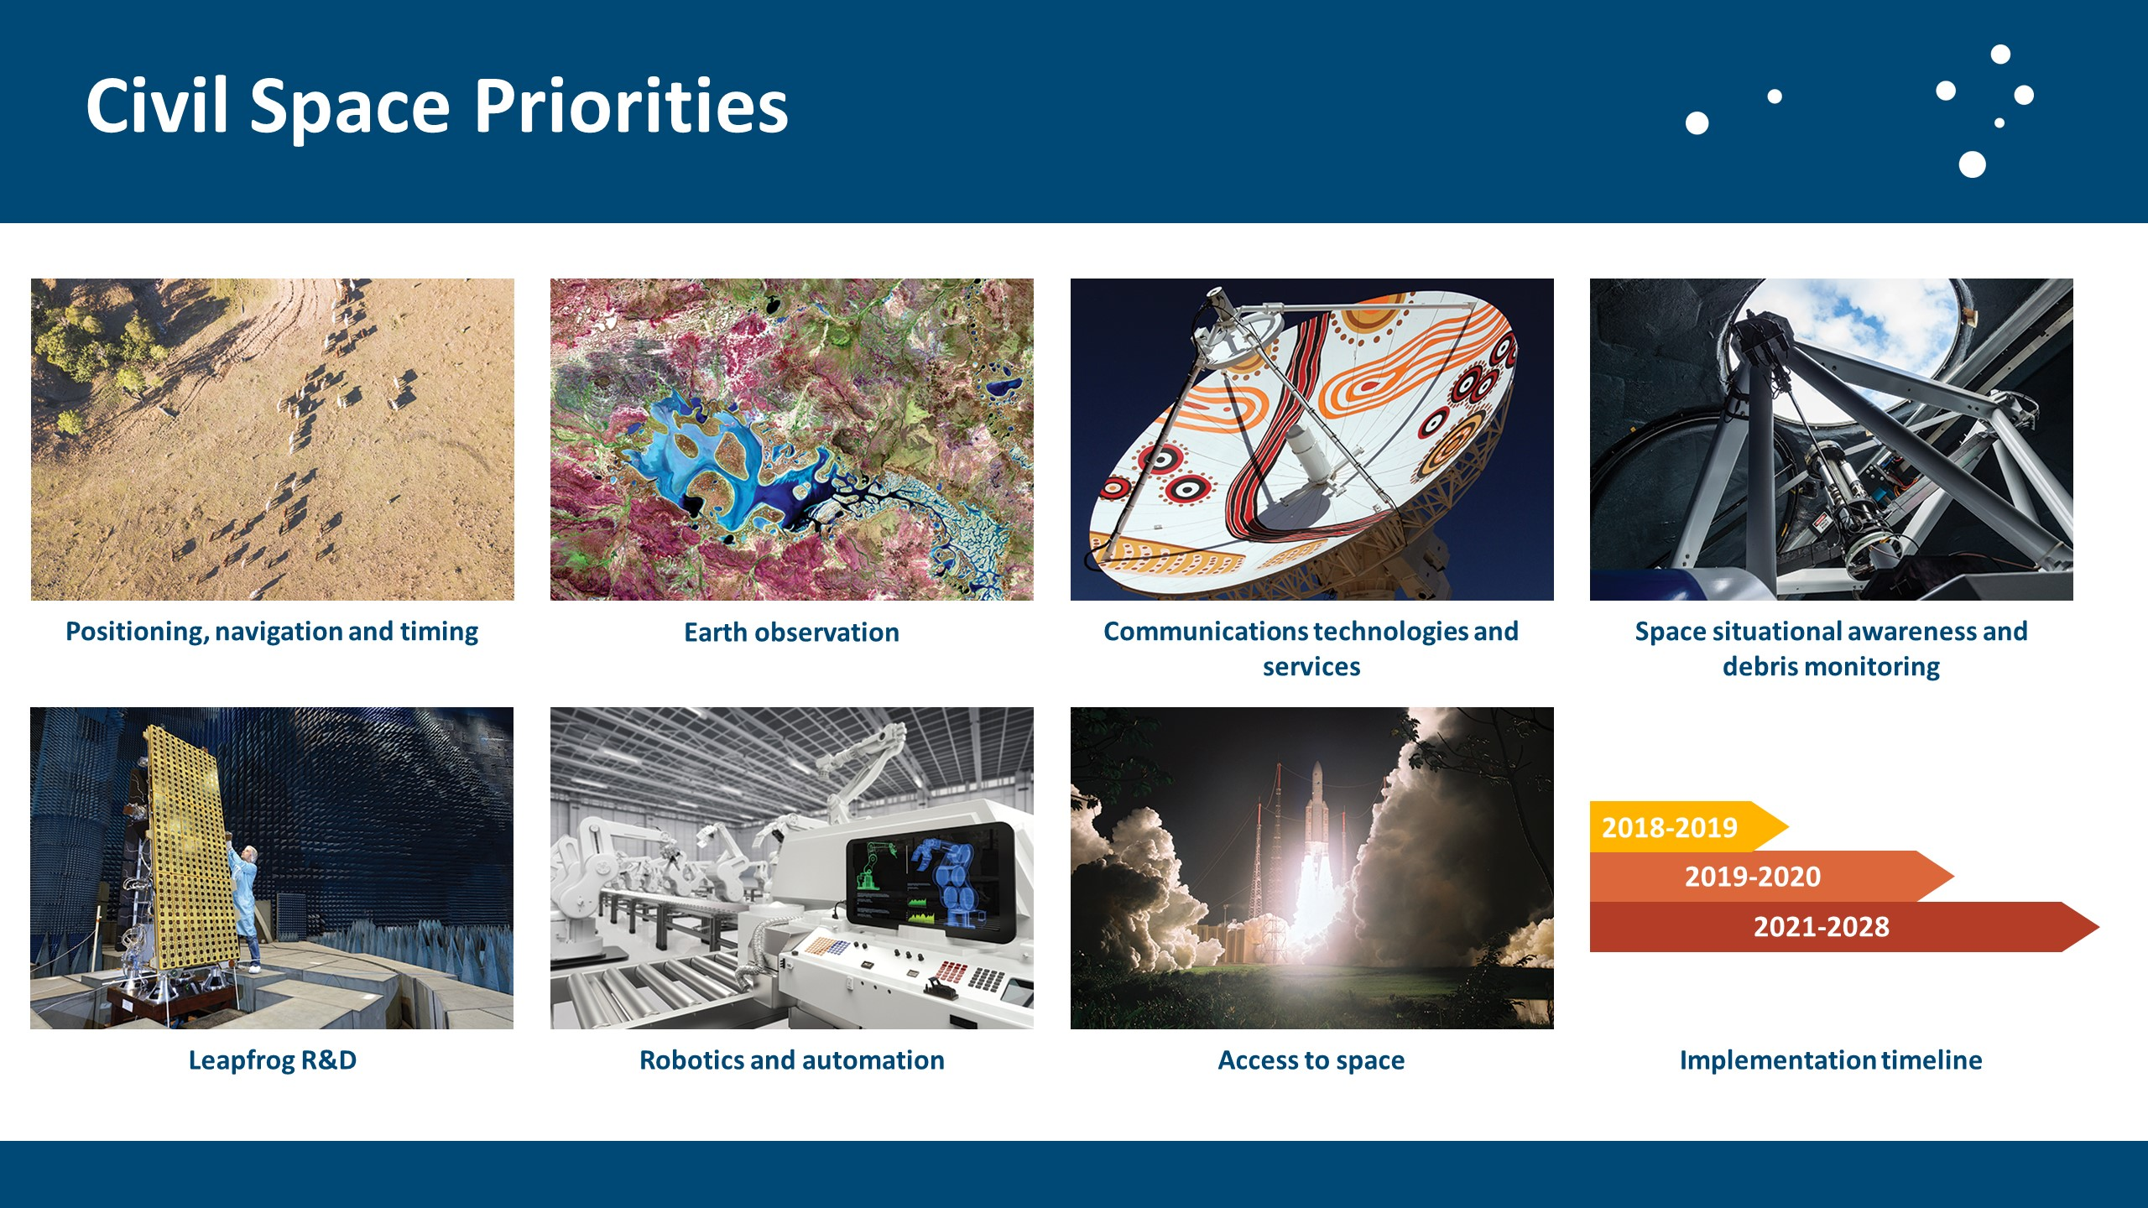

Civil Space Priorities
- Positioning, navigation and timing
- Earth observation
- Communication technologies and services
- Space situational awareness and debris monitoring
- Leapfrog R&D
- Robotics and automation
- Access to space
- Implementation timeline

Slide ten
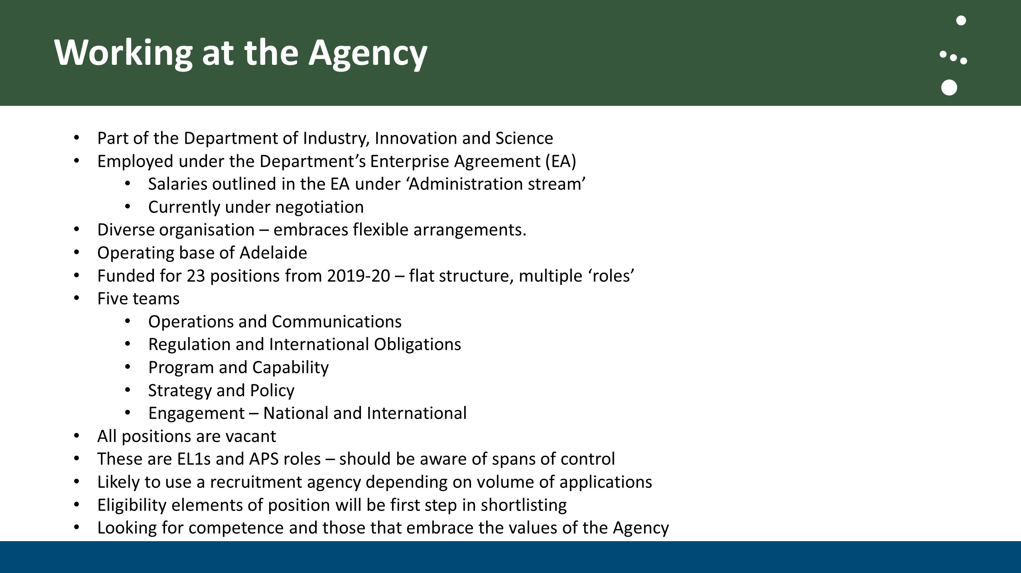

Working at the Agency
- Part of the Department of Industry, Innovation and Science
- Employed under the Department’s Enterprise Agreement (EA)
- Salaries outlined in the EA under ‘Administration stream’
- Currently under negotiation
- Diverse organisation – embraces flexible arrangements.
- Operating base of Adelaide
- Funded for 23 positions from 2019-20 – flat structure, multiple ‘roles’
- Five teams
- Operations and Communications
- Regulation and International Obligations
- Program and Capability
- Strategy and Policy
- Engagement – National and International
- All positions are vacant
- These are EL1s and APS roles – should be aware of spans of control
- Likely to use a recruitment agency depending on volume of applications
- Eligibility elements of position will be first step in shortlisting
- Looking for competence and those that embrace the values of the Agency
Slide eleven
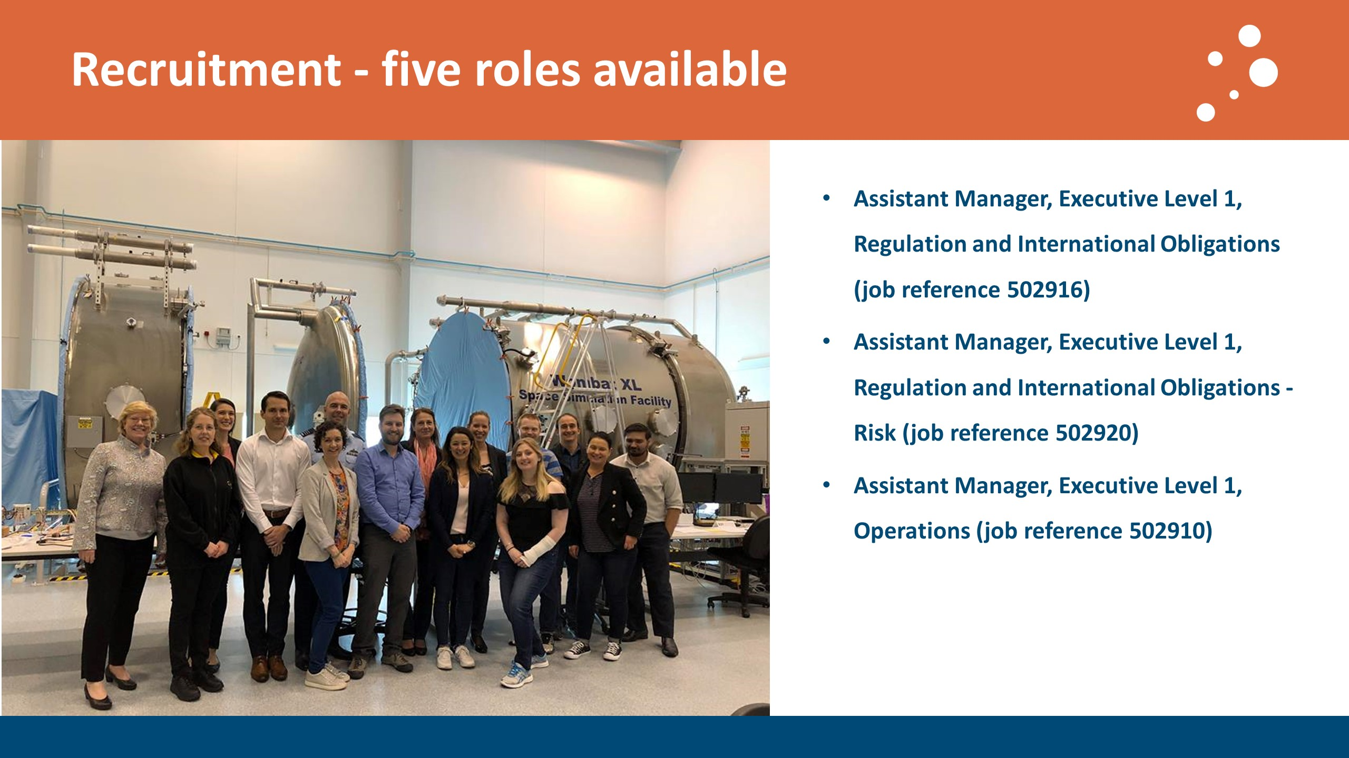

Recruitment – five roles available
Assistant Manager, Executive Level 1, Regulation and International Obligations (job reference 502916)
Assistant Manager, Executive Level 1, Regulation and International Obligations - Risk (job reference 502920)
Assistant Manager, Executive Level 1, Operations (job reference 502910)

Slide twelve
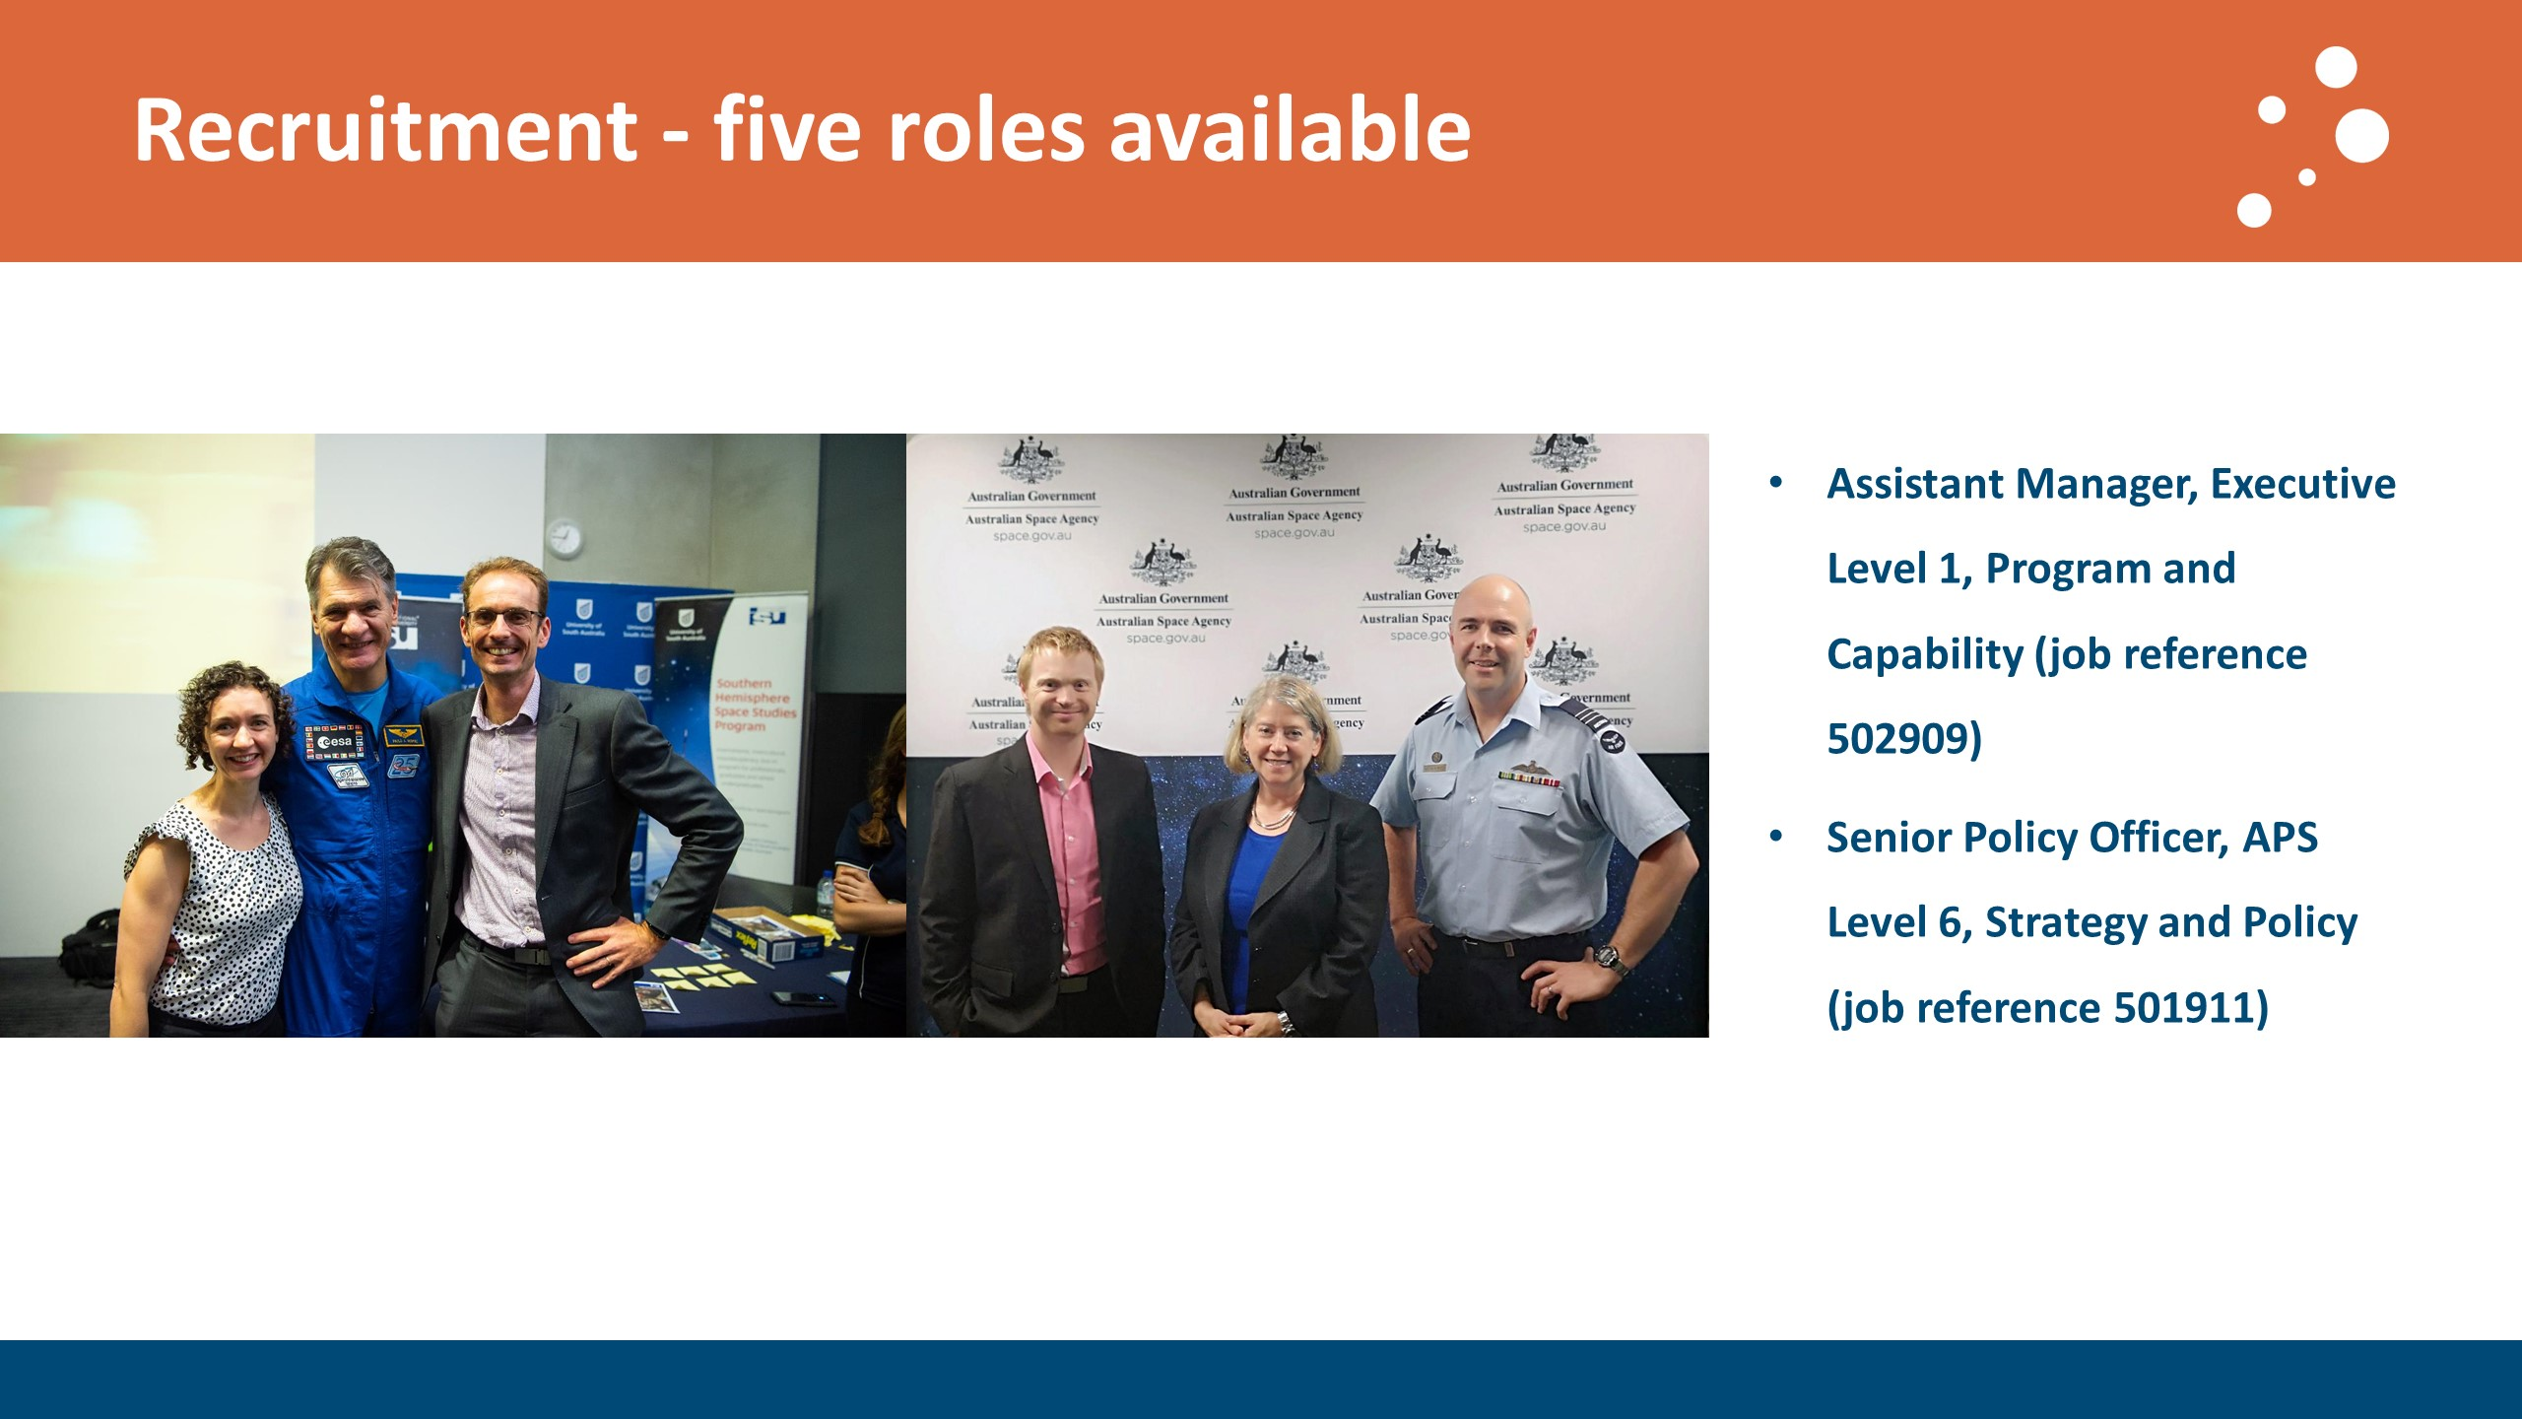

Recruitment – five roles available
- Assistant Manager, Executive Level 1, Program and Capability (job reference 502909)
- Senior Policy Officer, APS Level 6, Strategy and Policy (job reference 501911)
Slide thirteen
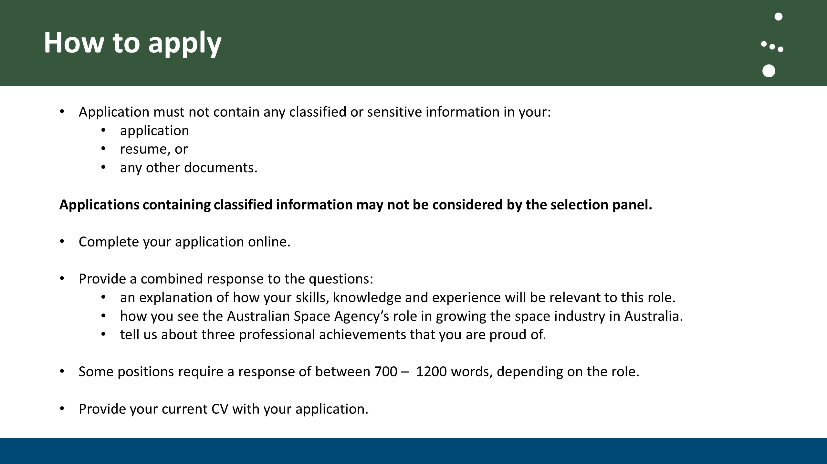

How to apply
- Application must not contain any classified or sensitive information in your:
  - application
  - resume, or
  - any other documents.
Applications containing classified information may not be considered by the selection panel
- Complete your application online.
- Provide a combined response to the questions:
- an explanation of how your skills, knowledge and experience will be relevant to this role.
- how you see the Australian Space Agency’s role in growing the space industry in Australia.
- tell us about three professional achievements that you are proud of.
- Some positions require a response of between 700 – 1200 words, depending on the role.
- Provide your current CV with your application.

Slide forteen
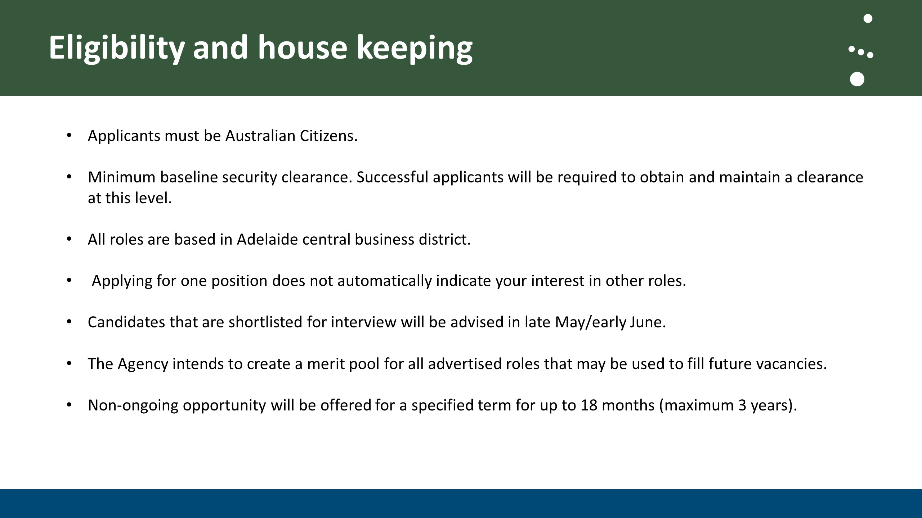

Eligibility and house keeping
- Applicants must be Australian Citizens.
- Minimum baseline security clearance. Successful applicants will be required to obtain and maintain a clearance at this level.
- All roles are based in Adelaide central business district.
- Applying for one position does not automatically indicate your interest in other roles.
- Candidates that are shortlisted for interview will be advised in late May/early June.
- The Agency intends to create a merit pool for all advertised roles that may be used to fill future vacancies.
- Non-ongoing opportunity will be offered for a specified term for up to 18 months (maximum 3 years).

Slide fifteen
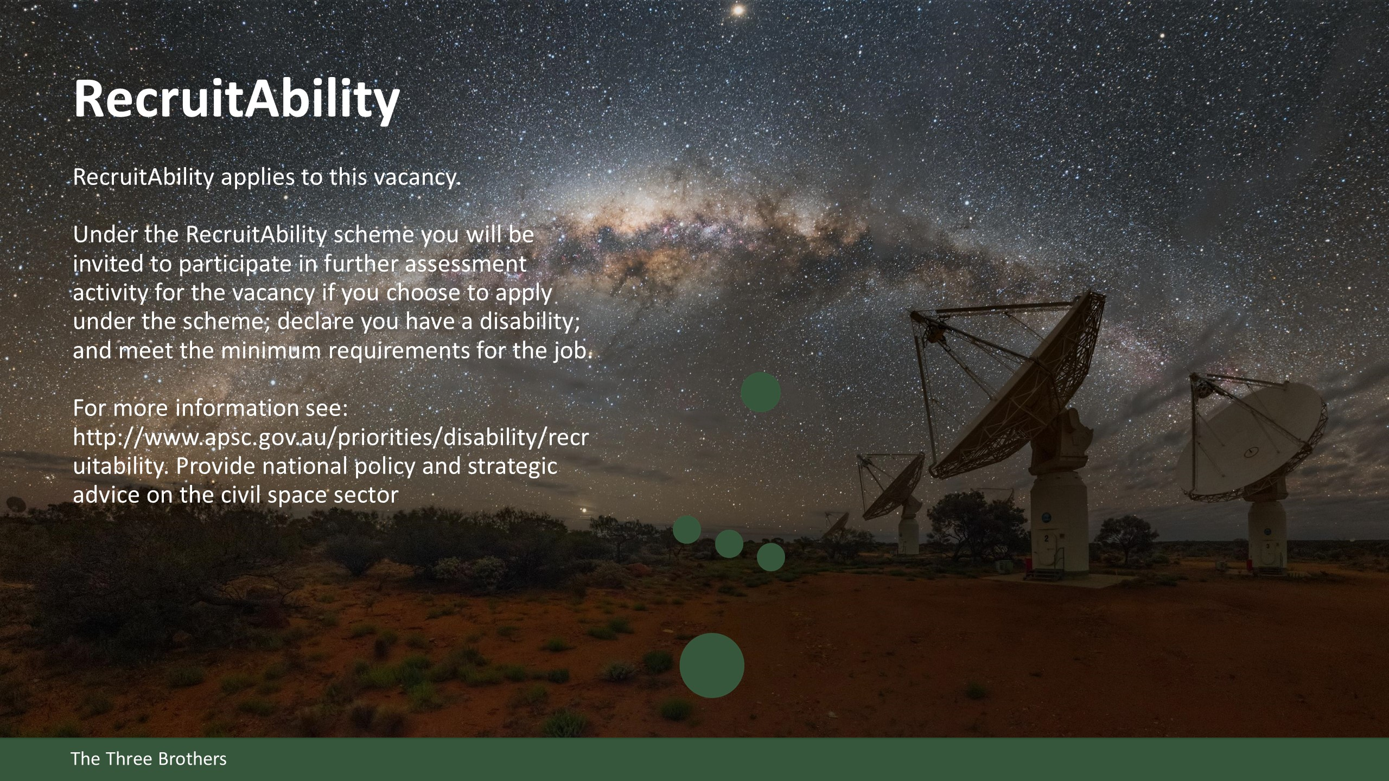

RecruitAbility
RecruitAbility applies to this vacancy.

Under the RecruitAbility scheme you will be invited to participate in further assessment activity for the vacancy if you choose to apply under the scheme; declare you have a disability; and meet the minimum requirements for the job.

For more information see: http://www.apsc.gov.au/priorities/disability/recruitability

Slide sixteen
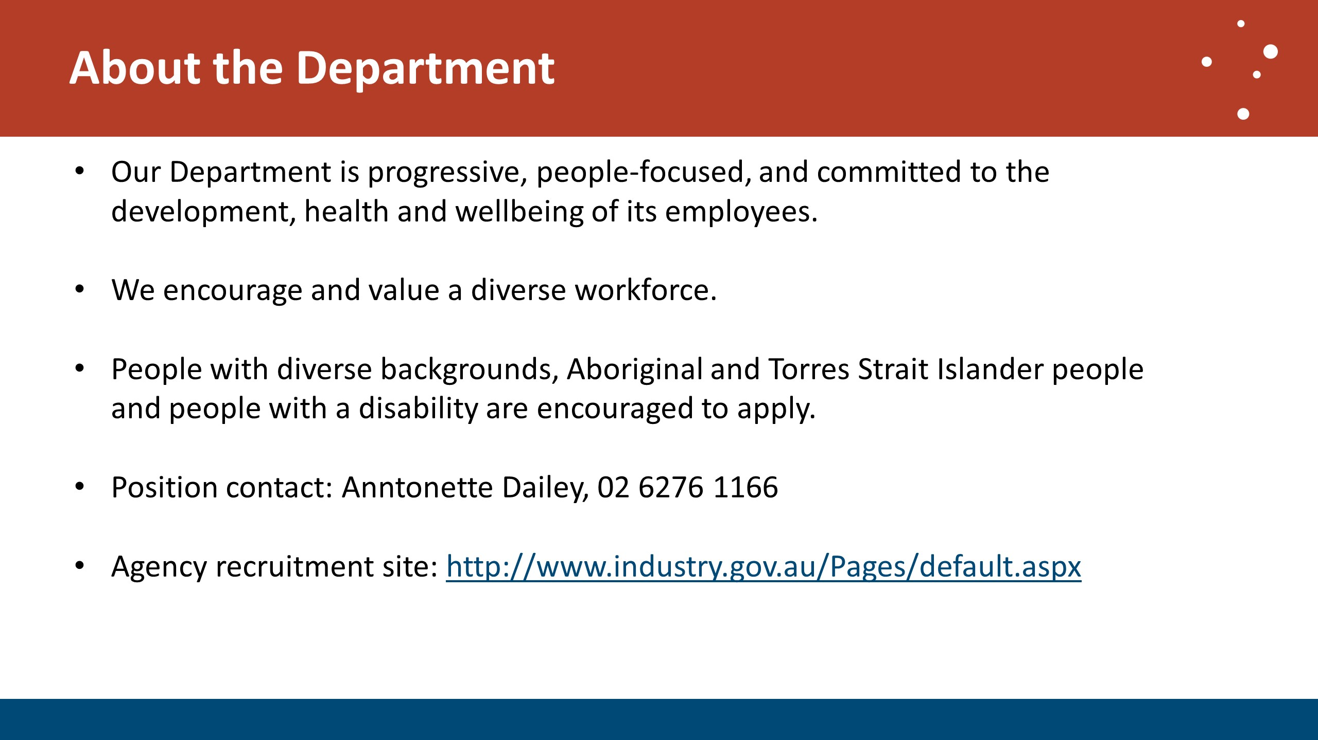

About the Department
- Our Department is progressive, people-focused, and committed to the development, health and wellbeing of its employees.
- We encourage and value a diverse workforce.
- People with diverse backgrounds, Aboriginal and Torres Strait Islander people and people with a disability are encouraged to apply.
- Position contact: Anntonette Dailey, 02 6276 1166
- Agency recruitment site: http://www.industry.gov.au/Pages/default.aspx

Slide seventeen
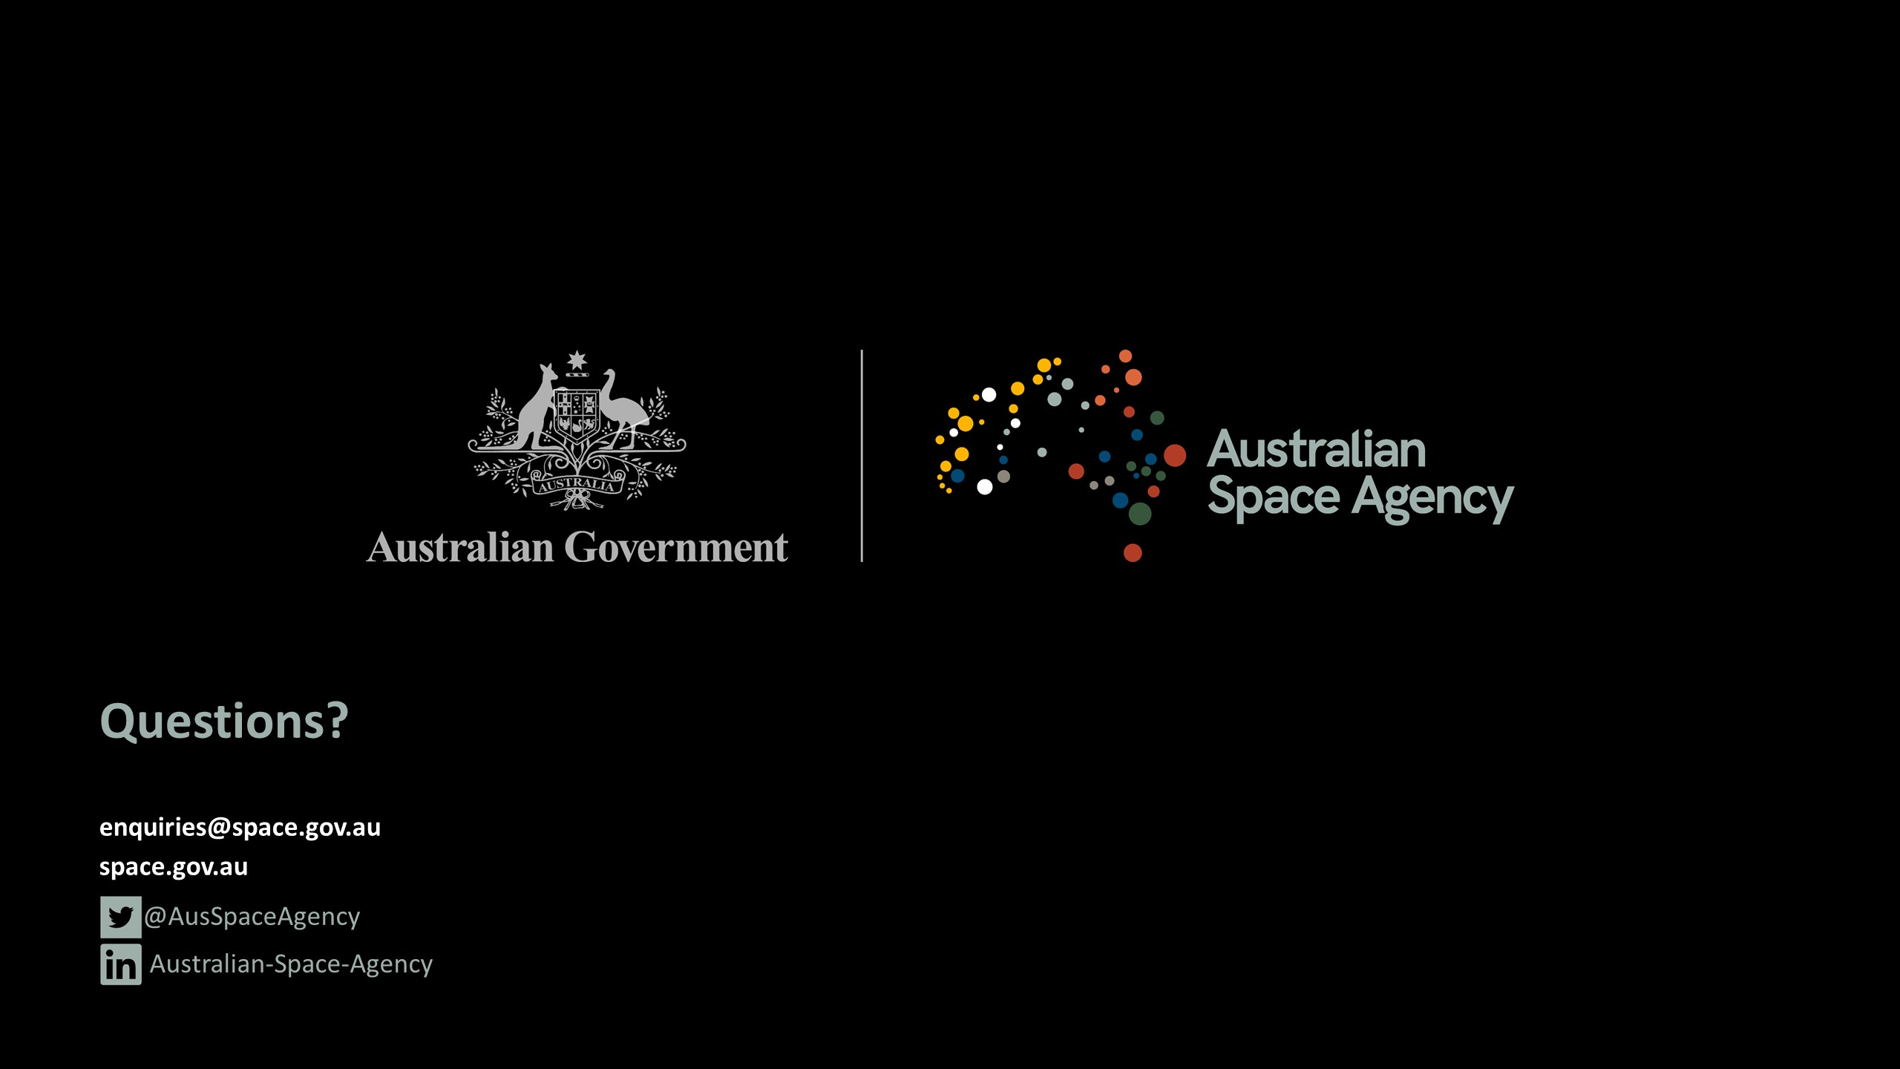

Contact
enquiries@space.gov.au
space.gov.au
Twitter @AusSpaceAgency
LinkedIn /Australian-Space-Agency

Frequently asked questions
Will the Programs and Capability team have a broader participation in distribution of funding/finances and grants to grow the space economy?
The successful candidate will engage directly with funded projects to increase the space economy’s footprint. The position may incorporate support for delivery of two programs announced in the Advancing Space Strategy.
Will the Agency give more consideration to experience or qualifications?
Neither will be given a specific preference. Experience will be counted, but the Agency will also take into account people who have qualifications or are working towards them.
While the eligibility indicates that qualifications will be considered favourably, experience will not be discounted.
Will the Assistant Manager Operations role have ownership of finances? How much ownership does the Agency have over its budget?
The Agency has control over the funds allocated within its budget, however the Commonwealth Public Service has specific guidelines and appropriations and allocation of funding.
Will there be APS roles created under the EL1 and EL2 roles in the Program and Capability area?
There will be no immediate increase in staff numbers beyond the five advertised roles at this stage. The Agency will create a merit pool which it can draw from for up to 12 months for similar or non-ongoing roles if required. The EL1 role will likely contain a good deal of autonomy and an expectation to provide possible ad-hoc supervision across teams.
Will the Regulation and International Obligations roles have access to specialist areas of the Department of Industry, Innovation and Science e.g. legal roles?
The Agency works closely with the legal team within the Department and also across other agencies and organisations depending on the legal advice required. The position being advertised is for the International Obligations role, and the successful candidate is likely to participate in a number of external engagements with the United Nations and other organisations. The pace of the Regulation and International Obligations team would give preference to the ability to manage sensitivities and the broader remit of the team and its role in the Agency.
How does the Agency manage the complex mix of responsibilities; specifically for the Operations role, how does the Agency manage its communication effectively, encompassing encouraging industry and STEM, intellectual property considerations, and other linkages?
The Agency is moving towards a process by which the inspiration element of its remit is more deeply enmeshed in the communications plan. As the Agency grows with the space sector, we anticipate the communications role will also grow and change. The Agency has an entrepreneurial approach, and flexibility in communication is a key enabler of this. However, it is not the Agency’s purpose is to support the commercial capability of other organisations or companies, rather than to support industry to manage their intellectual and other property.
Was there an initial Australian Space Agency strategy that was developed prior to creating the Agency?
An Expert Reference Group submitted a report to Government called the Review of Australia’s Space Industry Capability. This can be found on the Agency’s website.
Do you currently have staff that working in the roles being advertised?
No. These are new roles and there are no staff working or acting in the positions currently.
Will these positions be working to EL2 supervisors?
Yes, there are currently EL2 Executive Directors for each team.
Will the Agency give more weight to candidates with a higher level of security clearance when rating suitability for a role?
This will only be done in cases where there are two identically qualified candidates in other respects. The Agency will primarily focus on core capabilities to form its decisions.
Will the Programs & Capability area potentially respond to work load gaps that are identified within a particular team?
Once gaps have been identified and assessed, the workload can be managed across the Agency. However, the Agency is still fairly new and would need to have statutory authority, plus enough staff to identify and fill gaps. Current practice is for staff to work across teams as required.
Would the Agency be looking to create an Innovation Hub model program within the Agency where there is funding available for innovative projects?
The Agency anticipates, in time, working towards a program delivery model that is suited to identified issues – for example, through Memorandums of Understanding, grants, funding instruments. The Department of Industry, Innovation and Science has a number of different approaches which can be leveraged over time, including the Cooperative Research Centres program, Research and Development Tax Incentive, Growth Centres, etc.
Is it part of the Australian Space Agency's strategy to engage professional service providers?
That is not yet covered by the Agency's policies, however, each body of work will be structured appropriately and may include APS secondments, non-ongoing APS positions, external service providers, or whatever alternatives and combinations are suitable. This will be determined on a case-by-case basis.
If an applicant has a background which is strong in academia but has minimal experience in the public service, industry or defence sectors, is it worth applying?
The Australian Space Agency is willing to look 'outside the box' for good candidates. Experience in international engagement such as with the United Nations Committee on the Peaceful Uses of Outer Space or US Space Force is beneficial, and all candidates should be guided by the APS Integrated Leadership System (ILS) profile for the level of their application.
Each position has an extensive list of skills and responsibilities, with a multiple questions to answer in a single response. How strict is the word limit for those responses?
Fairly strict. The Agency is predicting a high number of applicants, so to allow all applications to be considered within a reasonable timeframe, responses must be within the word limit. The recruitment website may not accept responses over that limit, and if an external recruitment agency is hired to vet applicants they may truncate responses over the word limit.
The information session made it clear that the Agency's current workload is immense and its workforce is small, but also emphasised the importance of work-life balance and the possibility of flexible working arrangements. How do current staff handle these competing pressures?
The Agency has engaged staff who are flexible in working across domains and who are very productive - this allows us to focus our efforts where and when they are needed to meet immediate goals. Occasionally long hours are required, however, the Head’s policy is to balance work and life to mitigate the risk of staff burnout.

