

**Youth in STEM Research:  
Summary of results**



# Background

In a world of constant change, it is critical that the Australian population has the right skills to take advantage of the opportunities presented by the technological and innovative advancements happening around the world. An understanding of science, technology, engineering and mathematics (STEM) is invaluable to developing these skills.

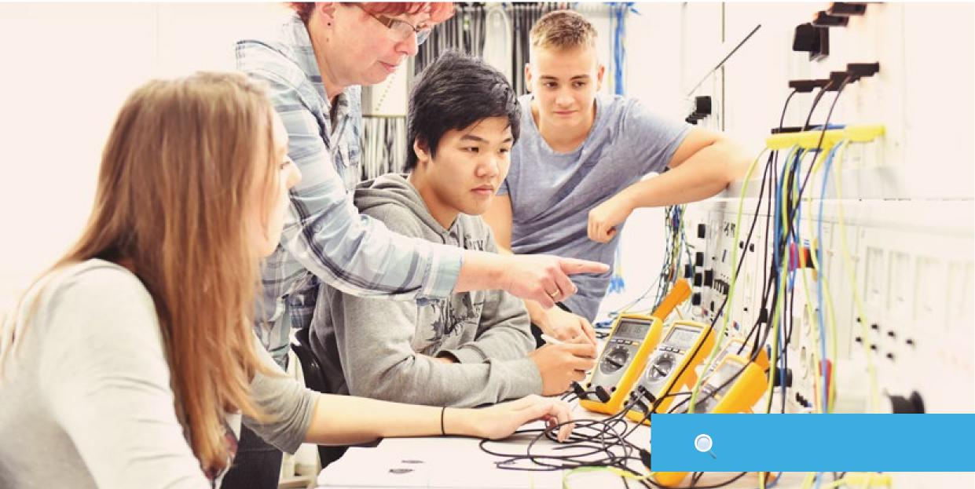

It’s not just our scientists and coders who need STEM skills. STEM knowledge and skills lead to new products, more efficient services, and a more diverse, resilient and sustainable economy across all sectors.

In light of this, the Department of Industry, Innovation and Science commissioned YouthInsight to conduct a nationwide study of Australian student attitudes and behaviours towards STEM education and careers in STEM-related fields.

The study was carried out online and surveyed 2,000 students aged between 12 and 25 years from all states and territories. The results provide a national benchmark of awareness and perceptions held by young Australians towards STEM. However, it should be noted that the group surveyed are an indication of broader attitudes and perceptions, rather than an absolute dataset of all young Australians.

Nurturing and tapping into the entire pool of STEM talent will support a more innovative, inclusive and prosperous economy. As such, this report particularly focuses on the gender inequity found throughout STEM education and careers.

# Objectives

The principal objective of the study was to create a national benchmark of young Australians’ awareness and perceptions of STEM subjects and STEM-related careers, with a particular focus on the difference between male and female students.

More specifically, the study looks at:

* Evaluating the perceived importance of STEM subjects to students
* Determining student interest in considering further STEM education
* Determining student interest in STEM careers
* Assessing young Australians’ engagement with STEM outside of education
* Understanding student awareness of STEM-related careers
* Identifying barriers and enablers to STEM careers
* Understanding the factors that influence career choices
* Determining student perceptions of technological advancements

# **Methodology**

To achieve the objectives, YouthInsight conducted a nationwide survey among a representative sample of people aged 12-25. A 15-minute survey of 2,092 students was conducted online using the Student Edge Youth Panel.

# Data Weighing

To ensure survey results were representative of the population, rim weighting was used to correct for under or over representation of sub-groups. Gender, age and location were the three factors rim weighting was used for.

An equal balance of males and females was sought within each age group (note that there were also participants who did not identify with binary genders). The sample of respondents aged 12 to 13 fell short of the representative target, so other age groups were slightly inflated to ensure we achieved our final quota of 2,000 respondents.

The sample was also weighted to align with the population distribution by states and territories, in line with Australian Bureau of Statistics records.

**Below are summary tables of the sample with applied weight factors for age, gender and location.**

**Weight factor 1**

| **Gender** | **Actual**  **Age**  **Sample** | | **Actual  Sample %** | | | **Weighted sample** | **Weighted  Sample %** | **% Variance** |
| --- | --- | --- | --- | --- | --- | --- | --- | --- |
| Male | 12-13 | 23 |  | 1% |  | 63 | 3% | 2% |
| Male | 14-17 | 347 |  | 17% |  | 314 | 15% | -2% |
| Male | 18 -21 | 375 |  | 18% |  | 335 | 16% | -2% |
| Male | 22- 25 | 233 |  | 11% |  | 293 | 14% | 3% |
| Female | 12 to13 | 54 |  | 3% |  | 63 | 3% | 0% |
| Female | 14-17 | 291 |  | 14% |  | 335 | 16% | 2% |
| Female | 18-21 | 372 |  | 18% |  | 335 | 16% | -2% |
| Female | 22-25 | 352 |  | 17% |  | 293 | 14% | -3% |
| Non-binary | 12-13 | 0 |  | 0% |  | 0 | 0% | 0% |
| Non-binary | 14-17 | 12 |  | 1% |  | 21 | 1% | 0% |
| Non-binary | 18-21 | 24 |  | 1% |  | 21 | 1% | 0% |
| Non-binary | 22-25 | 9 |  | 0% |  | 21 | 1% | 1% |

**Weight factor 2**

| **State**  **or Territory** | **Actual Sample** | **Actual Sample %** | |  | **Weighted sample** | | **Weighted Sample %** | **% Variance** |
| --- | --- | --- | --- | --- | --- | --- | --- | --- |
| NSW | 753 |  | 36% |  | 669 |  | 32% | -4% |
| VIC | 618 |  | 30% |  | 586 |  | 28% | -2% |
| QLD | 285 |  | 14% |  | 377 |  | 18% | 4% |
| WA | 237 |  | 11% |  | 230 |  | 11% | 0% |
| SA | 127 |  | 6% |  | 146 |  | 7% | 1% |
| ACT | 38 |  | 2% |  | 21 |  | 1% | -1% |
| TAS | 26 |  | 1% |  | 42 |  | 2% | 1% |
| NT | 8 |  | 0% |  | 21 |  | 1% | 1% |

# Section 1 – Overview

The survey results indicate that science, technology, engineering and mathematics (STEM) subjects and careers are seen as valuable and interesting to young Australians, and skills in these areas are important to achieving a good job across all industries in the future.

The story told by the survey reveals positive attitudes towards STEM. The majority of respondents (80 per cent) agree that ‘scientists make a positive impact on the world’ and 64 per cent say that ‘learning about science and technology is exciting.’ Just over half (55 per cent) believe ‘it’s important to know about science and technology to get a good job.’ However, only 46 per cent ‘discuss these subjects with their family’, which is concerning given how influential parents are in the decisions young people take.

General awareness of the term ‘STEM’ is relatively strong among Young Australians. Sixty-two per cent of respondents correctly identified the subjects that make up the acronym. Both males and females gave a similar number of correct responses, however, students aged 14-17 had the highest proportion of correct responses with 68 per cent. Among the respondents who were not aware of the subjects that make up ‘STEM’, the letters ‘E’ (engineering) and ‘M’ (mathematics) were most likely to be incorrect.

General interest was highest for science (64 per cent), technology (65 per cent) and maths (50 per cent). Only 42 per cent of respondents stated they were interested in engineering. Engineering was found throughout the survey to be the subject where young Australians had the least confidence, understanding and interest – factors that interact and reinforce each other to make engineering a significant barrier to those considering further study or a career in STEM.

Encouragingly, almost half of all young people (46 per cent) are considering studying STEM-related subjects in the future, although this is driven more by males (52 per cent) than females (40 per cent). Of the respondents, 23 per cent were not sure if they would consider studying STEM subjects, and 31 per cent were not interested at all.

Young people stated the main reasons for seeking to study STEM in the future was because they are interested in STEM, and have plans of pursuing a STEM-related career in the future. Some female students are also motivated by the concept of balancing out the unequal representation of genders.

**Below are some of the direct responses to why students are interested in STEM skills and subjects:**

“As they are in high demand across many industries and it’s important that women explore STEM within the future for subjects to become less male dominant.” Female, 17.

“I am just extremely interested in STEM, with the minimal amount of females interested it makes me aspire to study STEM related subjects to close the gender gap.”Female, 16

“Because I want to be an engineer.”Male, 15



**“As they are in high demand across many industries and it’s important that women explore STEM within the future for subjects to become less male dominant.”**

**“Because I want to be an engineer.”**

**Male, 15**

**Female, 17**

**“I am just extremely interested in STEM, with the minimal amount of females interested it makes me aspire to study STEM related subjects to close the gender gap.”**

**Female, 16**

Of the 31 per cent not interested in studying STEM, more than half (54 per cent) explained that it is due to interest in pursuing specific careers unrelated to STEM.

When asked about careers, 7 out of 10 young people have some level of certainty about their future career. Of these, 31 per cent are considering STEM-related roles in

the future, although again this is strongly driven by males (41 per cent vs 20 per cent). Health careers are the most popular amongst the surveyed cohort, with 21 per cent considering professions as ‘medical doctors or nurses.’

# Section 2 – Eduction, Careers and Attitudes Toward STEM

The current average number of STEM subjects being undertaken by Year 11 and 12 students is 4. The Year 9 and 10 students surveyed indicated an intention to study more STEM subjects in senior high school than the current average (on average, respondents were interested in taking 6 STEM subjects).

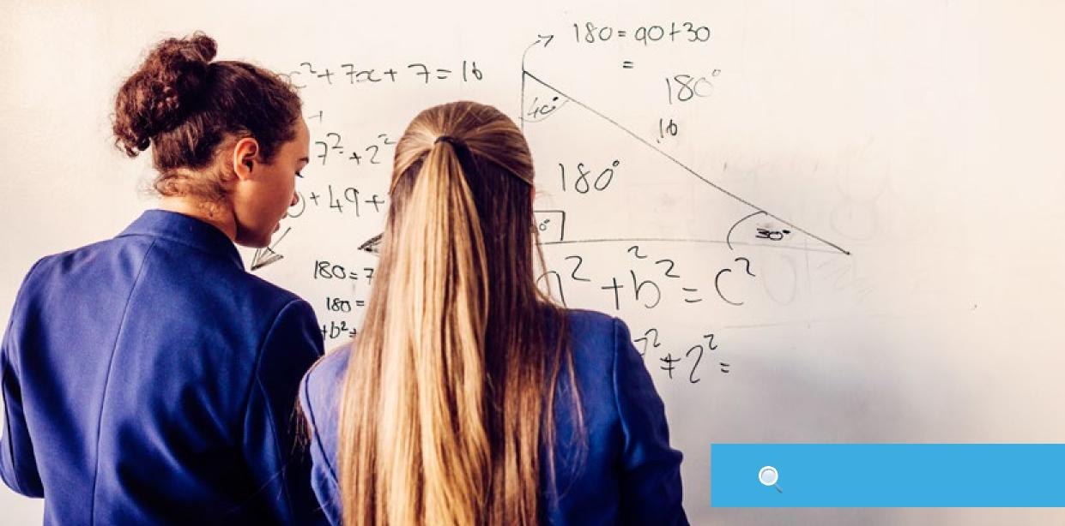

Within higher education, the most popular course currently is Business and Management with 14 per cent of students enrolled in this area. Of the 15 most popular higher education courses, three are STEM-related (Engineering and Technology, Computing and Information Technology and Biology).

Looking to the future of higher education, the same three STEM-related courses are found in the list of the 15 most popular courses preferences: Engineering and Technology, Computing and Information Technology and Biology. However, based on Year 11 and 12 students’ intentions for further study, Engineering and Technology is the most popular preference overall at 17 per cent. This is being strongly driven by male students (27 per cent males vs 7 per cent females).

Parents are key influencers of young Australians’ decisions about what subjects they will select in high school and higher education. Over half of all young people (54 per cent) say that their parents are the most influential people when it comes to subject selection and even more so for female students (58 per cent). After parents, friends (30 per cent) and teachers (24 per cent) rank in second and third for most influential people.

Other factors which play a significant role in the decision-making process of subject selection include ‘students’ own interests’ and ‘skills and abilities’. Among both genders, males tend to be more influenced by external stimuli such as ‘YouTube’ and ‘activities outside of school’ while females are driven more by an ‘ambition to change the world.’

Whether or not they are currently studying or intending to study STEM, around two thirds (approximately 63 per cent) of young people feel confident that they could achieve good results in science, technology and maths. However, only 38 per cent feel the same confidence levels when it comes to engineering.

Of those who felt low confidence in science, technology and engineering, the main reason was due to a lack of interest in these subjects. Low confidence in maths was more closely related to students’ mindsets, believing they are simply not good with numbers.

Low levels of understanding of engineering coupled with perceptions of it being a very ‘hard’ subject are major factors for the overall lower levels of confidence levels for this subject. This was seen with both genders but was more pronounced among females.

The ambiguity of the term ‘technology’ also contributed to students’ lower confidence levels, with many not even considering studying the subject as they perceive themselves as ‘non-techy’ people.

**Below are some direct responses about why young people feel they lack confidence with STEM subjects:**

**SCIENCE**

**TECHNOLOGY**

**MATHS**

**ENGINEERING**



**“I get lost and overwhelmed with all of the different terms and logic in science.”**

**“I’ve never been that good in science at school and now I feel like I know less so I wouldn’t consider it.”**

**Female, 21**

**“I find it difficult to grasp the concepts. Not motivated to learn and put effort in as I have no real interest in it.”**

**Female, 25**

**Male, 16**

**“I’ve never really been good with the programming/ coding side of technology. I can use it and get the hang of it, but programming and coding is something I didn’t pick up.”**

**“I don’t know much about technology nor have I expressed much interest.”**

**“I am terrible at anything technology related.”**

**Female, 19**

**Female, 18**

**Male, 15**



**“It is something I’ve never explored and was never encouraged in school to explore. As a female, there were never many role models that we could take courage and direction from in the sector.”**

**Female, 20**

**“I haven’t learnt anything about engineering, so I have no knowledge or skills to get good results.”**

**Female, 15**

**“Since engineering is very difficult from what I have heard. I don’t think I would be ready for it.”**

**Female, 20**

**“It’s difficult and requires lots of practice. I get distracted very easily and maths isn’t something you cram you need constant practice.”**

**“Cos I’m hopeless at it, my teacher reckons I have maths anxiety and I just freeze whenever I see a maths problem.”**

**“Maths was a subject I was good at, until a teacher in high school failed me as a student. I am no longer confident.”**

**Female, 15**

**Female, 23**

**Male, 22**

There was a strong perception among the respondents that knowledge and skills in all STEM subjects are important to getting a good job. Technology and maths are seen as the most important STEM subjects to acquire skills in with 85 per cent and 79 per cent saying it’s ‘very’ or ‘somewhat’ important respectively, followed by science with 74 per cent. Engineering knowledge and

**REASONS IN FAVOUR**

**Basic knowledge is important for all jobs**

**(Maths)**

“Every job will use some bits of maths, the most   
basic being able to know how to add,   
subtract, multiply and divide.” *Female, 17*

**Science is shaping the future (Science)**

“It represents the future, science teaches us a lot about the world which is important.” *Male, 25*

**Keeping up with the pace of technology   
(Technology)**

“Technology is evolving and one day, it may make up   
most of our jobs so understanding it is vital.” *Female, 14*

**Promotes, creativity, innovation   
and logical thinking (Engineering)**

“A lot of the skill set in the jobs available requires the   
ability to be creative and innovative.” *Male, 19*

**Requirement for good jobs (Technology)**

“Technology is being more heavily integrated with all   
occupations in modern society. Having fundamental   
knowledge and skills in the area will be helpful, perhaps   
even crucial, in order to find a good job” *Female, 15*

**Science skills are in high demand. (Science)**

“Most employers these days are seeking candidates with technology knowledge and the skills that one gains in a STEM degree.” *Female,18*

**It’s the future (Technology)**

“Technology represents the future including computers, AI, robots and automation.” *Male, 25*

skills were seen as less important to getting a job than other STEM subjects, but 59 per cent of respondents still stated they are important.

Below are some of the most common reasons students believe why it is, or is not, important to have knowledge and skills in STEM subjects:

**REASONS AGAINST**

**Not relevant skills for most jobs (Science)**

“For me personally, that’s not applicable.   
And for the majority of jobs, I cannot see how   
it’s relevant.” *Female, 16*

**Too specific a skill set (Engineer)**

“Unless you want to become an engineer, I don’t see it   
being useful in other professions.” *Male, 19*

**Dislike/not interested in the subject   
(Technology)**

“I don’t want a job that needs a technology   
skill set.” *Female, 25*

**Unrelated to my career choice (Maths)**

“Although it is helpful, an event manager does not need   
to be incredibly mathematical in order to secure a   
good job.” *Female, 23*

**Only basic knowledge is required   
(Technology)**

“Most jobs only require a basic knowledge of   
technology.” *Male, 24*

**Don’t know enough about it (Engineering)**

“I don’t have a good understanding of what   
engineering actually consists of. I feel like there   
should be more education around engineering   
and what it is.” *Female, 17*

**Machines do it better (Maths)**

“Computers do everything and are generally more time efficient and free from human error.” *Female, 23*

When asked what types of jobs people can work in with a STEM qualification, 7 out 10 people cited some form of engineering profession, indicating a strong association between the subject and the term ‘STEM.’ The close association and the lower levels of engagement with the subject could be a barrier for many people to get more involved with STEM. Other popular career associations included ‘scientists’ (43 per cent), ‘educators’ (29 per cent) and ‘mathematicians’ (23 per cent).

Overall, 11 per cent of people expressed interest in a science career in the future. Of those, biology fields were most sought out by females, while males leant more towards careers in chemistry.

In general, when young people are considering a career the most important factors include a work environment with ‘good working conditions’, ‘job security’ and ‘interesting work’. This was consistent across all age groups and genders. ‘Industries that have existed for a long time’ was the least important factor, suggesting this young cohort is cognisant of the potentially volatile nature of the future careers landscape.

There were also some distinct differences between males and females in importance factors for employment, with jobs that ‘use a lot of technology’ seen as a far more important a factor for males (63 per cent) compared to females (44 per cent), while ‘jobs that help people’ resonated much more with females (84 per cent vs 73 per cent).

To get an understanding of participation in

extracurricular activities and events related to STEM, respondents were asked about attendance at science activities outside of school and study over the past 12 months, of which 45 per cent claim to have attended at least one. Out of this group of 45 per cent, a quarter attended more than one. Encouragingly, 45 per cent say that their interest in studying science, technology, engineering or mathematics subjects in the future had increased as a result of attending these activities and events.

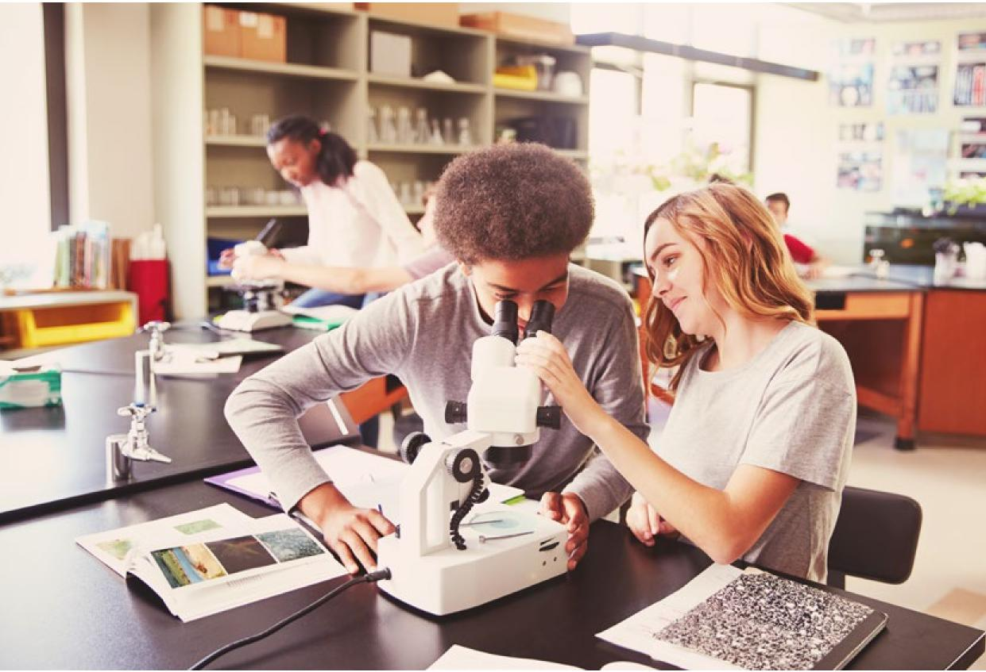

# Section 3 – Key Gender Differences

From the earliest age group surveyed, males were more likely to select to study STEM subjects than females. In Years 9 and 10, 70 per cent of male students surveyed were currently undertaking at least one STEM elective subject, compared to only 32 per cent of female students.



In Years 11 and 12, both genders have a high selection rate of STEM elective subjects, but males still surpass females with 99 per cent studying at least one STEM subject compared to 91 per cent of females. A similar pattern is seen in higher education, where the 26 per cent of students currently undertaking a STEM-related course is largely driven by male enrolments (35 per cent vs 18 per cent for females).

The male skew is evident again in preferences or intentions for higher education courses, with 58 per cent of males considering at least one STEM course, compared to 36 per cent of females.

Interestingly, male and female Year 9 and 10 students in this survey had approximately equal intentions to study STEM in their senior years of high school. 93 per cent of males and 95 per cent of females were intending to study at least one STEM subject.

While at a broad level there is a clear skew towards male students in selecting STEM subjects, it’s important to note that this is not the case across all subjects. A significantly higher proportion of the surveyed female students in Year 9 and 10 are currently undertaking biology (57 per cent vs 40 per cent for males) and more female students are intending to select chemistry (57 per cent) and biology (52 per cent) in Year 11 and 12 compared to only 46 per cent and 29 per cent of males respectively.

Female students also have generally less favourable attitudes towards STEM subjects and in particular towards engineering and technology.

General interest levels for all STEM subjects is significantly higher among males, with the biggest discrepancies seen in engineering with 55 per cent of males interested in the subject compared to only 28 per cent of females, and technology with 75 per cent males interested compared to 54 per cent females.

Following the same trend is confidence in STEM, while both genders have similar confidence levels in achieving good results in maths and science (60 per cent say they are ‘very’ or’ somewhat’ confident), the gap is much wider with engineering and technology. Males were more likely to say they are ‘very’ or ‘somewhat’ confident, with 50 per cent and 74 per cent saying this for engineering and technology respectively, compared with females with only 26 and 56 per cent.

The majority of young people (81 per cent) disagree that there is any gender superiority in STEM subjects; however, engineering and technology had highest proportion of respondents agreeing that ‘boys are better than girls (when it comes to STEM skills)’ at 24 per cent and 20 per cent, which was driven more by male respondents.

When asked to evaluate a list of professions and indicate if they were more male or female type jobs, the majority of careers were seen as gender-neutral; however, certain professions such as ‘labourer’ and ‘technician’ skewed male, while ‘hairdresser’ and ‘community and personal services’ skewed female.