
Weighbridge Operators Manual:
A Guide for Operators who Conduct Public Weighings
© Commonwealth of Australia 2008

First edition — February 2008
Second edition — September 2008
Third edition — December 2010
Fourth edition — February 2012
Fifth edition — January 2013

National Measurement Institute
Bradfield Road, Lindfield, NSW 2070
PO Box 264, Lindfield, NSW 2070
T (61 2) 8467 3600
F (61 2) 8467 3610
W www.measurement.gov.au
CONTENTS
Preface iv
1. Introduction 1
2. Terminology 1
3. Weighbridge Requirements 3
3.1 Approval and Verification 3
3.2 Display Sign 3
3.3 Location 3
3.4 Visibility 3
3.5 Approach 3
3.6 Platform 4
3.7 Pit 4
3.8 Electrical and Electronic Devices 4
4. Checking a Weighbridge 4
4.1 Visual Inspection 5
4.2 Zero Operation and Indication 5
4.3 Zero Tracking 5
4.4 Eccentricity 5
4.5 Comparison Check 7
5. Weighing Procedure 7
6. Weighing Methods 9
6.1 Direct Measurement 9
6.2 End-and-End Measurement 9
6.3 Axle Load Measurement 10
7. Measurement Tickets 10
7.1 General Requirements and Guidelines 10
7.2 Electronically Generated Measurement Tickets 11
7.3 Direct Measurement Tickets 12
7.4 End-and-End Measurement Tickets 12
7.5 Axle Measurement Tickets 13
8. Law Enforcement 13
8.1 Offences and Penalties 13
8.2 Trade Measurement Inspectors 13
9. Frequently Asked Questions 20
9.1 Accuracy of Measurements 20
9.2 Weighbridges used for Trade 21
9.3 Public Weighbridges 21

Preface
This manual provides guidance on how to operate weighbridges used for trade (including public weighbridges). It should not be relied upon for legal advice and it does not replace the requirements of the National Measurement Act 1960 and the National Trade Measurement Regulations 2009. If you are in anyway in doubt of your obligations you should seek independent legal advice.
The significant differences between the fourth and fifth editions of this manual are:
- it includes changes defined in licensing directives up to PW 12/05 (check www.measurement.gov.au/PWlicensees for more recent directives);
- a table has been added to clause 3.5 that defines allowable deviations for weighbridge approaches;
- worked examples of correctly completed measurement tickets have been added; and
- clauses related to portable and unattended weighbridges, measurement tickets for non-public weighings and law enforcement by road transport authorities have been deleted;
The following documents referred to in this manual may be downloaded from here or our website (www.measurement.gov.au):
- General Supplementary Certificate of Approval S1/0/A Electronic Indicating and Printing Devices for Measuring Instruments;
- General Supplementary Certificate of Approval S1/0B Electronic Indicating, Summing or Printing Devices which are Interfaced and Auxiliary to an Approved Measuring Instrument;
- National Measurement Act 1960 (Cth);
- National Measurement Regulations 1999 (Cth);
- National Trade Measurement Regulations 2009 (Cth);
- General Information for Test Procedures; and
- NITP 6.1 to 6.4 National Instrument Test Procedures for Non-automatic Weighing Instruments.

Introduction
This manual provides guidance on how to operate weighbridges used for trade (including public weighbridges) in compliance with the National Measurement Act and the National Trade Measurement Regulations.
A weighbridge is used for trade when it is used, or made available for others to use, to buy or sell goods, to determine freight costs or other charges based on weight, or to determine a tax.
A public weighbridge is defined in the National Measurement Act as a weighbridge that:
- is open for use by or on behalf of the public; and
- is available for use for a charge.
A public weighing occurs when a weighbridge is made available in either of the two circumstances stated above, without a prior contractual arrangement between the controller of the weighbridge and the person for whom the weighing is being performed.
A non-public weighing occurs when the use of the weighbridge:
- is subject to a prior contractual arrangement between the controller of the weighbridge and person for whom the weighing is being performed, which does not include a fee per use charge; or
- is for the operation of the controller’s business, i.e. to weigh goods in which the controller trades; or
- is to determine the tare mass of a vehicle or trailer for registration purposes.
Public weighbridge licensees are able to contract with other businesses to operate the weighbridge on their behalf.
Anyone 18 years or over may apply for a licence either individually or as a company or a partnership.
A licence is not required when:
- the third party measurements are for weighing ‘vehicles for registration purposes’ (specific conditions for issuing measurement tickets apply);
- weighing ‘stock on the hoof’; or
- there is a contractual arrangement between the weighbridge owner and the business using the weighbridge.
To operate a weighbridge effectively an operator must be able:
- to adhere to all legislative requirements;
- to understand their legal obligations and duties;
- to provide an accurate measurement for the vehicle or goods being weighed; and
- to issue measurement tickets correctly.
An operator should weigh any vehicle during normal operating hours, unless:
- the vehicle is too wide or too long to fit on the weighbridge;
- the operator believes the measurement would be inaccurate; or
- payment is requested up-front but the customer refuses to pay.
There are penalties for public weighbridge licensees and operators who fail to comply with legislative requirements. See
clause 8.1 for typical offences.
Operators must demonstrate they are competent. They can do this by completing a recognition kit found at www.measurement.gov.au/recognitionkit.

Terminology

Axle Load Measurement
A measurement, which is not an end-and-end measurement, made to determine the mass supported by separate axles, or groups of axles, of a vehicle (see clause 6.3).

End-and-End Measurement
When a vehicle is too long to fit on the platform, the weight of a vehicle is determined by adding two measurements, one for the front and one for the rear of the vehicle (see clause 6.2).

Indicating Device
Part of the measuring device from which the direct reading of the result is obtained.

Inspector
A trade measurement inspector.

Licence
A licence is either a servicing licence or a public weighbridge licence.

Licensee
A licensee is the holder of either a servicing licence or a public weighbridge licence.

Load-Bearing Points
The locations on the deck of a weighbridge directly over load cells or knife edges.

Load Cell
A load cell is a component of a weighbridge that measures a weight or force applied to it and sends an electronic signal to the indicator to display the weight. A weighbridge may incorporate several load cells.

Mass
The amount of matter of an object regardless of location (in simple terms the ‘weight’):
- Gross mass is the mass of the vehicle including the load.
- Tare mass is the mass of the vehicle prior to being loaded.
- Net mass is the result of the subtraction of the tare mass from the gross mass.

Maximum Permissible Error (MPE)
Maximum difference, positive or negative, allowed by regulation between the indication of an instrument and the corresponding true value, as determined using appropriate reference standards.

Measurement Ticket
Measurement tickets are issued for measurements made at public weighbridges. Includes original and copy tickets. There are three types of tickets:
- direct measurement tickets;
- end-and-end measurement tickets; and
- axle load measurement tickets;
Both direct and end-and-end measurement tickets can be used to record three different types of measurement information:
- gross mass only;
- tare mass only; and
- net mass.

Non-public Weighing
See clause 1.

Operator
The person who personally determines the measurement of a vehicle or goods by use of a weighbridge

Platform
The part of a weighbridge intended to receive the load.

Preservation Period
Three years from the date of issue, or cancellation, of a measurement ticket issued for a public weighbridge.

Public Weighing
See clause 1.

Scale Interval
The difference between the scale values corresponding to two successive scale marks or indications of a digital indicator.

Vehicle
Includes a vessel, aircraft or any other means of conveying persons or goods.

Verification Mark
An inspector’s mark (the mark allotted to a trade measurement inspector) or a servicing licensee’s mark (the mark approved for use by, or on behalf of, a servicing licensee) in verifying measuring instruments.

Verifier
A person permitted to verify a measuring instrument, namely a trade measurement inspector, a servicing licensee or an authorised employee of a servicing licensee.

Weighbridge
A measuring instrument of a capacity of
3 t or more which has one or more platforms capable of determining the mass of a vehicle or of livestock.

Weighbridge Requirements

Approval and Verification
Weighbridges used for trade must first be pattern approved, and then tested by a verifier in accordance with the requirements in NITP 6.1 to 6.4 National Instrument Test Procedures for Non-automatic Weighing Instruments to ensure:
- they measure to within the maximum permissible errors specified in the National Trade Measurement Regulations;
- they comply with their certificate of approval; and
- they comply with the requirements of National Trade Measurement Regulations.
A verification mark is applied to weigh-bridges which meet these requirements.
Verification marks must contain the following information:
- the code identification for the verifier (e.g. ABC0123) which is comprised of the servicing licensee’ mark (e.g. ABC) or inspector’s mark (NMI) followed by a four digit verifier verification number
(e.g. 0123);
- the month code on which the mark was made (A = Jan, B = Feb etc); and
- the year code on which the mark was made (0 = first year of decade, 9 = last year of decade).
Here is an example of a completed label bearing a verification mark.
INSTRUMENT VERIFIED UNDER THE
NATIONAL MEASUREMENT ACT 1960
ABC0123 A 0
Public weighbridges must be re-verified every 12 months. If a public weighbridge fails re-verification, the verifier will remove the verification mark and advise the operator the weighbridge may not be used for any weighing (public or non-public). Once repaired, the weighbridge must be re-tested and re-verified before it can be used for trade.

Display Sign
At public weighbridges there must be a sign displayed in a prominent position which identifies the weighbridge as a public weighbridge and includes its public weighbridge licence number. The sign must be easy to read, each letter and number must be at least 100 mm high and contrast with the background colour.

Location
A weighbridge must be located so:
- a vehicle has enough room to move on and off the weighbridge without having to turn on any platform;
- any indicating or visual summing device is protected from wind and rain;
- water, mud or debris does not accumulate on or under a platform; or in the pit; and
- vehicles must be able to move on and off the weighbridge without having to reverse.

Visibility
An operator must have a clear view of each platform and the measurement displayed on the indicator, without moving from their normal operating position. The driver of a vehicle being weighed should have a clear view of the indicator.

Approach
An approach to a weighbridge must:
- have a hard, true and durable surface of concrete or another approved material;
- have the perimeters of the level approaches clearly indicated by painted marks or other approved means;
- be arranged so drainage from the surface of the approach does not flow into the pit; and
- be ‘in the same plane’ as the platform for a minimum distance of 3 m if the platform is less than 18 m or 1 m if the platform is 18 m or more (may need to be longer for end-and-end and axle measurements).
The approach is in the same plane as the platform if:
- for weighbridges not used for end-and-end weighing, the whole of the surface of the approach is within ±2° of level (horizontal) measured from the end next to the platform;
- for weighbridges used for end-and-end weighing, the approaches are within ±0.25° of level (horizontal) measured from the end next to the platform.
For multi-platform weighbridges, the dead space (if applicable) between the platforms of the weighbridge shall be level and in the same plane as each of the platforms.
See Table 1 for more information on in the same plane.

Platform
Each platform of a weighbridge must be composed of concrete, steel or other approved material.
If a weighbridge has more than one platform:
- the dead space between each platform must not exceed 2 m;
- each platform must operate in a manner that does not affect the operation of any other platform;
- the upper surface of a platform should be in the same plane as the upper surface of each other platform; and
- a summing indicator must be installed.
If a weighbridge does not have a pit:
- the clearance under the lowest live part of the platforms must be at least 150 mm;
- the floor between load cell supports must be composed of concrete at least 75 mm thick, effectively drained and kept free from any accumulation of water, mud or debris;
- the clearance from the external edges of the platform must be wide enough for servicing, maintenance and drainage and must be free from obstructions that may interfere with the operation or accuracy of the weighbridge; and
  - the load cell footings must be stable.

Pit
If a weighbridge has one or more pits:
- each pit entrance must be covered;
- each part of the underwork must be freely accessible; and
- pits must be kept free from any accumulation of water, mud or debris, and be free-draining or be provided with automatic mechanical drainage.

Electrical and Electronic Devices
If a weighbridge is equipped with electrical or electronic devices they must be protected from electrical and electronic interference and the rays of the sun. Also the load cell data plate must be accessible so it may be read with ease.

Checking a Weighbridge
The operator must make sure the weighbridge always operates correctly and advise the public weighbridge licensee whenever there is a problem. To achieve this, an operator should:
- visually inspect the weighbridge at the beginning of each shift (see clause 4.1);
- conduct regular checks which might indicate a problem with weighbridge accuracy (see clauses 4.2 to 4.5); and
- monitor performance (keep records of the tare mass of specific vehicles and report unexplained variations in mass).
Results can be recorded on the checklist.

Table 1. Defining level for weighbridge approaches
Distance from end of  weighbridge (m) | 1 | 2 | 3 | 4 | 5 | 6 | 7 | 8 | 9 | 10
Maximum deviation for  ± 0.25° (± mm) | 4.4 | 8.7 | 13.1 | 17.5 | 21.8 | 26.2 | 30.5 | 34.9 | 39.3 | 43.6
Maximum deviation for  ± 2.0° (± mm) | 34.9 | 69.8 | 104.8 | 139.7 | 174.6 | 209.5 | 244.4 | 279.4 | 314.3 | 349.2

When it is suspected a weighbridge will produce an incorrect measurement, withdraw the weighbridge from use until it is repaired, tested and marked with a verification mark (clause 3.1). If it cannot be repaired the public weighbridge licensee must inform NMI.
Note: Weighbridges should also comply with the relevant requirements in clause 3.

Visual Inspection
Refer to the suggested checklist on the next page and also check:
- There is a continuous gap between the platform and the edge of the weighbridge surround to prevent binding. Stones or other foreign matter jammed between the platform and its surrounds may cause binding.
- There is no water, mud or debris on the platform. Water can accumulate on the platform due to rain or run-off from a vehicle being weighed. Excess water can affect zero/balance.
- There is no water, mud or debris under the weighbridge. Loose loads, such as sand, can accumulate in the pit or build up under the platform and affect zero/ balance (see clause 3.7).
- The weighbridge structure is in good condition with no lose bolts and no broken, missing or rusty components.
- The weighbridge approaches are in good condition and the perimeters are clearly marked (see clause 3.5).
- Any steelyards or dial and weight unit mechanisms are in good working condition.
- Any digital indications are clear and all segments work.
- Any additional indicating devices work and repeat the indication exactly.

Zero Operation and Indication
The operator must ensure the indicator is at zero or the steelyard is in balance before the vehicle drives onto the platform. Always zero/balance the weighbridge in accordance with the manufacturer’s instructions.
The operator should also observe the indicator after the vehicle has left the platform to ensure it returns to zero/balance.
During wet weather it is important to check the zero/balance frequently to allow for the accumulation of water on the platform.

Zero Tracking
A weighbridge with zero tracking will automatically return to zero if the amount left on the platform does not exceed half a scale interval. This can be up to 10 kg on a weighbridge with 20 kg scale intervals. However if sufficient debris is allowed to build up on the platform the weighbridge will not return to zero/balance and the platform will need to be cleaned in order for the weighbridge to return to zero/balance.

Eccentricity
The eccentricity check is designed to ensure the weighbridge weighs the same regardless of where the load is placed on the platform. To complete this check:
- Place a forklift (5 to 6 t) in the centre of the platform and note the reading.
- Progressively place the forklift over the load bearing points (knife edges or load cells) until all load bearing points have been tested. Record the indications in each position. It is good practice to ensure there is no more than one scale interval variation between all the indications.
For example, on a weighbridge with a scale interval of 20 kg, a forklift that indicates
5 960 kg in the centre of the platform is placed over the four load bearing points. Indications ranging between 5 940 and
5 960 kg or 5 960 and 5 980 kg are considered acceptable. However indications less than 5 940 or more than 5 980 kg are not acceptable.

Weighbridge Checklist
Weighbridge location
Operator’s name Date of check
Visual Inspection (clause 4.1)
Is/are the verification mark/s present and current? | yes/no
Is/are the platform/s free from binding? | yes/no
Is/are the platform/s free from accumulated water, mud and debris? | yes/no
Is the pit/space under the weighbridge free from accumulated water, mud and debris? | yes/no
Is the pit pump operational? | yes/no/na
Is the weighbridge in good condition? | yes/no
Are the weighbridge approaches smooth, level and in good condition and are the perimeters clearly marked? | yes/no
Is any steelyard in good working condition? | yes/no/na
Are any dial and unit weight mechanisms in good working condition? | yes/no/na
Are any digital indications clear and are all segments working? | yes/no/na
Do additional indicating devices work and repeat the indication exactly? | yes/no/na
Is the indicator set to zero? | yes/no
Check Results
Zero tracking check (clause 4.3) | □ Pass □ Fail □ N/A
Eccentricity check (clause 4.4) | □ Pass □ Fail □ N/A
Comparison check A (clause 4.5.1)  Difference between measurements of the same mass on  two different weighbridges ..…. – …... = ……. kg/t | □ Pass □ Fail □ N/A
Comparison check B (clause 4.5.2)  Difference between the known mass of a test object and the mass of the test object indicated by the weighbridge …... – …... = ……. kg/t | □ Pass □ Fail □ N/A
Comments

Comparison Check

Comparison Check A
Use the direct measurement method (see clause 6.1) to weigh a load of 50 to 70% of the capacity on both your weighbridge and another verified weighbridge. After making allowance for the weight of fuel used
(10 L of diesel has a weight of about 8.3 kg) compare the indications. The difference should not exceed two scale intervals.

Comparison Check B
Weigh a test object and compare the indication with the known mass of the test object (i.e. the mass determined directly after verification). The difference should not exceed one scale interval.
Test objects should be:
- at least one-third the capacity of the weighbridge (although other suitable capacities may be used); and
- retained solely as a test object and not be subject to weight change.

Weighing Procedure
Generally a weighbridge is used to determine the weight of goods being carried or to determine the load on each axle to ensure the vehicle is not overloaded before travelling on a public road. Fees for the use of a weighbridge are not prescribed by legislation.
At the beginning of each shift visually inspect the weighbridge to ensure it is in good working order (see clause 4.1).
Before each measurement, make sure the weighbridge indicates zero (see clause 4.2).
Weigh the vehicle using the appropriate weighing method. When the vehicle fits on the platform you must use direct measurement (clause 6.1) otherwise use end-and-end measurement (clause 6.2).
Use axle measurement (clause 6.3) to determine the load on each axle or axle group.
Note: End-and-end measurement may only take place on weighbridges permitted to conduct such measurements.
Complete the measurement ticket in an approved form, in numerical order, with appropriate care and as soon as practicable after making the measurement. For more information see clause 7.
To ensure the weighbridge is weighing accurately at all times, conduct regular accuracy checks (see clauses 4.2 to 4.5).
When it is suspected a weighbridge will produce an incorrect measurement, withdraw the weighbridge from use until it is repaired, tested and marked with a verification mark
by an authorised verifier (clause 3.1). If it cannot be repaired the public weighbridge licensee must inform NMI.
The following basic procedure is good practice for determining the net weight of a load on a vehicle.
- Instruct the driver to approach the weighbridge slowly and to proceed directly onto the platform without turning or harshly applying brakes.
- Ensure the vehicle is completely on the platform. Ensure no tyres are rubbing against anything because this will produce inaccurate results.
- Unless prohibited for occupational health and safety reasons, ask the driver and any passengers to get out of the vehicle and off the platform. It may not be the same driver, or the passengers could be missing, when the vehicle returns. (This is the appropriate procedure for trade transactions however for law enforcement of road rules the driver may be required to stay in the vehicle.)
- Weigh the loaded (or unloaded) vehicle. Record the gross (or tare) mass on the measurement ticket as soon as the weighing is completed.
- Once the vehicle returns, weigh the unloaded (or loaded) vehicle. Ensure the tare (or gross) mass is included on the measurement ticket as soon as the weighing is completed.
- To obtain the net mass, subtract the tare mass from the gross mass. Record the net mass on the measurement ticket.
Notes:
- Always determine measurements with appropriate care.
- Never use a weighbridge in conditions which affect its performance.
- Always keep the platform clean.
- Make sure the space between the frame and the platform is kept free from obstructions.
- When tare and gross measurements are made, the operation generally occurs within 24 hours.
- Tare only and gross only measurement must not be stored for more than 24 hours.
- Registration numbers must be recorded and it is good practice to record the configuration of the vehicle/s (refer to the chart below). This is to ensure the tare and gross masses recorded are identified for the same vehicle and the vehicle configuration has not changed between measurements.

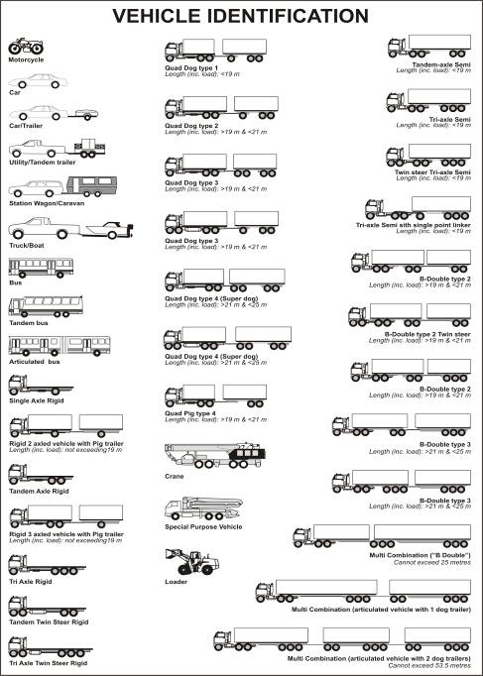

Weighing Methods

Direct Measurement
Direct measurement is used when the vehicle fits on the platform; it is the most accurate weighing method and must be used whenever possible
Direct measurement is a single operation, namely the vehicle has all wheels of all axles on one or more platforms of the weighbridge at all times.

End-and-End Measurement
End-and-end measurement is used when it is not possible to determine the mass of a vehicle by direct measurement because the entire vehicle does not fit onto the platform/s. As a result two measurements have to be determined, one for the front and the other for the rear of the vehicle.
End-and-end measurement may only be performed on a weighbridge that has suitable approaches and is permitted to perform such measurements.
Refer to clause 7, particularly clause 7.4, on how to complete an end-and-end measurement ticket.
Before weighing ensure the approaches to the weighbridge:
- have a smooth and level surface;
- are in the same plane as the top of the platform/s (see clause 3.5); and
- have a clearly indicated perimeter.
Weighing can only proceed if:
- the brakes, gears etc are not engaged;
- the suspension of the vehicle is not manipulated;
- there are no items or mechanisms affecting the measurement;
- the wheels of the axles being weighed are wholly on the platform; and
- all the wheels of the axles not being weighed are inside the marked perimeter.
The following method could be used for end-and-end measurement of a semi-trailer.
- Position the prime mover on the platform so the trailer axles are as close as possible to the platform on the level approach.
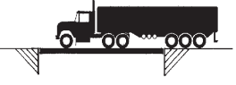
- Record the weight of the prime mover (weight 1).
- Move the vehicle forward so the trailer axles are on the platform. Ensure the prime mover axles are as close as possible to the platform on the level approach.
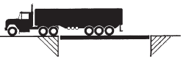
- Record the weight of the trailer axles (weight 2).
- To determine the total weight, add weight 1 and weight 2 together.
Example
Tare mass prime mover (566 JVN) = 6.90 t
Tare mass trailer (QBB 932) = 7.19 t
Gross mass prime mover (566 JVN) = 17.10 t
Gross mass of trailer (QBB 932) = 19.01 t
- Add the tare mass of the prime mover and trailer together to obtain the total tare mass = 6.90 t + 7.19 t = 14.09 t.
- Record this mass on the measurement ticket.
- Add the gross mass of the prime mover and trailer together to obtain the total gross mass = 17.10 t + 19.01 t = 36.11 t.
- Record this mass on the measurement ticket.
- Subtract the total tare mass from the
total gross mass to obtain the net mass
of the load = 36.11 t – 14.09 t = 22.02 t.

Axle Load Measurement
Axle load measurements are made to determine the mass supported by separate axles, or groups of axles, of a vehicle.
Refer to clause 7, particularly clause 7.5, on how to complete an axle measurement ticket. Such tickets may not be used for trade.
Before weighing ensure the approaches to the weighbridge:
- have a smooth and level surface;
- are in the same horizontal plane as the top of the platform/s; and
- have a clearly indicated perimeter.
Weighing can only proceed if:
- the brakes, gears etc are not engaged;
- the suspension of the vehicle is not manipulated;
- there are no items or mechanisms affecting the measurement;
- the wheels of the axles being weighed are wholly on the platform; and
- the wheels on all of the axles of the vehicle not being weighed are intside the marked perimeter.
The following is a suggested method normally used for axle weighing. However, there are a number of variations that can be used because of different platform lengths, axle configurations and wheelbase lengths.
- Drive the vehicle completely onto the platform and record the total weight of the vehicle (weight 1).
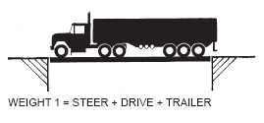
- Move the vehicle forward so the steer axle is just off the platform and on the level approach (to minimise inaccuracies the axles which are off the platform should be as close as possible to the platform). Record the weight of the drive and trailer axles (weight 2). Subtract weight 2 from weight 1 to give the weight on the steer axle.
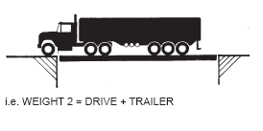
- Move the vehicle forward again until the drive axles are just off the platform with the prime mover on the level approach. Record the weight of the trailer axles (weight 3).
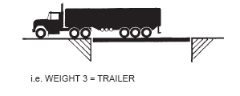
- Subtract weight 3 from weight 2 to determine the weight on the drive axle.
- Where approaches are sufficiently long, the measurements may be determined by advancing the truck onto the weighbridge platform by one axle/axle group at a time.

Measurement Tickets

General Requirements and Guidelines
Refer to Regulations 3.26 to 3.36 of the National Trade Measurement Regulations for the minimum requirements for completing measurement tickets.
Ensure your tickets comply with the directives published after PW 12/05 on www.measurement.gov.au/PWlicensees.
Complete measurement tickets in the appropriate form for the measurement made, namely:
- direct measurement (tare, gross and net) – see clause 7.3;
- end-and-end measurement (tare, gross and net) – see clause 7.4; and
- axle load measurement – see clause 7.5.
Use the same unit of measurement as the indicator of the weighbridge (kilograms or tonnes).
Issue measurement tickets from a bound book (or pad) of tickets or generate them electronically. A bound book (or pad) may contain more than one copy of each original ticket.
Issue measurement tickets in numerical order from within the same book.
Faithfully reproduce the exact value and units of measurement indicated by the weighbridge on the measurement ticket. Do not include extra zeros or move the decimal point.
Some vehicles have a tare mass marked on the vehicle. This must not be used as it is only an indication of what the vehicle weighed when registered; over time tare mass may vary due to wear and tear and modifications made to the vehicle.
Ensure the time and date of each measurement is completed.
Enter all registration numbers for separately registered vehicles which are weighed in combination, on the same measurement ticket. If unregistered, use any relevant information, such as the VIN, engine, chassis or manufacturer’s number.
Never leave a blank space on a measurement ticket. Every line on the ticket must be completed unless the line is not applicable (mark with a line or N/A).
Enter additional information in the margin, at the foot, or on the back of the measurement ticket (not on the ticket itself). Such information should be consistent with, and should not qualify the meaning or accuracy
of, the information on the measurement ticket.
Retain original measurement tickets and only issue duplicate tickets.
Issue a measurement ticket immediately after its completion, except if cancelled or when waiting for a net weight to be completed.
Ensure duplicate measurement tickets are an exact copy of the original ticket.
Ensure the original measurement ticket is not altered after a duplicate ticket has been issued.
Do not remove an original or unused measurement ticket from the book/pad.
When a mistake is made completing a measurement ticket, cancel the ticket and retain all copies of the ticket. Issue a new ticket to replace the cancelled ticket.
Providing any required fee is paid, you must provide a copy of a previously issued measurement ticket to an interested party within the preservation period. If a duplicate is not available either:
- take a photocopy of the original measurement ticket and clearly mark it as a copy; or
- copy the information from the original measurement ticket onto the next ticket in the book; and strike out the ticket number and write the words ‘copy of ticket no …’ (quoting the number of the original ticket).
Maintain client confidentiality of the information on the measurement tickets.
Retain all used original measurement tickets, all copies of any cancelled tickets and any unissued copies of the measurement ticket in the book or system for at least 3 years from the date of issue.
Note: Other legislation may require a longer preservation period.
Ensure measurement tickets are kept in an accessible but secure location. Blank and incomplete tickets left inappropriately may lead to fraudulent activities.
Measurement tickets can incorporate other business information and may be a tax invoice.

Electronically Generated Measurement Tickets
If the weighbridge is fitted with a ticket printer, check the printed measurement ticket reproduces the exact figures shown on the indicator. If it does not, either the ticket printer is faulty or the computer software may not have been programmed correctly. The weighbridge must not be used until repaired or corrected.
The requirements for printers connected to a weighbridge that simply reproduce information shown on the indicator are given in general supplementary certificates S1/0/A and S1/0B.
Computerised ticketing systems that store information or perform calculations shall be approved by NMI and verified.

Direct Measurement Tickets
Direct measurement tickets can be used to record:
- tare mass only (see clause 7.3.1);
- gross mass only (see clause 7.3.2); and
- net mass (see clause 7.3.3).
See Figure 1 for an example of the approved form of a direct measurement ticket and Figure 2 for a worked example.

Tare Mass Only Measurement
When only the tare (unloaded) mass of a vehicle is required you must clearly indicate it is a tare mass measurement by, for example, crossing out the words ‘gross mass’ and ‘net mass’ and writing ‘tare mass only’ in the blank spaces provided for those measurements. You may also mark TARE MASS ONLY across the face of the ticket.
Tonnes (including decimals) |  | Date and time
Gross mass | Tare mass only
Tare mass | 15.00 | 13/7/2011, 4:25 pm
Net mass | Tare mass only
Note: When weighing a vehicle to determine the tare mass for the purposes of registration, an operator must issue the appropriate ‘tare mass only’ measurement ticket.

Gross Mass Only Measurement
When only the gross mass of a vehicle is required you must clearly indicate it is a gross mass measurement by, for example, crossing out the words ‘tare mass’ and ‘net mass’ and writing ‘gross mass only’ in the blank spaces provided for those measurements. You may also mark GROSS MASS ONLY across the face of the measurement ticket.
Tonnes (including decimals) |  | Date and time
Gross mass | 42.40 | 12/8/2011, 10:00 am
Tare mass | Gross mass only
Net mass | Gross mass only

Net Mass Measurement
When the net mass of a vehicle is required, record the two measurement activities in the order they occur. Record the ‘tare mass’ and the ‘gross mass’ in the appropriate spaces on the same measurement ticket. Subtract tare mass from gross mass and record the result in the net mass space.
Tonnes (including decimals) |  | Date and time
Gross mass | 42.40 | 12/9/2011, 4:35 pm
Tare mass | 15.00 | 12/9/2011, 3:15 pm
Net mass | 27.40
The tare and gross measurements must be made and recorded within 24 hours of one another.
When a net mass measurement is requested but the second measurement is made between 24 and 72 hours of the first measurement,
the measurement ticket may be issued as a ‘tare mass only’ or ‘gross mass only’ measurement ticket, as appropriate.
Cancel partially completed tickets if no request for a completed measurement ticket is made within 72 hours of the first measurement.

End-and-End Measurement Tickets
End-and-end measurement tickets can be used to record:
- tare mass only ― clearly indicate it is a tare mass measurement by following the instructions in clause 7.3.1;
- gross mass only ― clearly indicate it is a gross mass measurement by following the instructions in
clause 7.3.2; and
- net mass.
See Figure 3 for an example of an approved form of an end-and-end measurement ticket and Figure 4 for a worked example.
Write each separate measurement on the ticket and calculate the total mass.

Axle Measurement Tickets
Axle measurement tickets are used to determine the mass of a single axle or groups of axles on a weighbridge that is permitted to perform such measurements. See Figure 5 for an example of the approved form of an axle measurement ticket and Figure 6 for a worked example.
When recording the mass supported by an axle group, bracket those axles on the ticket.
Never add the axle weights together to give a total mass. If a total weight is required, complete a standard measurement ticket using the weight determined by direct measurement (or end-and-end measurement if direct measurement is not feasible).

Law Enforcement

Offences and Penalties
Failure to comply with legislative requirements may result in a financial penalty for the operator and/or public weighbridge licensee.
Typical offences include using a weighbridge:
- which is not verified;
- which is not accurate;
- in an unjust manner, e.g. not on zero at start of the measurement operation;
- to weigh a mass greater than the maximum capacity of the weighbridge (in a single measurement);
- which is not clean; and
- when the approaches are unsuitable.
The following offences only apply to public weighbridges:
- conducting public weighings without obtaining a licence from NMI;
- engaging in fraudulent activities;
- failure to notify NMI within 14 days of:
- change of address of licensee;
- names and addresses of new operators and contractors; and
- last date of employment of
ex-operators and ex-contractors;
  - failure to keep unloaded weighbridge indication at zero;
- failure to keep original measurement tickets in a book or filing system or electronically during the preservation period;
- failure to complete measurement tickets in numerical order;
- carrying out end-and-end measurement when the measurement can be performed in a single operation or when the weighbridge is not approved for such measurement;
- failure to produce a measurement ticket to a relevant person during the preservation period; and
- removal or alteration of an original measurement ticket.

Trade Measurement Inspectors
Trade measurement inspectors have the power to enter business and residential premises and to inspect business vehicles. Inspectors also have the power to search and seize items.
This includes powers to copy documents, record information and test articles and measuring instruments.
Inspectors routinely audit weighbridges to ensure weighings and measurement tickets comply with legislation. If an inspector asks an operator to determine a measurement of a loaded or unloaded vehicle the operator must comply with the inspector’s request and no fee should be charged.
If a weighbridge is either inaccurate or in breach of legislation the inspector will issue a notice and may remove the verification mark. The weighbridge will then require repair and/or recalibration followed by re-testing and re-verification (see clause 3.1).

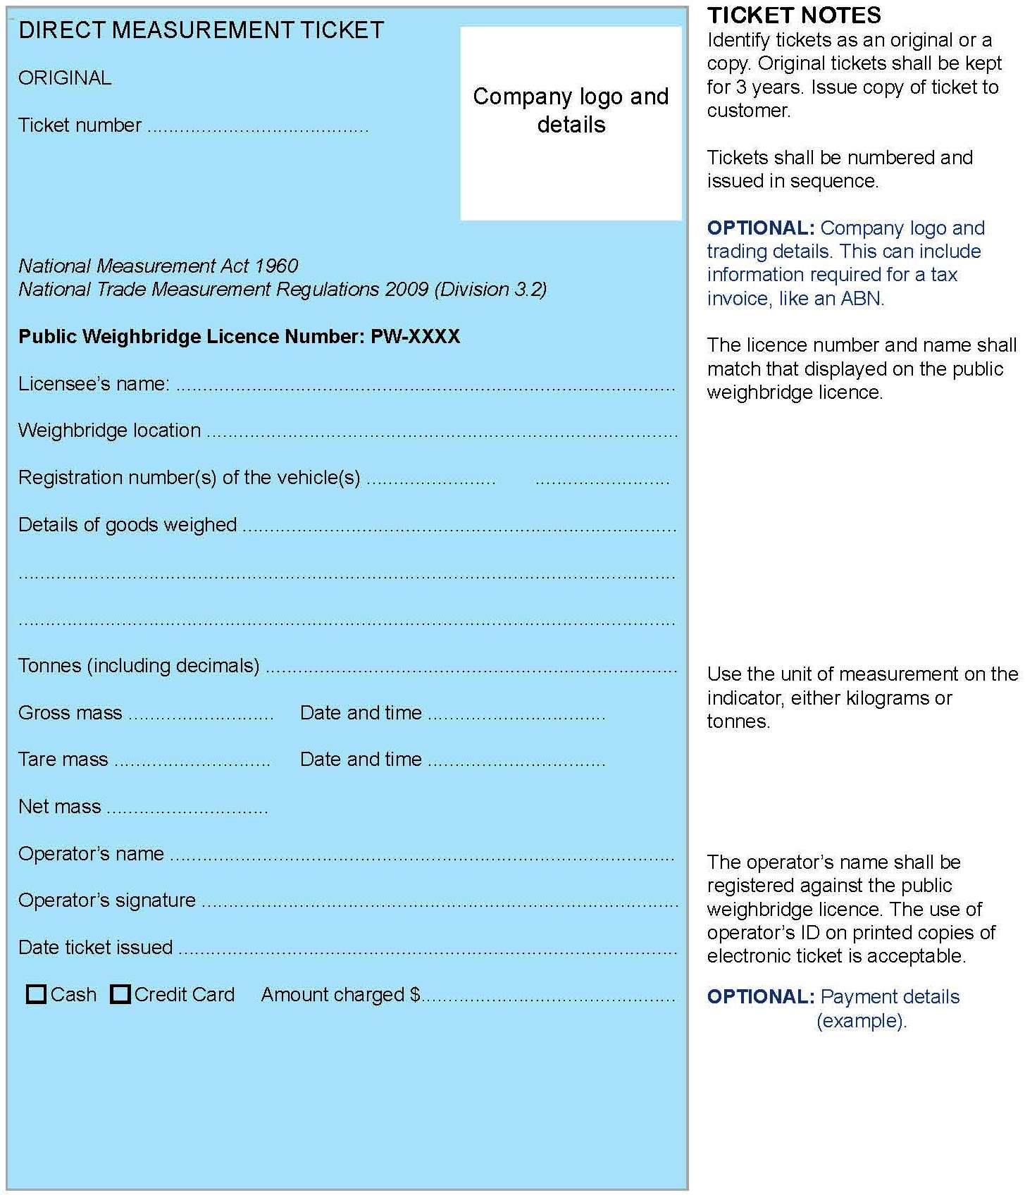
Figure 1. An approved form of a direct measurement ticket

DIRECT MEASUREMENT TICKET

ORIGINAL

Ticket number 09703
National Measurement Act 1960
National Trade Measurement Regulations 2009 (Division 3.2)
Public Weighbridge Licence Number PW-0742
Public Weighing Services P/L
457 Junction Road, White Hill, WA 6152
Registration number(s) of the vehicle(s) QNX 587 OSM 129
Details of goods weighed Meat
Tonnes (including decimals)
Gross mass 44.80 Date and time 2/10/2012, 4:45 pm
Tare mass 16.52 Date and time 2/10/2012, 3:27 pm
Net mass 28.28
Operator’s name Alex Haines
Operator’s signature A Haines
Date ticket issued 2/10/2012

On 2 October 2012 Simon Ng of SouthWest Abattoirs drives his unloaded truck and trailer to the public weighbridge at 457 Junction Road,
White Hill, WA 6152.
The truck registration number is QNX 587 and the trailer registration is
OSM 129.
At 3:27 pm his vehicle is weighed in a single operation by operator
Alex Haines. The weight of the truck and trailer is 16.52 t.
At 4:45 pm he returns, fully loaded with meat. The meat is being delivered to Joe’s Butchery. Alex Haines determines the weight of the loaded vehicle to be 44.80 t.
Figure 2. Worked example of a direct measurement ticket
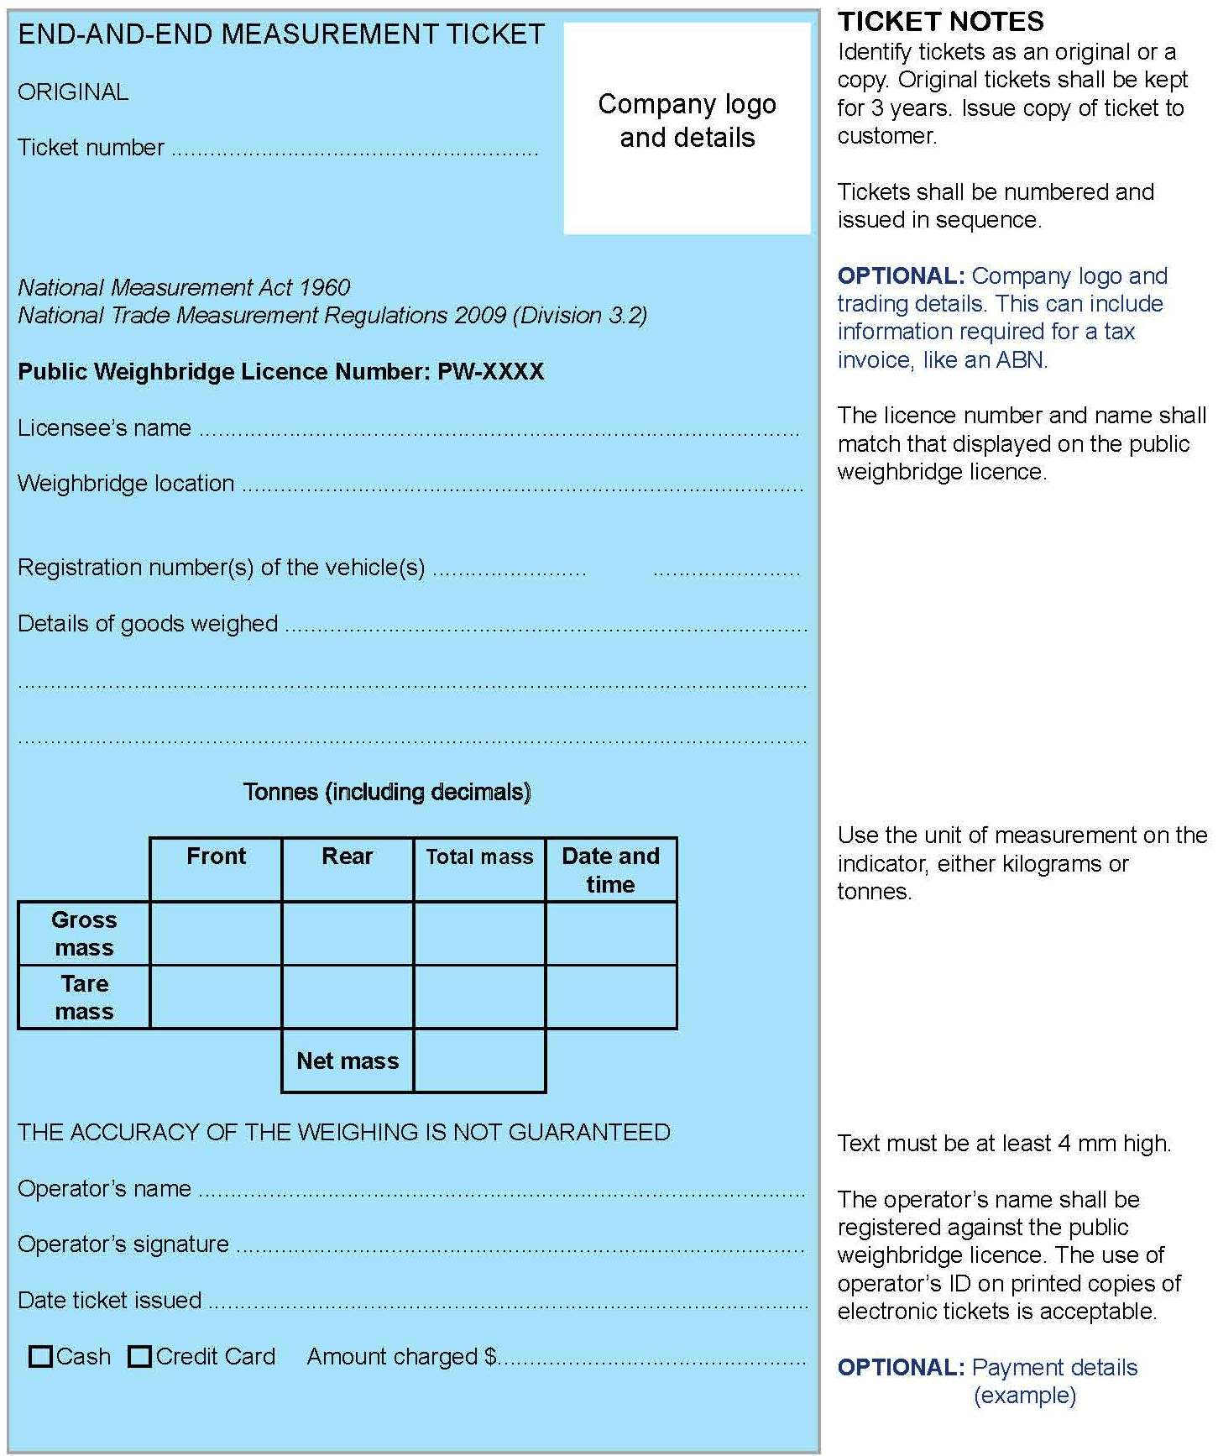
Figure 3. An approved form of an end-and-end measurement ticket

END-AND-END MEASUREMENT TICKET

ORIGINAL

Ticket number 00832
National Measurement Act 1960
National Trade Measurement Regulations 2009 (Division 3.2)
Public Weighbridge Licence Number PW-0742
Public Weighing Services P/L
457 Junction Road, White Hill, WA 6152
Registration number(s) of the vehicle(s) NMI 195 TMS 013 TMC 007
Details of goods weighed Sheep
Tonnes (including decimals)
 | Front | Rear | Total mass | Date and time
Gross mass | 33.02 | 29.78 | 62.80 | 28/9/2012, 11:35 am
Tare mass | 15.90 | 8.72 | 24.62 | 29/9/2012, 9:15 am
 |  | Net mass | 38.18

The accuracy of thE weighing is not guaranteed
Operator’s name Alison Jones
Operator’s signature A Jones
Date ticket issued 29/9/2012

A truck, driven by Norah Abbot, carrying sheep arrives at the public weighbridge at 457 Junction Road, White Hill, WA 6152 at 11:35 am on 28 September 2012. The:
  - prime mover registration number is NMI 195;
  - registration number of the first trailer is TMS 013 and the second trailer is TMC 007;
  - weighbridge operator is Alison Jones; and
  - weighbridge is permitted to conduct end-and-end weighing.
At 9:15 am the next day Norah returns with the empty vehicle to the weighbridge where Alison completes another end-and-end weighing and completes the ticket.

Figure 4. Worked example of an end-and-end measurement ticket
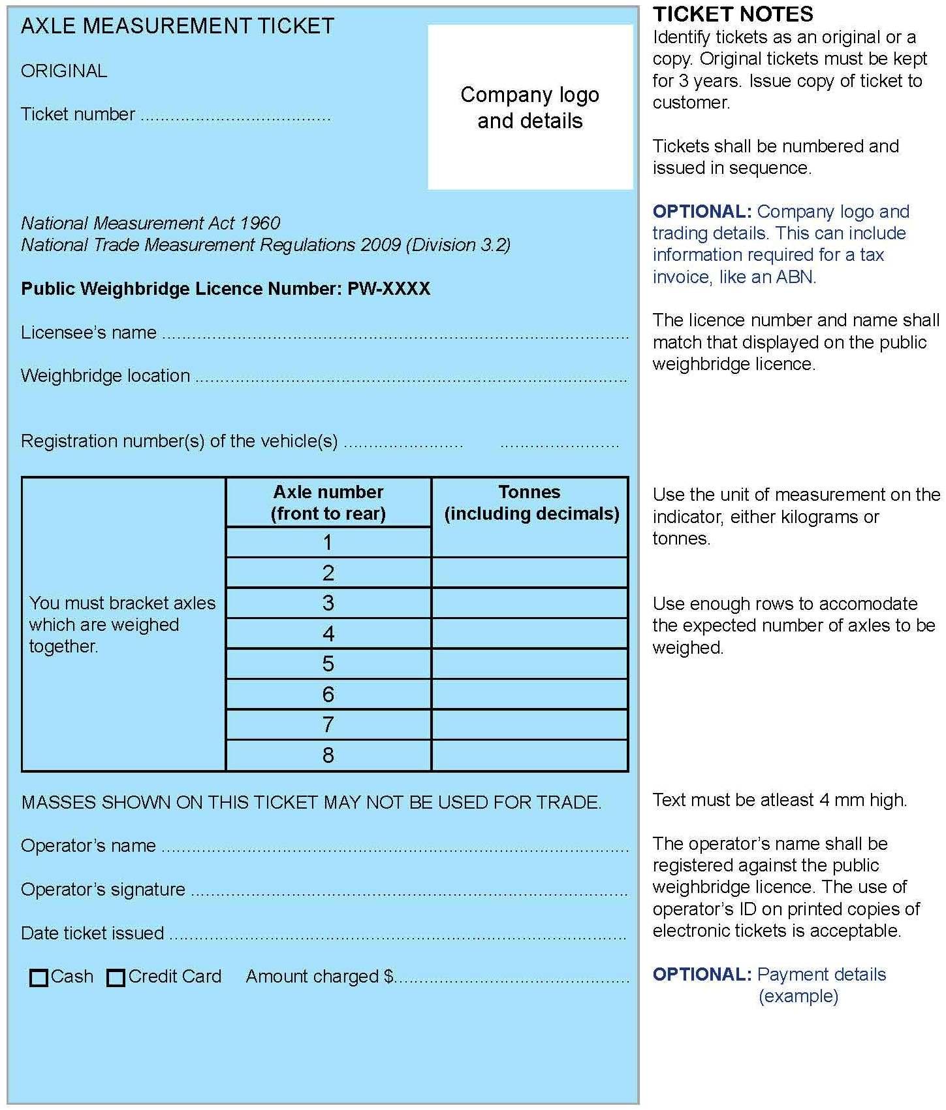
Figure 5. An approved form of an axle measurement ticket

AXLE MEASUREMENT TICKET

ORIGINAL

Ticket number 00411
National Measurement Act 1960
National Trade Measurement Regulations 2009 (Division 3.2)
Public Weighbridge Licence Number PW-0742
Public Weighing Services P/L
457 Junction Road, White Hill, WA 6152
Registration number(s) of the vehicle(s) WSD 991 NBC743 ALD337

You must bracket axles which are weighed together | Axle number  (front to rear) | Tonnes  (including decimals)
You must bracket axles which are weighed together | 1 | 5.22
You must bracket axles which are weighed together | 2 | 15.86
You must bracket axles which are weighed together | 3
You must bracket axles which are weighed together | 4 | 12.76
You must bracket axles which are weighed together | 5
You must bracket axles which are weighed together | 6 | 12.62
You must bracket axles which are weighed together | 7
MASSES SHOWN ON THIS TICKET MAY NOT BE USED FOR TRADE
Operator’s name Hamid Al-Shazar
Operator’s signature H Al-Shazar
Date ticket issued 10/10/2012

On 10 October 2012 Rodney James drives his loaded truck consisting of a prime mover and two trailers to the public weighbridge at 457 Junction Road, White Hill, WA 6152.
The prime mover registration number is WSD 991 and registration number of the first trailer is NBC743 and the second trailer is ALD337.
Rodney requests an axle measurement, which this weighbridge is suitable to conduct. Operator Hamid Al-Shazar:
- weighs the different axles and groups of axles ― the weights are shown on the diagram below;
- calculates the weights for each axle / axle group, records them on the ticket and brackets those axle groups weighed or calculated together.
Figure 6. Worked example of an axle measurement ticket

Frequently Asked Questions

Accuracy of Measurements
Do I need to check the accuracy of my weighbridge on a regular basis?
Yes, as part of your quality system, simple tests should be carried out on a regular basis.
As an operator what checks must I do to ensure the weighbridge is operating correctly?
Check the platform/s is clean. Ensure the space between the platform/s and the approaches or surround frame is free from obstructions. Ensure there is no debris on or under the platform/s. Ensure the pit (if applicable) is clean, the pump (if required) is working, and the pit does not contain a build-up of water, mud or debris. Before every weighing operation, ensure the weighbridge indicator is at zero or the steelyard is in balance.
What must I do if I know or have reason to believe my weighbridge is incorrect?
Immediately stop using your weighbridge, and contact a weighbridge repair/servicing company urgently. If an operator issues a measurement ticket using a weighbridge which he/she knows or believes to be incorrect, the operator commits a breach of measurement legislation. In the case of a public weighbridge the operator must immediately advise NMI that the weighbridge is out of use.
What action must I take if the load to be weighed is too heavy for the weighbridge or is too wide or too long to fit on the platform?
Refuse to weigh the load and refer the person to a larger weighbridge. However, it may be possible to carry out an end-and-end measurement if the weighbridge is permitted to be used for this purpose. It may also be possible to weigh the vehicle by unhooking the trailer and weighing the truck and trailer separately and completing separate tickets for each part.
Can I conduct an end-and-end measurement on a semi-trailer on my weighbridge because the unit is too long to fit on the platform or too heavy when weighed as a total unit?
Yes, providing your weighbridge is permitted for end-and-end measurement (see above) and the approaches can accommodate the length of the semitrailer not on the platform.
Are there any precautions I should take when weighing in wet weather?
Be aware that an accumulation of water and mud on the platform, under the platform or in the pit may require adjustment to zero balance. Also be aware the stored tare mass of the vehicle could change due to the accumulation of water and/or mud. This may require tare masses to be determined more often.
Can a person leaning on a vehicle being weighed affect the weight?
Yes. The person adds mass to the measurement. Unless prohibited for occupational health and safety reasons, the driver and any passengers should get out of the vehicle and stand clear of the platform.
When weighing sand, gravel or grain trucks etc continuously, am I allowed to store the tare mass of the vehicle in my computer system?
Stored tare masses should not be used unless you can guarantee they are correct. The use of stored tare masses could result in incorrect net weights, particularly if fuel usage is considerable or if the tare mass is changed through the removal of spare tyres, gates and tarps. The onus is on the public weighbridge licensee or operator to ensure all measurements or net weight calculations are correct. Remember for public weighing there is a 24 hour limit for stored tare only and gross only masses.

Weighbridges used for Trade
What does ‘used for trade’ mean?
Weighbridges used for trade include those used for buying or selling goods, to determine freight or other charges, or to determine any tax.
What is required for my weighbridge to be legal if it is to be used for trade?
Before your weighbridge can be used for trade it must be of a pattern approved by NMI and must be tested and marked (verified) by a verifier. A verifier is a trade measurement inspector, a servicing licensee or an authorised employee of a servicing licensee.
How can I tell if my weighbridge has been tested and marked?
Marked weighbridges are identified by a verification mark. These marks are applied by verifiers and are normally applied to the primary indicator. In the case of digital indicators, where there is more than one indicator (i.e. multi-platform weighbridges) the verification mark is applied to each primary indicator. These marks indicate the weighbridge was found to be correct at the time of testing. When verifying weighbridges, verifiers are required to issue a written verification form to owners. It is an offence not to have a verification mark on a weighbridge used for trade.
Do I have to get my weighbridge tested and marked regularly?
Public weighbridges must be re-verified every 12 months. Additionally, the onus is on the weighbridge owner/operator to ensure their weighbridge measures accurately at all times. As a result, owners/operators should regularly test their weighbridges themselves or engage servicing licensees to do so.

Public Weighbridges
Who may apply for a public weighbridge licence?
Individuals, partnerships and companies who are able to satisfy the legal requirements and are over 18 may apply for a public weighbridge licence. When licensed they are known as ‘public weighbridge licensees’.
What are the display requirements for a public weighbridge?
You must clearly display a sign which is marked (in clear and contrasting lettering at least 100 mm high) with the words and figures ‘public weighbridge no …’ showing the registration (licence) number of the weighbridge.
Who is responsible for operating the public weighbridge correctly?
The public weighbridge licensee/contractor and the operator are responsible for the day-to-day operation of the public weighbridge. However the public weighbridge licensee is responsible for employing competent operators and making them aware of the conditions set out in the legislation.
Who is permitted to conduct public weighings?
Only the public weighbridge licensee/ contractor and their employee/s, who are competent to do so.
What documentation is required at a public weighbridge?
The public weighbridge licensee is responsible for obtaining and making available measurement tickets in the appropriate approved format.
Do operators need to be aware of the conditions of a public weighbridge licence?
Yes operators must be able to understand the conditions of the public weighbridge licence that affect their duties.
What fees can I charge customers for public weighing?
The fees charged for public weighing are not regulated. Every business can make its own commercial decisions with regard to fees.
If I don’t charge the public a fee for conducting measurements on a weighbridge, is it still public weighing?
Yes, it is public weighing whenever a vehicle is weighed for a member of the public (a third party) – unless specifically exempt.
Can I use end-and-end measurement to weigh produce for the public weighbridge licensee’s grain store?
Yes, provided the weighbridge is permitted to conduct end-and-end measurement. NMI approval is only required for trade weighbridges where the weighbridge wasn’t previously permitted to end-and-end weigh under state legislation.
Can I issue a net mass measurement ticket to a driver who gross weighed a vehicle 2 days ago and has returned today to determine the tare mass?
No. The vehicle must be reweighed within
24 hours of the first measurement.
What can I do in these circumstances?
Complete and issue the measurement ticket initiated 2 days ago as a ‘gross mass only’ measurement ticket. Then issue a separate ‘tare mass only’ measurement ticket dated today. You are entitled to charge the appropriate fees for the separate measurements. ‘Gross mass only’ and ‘tare mass only’ measurement tickets can be issued up to 72 hours after the initial measurement. After 72 hours the measurement ticket must be cancelled.
Can I determine the weight of a caravan while it is connected to a tow vehicle?
No. To correctly weigh the caravan you should place the caravan centrally on the platform, uncouple it from the towing vehicle, then remove the towing vehicle from the platform.
A caravan company has eight similar caravans to weigh. Can I issue eight tare mass tickets for them by just weighing one?
No. Because there may be slight variations in the construction and materials used, you must weigh each one individually.
Am I correct in telling drivers that the axle masses I determine for them are for their own purposes (e.g. to check for overloading) and cannot be used for trade?
Yes. Axle masses cannot be used for trade transactions. Any axle measurement tickets must be in the approved format and be marked ‘masses shown on this ticket are not suitable for trade’. These tickets must never be endorsed nor bear any additional markings which could indicate they are a prescribed measurement ticket to be used for trade. They must never be marked ‘gross mass only’, ‘tare mass only’, have the axle weights totalled or have all the axles bracketed together with one total mass shown.
What if I don’t have the correct axle measurement tickets? Could I use direct measurement tickets and alter them to suit?
No. You are not permitted to carry out weighing of axles unless you use the correctly formatted axle measurement tickets.

