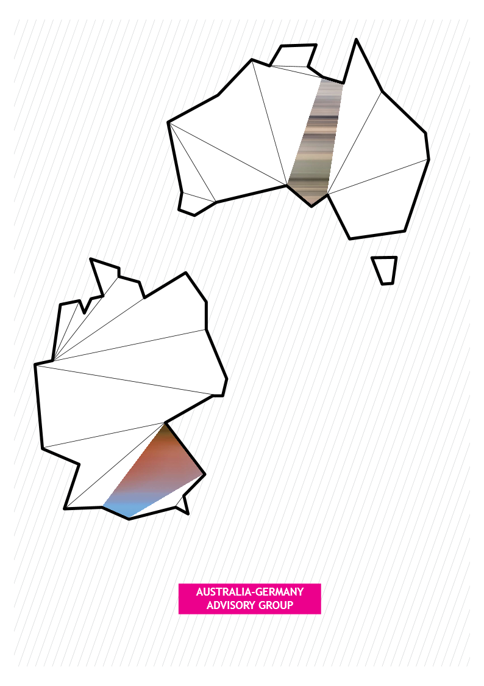

**German-Australian Cooperation on Industrie 4.0**

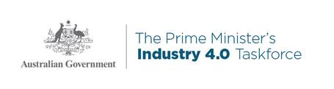

# German-Australian Cooperation on Industrie 4.0

The digitisation and the linking of manufacturing processes along the whole global value chain via internet, i.e. smart manufacturing using the Internet of Things (IoT) / Industrie 4.0, offers great economic potential for the economies of Germany and Australia.

Industrie 4.0 is radically transforming national economies, as innovation and digitisation call for a paradigm shift in manufacturing, industrial production, products and business models. Since value chains do not end at national borders, closer international cooperation is key to the success of national economies in this field. Germany and Australia as dynamic players in the field of digitisation have both started initiatives, Plattform Industrie 4.0 in Germany and the Prime Minister’s Industry 4.0 Taskforce in Australia, to keep up and improve their position in Industrie 4.0 and IoT.

Plattform Industrie 4.0 in Germany and the Prime Minister’s Industry 4.0 Taskforce in Australia have agreed to cooperate in the following areas:

1. Reference architectures, standards and norms
2. Support for Small- and medium sized enterprises (SMEs)
3. Industrie 4.0 Testlabs
4. Security of Networked Systems
5. Work, education and training

## 1. Reference architectures, standards and norms

Interoperability and global standardisation are crucial in the adoption of Industrie 4.0. Both initiatives recognise the importance of standards and openness and its adoption by small and medium enterprises (SMEs).

Key action items:

* Establish a standards cooperation partnership to support and promote global standards (consensus and consortia based).
* Intend to jointly cooperate on IoT standardisation in international standardisation fora (e.g. International Electrotechnical Commission, IEC). Both initiatives intend to fully utilise the Reference Architecture Model Industrie 4.0 (RAMI 4.0) as one of the most important architecture models.

## 2. Support for Small and medium sized enterprises (SMEs)

Industrie 4.0 will transform the business of many SMEs. They should start to rethink their processes and products, even their business models, in order to be prepared for a digital economy. Hence, it is important for SMEs to easily access Industrie 4.0 applications ("IoT" in general) as well as digital skills. “Use Cases” – concrete examples of Industrie 4.0 in practice in companies today – are a way of making SMEs aware of Industrie 4.0.

Key action items:

* Intend to share information and best practices on how to support SMEs through the digital transformation of their business models and practices in their respective country.
* Intend to set up, enhance and inter-connect online virtual use-cases in both countries stemming from their respective application experiences.

## 3. Industrie 4.0 Testlabs

The development of Industrie 4.0 technologies, applications and standards before used in real environments such as production requires appropriate testing possibilities (testlabs). Furthermore, testing environments provide active “matching” opportunities between SMEs, Industrie 4.0 tech solutions and knowledge. There are already dozens of testlabs available in Germany. Recently a joint testcase was established between Australia and Germany, with plans to establish more.

Key actions item:

* Intend to develop and operationalise a network of Industrie 4.0 Testlabs involving universities and companies (especially SMEs), in both countries and grant mutual access to relevant information and contacts from these networks in line with the respective available capacities and access regulations.
* Welcome an exchange and collaboration of staff and students between organisations involved with Industrie 4.0 Testlabs, research and education, in both countries.

## 4. Security of Networked Systems

Security of systems is vital in ensuring increased adoption of Industrie 4.0 and systems are safe from vulnerabilities.

Key action items:

* Endeavour to simultaneously release German and English language versions of important publications.
* Share methodologies and best practices on security of networked systems.

## 5. Work, education and training

Both initiatives recognise that digital skills are key factors in the competitiveness of industry in both countries. There is a need to promote digital skills in vocational training and education as well as in on-the-job-training in order to make employees ready for the age of digital transformation.

Key action items:

* Intend to share information and best practices on work, education and training in sectors relevant for Industrie 4.0.
* Intend to facilitate cooperation on digital re-education for existing employees, if appropriate.

For more information on the Plattform Industrie 4.0, please contact Henning Banthien, Plattform Industrie 4.0 Secretary General (h.banthien@plattform-i40.de).

For more information on Prime Minister’s Industry 4.0 Taskforce, please contact Jens Goennemann, Managing Director, Advanced Manufacturing Growth Centre Ltd (Jens.goennemann@amgc.org.au).

# Background to this agreement

This cooperation agreement flows from bilateral initiatives to foster closer ties between Germany and Australia including the Australia-Germany Treaty on Science and Technology Cooperation and the Australia-Germany Advisory Group (AGAG).

The Australia-Germany Treaty on Science and Technology Cooperation between the Government of the Federal Republic of Germany and the Government of Australia, signed 24 August 1976, seeks to encourage scientific and technical cooperation.

The AGAG was established in 2014 to examine ways to build closer ties between Germany and Australia. Co-chaired by Australian Finance Minister Senator the Hon Mathias Cormann and German Minister of State at the Federal Foreign Office Professor Dr Maria Böhmer, the group comprised senior leaders from business, academia, and the arts.

AGAG’s report presented to Chancellor Merkel and Prime Minister Turnbull in Berlin on 13 November 2015 contained 59 recommendations across five themes. Recommendation no.10, states that ‘SAP and Siemens will collaborate with government and industry in both countries to promote increased thought leadership on digital transformation, including initiating a collaborative approach to the development of global Industry 4.0 standards.’