Csiro land and water

Stakeholder engagement processes for mining projects - Phase 2:



**Testing the effects of benefits and governance information on social acceptance of different mining activities**

Rod McCrea, Andrea Walton and Tom Measham

September 2018

Citation

McCrea, R., Walton, A. and Measham, T. (2018). Stakeholder engagement processes for mining projects - Phase 2: Testing the effects of benefits and governance information on social acceptance of mining activities. A report prepared for the Department of Industry, Innovation and Science. CSIRO, Canberra.

Copyright

© Commonwealth Scientific and Industrial Research Organisation 2016. To the extent permitted by law, all rights are reserved and no part of this publication covered by copyright may be reproduced or copied in any form or by any means except with the written permission of CSIRO.

Important disclaimer

CSIRO advises that the information contained in this publication comprises general statements based on scientific research. The reader is advised and needs to be aware that such information may be incomplete or unable to be used in any specific situation. No reliance or actions must therefore be made on that information without seeking prior expert professional, scientific and technical advice. To the extent permitted by law, CSIRO (including its employees and consultants) excludes all liability to any person for any consequences, including but not limited to all losses, damages, costs, expenses and any other compensation, arising directly or indirectly from using this publication (in part or in whole) and any information or material contained in it.

Contents

Contents 2

Executive summary 4

1 Introduction 7

Research overview 7

Social licence to operate 8

1.1 Research aims 9

1.2 Research questions 9

2 Methods 10

2.1 Participants 10

2.2 Experimental manipulations 10

2.2.1 Information conditions 10

2.2.2 Industry 12

2.3 Questionnaire 13

2.3.1 Measures 14

2.4 Procedure 15

3 Results 16

3.1 Socio-demographic differences 16

3.1.1 Gender and age 16

3.1.2 Individual worldviews around environmental risks 17

3.1.3 Regional verses metropolitan residents 19

3.1.4 Social acceptance by state 20

3.2 Differences among different types of industries 20

3.3 Effects of different types of information 21

3.3.1 Effect of benefit information 21

3.3.2 Effect of governance and engagement information 23

3.3.3 Summary of effects of different information types 24

3.4 Statistical path modelling 26

3.5 Conclusions 29

3.5.1 Effects of information manipulations 29

3.5.2 Model of trust, social acceptance and associated behaviours 30

3.5.3 Potential future questions 31

References 33

Appendices 34

**Appendix A** Letter types (iron ore mine example) 34

**Appendix B** Letters for each industry (basic letter example) 38

**Appendix C** Main survey questions 42

#### Tables and Figures

Table 1. Representative sample by age and sex 10

Table 2. Information provided for iron-ore project - Extract from letter in Appendix A 12

Table 3. Broad areas and topics of survey questions 13

Table 4. Brief description of survey measures 14

Table 5. Summary of the effects of providing information 25

Figure 1. A model for social licence to operate 8

Figure 2. Experimental design: Four types of letters with differing information 11

Figure 3. The 16 experimental conditions 13

Figure 4. Social licence to operate perceptions and behaviours - by gender 16

Figure 5. Social licence to operate perceptions and behaviours - by age groupings 17

Figure 6. Social licence to operate perceptions and behaviours – by worldview 18

Figure 7. Comparison regional and metropolitan residents 19

Figure 8. Social acceptance of a local mine by state – for all industry types 20

Figure 9. Social acceptance by industry 21

Figure 10. Effect of benefit information on perceived benefits, fairness, relationships, and trust 22

Figure 11. Effect of benefit information on social acceptance and associated behaviours 22

Figure 12. Effect of governance and engagement information on relational aspects between company and community 23

Figure 13. Effect of governance and engagement information on social acceptance and associated behaviours 24

Figure 14. Model of trust, social acceptance and associated behaviours 27

Figure 15. Main drivers in the model of trust, social acceptance and associated behaviours 28

Executive summary

Understanding the information needs, concerns and aspirations of people affected by mining developments is an important component of early and effective community engagement. This report presents the outcomes of novel research on trust and acceptance of mining activities at the initial phase of engaging with communities about a proposed hypothetical mining development. Recent research also undertaken for the Department of Industry, Innovation and Science (Phase 1) has shown that providing information about opportunities for community engagement and governance processes is linked to more positive attitudes of a proposed mining project. This report on Phase 2 extends this knowledge by addressing two key questions. The first is to determine whether adding further information about the economic benefits of a proposed mining operation has an additional independent effect on social acceptance and its underlying factors. The second is to determine whether people respond differently to the information provided to them depending on the type of commodity being extracted.

The research presented in this report was conducted in February 2018 and employed an experimental method, which tested the effect of providing benefit, and governance and engagement information in the form of different versions of a letter about a hypothetical proposed mining project. The experiment also used four different mining scenarios (iron-ore, coal, tech metals, and unconventional gas) and examined differences among the various types of mining. The study used an online survey tool and a sample of 1,221 regional residents from five of the mining states (VIC, NSW, QLD, WA and SA). The sample was representative in terms of age and gender.

Participants were randomly allocated to one of the experimental conditions, which differed by type of information and industry. They were asked to read an initial community engagement letter from a fictitious mining company and then to answer a number of survey questions. The questions measured people’s perceptions of procedural fairness, governance, trust in industry and governance, and a range of other variables known to influence a person’s attitude towards mining. Participants were also asked to indicate their level of acceptance towards the hypothetical project and their likely behaviour (participatory, oppositional, and information seeking).

The key findings from the sample are as follows:

* Females perceive the potential impacts about a proposed mining project to be higher than males
* Males are more likely to consider participating and contributing to the success of the project than females
* Younger adults are more likely to consider benefits from the project as fairly distributed, while
* Older adults have less confidence in governance (trust and confidence in government to hold mining companies accountable, to listen and respect opinions, and to do the right thing by the community)
* Respondents commonly view the environment as fragile and only protected with large changes in human behaviour and society (46%) and this is associated with mining’s social licence
* Regional residents had more favourable perceptions and less oppositional behavioural intentions towards mining than residents in metropolitan areas surveyed in Phase 1 (though only testable for the iron ore scenario)
* Social acceptance of mining is significantly higher in WA
* Unconventional gas extraction is accepted significantly less than coal mining, iron ore and ‘tech metal’ mines
* Providing information about benefits increases perceptions about benefits, distributional fairness and relationship quality.
* Providing governance and engagement information improves perceptions of governance, trust in industry, relationship quality between industry and community, and procedural fairness. It also increased social acceptance and reduced oppositional behavioural intentions.
* Providing *information* on governance and engagement processes improves a wider range of social licence variables than providing information on local economic benefits. This extends to increasing trust and acceptance, and reducing oppositional behaviour intentions. However, modelling shows that *perceptions* of benefits is generally more important than perceptions of governance in predicting social licence variables because it acts on a wider range of social licence variables.
* *Perceived* benefits influences a wider range of social licence variables, though providing *information* on economic benefits does not directly affect trust, social acceptance, or behavioural intentions (participatory, oppositional, or information seeking behaviours)
* Communicating information about benefits, governance and engagement stimulates information seeking behaviour such as intentions to attend a community information session and visit the mining project website
* Overall, people are highly motivated to seek out information from project websites or attending an information session, especially when people want to participate in the success of a mining project.
* Statistical modelling of social acceptance shows there are multiple pathways to leading to acceptance and that the relationships among the different social licence variables are complex.

Overall, the report shows that providing information on economic benefits and engagement processes has small though significant positive effects on a range of factors underlying a proposed mining company’s social licence to operate, such as perceptions of benefits and good governance. This effect was common across the four different commodity types. There was no significant difference between acceptance levels for coal, iron ore and tech metals. However the acceptance levels for coal seam gas were significantly lower than the other commodities considered in this report.

We know from the evolving body of research on social licence that concerns and perceptions about possible negative impacts have a substantial influence on social acceptance. On this basis, one important area for further research is the effect of providing information on how potential impacts may be avoided or mitigated.

# Introduction

Research overview

This study builds on Phase 1 research conducted in 2017. The previous study established the effectiveness of early social engagement practices in improving people’s trust and perceptions of fairness towards a prospective mining project (Zhang, Measham, & Moffat, 2018; Zhang, Moffat, & Measham, 2016). Specifically, research in Phase 1 demonstrated how information about procedural fairness, government oversight, and providing opportunities for people to have a say influenced attitudes and engagement intentions towards a proposed hypothetical project in a positive direction. This was achieved by providing early communication in the form of an invitation letter to attend community engagement activities and two key pieces of information. The letter, assured the reader about good governance of the proposed project, and provided a detailed range of opportunities on how community perspectives would be included in decision making. The previous study used residents in Australian capital cities as the sample population.

In Phase 2 of this study, we again use an experiment to test for any effects of providing additional information about employment and economic benefits associated with the new mining operations on people’s attitudes and acceptance of the proposed hypothetical mine. We also test a comprehensive model of social licence to operate and use a regional rather than metropolitan sample of residents.

In the experiment, participants received one of four different versions of a letter. These letters included either:

1. a short letter containing basic information about the project
2. additional information on local employment and business opportunities as potential benefits from the project
3. additional information on governance and how residents could engage with the proposed mining project (The same as used in Phase 1, allowing for comparisons with that study)
4. all of the above information

By manipulating information on benefits and governance/engagement, the survey tested whether information about benefits from mining also enhances residents’ views about a range of drivers of social acceptance, and how this compares to information on governance and engagement opportunities.

In addition, we included hypothetical mining proposals for four different types of mining (iron-ore, coal, tech metals, and coal seam gas) to be able to compare for any differences across industries. Also, the regional sample provided new information about attitudes by focusing on non-metropolitan regions, where mining activity typically takes place. We were able to compare perceptions of mining in regional areas with perceptions in metropolitan areas from the previous study (for iron-ore only).

Social licence to operate

Research at both community and national levels show that perceptions about *governance,* *engagement processes* and *benefits* can affect a range of drivers underlying social acceptance of locally based resource projects (Moffat et al., 2017; Moffat & Zhang, 2014; Walton & McCrea, 2017; Zhang et al., 2018; Zhang et al., 2016). These other drivers include perceptions of *perceived impacts*, *distributional fairness*, *relationship quality*, *trust in industry*.

Trust in industry, social acceptance of a project, and their underlying drivers, all form part of what has come to be known as a social licence to operate. For example, see Figure 1 from Moffat et al. (2017). Moreover, perceptions surrounding a mining company’s social licence to operate may also influence how local residents behave in terms of participating and engaging with the project or potentially opposing it.

Figure 1. A model for social licence to operate

This diagram shows relationships between four factors driving trust in the mining industry and acceptance of mining. The factors are: 1) balance of benefits over impacts, 2) procedural fairness, 3) distributional fairness, and 4) governance capacity. Also see Figure 14 for a more comprehensive model developed in this study. 

Source: Moffat et al. (2017)

## Research aims

1. To test the effect of framing different types of information (benefit and governance-engagement information) on:

* Perceived benefits
* Perceived governance and engagement activities
* Trust and other drivers of social acceptance
* Social acceptance and behavioural intentions (participatory, oppositional, and information seeking)

1. To identify differences based on demographic characteristics

* Age
* Gender
* State-based locations

1. To identify differences based on types of extractive industries

* Iron ore
* Coal
* Tech metals
* Unconventional Gas

1. To test a comprehensive model of social licence to operate that explains

* Social acceptance of mining
* Participatory, oppositional and information seeking behavioural intentions

## Research questions

In line with these aims, a number of important research questions arise:

1. Can providing information about potential employment and business opportunities affect regional people’s *perceptions* benefits, along with other drivers of social acceptance?
2. Does providing information on governance and engagement processes impact *perceptions* of governance and engagement processes in regional populations, along with other drivers of social acceptance
3. Does information on perceptions of benefits, governance and engagement processes affect resident *behavioural intentions* to participate in or perhaps oppose new local mining proposals, or to seek more information?
4. Do the effects of information framing vary based on demographic characteristics?
5. Do the effects of information framing vary across different types of mining?
6. How do all the drivers underlying trust in industry, social acceptance, and associated behaviours fit together?

# Methods

## Participants

Using an online panel from a survey company, 1,221 participants were drawn from a representative pool of the Australian population from five main mining states (NSW, Qld, Vic, SA and WA). Quota sampling was applied to ensure that participants were representative of regional Australia on age and sex, based on the 2016 population census. Regional residents excluded those from capital cities and the Gold Coast. Within this criteria, participants were randomly allocated to one of the four different versions of a hypothetical letter from a fictitious mining company called “Nortor Mining Corporation (NMC)” and then asked to complete an online questionnaire.

A representative sample was obtained by age and sex for residents 18 years and older in regional Australia. Higher percentage of residents were sampled from the three main states of NSW, Qld and Vic, followed by a smaller percentage from WA and SA. See Table 1.

Table 1. Representative sample by age and sex

| **Age and sex** |  | **State** |  |
| --- | --- | --- | --- |
| Male | 49.7% | NSW | 26.9 % |
| Female | 50.3% | Qld | 26.8 % |
|  |  | Vic | 23.9 % |
| 18-34 yrs | 24.7 % | SA | 10.7 % |
| 35-54 yrs | 33.3 % | WA | 11.7 % |
| 55+ yrs | 42.0 % | Total | 100% |

## Experimental manipulations

### Information conditions

An experimental survey design was employed whereby participants were randomly allocated to receive one of four letters introducing a proposed hypothetical mining operation. These were:

a) basic letter advising of a proposed local mine, together with an invitation to a community meeting (*N*=280);

b) another letter with additional information on expected local jobs and flow on effects to boost the local economy (*N*=280);

c) another with the basic letter information plus additional information about governance of the mine and how the local community can participate (*N*=281); and

d) a letter with the basic information, plus the additional information about potential benefits, governance and community engagement (*N*=280).

The basic letter is modelled after a real letter from a real mining company regarding a real mine development proposal. Through systematically adding information to the basic letter, another three conditions are developed. Figure 2 shows the type information introduced in each letter.

Figure 2. Experimental design: Four types of letters with differing information

This diagram explains what is in each letter: 1)  basic letter advising of a proposed local mine, together with an invitation to a community meeting; 2) another letter with additional information on expected local jobs and flow on effects to boost the local economy; 3) another with the basic letter information plus additional information about governance of the mine and how the local community can participate; and 4) a letter with the basic information, plus the additional information about potential benefits, governance and community engagement. 

We also tested these different conditions with four types of mining activities (iron ore, tech metals, coal, and coal seam gas). As an example, Table 2 shows the information provided for the iron ore project while the actual letters for the iron ore project are shown in Appendices A and B.

Table 2. Information provided for iron-ore project - Extract from letter in Appendix A

| Basic information: |
| --- |
| To give you some background, Nortor Mining Corporation (NMC) has applied for a Mining Lease to develop a small open-cut mine on a 1023 ha site, at least 10 km from the nearest residence at Sanstwel. NMC proposes to mine approximately five million tonnes of iron ore over a period of 8-10 years. |
|  |
| Benefit information: |
| ***Local jobs growth***  Independent economic research shows a benefit to the region of between 200 – 400 ongoing local jobs over the life of the project. This would come from direct jobs in the industry and flow on effects to other sectors. The modelling also shows this would significantly contribute to the region’s local economy. |
|  |
| Governance and engagement information |
| Our commitment |
| NMC commits to working with you to address any concerns and issues that are important to Sanstwel community. We propose to establish a Community Working Committee, the majority of whose members will come from the community. It will consist of 5 community members, 2 local council representatives, and 2 NMC representatives. The role of the Committee is to facilitate constructive dialogue between community, NMC, and the local council. The community positions will be advertised publicly and the selection will be conducted through a community meeting. All meeting minutes and decisions of the Community Working Committee will be shared publically. |
| Government requirements |
| The State Government has a framework of legislation and regulation that companies must comply with to ensure the protection of environment, land and water resources as they are affected by mining activity. Compliance with conditions is mandatory under the *Environmental Protection Act.* There are heavy penalties for non-compliance. NMC will strictly follow government requirements and will soon submit an Environmental Management Plan (EMP) for the mine project for the State Government’s review. The EMP will include reports of baseline studies on all issues related to the project and will outline the measures proposed by NMC to deal potential future issues, impacts and opportunities for local communities and the environment. |
| Your say in the process |
| Your concerns and suggestions will be heard and addressed through the proposed Community Working Committee discussed above, as well as through the State Government’s assessment process. The government will make the EMP submitted by NMC public, and invites community members to make comments as well as discuss their concerns in relation to the Project. Your feedback on the proposed project will be an integral part of the government’s evaluation of our proposed project. |

### Industry

The participants were also randomly allocated to one of four different types of mining:

1. Iron ore (*N*=280)
2. Coal (*N*=280)
3. Tech metals (*N*=281)
4. Coal seam gas or CSG (*N*=280)

Even though CSG extraction is not technically a mining industry – it is an oil and gas industry – residents often view onshore CSG extraction as a type of mining and it was included for comparison as an industry with social licence issues. So participants were randomly allocated to receive one of four types of letter for one of four types of industries, making 16 conditions in all (4 letters x 4 industries). See Figure 3.

Figure 3. The 16 experimental conditions

This diagram shows four types of letters under each of the four industries—iron ore, coal, tech metals and coal seam gas.

## Questionnaire

Participants of the survey first read the hypothetical letter from the fictional mining company, Nortor Mining Corporation (NMC), regarding its proposal for a mining development in their local area. They were then asked a range of questions covering six broad topic areas encompassing key social licence to operate variables and some demographic questions (see Table 3). An example of the full questionnaire is shown in Appendix C.

Table 3. Broad areas and topics of survey questions

| **Broad topic areas** | **Social licence to operate and demographic variables** |
| --- | --- |
| **Relational aspects: between operator & community** | 1. Trust in Industry 2. Relationship quality with industry 3. Perceived fairness |
| **Industry effects** | 1. Perceived impacts 2. Perceived benefits |
| **Fairness** | 1. Distributional fairness (procedural fairness - see relational aspects) |
| **Governance** | 1. Governance (compliance, competence, trust in government) |
| **Attitudes and behaviours** | 1. Acceptance of the industry 2. Feelings towards the industry 3. Participatory behaviours 4. Oppositional behaviours 5. Information seeking behaviours |
| **Demographics** | 1. Age 2. Gender 3. State location 4. Worldview around environmental risks |

### Measures

Table 4 provides a brief description of the main measures used in the survey. It lists the measure name, relevant survey question detailed in Appendix C, the scale type and reliability, and some example items. Reliability was measured using Cronbach’s alpha where over .80 is considered good and over .90 is excellent.

Participants answered questions around their social acceptance of mining and its underlying drivers on an agreement scale, as well as their behavioural intentions toward the mining project on a Likelihood scale. The agreement scale went from 1 = ‘strongly disagree’ to 7 ‘strong agree’, with a midpoint of 4 = ‘not sure’, while the likelihood scale went from 1 = ‘very unlikely’ to 7 = ‘very likely’, with a midpoint of 4 = ‘not sure’.

Table 4. Brief description of survey measures

| Measures of social licence variables | Qtn /  Items. | Scale type / reliability | Example items (abbreviated) |
| --- | --- | --- | --- |
| Perceived benefits | Q8 1-6 | Agreement .95 | Local employment and business opportunities, opportunities for young people, and community support |
| Perceived impacts | Q9 1-6 | Agreement .90 | Dust and noise, natural environment, living expenses, health, and community division |
| Procedural fairness | Q4 1-4 | Agreement .87 | Opportunities to participate, being respected and listened to, and able to change practices |
| Relationship quality | Q4 7-8 | Agreement .90 | The company is open, honest and transparent; and engages in two-way dialogue |
| Trust in industry | Q4 5-6 | Agreement .93 | Able to trust the company to do the right thing, and act responsibility |
| Governance | Q5 1-6 | Agreement .94 | See subscales below |
| Formal governance | Q5 1-2 | Agreement .87 | Government is able to holding mining accountable, and legislation can ensure mining companies do the right thing |
| Informal governance | Q5 3-4 | Agreement .91 | Government interested in knowing what I think, and will listen to and respect my opinions |
| Trust in governance | Q5 5-6 | Agreement .95 | Able to trust the government to regulate the mining development, and to do the right thing by community |
| Distributional fairness | Q7 1-2 | Agreement .85 | My local area would receive a fair share of the benefits, and my local council would be compensated accordingly |
| Social acceptance | Q11 1-4 | Agreement .97 | I would tolerate, accept, approve, embrace the mining project |
| Participatory behavioural intentions | Q14 5,6,10 | Likelihood .77 | Apply for a position on the community working committee, contribute to the mining project, and help make it a success in your town |
| Oppositional behavioural intentions | Q14 7-9 | Likelihood .90 | Complain to people you know about the project, discourage others from participating, and resist the mining project |
| Information seeking behavioural intentions | Q14 1-4 | Likelihood .85 | Want more information about the project, attend an information session, visit the project website, and ring the project toll free number |

## Procedure

Participants were invited via email to participate in the online survey. They were informed that no personal identifiable information would be collected and they could withdraw from the survey at any time without penalty. Participants read a hypothetical letter from a hypothetical mining company Nortor Mining Corporation (NMC) regarding its plan to develop a mine in their local area. They were asked to imagine themselves as a resident of the area where the mine is going to operate and indicate their agreement with a number of statements.

The same social research company that was used in Phase 1 was engaged to conduct data collection online with participants drawn from their panel. Participants were randomly allocated to one of the 16 experimental conditions before reading their letter and answering the questionnaire. These participants received a small incentive from the survey company to participate in the online survey, which was conducted in February, 2017.

The research design and survey materials were submitted to CSIRO’s Health and Medical Human Research Ethics Committee and subsequently cleared in accordance with the ethical review processes of CSIRO within the guidelines of the National Statement on Ethical Conduct in Human Research.

# Results

## Socio-demographic differences

### Gender and age

Females perceive higher impacts

Males are more likely to participate with the project

Younger adults are more likely to see benefits as fairly distributed

Older adults have less confidence in overall governance and more likely to seek out more information

Irrespective of the letter version that participants received, perceptions around social licence to operate variables did not vary much between genders. However, females were more likely to perceive impacts from the proposed mining project to be higher, while males were more likely to consider participating and contributing to the success of the project (see Figure 4).

Figure 4. Social licence to operate perceptions and behaviours - by gender

Note: * indicates statistically significant differences (p<.05)

Nor did perceptions vary much between younger, middle-aged and older persons. However, younger people aged 18-35 were more likely to think that their local area and council would receive a fair share of the benefits (distributional fairness). Older residents on the other hand were likely to have less confidence in overall governance and more likely to seek out more information. See Figure 5.

Figure 5. Social licence to operate perceptions and behaviours - by age groupings

Note: * indicates statistically significant differences (p<.05)

### Individual worldviews around environmental risks

A view that the environment is fragile is associated with less favourable perceptions of social licence variables and behaviours for a proposed mine

In contrast to age and gender, individual worldviews had a pervasive effect across all the perceptions of social licence variables and behaviours, even though they received different information. Participants were asked which of the following statements *best* matched their views about environmental risks:

1. The environment is fragile and will only be protected if there are large changes in human behaviour and society (46.4%)
2. The environment can be managed by the government and experts if there are clear rules about what is allowed (35.2%)
3. The environment can adapt to changes and technology will solve environmental problems eventually (7.3%)
4. The environment is unpredictable and we can't control what happens   
   (11.1%)

The most common view was that the environment is fragile (46.4%). Figure 6 shows comparisons between those who hold the worldview that the environment is fragile and needs to be protected and the other three worldviews, which were grouped together because they were similar in their perceptions and behaviours relating to the proposed mine’s social licence to operate. Figure 6 shows that the ‘environment is fragile’ worldview is associated with significantly less favourable ratings across all the perceptions and behaviours associated with a proposed mine’s social licence to operate, except information seeking which showed no real differences based on worldviews .

Figure 6. Social licence to operate perceptions and behaviours – by worldview

Note: * indicates statistically significant differences (p<.05)

### Regional verses metropolitan residents

Regional residents had more favourable perceptions and less oppositional behaviours to a proposed iron ore mine than residents in metropolitan areas

This survey of residents in regional Australia in 2018 was compared to residents in the Phase 1 survey of metropolitan residents in 2016. These perceptions related to a proposed iron ore mine using Letter C providing additional information on engagement and information. Figure 7 shows that residents in regional Australia generally had more favourable perceptions and less oppositional behavioural intentions than residents in metropolitan areas (*p*<.05). While this trend was significant overall, no significant differences were found on any one particular variable.

Figure 7. Comparison regional and metropolitan residents

### Social acceptance by state

Social acceptance of mining significantly higher in WA

Social acceptance refers to how much respondents agreed they would tolerate, accept, approve, or embrace the mining project. Social acceptance of mining is significantly higher in WA compared to NSW and Victoria, though not significantly higher than SA and QLD. Social acceptance was lowest in NSW, significantly lower than other states, except Victoria. See Figure 8.

Figure 8. Social acceptance of a local mine by state – for all industry types

## Differences among different types of industries

Acceptance for CSG extraction was significantly less than other types of mining

Social acceptance for the three industries iron ore, coal and tech metal mining were not significantly different from each other. However, the social acceptance of CSG extraction was significantly less than the other mining industries. Figure 9 shows that acceptance levels for iron ore, coal and tech metals were somewhat positive while respondents were unsure about CSG on average.

Figure 9. Social acceptance by industry

## Effects of different types of information

This subsection reports on the independent effects of the experimental manipulations, which presented different types of information in four different letters (see section 2.2.1).

Looking at the effect of different types of information on social licence variables by industry, we found that there were no significant differences between the different types of mining industries and how they responded to the different versions of the letter.

### Effect of benefit information

Providing information about benefits increases perceived benefits, distributional fairness, and relationship quality

Respondents were randomly allocated to receive additional information (or not) in their letter on expected benefits from the proposed mine in terms of expected local jobs and flow on effects for the local economy. This information included: between 200 – 400 ongoing local jobs; direct jobs in the industry and flow on effects to other sectors; and a significant contribution to the region’s local economy. It also indicated that “independent economic research” had provided the job estimates. An example letter for iron-ore can be found on page 35.

Providing information on expected benefits from the proposed mine significantly increased perceptions of benefits, distributional fairness (whether residents felt their local community would receive a fair share of the benefits) and relationship quality (how open, honest and transparent they believed the company to be). In contrast, providing information on expected benefits did not significantly increase trust in the industry (see Figure 10), nor did it have any significant effects on social acceptance and any associated participatory, oppositional, or information seeking behaviours (see Figure 11).

Figure 10. Effect of benefit information on perceived benefits, fairness, relationships, and trust

Figure 11. Effect of benefit information on social acceptance and associated behaviours

*Note*: No statistically significant differences

### Effect of governance and engagement information

Governance and engagement information improves perceptions of governance and relational aspects between the company and community

It also increases acceptance and reduces oppositional behavioural intentions

Respondents were also randomly allocated to receive additional information (or not) about aspects of the proposed mine governance, the company’s commitment to community engagement, and how the local community could participate in the process of governing the proposed mine (see sub-section 2.2.1 Information conditions).

Providing information on governance and engagement processes significantly improved perceptions of overall governance (formal, informal and trust in governance), as well as perceived procedural fairness and trust in the mining company. However, this information did not significantly improve perceptions of distributional fairness. See Figure 12.

Figure 12. Effect of governance and engagement information on relational aspects between company and community

Providing information about governance and engagement processes also significantly improved social acceptance of the project and reduced oppositional behavioural intentions towards it (*p* <.05). However, information on engagement processes did not increase intentions to participate in these processes nor seek out further information. See Figure 13.

Figure 13. Effect of governance and engagement information on social acceptance and associated behaviours

*Note:* Statistically significant effects on social acceptance and oppositional behaviour (*p* < .05)

### Summary of effects of different information types

Information on governance and engagement processes improves a wider range of social licence variables than information on local benefits alone

Information on governance and engagement processes translates through to improvements in social acceptance and behavioural intentions, whereas information on benefits is more constrained in its effect and did not improve acceptance and behaviours

Table 5 summarises the independent effects of the two different types of information on a range of variables relating to the hypothetical mining company’s social licence to operate. Information on benefits improved perceived benefits, distributional fairness, and relationship quality. However, information on governance and engagement processes improved a wider range of perceptions, including the overall acceptance of the project and reducing oppositional behavioural intentions. The combination letter of both benefits and governance-engagement information had no additional effects.

The more widespread effect of the governance and engagement information may be due to more information being provided for this information condition. However, this seems to be due to the type of information provided in this condition rather than the volume of information per se. Generally speaking, combining both benefits and governance-engagement information together, as in Letter 4, provided no significant additive effect in changes to perceptions beyond the effects of benefits and governance information.

Another possible reason for the relatively constrained effect of benefit information compared to governance engagement information may be that benefit information addresses only one driver of acceptance. In contrast, the governance-engagement information addresses two other influential drivers of acceptance. This suggests that addressing a single driver is not as effective as addressing multiple drivers if the intention is to build trust and improve social acceptance.

Finally, another suggestion is that the experimental stimulus for benefit information may have been weaker than that for the governance and engagement manipulation. The potential local jobs and flow on effects for the local economy were relatively modest compared to information provided about relatively rigorous governance and engagement processes, and the pledge of commitment by the company to involve community and be transparent in their processes.

Table 5. Summary of the effects of providing information

| Perceptions | Benefit information  V  No Benefit information | Governance-engagement information  V  No governance–engagement information |
| --- | --- | --- |
| **Perceived benefits** | Improved | No effect. |
| **Distributional fairness** | Improved | No effect |
| **Trust in industry** | No effect | Improved |
| **Relationship quality** | Improved | Improved |
| **Procedural fairness** | No effect | Improved |
| **Overall governance** | No effect | Improved |
| **Perceived impacts** | No effect | No effect |
| **Social acceptance** | No effect | Increased |
| **Oppositional behaviour** | No effect | Reduced |
| **Participation behaviour** | No effect | No effect |
| **Information seeking behaviour** | No effect | No effect |

## Statistical path modelling

The direct drivers of social acceptance are perceived impacts and benefits, trust in industry, and distributional fairness. More indirect drivers include governance, procedural fairness and relationship quality with the industry

Perceived impacts relate more to oppositional behaviours, whereas perceived benefits relate more to participatory behaviours.

Information seeking is driven mainly by intentions to undertake participatory or oppositional behaviours

Using the whole sample, statistical path modelling was undertaken to show how the underlying drivers of a proposed mine’s social licence work together to best explain trust in industry, social acceptance and associated oppositional, participatory, and information seeking behavioural intentions.

The blue boxes in Figure 14 show that the model explains 79% of individual variation in people’s trust in the industry, 71% of their social acceptance, 61% of their oppositional behaviours, 39% of their information seeking behaviours, though only 27% of their participatory behaviours. This means the variables in the model are very good at explaining trust, social acceptance, and oppositional behavioural intentions and reasonable at explaining information seeking. The arrows show significant pathways in the model.

In contrast, the model is weak at explaining participatory behaviours, which means other factors beyond those that are in the model influence participatory behavioural intentions. Another reason for this difference could be methodological and due to the measures that were used for participatory behaviours such as involvement in a community working committee, which may not be something that interests everyone despite a person wanting to have a say or be involved with a proposed project.

Figure 14. Model of trust, social acceptance and associated behavioural intentions

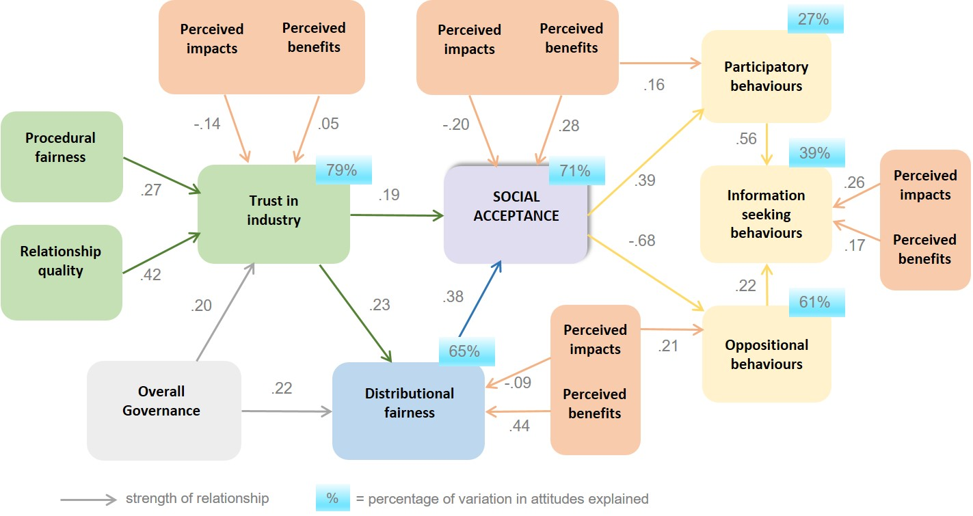

The relationships between all these factors were positive except for those with perceived impacts, which demonstrated negative relationships. A positive relationship means that when a person perceives one variable to be high they are more likely to perceive the corresponding variable to also be high. In contrast, a negative relationship means that when a person perceives one variable to be high they are more likely to perceive the other variable to be low.

In addition, some variables act directly on a variable and some act indirectly by influencing another variable in the pathway. For example, governance influences social acceptance through its influence on creating trust in industry and making things seem fair to communities (distributional fairness). An element of trust also underlies perceptions of distributional fairness.

Based on the total effects of the variables and looking at the numbers on the arrows, the main points in the model are:

* The direct drivers of social acceptance are perceived impacts and benefits, trust in industry, and distributional fairness.
  + Perceived impacts and benefits are also indirect drivers of social acceptance by influencing perceptions of distributional fairness and trust in industry.
  + When looking at total effects of various drivers on social acceptance, perceived benefits is most important in this scenario because of its importance to distributional fairness
* Social acceptance, or lack of, is a greater driver of oppositional behaviours than it is of participatory behaviours.
* Participatory behaviours are linked to perceived benefits, while oppositional behaviours are more associated with perceived impacts.
  + In contrast, information seeking behaviour is mainly driven by those wanting to participate and contribute to the success of the project (e.g., applying for a position on a working committee)
  + While oppositional behaviours are mainly associated with perceived impacts, they are also mitigated indirectly by perceived benefits and distributional fairness
* Good overall governance underpins trust in the industry and perceived distributional fairness, thereby acting as an important contributor to social acceptance, even though it acts indirectly.
* Trust in industry is mostly explained by relationship quality, procedural fairness, and governance. These variables indicate the importance of the relational aspects between community residents and the mining industry in building trust.
  + Perceived impacts and benefits are only minor contributors to trust in industry, rather than being main drivers.

Understanding the way each of the variables influences other variable in Figure 14 provides opportunities for how best to apply interventions or initiatives to improve a particular variable. Figure 15 also summarises the main drivers of each dependent variable in the model, listed in order of importance, where main drivers had total effects over .20.

Figure 15. Main drivers in the model of trust, social acceptance and associated behaviours

This diagram shows main drivers of six social licence variables. 1) Trust in industry: relationship quality, procedural fairness, overall governance. 2) Social acceptance: perceived benefits, distributional fairness, trust in industry, perceived impacts. 3) Distributional fairness: perceived benefits, overall governance, trust in industry. 4) Participatory behaviours: social acceptance, perceived benefits. 5) oppositional behaviours: perceived impacts, perceived benefits, distributional fairness. 6) Information seeking behaviours: perceived impacts, perceived benefits, distributional fairness.

## Conclusions

Providing information on benefits and governance and engagement processes have small though significant positive effects on social licence variables, social acceptance, and behavioural intentions.

* Benefits information tends to improve perceptions of benefits, distributional fairness, and relationship quality
* Governance and engagement information improves perceptions of governance, trust in industry, relationship quality between industry and community, and procedural fairness. It also increases social acceptance and reduces oppositional behavioural intentions

Information on governance and engagement processes improves a wider range of social licence variables than information on local benefits, including improving trust and acceptance, and reducing oppositional behaviour.

* However, modelling shows that perceptions of benefits are generally more important than perceptions of governance in predicting social licence variables

Even though acceptance levels of a hypothetical project may be modest, people are highly motivated to seek further information.

* When people want to participate in the success of a project they are more likely to seek further information about the project than those who want to oppose it.

The model shows multiple and complex pathways to social acceptance and associated behaviours, and identifies opportunities for improving these outcomes.

### Independent effects of information manipulations

Providing information on benefits , governance and engagement processes via a letter to residents has small though significant positive effects on a range of factors underlying a proposed mining company’s social licence to operate. The information on benefits, which included creating local employment and business opportunities; boosting the local economy through flow on effects to other sectors; and explaining that the estimates for jobs came from independent economic research, resulted in improved perceptions of benefits and distributional fairness about the project. It also increased favourable perceptions of the quality of the relationship between the company and the community, potentially achieved by indicating that independent economic research had determined the likely jobs created from the project (between 200 – 400 jobs). People may have viewed these job numbers as reasonably likely (i.e., not over-stated) and perceived the company as being more open, honest and transparent in using an independent source, which translated into improved perceptions of relationship quality. It is also possible that the effect of benefit information may be have been greater if the scenario of a larger project was used, though so would perceptions of impacts.

In contrast, information on governance and engagement processes had a more widespread effect than benefit information, extending to improvements in social acceptance and reductions in oppositional behaviour. This information referred to the mining company’s commitment to address any concerns and issues; detailed a range of opportunities on how community perspectives would be included in decision making, and assured the public about governance initiatives, including details on state government regulations and legislation related to protecting water, land and the environment. Provision of this type of information significantly improved perceptions of relationship quality between the company and community, trust in the mining company, and confidence and trust in governance. It also increased overall social acceptance of the mining project and reduced oppositional behaviour intentions.

The effect of governance and engagement information was more widespread than the effect of benefit information. Benefits information directly targeted only one driver of social acceptance compared to the combined effect of providing information about governance and engagement commitments, which targets two other very influential drivers of acceptance. This suggests that addressing a single driver is not as effective as addressing multiple drivers.

The effect of benefit information could potentially be enhanced by including a broader range of benefits such as opportunities for young people to stay in the region, and community support for local clubs and activities. It may also be more effective if it included benefits that the project provides at a societal level.

While there are limitations on how much perceptions can be influenced by simply providing information, such as an initial engagement letter about local benefits, governance arrangements and opportunities to engage with a mining project, it is an effective way of initially enhancing the social licence for a local mining activity. It also provides a gateway for other engagement activities and opportunities for addressing a range of drivers underlying trust, social acceptance, and associated behaviours.

### Model of trust, social acceptance and associated behaviours

The model shows multiple and complex pathways to social acceptance and associated behaviours, and identifies opportunities for improving these outcomes. By targeting specific and multiple underlying drivers it is reasonable to expect that improvements in trust, social acceptance and subsequent behaviours can be achieved. This means focussing information on the key issues related to specific drivers.

The items that measure each variable indicate the key attributes that are important to people as identified and tested in previous CSIRO mining and unconventional gas research. For example, relationship quality between the industry and community is all about the company being open, honest, transparent, and genuine with the community. This is the manner in which the community expects the company to engage with them. Providing information as to how the company will conduct their engagement, as well as their commitment to these processes, will help to improve people’s view of the company, and result in increased social acceptance. This has also been demonstrated in the findings of this research.

Other opportunities potentially exist by providing the ‘right’ sort of information from the perspective of local communities about other drivers. For example, providing information about risk management and mitigation processes may be as important as risk probabilities; and providing information on costs and benefits which are seen as fairly shared and distributed. However, this requires an understanding of the impacts and benefits most important to each community, and raises relevant future questions for social science research.

### Potential future questions

What is the effect of providing information about impact mitigation and avoidance? How best do we convey impact mitigation?

* We know from the evolving body of research on social licence that concerns and perceptions about possible negative impacts have a substantial influence on social acceptance.
* We also know that perceived manageability of the impact and how well it is understood by science are both inked to perceptions of risk and offer potential ways to convey impact mitigation.

What do people consider is ‘fair distribution’ of costs and benefits? And how is this best conveyed in initial engagement?

* If benefits are the main driver of distributional fairness, what will be the benefits considered ‘fair’ to communities if local jobs and employment opportunities diminish as mining becomes more automated in the future?

Given that men and women respond differently to the information provided, how can initial engagement letters respond better to both the needs of men and women?

* For example, by providing different types of information targeted to men and to women in the same letter such as outlining job opportunities for women

Which drivers of social licence are more important for men and women

* What other factors drive or inhibit participatory behaviours, especially for women?

How do attitudes differ between people who actually live in mining regions as opposed to those who live in regional areas that do not have mining?

References

Moffat, K., Pert, P., McCrea, R., Boughen, N., Rodriguez, M., & Lacey, J. (2017). *Australian attitudes toward mining: Citizen survey - 2017 results*. Brisbane: CSIRO Retrieved from https://[www.csiro.au/en/Research/MRF/Areas/Community-and-environment/Understanding-community-attitudes/Australian-attitudes-to-mining-2017](http://www.csiro.au/en/Research/MRF/Areas/Community-and-environment/Understanding-community-attitudes/Australian-attitudes-to-mining-2017).

Moffat, K., & Zhang, A. (2014). The paths to social licence to operate: An integrative model explaining community acceptance of mining. *Resources Policy*, 61-70.

Walton, A., & McCrea, R. (2017). Community wellbeing and local attitudes to coal seam gas development Social Baseline Assessment: Narrabri project - Phase 3 Survey report. Australia: CSIRO.

Zhang, A., Measham, T., & Moffat, K. (2018). Preconditions for social licence: The importance of information in initial engagement. *Journal of Cleaner Production, 172*(Supplement C), 1559-1566. doi: https://doi.org/10.1016/j.jclepro.2017.10.323

Zhang, A., Moffat, K., & Measham, T. (2016). Stakeholder engagement processes: Exploring the mechanisms for constructive social engagement around mine site development. A report prepared for the Department of Industry, Innovation and Science. Canberra: CSIRO.

Appendices

1. Letter types (iron ore mine example)

Letter: Condition A1 / Iron Ore – *basic* information

Dear Home Owner,

**Re: local iron ore** **mine proposal**

I am writing to you because our records show that you own a residence in or near the township of Sanstwel. We are organising a Community Information Session on 20 March 2018 at Sanstwel.

To give you some background, Nortor Mining Corporation (NMC) has applied for a Mining Lease to develop a small open-cut mine on a 1023 ha site, at least 10 km from the nearest residence at Sanstwel. NMC proposes to mine approximately five million tonnes of iron ore over a period of 8-10 years.

During the Community Information Session, we would like to present the Project to the community and to have our experts on hand to answer any queries directly.

We would like to meet you in person. But if for any reason you or a family member are unable to attend the information session, we would like you to know that all information about the mine project has been posted on our website. I invite you to read through the information on our website at the following address: www.nortorminingcorp.org.au/projects

Alternatively, if you have any questions, we encourage you to either contact the Project toll free number on 333 111 222 or email us at sanstwel@nortorminingcorp.org.au.

Yours sincerely

Waynne Thomsson  
Chief Operating Officer  
Nortor Mining Corporation

Letter: Condition B1 / Iron Ore - Basic plus *benefit* information

Dear Home Owner,

**Re: local iron ore** **mine proposal**

I am writing to you because our records show that you own a residence in or near the township of Sanstwel. We are organising a Community Information Session on 20 March 2018 at Sanstwel.

To give you some background, Nortor Mining Corporation (NMC) has applied for a Mining Lease to develop a small open-cut mine on a 1023 ha site, at least 10 km from the nearest residence at Sanstwel. NMC proposes to mine approximately five million tonnes of iron ore over a period of 8-10 years.

During the Community Information Session, we would like to present the Project to the community and to have our experts on hand to answer any queries directly.

***Local jobs growth***

Independent economic research shows a benefit to the region of between 200 – 400 ongoing local jobs over the life of the project. This would come from direct jobs in the industry and flow on effects to other sectors. The modelling also shows this would significantly contribute to the region’s local economy.

We would like to meet you in person. But if for any reason you or a family member are unable to attend the information session, we would like you to know that all information about the mine project has been posted on our website. I invite you to read through the information on our website at the following address: www.nortorminingcorp.org.au/projects

Alternatively, if you have any questions, we encourage you to either contact the Project toll free number on 333 111 222 or email us at sanstwel@nortorminingcorp.org.au.

Yours sincerely

Waynne Thomsson  
Chief Operating Officer  
Nortor Mining Corporation

Letter: Condition C1 / Iron Ore - Basic plus *governance* and *engagement* information

Dear Home Owner,

**Re: local iron ore** **mine proposal**

I am writing to you because our records show that you own a residence in or near the township of Sanstwel. We are organising a Community Information Session on 20 March 2018 at Sanstwel.

To give you some background, Nortor Mining Corporation (NMC) has applied for a Mining Lease to develop a small open-cut mine on a 1023 ha site, at least 10 km from the nearest residence at Sanstwel. NMC proposes to mine approximately five million tonnes of iron ore over a period of 8-10 years.

During the Community Information Session, we would like to present the Project to the community and to have our experts on hand to answer any queries directly.

***Our commitment***

NMC commits to working with you to address any concerns and issues that are important to Sanstwel community. We propose to establish a Community Working Committee, the majority of whose members will come from the community. It will consist of 5 community members, 2 local council representatives, and 2 NMC representatives. The role of the Committee is to facilitate constructive dialogue between community, NMC, and the local council. The community positions will be advertised publicly and the selection will be conducted through a community meeting. All meeting minutes and decisions of the Community Working Committee will be shared publically.

***Government requirements***

The State Government has a framework of legislation and regulation that companies must comply with to ensure the protection of environment, land and water resources as they are affected by mining activity. Compliance with conditions is mandatory under the *Environmental Protection Act.* There are heavy penalties for non-compliance. NMC will strictly follow government requirements and will soon submit an Environmental Management Plan (EMP) for the mine project for the State Government’s review. The EMP will include reports of baseline studies on all issues related to the project and will outline the measures proposed by NMC to deal potential future issues, impacts and opportunities for local communities and the environment.

***Your say in the process***

Your concerns and suggestions will be heard and addressed through the proposed Community Working Committee discussed above, as well as through the State Government’s assessment process. The government will make the EMP submitted by NMC public, and invites community members to make comments as well as discuss their concerns in relation to the Project. Your feedback on the proposed project will be an integral part of the government’s evaluation of our proposed project.

We would like to meet you in person. But if for any reason you or a family member are unable to attend the information session, we would like you to know that all information about the mine project has been posted on our website. I invite you to read through the information on our website at the following address: www.nortorminingcorp.org.au/projects

Alternatively, if you have any questions, we encourage you to either contact the Project toll free number on 333 111 222 or email us at sanstwel@nortorminingcorp.org.au.

Yours sincerely

Waynne Thomsson  
Chief Operating Officer  
Nortor Mining Corporation

Letter: Condition D1 / Iron Ore - Basic plus *governance*, *engagement* and *benefit* information

Dear Home Owner,

**Re: local iron ore** **mine proposal**

I am writing to you because our records show that you own a residence in or near the township of Sanstwel. We are organising a Community Information Session on 20 March 2018 at Sanstwel.

To give you some background, Nortor Mining Corporation (NMC) has applied for a Mining Lease to develop a small open-cut mine on a 1023 ha site, at least 10 km from the nearest residence at Sanstwel. NMC proposes to mine approximately five million tonnes of iron ore over a period of 8-10 years.

During the Community Information Session, we would like to present the Project to the community and to have our experts on hand to answer any queries directly.

***Local jobs growth***

Independent economic research shows a benefit to the region of between 200 – 400 ongoing local jobs over the life of the project. This would come from direct jobs in the industry and flow on effects to other sectors. The modelling also shows this would significantly contribute to the region’s local economy.

***Our commitment***

NMC commits to working with you to address any concerns and issues that are important to Sanstwel community. We propose to establish a Community Working Committee, the majority of whose members will come from the community. It will consist of 5 community members, 2 local council representatives, and 2 NMC representatives. The role of the Committee is to facilitate constructive dialogue between community, NMC, and the local council. The community positions will be advertised publicly and the selection will be conducted through a community meeting. All meeting minutes and decisions of the Community Working Committee will be shared publically.

***Government requirements***

The State Government has a framework of legislation and regulation that companies must comply with to ensure the protection of environment, land and water resources as they are affected by mining activity. Compliance with conditions is mandatory under the *Environmental Protection Act.* There are heavy penalties for non-compliance. NMC will strictly follow government requirements and will soon submit an Environmental Management Plan (EMP) for the mine project for the State Government’s review. The EMP will include reports of baseline studies on all issues related to the project and will outline the measures proposed by NMC to deal potential future issues, impacts and opportunities for local communities and the environment.

***Your say in the process***

Your concerns and suggestions will be heard and addressed through the proposed Community Working Committee discussed above, as well as through the State Government’s assessment process. The government will make the EMP submitted by NMC public, and invites community members to make comments as well as discuss their concerns in relation to the Project. Your feedback on the proposed project will be an integral part of the government’s evaluation of our proposed project.

We would like to meet you in person. But if for any reason you or a family member are unable to attend the information session, we would like you to know that all information about the mine project has been posted on our website. I invite you to read through the information on our website at the following address: www.nortorminingcorp.org.au/projects

Alternatively, if you have any questions, we encourage you to either contact the Project toll free number on 333 111 222 or email us at sanstwel@nortorminingcorp.org.au.

Yours sincerely [signature block]

1. Letters for each industry (basic letter example)

Iron Ore - basic letter

Dear Home Owner,

**Re: local iron ore** **mine proposal**

I am writing to you because our records show that you own a residence in or near the township of Sanstwel. We are organising a Community Information Session on 20 March 2018 at Sanstwel.

To give you some background, Nortor Mining Corporation (NMC) has applied for a Mining Lease to develop a small open-cut mine on a 1023 ha site, at least 10 km from the nearest residence at Sanstwel. NMC proposes to mine approximately five million tonnes of iron ore over a period of 8-10 years.

During the Community Information Session, we would like to present the Project to the community and to have our experts on hand to answer any queries directly.

We would like to meet you in person. But if for any reason you or a family member are unable to attend the information session, we would like you to know that all information about the mine project has been posted on our website. I invite you to read through the information on our website at the following address: www.nortorminingcorp.org.au/projects

Alternatively, if you have any questions, we encourage you to either contact the Project toll free number on 333 111 222 or email us at sanstwel@nortorminingcorp.org.au.

Yours sincerely

Waynne Thomsson  
Chief Operating Officer  
Nortor Mining Corporation

Coal - basic letter

Dear Home Owner,

**Re: local coal mine proposal**

I am writing to you because our records show that you own a residence in or near the township of Sanstwel. We are organising a Community Information Session on 20 March 2018 at Sanstwel.

To give you some background, Nortor Mining Corporation (NMC) has applied for a Mining Lease to develop a small open-cut mine on a 1023 ha site, at least 10 km from the nearest residence at Sanstwel. NMC proposes to mine approximately five million tonnes of coal over a period of 8-10 years.

During the Community Information Session, we would like to present the Project to the community and to have our experts on hand to answer any queries directly.

We would like to meet you in person. But if for any reason you or a family member are unable to attend the information session, we would like you to know that all information about the mine project has been posted on our website. I invite you to read through the information on our website at the following address: www.nortorminingcorp.org.au/projects

Alternatively, if you have any questions, we encourage you to either contact the Project toll free number on 333 111 222 or email us at sanstwel@nortorminingcorp.org.au.

Yours sincerely

Waynne Thomsson  
Chief Operating Officer  
Nortor Mining Corporation

Tech metals - basic letter

Dear Home Owner,

**Re: local tech metals mine proposal**

I am writing to you because our records show that you own a residence in or near the township of Sanstwel. We are organising a Community Information Session on 20 March 2018 at Sanstwel.

To give you some background, Nortor Mining Corporation (NMC) has applied for a Mining Lease to develop a small open-cut mine on a 1023 ha site, at least 10 km from the nearest residence at Sanstwel. NMC proposes to mine approximately five million tonnes of tech metals (e.g. for batteries and electronics) over a period of 8-10 years.

During the Community Information Session, we would like to present the Project to the community and to have our experts on hand to answer any queries directly.

We would like to meet you in person. But if for any reason you or a family member are unable to attend the information session, we would like you to know that all information about the mine project has been posted on our website. I invite you to read through the information on our website at the following address: www.nortorminingcorp.org.au/projects

Alternatively, if you have any questions, we encourage you to either contact the Project toll free number on 333 111 222 or email us at sanstwel@nortorminingcorp.org.au.

Yours sincerely

Waynne Thomsson  
Chief Operating Officer  
Nortor Mining Corporation

Coal seam gas – basic letter

Dear Home Owner,

**Re: local coal seam gas development proposal**

I am writing to you because our records show that you own a residence in or near the township of Sanstwel. We are organising a Community Information Session on 20 March 2018 at Sanstwel.

To give you some background, Nortor Mining Corporation (NMC) has applied for a Petroleum Lease for a localised coal seam gas (CSG) development on a 1023 ha site, at least 10 km from the nearest residence at Sanstwel. NMC proposes to drill approximately 850 wells over a period of 8-10 years.

During the Community Information Session, we would like to present the Project to the community and to have our experts on hand to answer any queries directly.

We would like to meet you in person. But if for any reason you or a family member are unable to attend the information session, we would like you to know that all information about the CSG project has been posted on our website. I invite you to read through the information on our website at the following address: www.nortorminingcorp.org.au/projects

Alternatively, if you have any questions, we encourage you to either contact the Project toll free number on 333 111 222 or email us at sanstwel@nortorminingcorp.org.au.

Yours sincerely

Waynne Thomsson  
Chief Operating Officer  
Nortor Mining Corporation

1. Main survey questions

Starting from Q4, after questions on age, sex, and state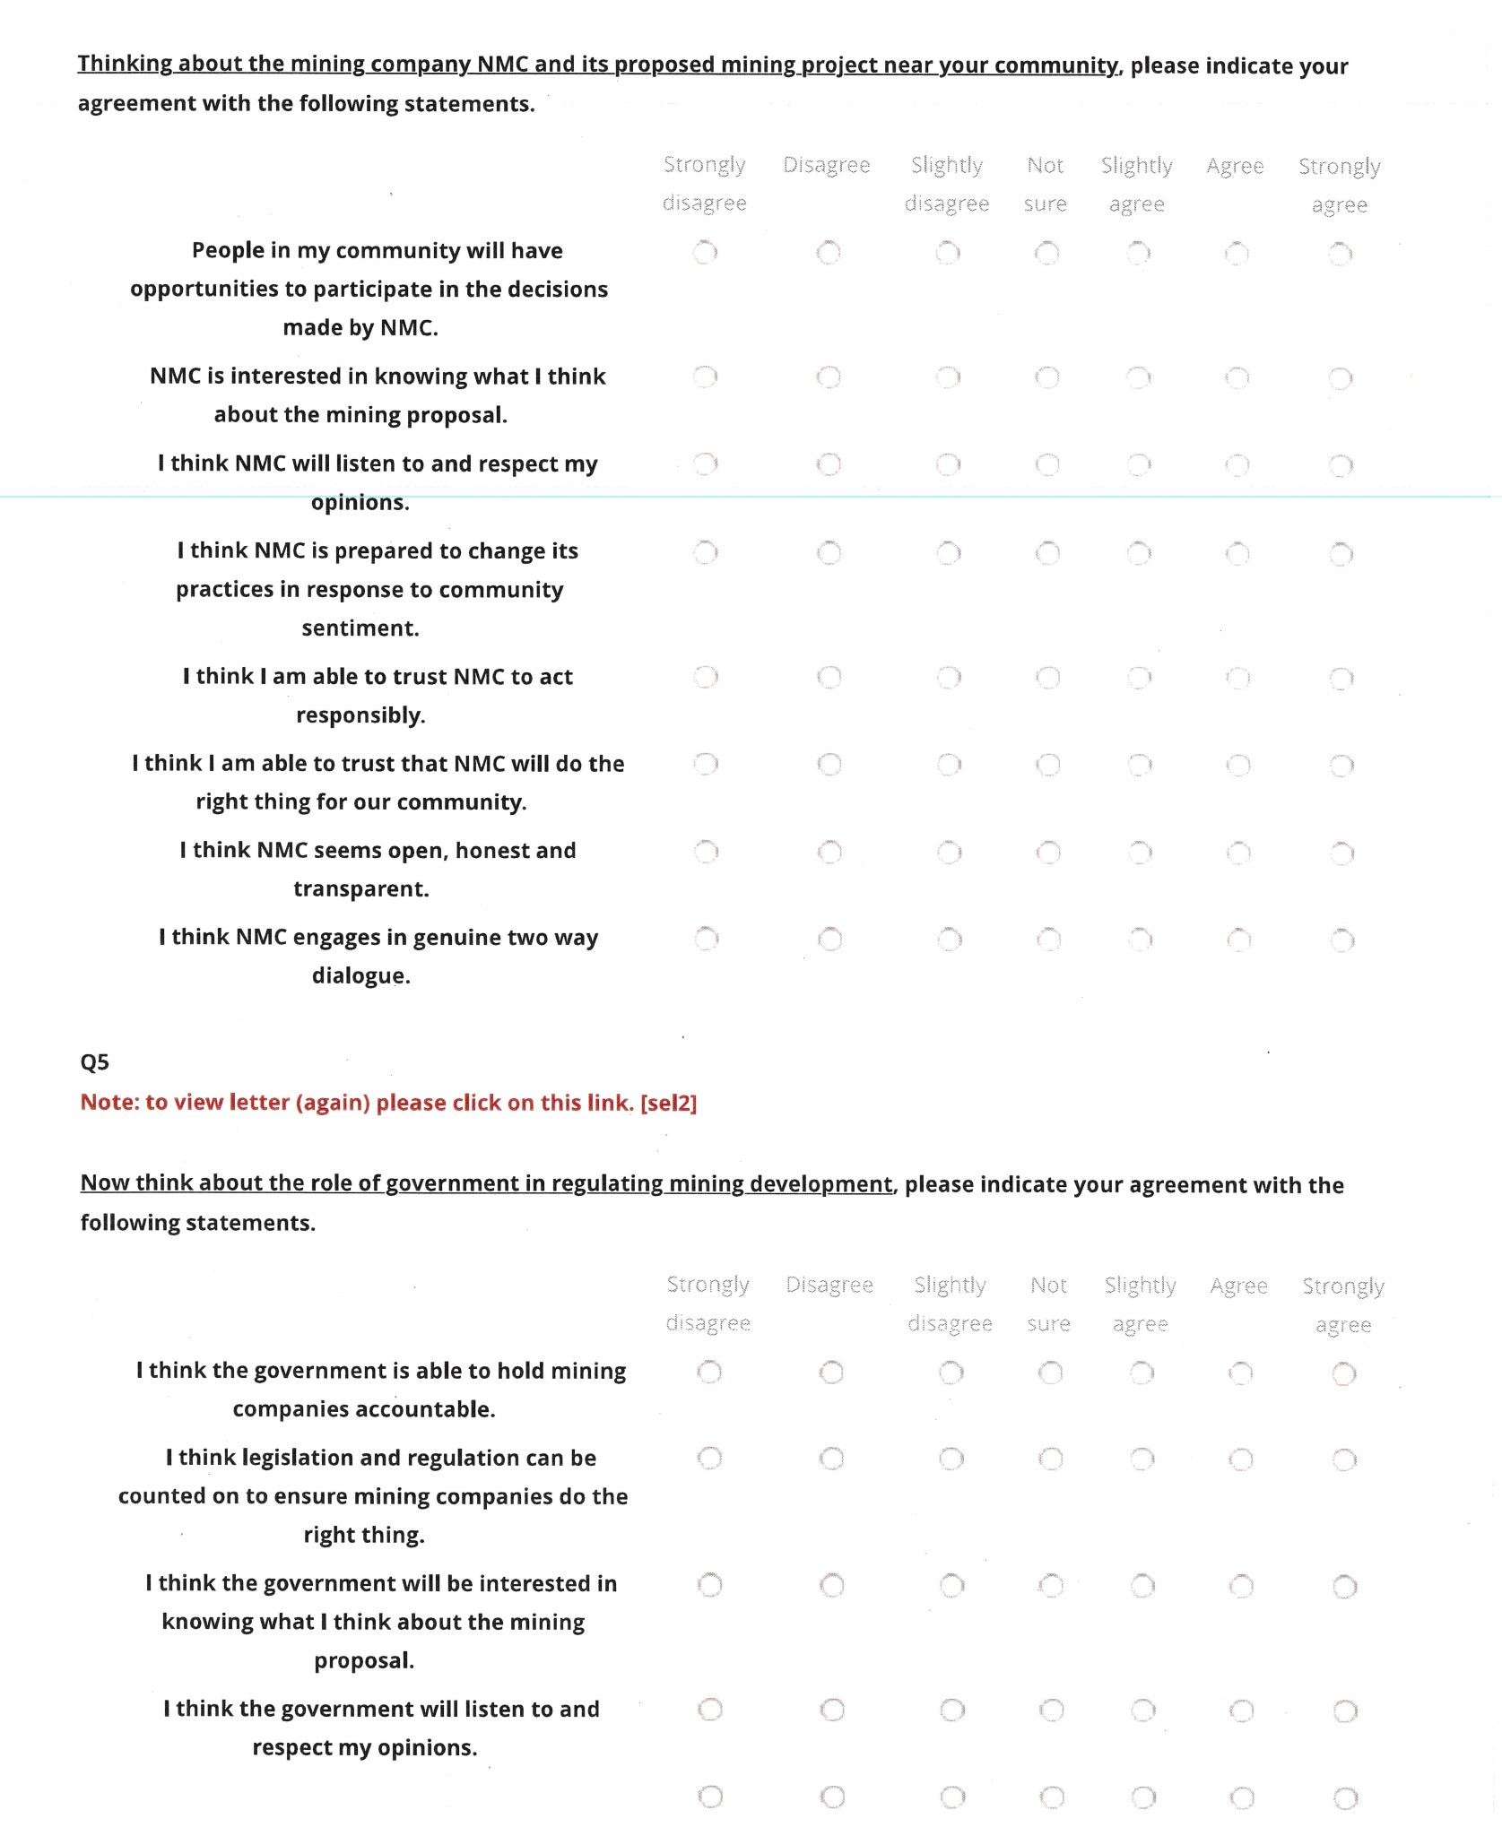

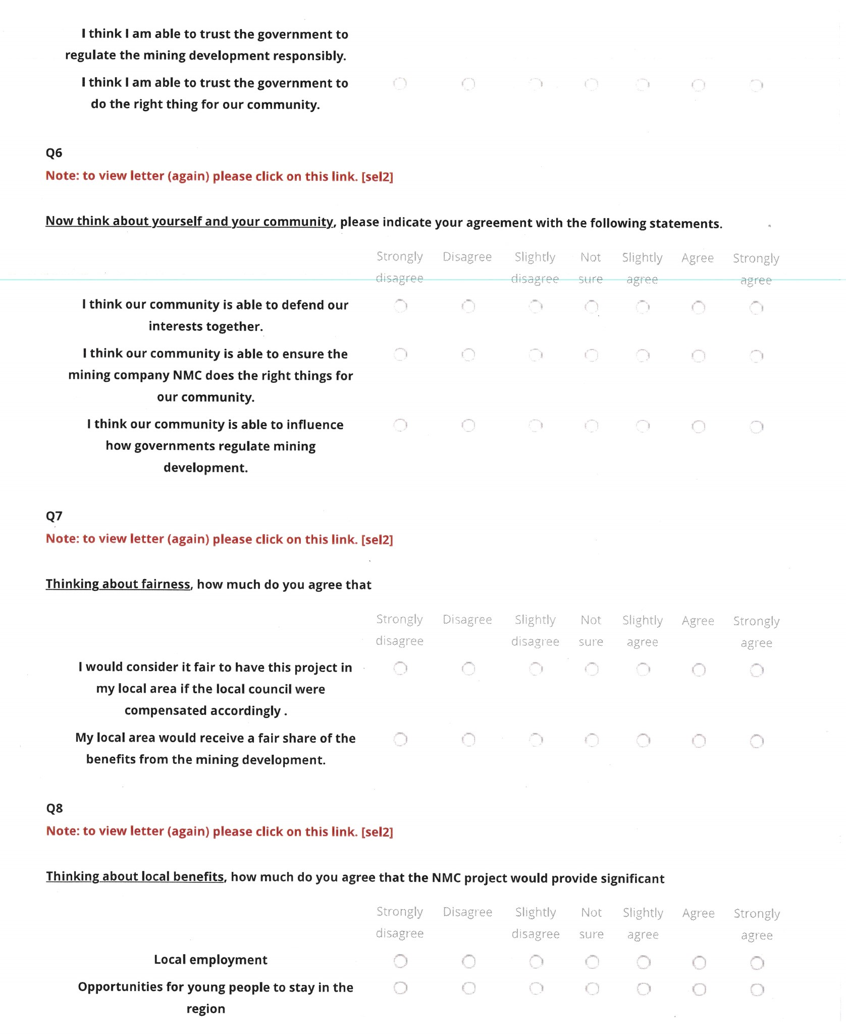

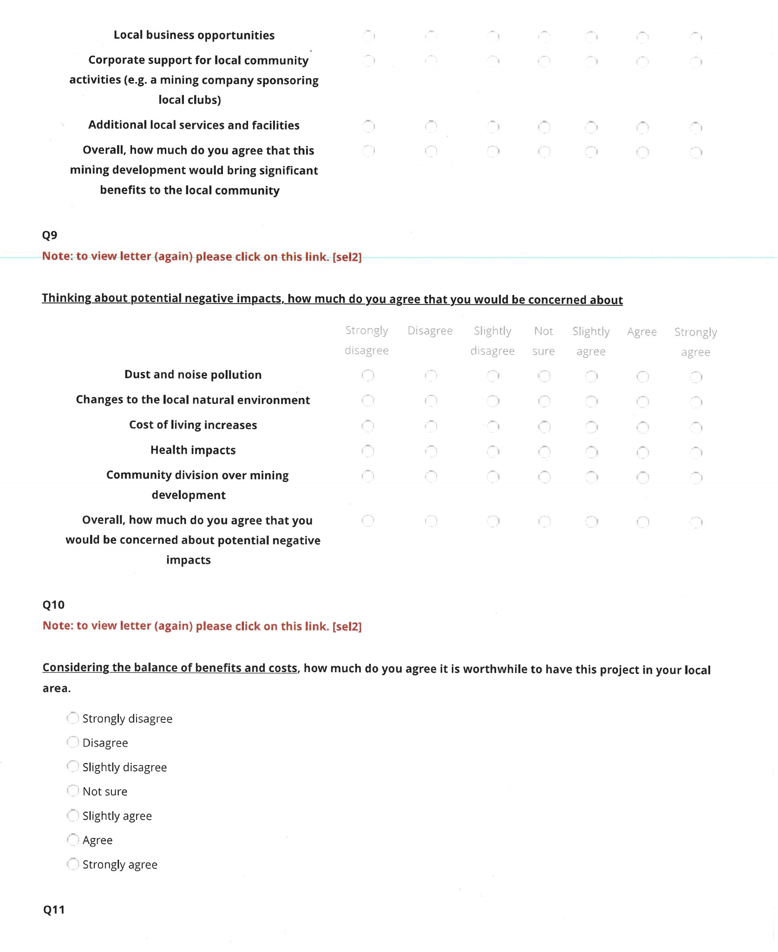

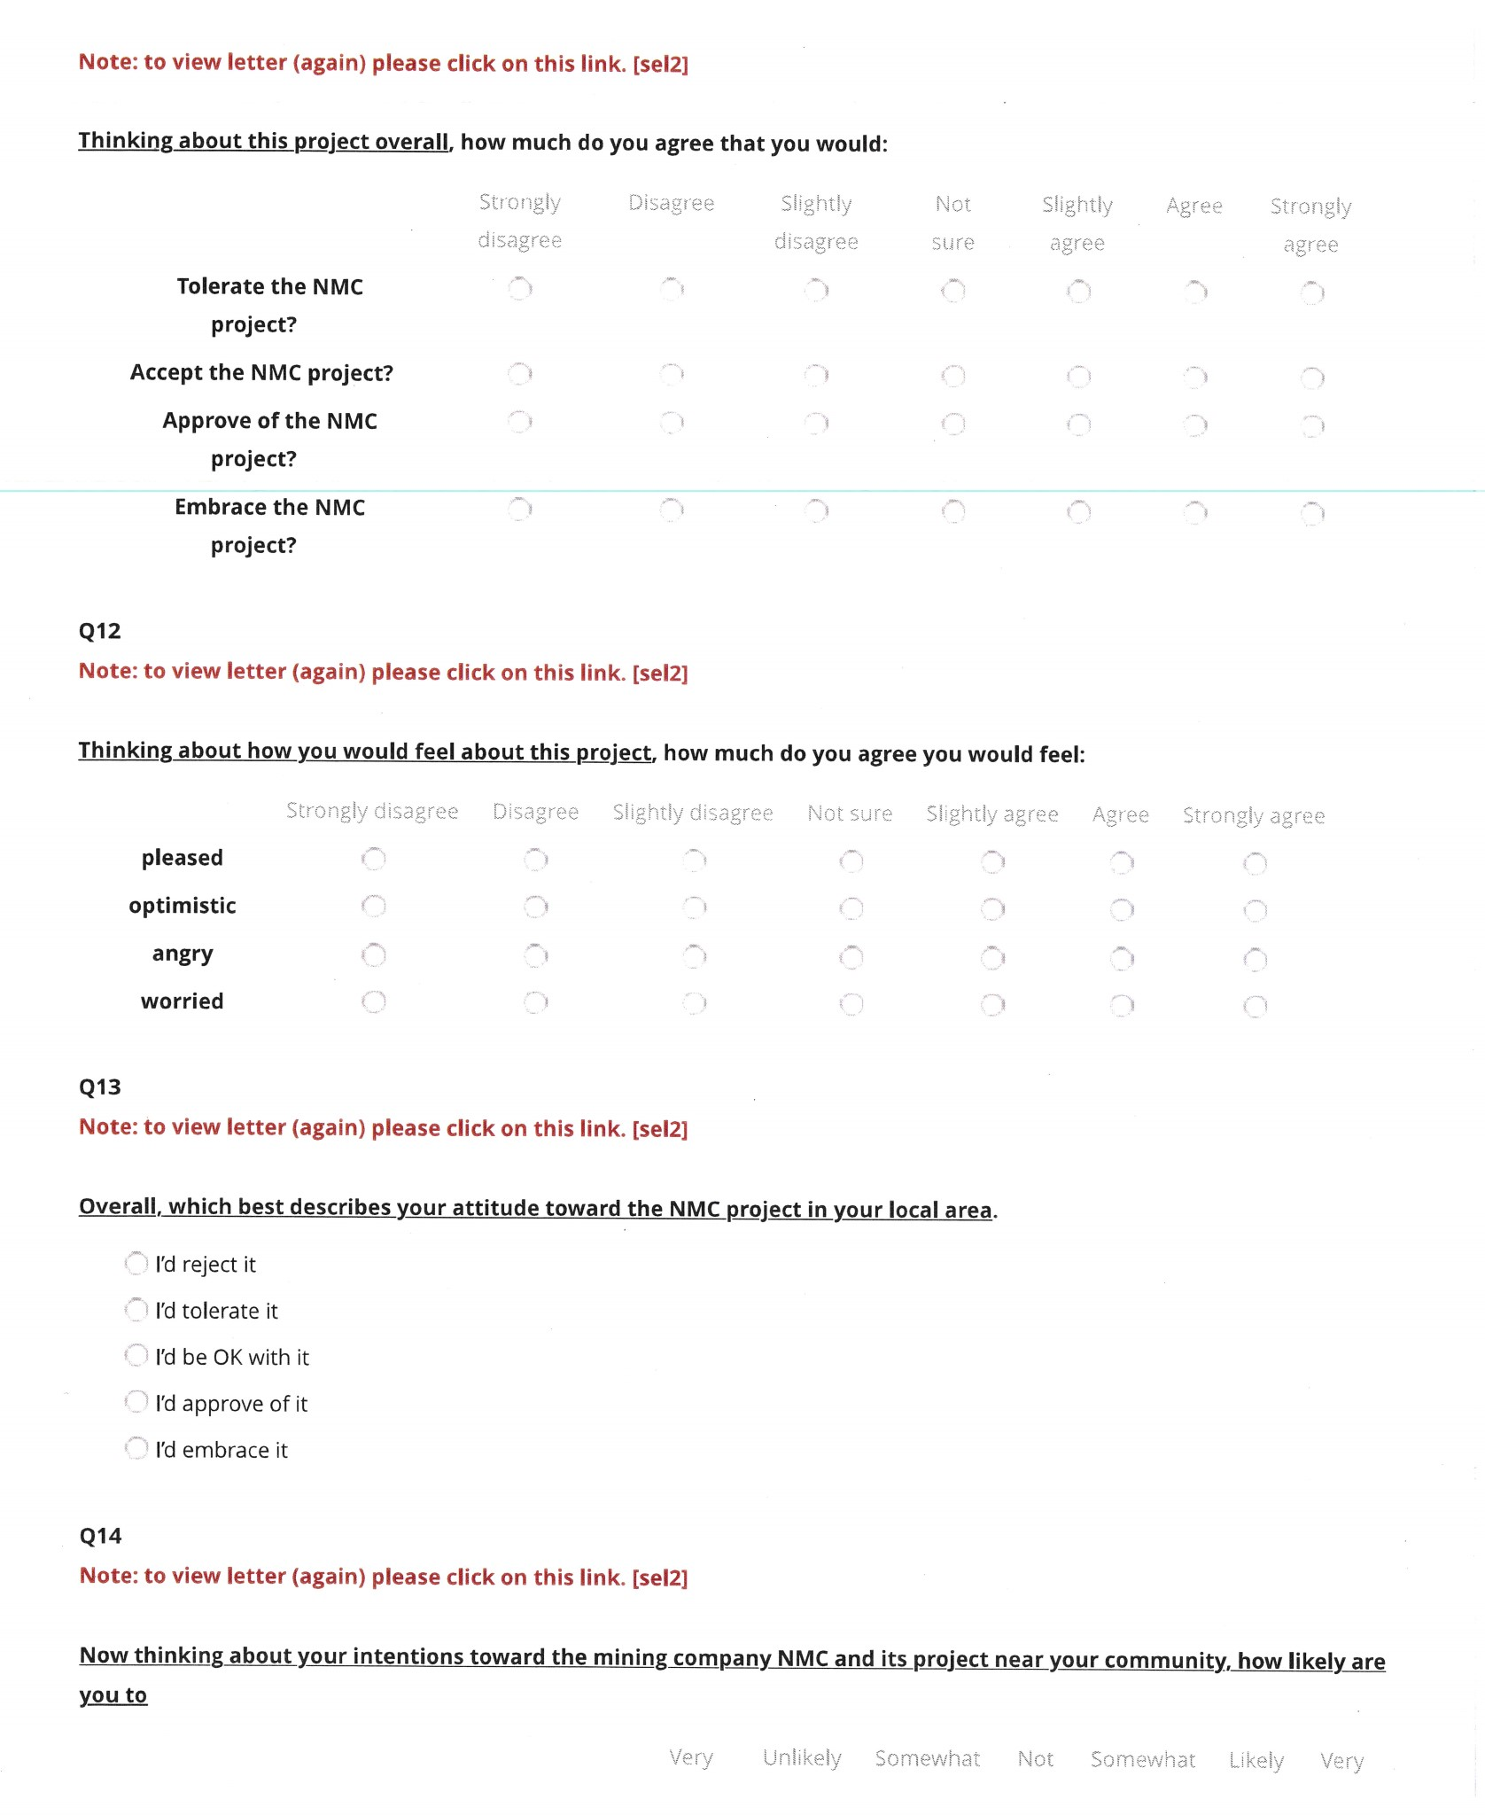

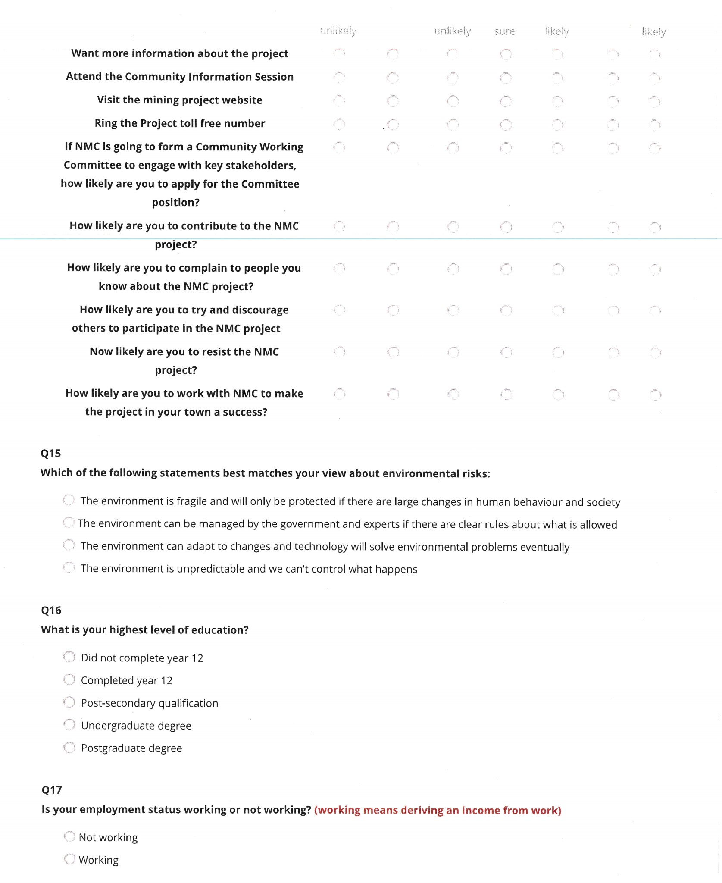

|  | | |
| --- | --- | --- |
| CONTACT US  t 1300 363 400  +61 3 9545 2176  e csiroenquiries@csiro.au  w www.csiro.au  At CSIRO, we do the  extraordinary every day  We innovate for tomorrow and help improve today – for our customers, all Australians and the world.  Our innovations contribute billions of dollars to the Australian economy  every year. As the largest patent holder  in the nation, our vast wealth of intellectual property has led to more  than 150 spin-off companies.  With more than 5,000 experts and a burning desire to get things done, we are Australia’s catalyst for innovation.  CSIRO. WE IMAGINE. WE COLLABORATE.  WE INNOVATE. |  | For further information  CSIRO Land and Water  Rod McCrea t +61 7 3833 5677  e airong.zhang@csiro.au  w [www.csiro.au](http://www.csiro.au)  Andrea Walton  t +61 7 3833 5675  e kieren.moffat@csiro.au  w [www.csiro.au](http://www.csiro.au)  Tom Measham t +61 7 3833 5962  e Tom.Measham@csiro.au  w [www.csiro.au](http://www.csiro.au) |