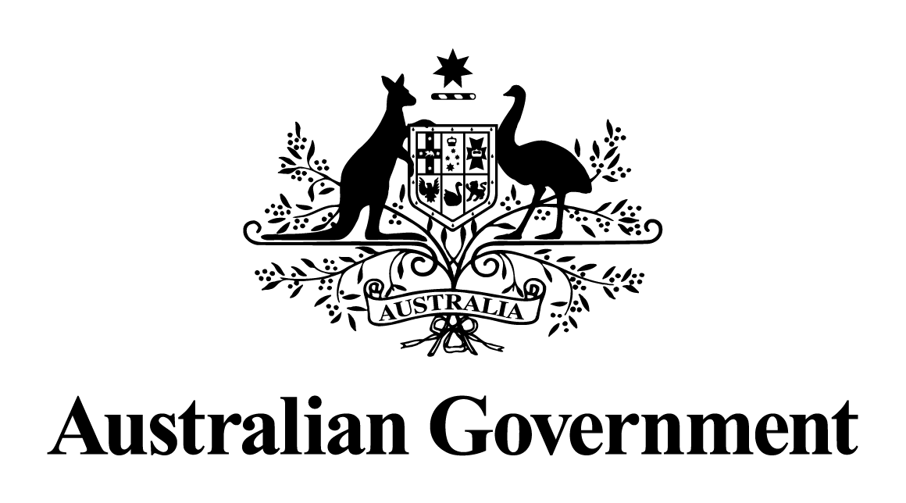

Australian Government response to the   
 Senate Education and Employment References Committee report:

Work health and safety of workers involved in the offshore petroleum industry

January 2019

## Introduction

The Australian Government welcomes the report by the Senate Education and Employment References Committee in relation to the inquiry into the work health and safety of offshore workers involved in the offshore petroleum industry, and thanks the Committee for the work it has done in preparing this report. This work is important for offshore workers, the government and the offshore oil and gas industry.

The Government would like to acknowledge the contribution individuals and organisations have made to this inquiry in preparing written submissions and appearing at public hearings.

The Government notes that the report includes analysis and a number of recommendations from the Committee, and a dissenting report by Government Senators.

## Government Response to Committee Recommendations

The safety of workers and operations are of the utmost importance to the Australian Government, and we are committed to ensuring the offshore petroleum industry is supported by an effective and robust occupational health and safety (OHS) regime.

The Government notes that the current OHS regulatory regime delivers high safety performance outcomes, and consistently performs well compared to other high-hazard industries in Australia, and overseas offshore petroleum sectors.

Australia’s offshore OHS regime has evolved over many years and has been shaped by lessons learned from major accident events in Australia and internationally. It seeks to protect the personal safety of workers and to prevent major accident events through process safety.

The Government recognises that a leading practice OHS regime must incorporate an effective regulatory and legislative framework, an independent and competent regulator and involvement of all relevant stakeholders in health and safety issues. The Government notes that the current regulatory regime provides for these principles, specifically through:

* the adoption of objective-based regulation and a safety case model where risk owners must demonstrate how they control risks to health and safety;
* the establishment of the National Offshore Petroleum Safety and Environmental Management Authority (NOPSEMA) and its role in promoting health and safety, monitoring and enforcement and stakeholder engagement; and
* formal provision for workforce involvement in the legislation.

The Government is committed to ensuring the regulation remains relevant and effective over time, and notes that the inquiry process and the Committee’s report has provided the Government with a good opportunity to focus its attention on issues raised by stakeholders.

It is in this context that **the Government notes all recommendations made in the Committee report**, and will consider the recommendations as part of the Department of Industry, Innovation and Science’s current review of the offshore safety regulatory regime.

## Offshore Safety Regulatory Regime Review

In July 2018, the Department of Industry, Innovation and Science commenced a review of the offshore safety regulatory regime, as part of its normal regulatory and continuous improvement process, and in anticipation of the sunsetting of the current safety regulations in April 2020. The purpose of the Safety Review is to ensure that the regime continues to provide an effective framework to secure the health, safety and welfare of offshore workers.

The Safety Review will be evidence-based and propose policy changes and legislative amendments, where necessary, to improve the offshore OHS regime. The Safety Review will consider the offshore OHS legislative framework (including risk management plans and jurisdictional coverage); workplace arrangements (including Health and Safety Representatives, consultation and participation, training and competency); and compliance and enforcement (inspections, reporting, offences and penalties). Key issues raised in the Committee report pertaining to the OHS regime will be considered as part of the Safety Review. Some issues may be identified for further analysis following the Safety Review. The Terms of Reference of the review are at Attachment A.

Integral to the effectiveness of the Safety Review is engagement with, and input from, stakeholders involved in offshore health and safety issues, through a number of different consultation mechanisms. The department has established a Safety Stakeholder Group as a forum for representatives from the offshore industry, unions and the workforce, and state and Commonwealth governments, to exchange views and information on issues relevant to the review and allow ideas to be tested and discussed prior to a final policy position being reached. The department will also be holding targeted stakeholder meetings and workshops and undertake formal public consultation. The department held a stakeholder workshop in Melbourne in August to explore issues and concerns of a wide range of participants involved in the offshore industry.

As part of the Safety Review a wide variety of information sources will be considered, including equivalent international offshore and onshore safety regimes, as well as issues arising from the Review of the Model Work Health and Safety laws currently being undertaken by Safe Work Australia.

## Conclusion

The Government notes the Safety Review provides a timely and sensible opportunity to carefully consider the findings of the Committee report and evidence provided during the course of the inquiry, and will draw upon this information while undertaking the Safety Review.

The Government recognises the benefits a prosperous offshore resources sector offers to Australia and the Australian people, and understands that to maintain and maximise this prosperity we must protect and secure the health and safety of those people who work in the offshore industry. The Government remains committed to ensuring the OHS regulatory regime is effective and achieves optimal safety outcomes for all stakeholders involved.

**Review of the Occupational Health and Safety Regime for Workers involved in Offshore Petroleum Operations in Commonwealth Waters**

**Terms of Reference**

**Purpose:**

To review the *Offshore Petroleum and Greenhouse Gas Storage (Safety) Regulations 2009* and the associated parts of the *Offshore Petroleum and Greenhouse Gas Storage Act 2006* to ensure that they:

1. provide an effective framework for securing the occupational health and safety of persons engaged in offshore petroleum or greenhouse gas storage operations in Commonwealth waters of Australia, and
2. represent leading practice that promotes and delivers safe offshore petroleum and greenhouse gas storage activities.

The review will be evidence-based and propose policy changes and legislative amendments, where necessary, to improve the offshore OHS regime. Some areas may be identified that require further analysis following the review.

**Background:**

The *Offshore Petroleum and Greenhouse Gas Storage Act 2006* (OPGGS Act) provides the legal framework for the exploration and recovery of petroleum and for the injection and storage of greenhouse gas substances in Commonwealth waters. This Act is administered by the Commonwealth Government, with some decisions made jointly with the state and Northern Territory governments. The National Offshore Petroleum Safety and Environmental Management Authority (NOPSEMA) is responsible for the administration of occupational health and safety, environmental management and well integrity provisions.

Section 781 of the OPGGS Act provides that the Governor-General may make regulations prescribing matters that are required or permitted by the OPGGS Act, or necessary or convenient to be prescribed for carrying out or giving effect to the OPGGS Act. Clause 17 of Schedule 3 to the OPGGS Act provides that regulations may make provision relating to any matter affecting, or likely to affect, the occupational health and safety of persons at a facility.

Regulations have been in place for the safety of persons in connection with petroleum operations in Commonwealth waters since 1993, when they were created under the *Petroleum (Submerged Lands) Act 1967* (PSLA). The regulations were administered by the Designated Authorities in each state and the Northern Territory until 2005, when regulatory responsibility was transferred to the National Offshore Petroleum Safety Authority (now NOPSEMA). Continuing changes to implement various reforms have resulted in the current *Offshore Petroleum and Greenhouse Gas Storage (Safety) Regulations 2009* (the Safety Regulations).

The current Safety Regulations have been in operation since 1 January 2010 and are due to sunset on 1 April 2020. Given they will need to be remade before this date, it is an opportune time to undertake a holistic review of their efficiency and effectiveness, ensure consistency with leading practice, check the justifications for the current Safety Regulations, and, where necessary, propose changes to improve their operation. While some minor and technical amendments have been made to clarify and improve the Safety Regulations, a comprehensive review has not been undertaken since its commencement.

**Objectives:** The review will be conducted in line with requirements of Australian Government policy and guidance on regulation, including the Australian Government Guide to Regulation 2014 and other relevant references.

The review of the operation of the Safety Regulations and Schedule 3 to the OPGGS Act will specifically consider:

1. The extent to which the offshore OHS regime is securing the health and safety of persons engaged in offshore petroleum operations and driving continuous improvement in safety performance.
2. The effectiveness of the Safety Case provisions as a mechanism for achieving health and safety performance at offshore facilities.
3. The effectiveness of the Diving Safety Management Systems and Diving Project Plans for achieving safety performance in diving operations.
4. The appropriateness of definitions of facilities, vessels and structures, and associated offshore places for the purpose of ensuring occupational health and safety for persons working in the offshore resources industry.
5. The effectiveness of the framework of duties in protecting the health and safety of workers in offshore resources operations.
6. The appropriateness and effectiveness of provisions for workplace arrangements.
7. The transparency of current arrangements, including provision of information to the workforce.
8. The effectiveness of routine and non-routine notification and reporting arrangements.
9. The effectiveness of compliance and enforcement mechanisms for improving OHS performance.
10. Alignment of terminology throughout the OHS regime and related legislation.
11. Any other changes that may be necessary to ensure the OHS regime reflects current Australian Government policy and guidance on best practice regulation.
12. Any other matter raised during the process considered relevant.

**Scope:**

The review will consider regulation of OHS within the scope of:

* The Safety Regulations
* Schedule 3 (Occupational Health and Safety) to the OPGGS Act.
* Any other matters under the OPGGS Act which are incidental to the above items, but necessary for a comprehensive review of the safety regime.

Since 2013, a number of OHS-related amendments have been proposed and consulted on with stakeholders, which are yet to be presented as bills to Parliament or amended regulations to the Executive Council. While those items will be included within the review, it is anticipated that previous consultation on these matters should assist their timely finalisation as part of this review.

The review will, in general, not address:

* other regulations under the OPGGS Act including environment, well integrity or resource management and administration;
* policy regarding cost recovery through levies;
* changes to other legislation or regulations beyond the scope of the OPGGS Act
* decisions by states or the Northern Territory on the conferral of functions to NOPSEMA.

The review will be undertaken concurrently with the Senate Inquiry on the work health and safety of workers in the offshore petroleum industry and the independent review of the model work health and safety laws. While the review is a separate process to these, relevant matters arising from other inquiries and reviews will be considered as appropriate.

**Timing and Process:**

The policy review is expected to be completed by mid-2019. Any proposed amendments will be subject to parliamentary and Executive Council processes applying to legislative and regulatory change, which will need to be completed during 2019 to ensure the Safety Regulations can be remade prior to them sun-setting on 1 April 2020. This timeframe necessarily allows for the unpredictable length of time required for the passage of legislation.

The following arrangements will be adopted to progress the formulation of proposed amendments:

*Organisation:* The review will be managed by the Commonwealth Department of Industry, Innovation and Science (DIIS), with technical input from NOPSEMA. Inputs from other relevant government departments will be sought where appropriate.

*Consultation:* A Safety Stakeholder Group (SSG) will be established to ensure a broad range of perspectives and views are considered and taken into account when considering issues and policy options. This will allow a robust examination to take place with consideration for all parties affected by any changes. The SSG will serve as a consultation group, not a decision-making body, to allow ideas and issues to be tested and discussed prior to a final policy position being reached.

The SSG will meet at key points during the review project, and the group’s input will inform the development of consultation papers. Targeted meetings with specific stakeholder groups will also be held to complement the SSG. People from the same stakeholder representative type will be able to meet with the project team to discuss issues directly relevant to their group and the project, and in greater detail.

*Publication:* Information relating to the review will be published on the DIIS website. Any amendments to the OPGGS Act and Safety Regulations will be approved and published in accordance with the Australian Government parliamentary process on the Federal Register of Legislation at www.legislation.gov.au.