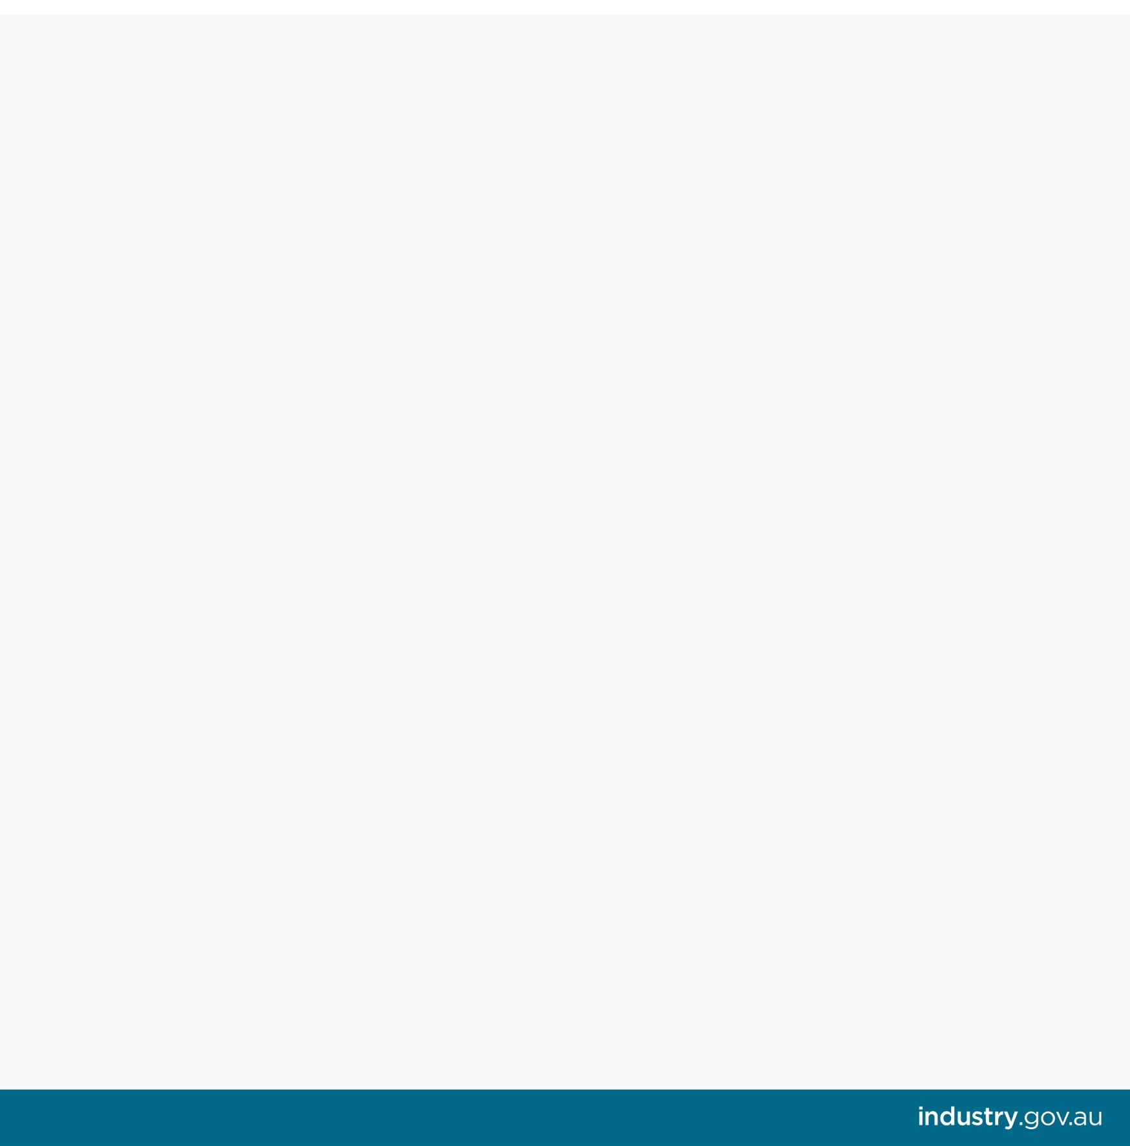
Offshore Petroleum

Safety Review

Consultation Plan

Department of Industry, Innovation and Science

December 2018
https://www.industry.gov.au/news-media/offshore-petroleum-safety-regime-review

Contents
Introduction 3
What will be delivered 3
Consultation Plan 3
Offshore Safety Review Workshops 5
Safety Stakeholder Group (SSG) 5
Targeted Meetings 6
Online surveys 6
Public Consultation 6
How to stay updated 7

Introduction
The Department of Industry, Innovation and Science has commenced a review of the occupational health and safety (OHS) regime for offshore petroleum workers in Australian waters.
This review will ensure that the regime provides an effective framework for securing the health and safety of persons engaged in offshore petroleum operations, and represents leading practice that promotes and delivers safe activities. In line with good policy development, the review will be driven by an analysis of available options, be evidence-based and engage with all affected stakeholders.
The department is committed to ensuring that everyone involved in or affected by the offshore safety regime has an opportunity to participate in the Offshore Petroleum Safety Review.

What will be delivered
As part of the review process, a Discussion Paper and a Policy Framework will be published by the department for public consultation.
A Discussion Paper provides an overview of the current state of play, identifies known key issues and challenges, and invites stakeholders to consider their experience and provide views supported by evidence where possible. A Discussion Paper does not propose solutions or options. Instead, views and evidence provided by stakeholders inform the development of options for areas of improvement that feed into the Policy Framework.
A Policy Framework outlines the proposed policy position of the Government and identifies areas for improvement, where relevant. The Policy Framework describes the policy intent of these areas for improvement and how they might be addressed through regulatory amendment if appropriate. The document is prepared after consideration of a variety of information sources, including submissions on the Discussion Paper and feedback from stakeholder meetings, and evidence-based data and analysis.
After analysing public comments and finalising the Policy Framework, Ministerial policy approval will be sought. Once this is granted, government processes will be undertaken by the department to ensure the policy is reflected and enacted in legislation and regulations.

Consultation Plan
This Consultation Plan outlines how the department will consult with stakeholders throughout the review process. This document outlines the consultation methods to be used in the review, and the points in the process when consultation will take place. Consultation opportunities are described in greater detail later in this document and are outlined in the diagrams below.

Offshore Petroleum Safety Review – Consultation timeline

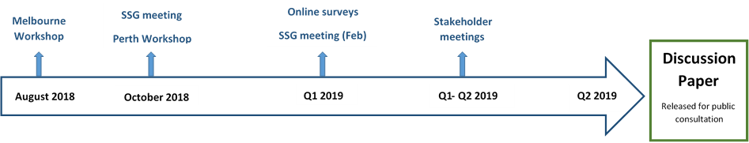

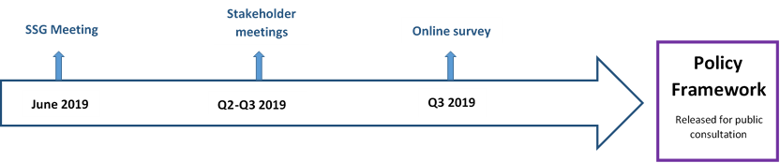

Offshore Safety Review Workshops
Offshore Safety Review workshops were held in Melbourne on 13 August 2018 and in Perth on 22 October 2018 early in the review process, to identify issues and concerns stakeholders have with the current safety regime. Both workshops were well attended by a variety of stakeholders and the workshop reports are published on the department’s website.

Safety Stakeholder Group (SSG)
The Safety Stakeholder Group (SSG) is an important consultation avenue that allows key stakeholders with significant interest in offshore petroleum safety to be involved in the offshore safety review process.
The SSG is consultative group that allows ideas and issues to be tested and discussed through information sharing and constructive engagement. The SSG is not a decision making body.
SSG members have been nominated by their member organisation and some represent their wider stakeholder group or affiliated members. SSG members commit to keeping their own employees/members/workgroup informed, where appropriate, of the review’s progress, including deadlines for submissions and opportunities for engagement in public consultation processes. They also provide advice and assistance to the department in contacting the people they represent.
SSG meetings are held approximately every two months, with meeting notes published on the department’s website and emailed to interested stakeholders. The first SSG meeting was held in October 2018.
SSG Member | Representing
Commonwealth Department of Industry, Innovation and Science | Commonwealth (Regulatory oversight for OHS of offshore petroleum activities)
Commonwealth Department of Jobs and Small Business | Commonwealth (Regulatory oversight for national WHS)
Australian Maritime and Safety Authority (AMSA) | Regulator (Maritime safety)
National Offshore Petroleum Safety and Environmental Management Authority (NOPSEMA) | Regulator (Offshore Petroleum)
Work Safe Victoria | Victorian Government
New South Wales Resources Regulator | New South Wales Government
Western Australian Department of Mines, Industry Regulation and Safety | Western Australian Government
Australian Petroleum Production & Exploration Association (APPEA) | Australia’s oil and gas exploration and production industry
Quadrant Energy (Santos) | Australia’s offshore oil and gas operators
Australian Council of Trade Unions (ACTU) | Offshore workers – union members, all offshore workers
Health and Safety Representative (HSR) | HSRs, offshore workers
International Association of Drilling Contractors (IADC) | IADC members, third-party contractors

Targeted Meetings
Targeted meetings will be held to complement the SSG and public consultation periods. These meetings will include:
- Meetings with people from the same stakeholder representative type to discuss issues directly relevant to their group.
- Meetings to discuss specific topics with a range of stakeholders that have a direct interest in that particular topic.
In 2019, targeted meetings will be held on an as-needed basis to assist with the development and finalisation of the Discussion Paper and subsequent Policy Framework.
These meetings will be confidential, unless otherwise stated or agreed, to encourage stakeholders to share their views and concerns with the department.

Online surveys
We will use online surveys as part of the consultation process, as an efficient and effective way to engage with stakeholders, in particular the offshore workforce, who may not be able to attend other consultation opportunities in person.
Hearing offshore workers’ views on offshore safety, and learning from their real-life experiences working within the regime is critical to the review. However, we recognise that time pressures and the remote nature of working offshore means that some stakeholders have limited availability and ability to engage in face-to-face or virtual meetings with the department.
Online surveys will be used to provide offshore workers with a less intrusive and time-consuming method of engagement. Workers will be able complete anonymous surveys, vote in polls and provide comments. The department will work with oil and gas operators, third-party contractors and unions to facilitate the involvement of the offshore workforce in these online mechanisms.

Public Consultation
There will be two formal public consultation rounds as part of the Review. During each public consultation period, a document will be published by the department, seeking feedback from stakeholders on the issues presented in the document through written submission. Public consultation periods generally run for 4-6 weeks.
The first public consultation period will be held in the second quarter of 2019 to seek views on the Discussion Paper. Stakeholders will be asked to provide written submissions on the Discussion Paper, and comments and evidence provided will inform the development of the policy recommendations.
Following analysis of the written submissions and discussions with stakeholders through targeted meetings, the department will prepare a Policy Framework.
The second public consultation period will be held in the third quarter of 2019 to seek views on the proposed Policy Framework.

How to stay updated
The department wants to ensure all interested people and organisations are aware of the review, regularly receive information and progress updates, and know how and when to be involved in the consultation process.
As an offshore safety stakeholder you can:
- Indicate your particular interest in a topic and advise the department that you wish to be further engaged where appropriate.
- Provide the department with your email address to receive information on the review, meetings notes from Safety Stakeholder Group meetings and updates on upcoming ways to be involved.
- Contact your Safety Stakeholder Group representative member or organisation to discuss any offshore safety related issue relevant to the review. The department will provide contact names and details for any representative on request.
- Subscribe to Australian Petroleum News, a departmental newsletter covering offshore oil and gas matters, including offshore safety. Subscribe at https://www.industry.gov.au/subscribe-to-australian-petroleum-news
- Follow the department on Twitter (@ResourcesGovAu).
- Visit the department’s website to access key documents, SSG meeting notes and consultation papers.
- Contact the department with your query on any of the above methods of involvement or another matter relating to the Offshore Safety Review by emailing us at: Offshore.Regulations@industry.gov.au.

Offshore Petroleum Safety Review – Summary table of consultation mechanisms

Consultation Mechanism | Audience | Timing | Promotion
Workshops | All offshore safety stakeholders | August & October 2018 | Email, APN, website, twitter
Safety Stakeholder Group | Key stakeholder groups | Meetings every two months | Meeting notes published on website and emailed to interested stakeholders, SSG members
Targeted Meetings | Key stakeholder groups | Q1-Q4 2019 | SSG members, emails, word-of-mouth,
Online Surveys | Workforce, contractors | As needed, 2019 | Email, word-of-mouth, SSG, stakeholder groups, emails, APN, twitter
Public consultations | All offshore safety stakeholders | Q2-4 2019 | Email, word-of-mouth, website, SSG, targeted meetings, APN, twitter, department’s Consultation Hub
Dissemination of information | All offshore safety stakeholders | Throughout Review | APN, email, website updates, twitter  SSG to their members/communities

