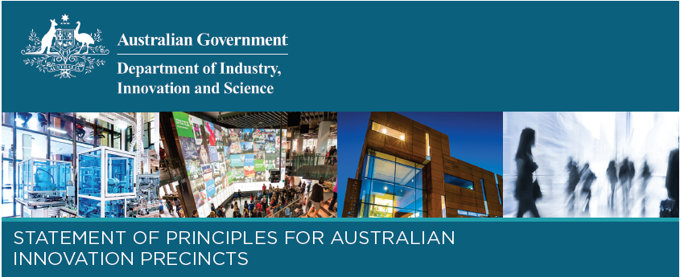

# Interview with Philipp Dautel, Precinct Director, Tonsley Innovation District

Tonsley Innovation District brings together leading research and education institutions, established businesses, such as Tesla, SAGE Automation and Siemens, as well as start-ups and business incubators and accelerators. Located 10 km from the Adelaide CBD, it is connected by rail, bus and the GigCity network, which provides internet speeds of up to 100 times the national average. The Tonsley project has made significant progress since construction commenced in 2012. This issue, we spoke with Precinct Director Philipp Dautel to gain some insights on this success.

***Australian Innovation Precinct Champions:***Tonsley Innovation District has recently been covered in the [New York Times](https://www.nytimes.com/2018/04/09/world/australia/adelaide-tech-innovation.html), hosted global leaders like Dr Alan Finkel and attracted investment from Siemens. What has been the secret behind the success of Tonsley?

### Philipp Dautel, Precinct Director, Tonsley Innovation District:

I’d say ‘continuity’ and ‘ingenuity’ would best describe the secret behind the success of Tonsley.

It is 10 years since the car manufacturing plant shut down and a bit over 6 years since the project effectively started. The ambition to redevelop an old car plant 10km south of Adelaide and to create the knowledge economy and the jobs of the future as well as building a residential community needs time. It requires a strong vision that is shared, understood and committed across all stakeholders over the many years to date and the years to come.

Speaking of the vision itself, the different approach to set the vision was a key contributor to the success today. Let me further explain that.

Knowing that South Australia’s economy faced challenges and needed to change – necessity being the mother of invention – gave the project the imperative to be bold and innovative in how to address this opportunity. It was the next evolution of the old industrial districts or science parks.

The process of master planning began in 2010, long before there was such a term as Innovation District, coined by Brookings Institution research in 2014.  That said, the planning was being influenced by the global megatrends that were giving rise to the kinds of outcomes that Brookings would go on to articulate in its research paper “the Rise of Innovation Districts”.

Things like the increasing growth of the innovation economy; increased preference for co-location and collaboration with research institutions and other businesses, both large established firms and small innovative start-ups; the value of open innovation models of business development; the desire for being in locations that have high physical amenity and are shaped by place making strategies that have a focus on building social capital that facilitates knowledge spill-over; and infrastructure that supports physical and virtual connectivity.

So, in summary, the foundations of Tonsley’s success as we see it today were laid several years ago, through defining a new approach to urban renewal and economic development. This vision has been protected in times where Tonsley has been questioned, like most projects do during their development phase. The white elephant learned to walk and has grown in size significantly. Well, it’s not white anymore either but somehow appealing enough to attract interest and investment from around the world and to have become a benchmark for many redevelopments of a similar kind globally. But the elephant needs to be fed and groomed; a dedicated project team and most parts of the South Australian Government work collectively and very hard to ensure the success continues.

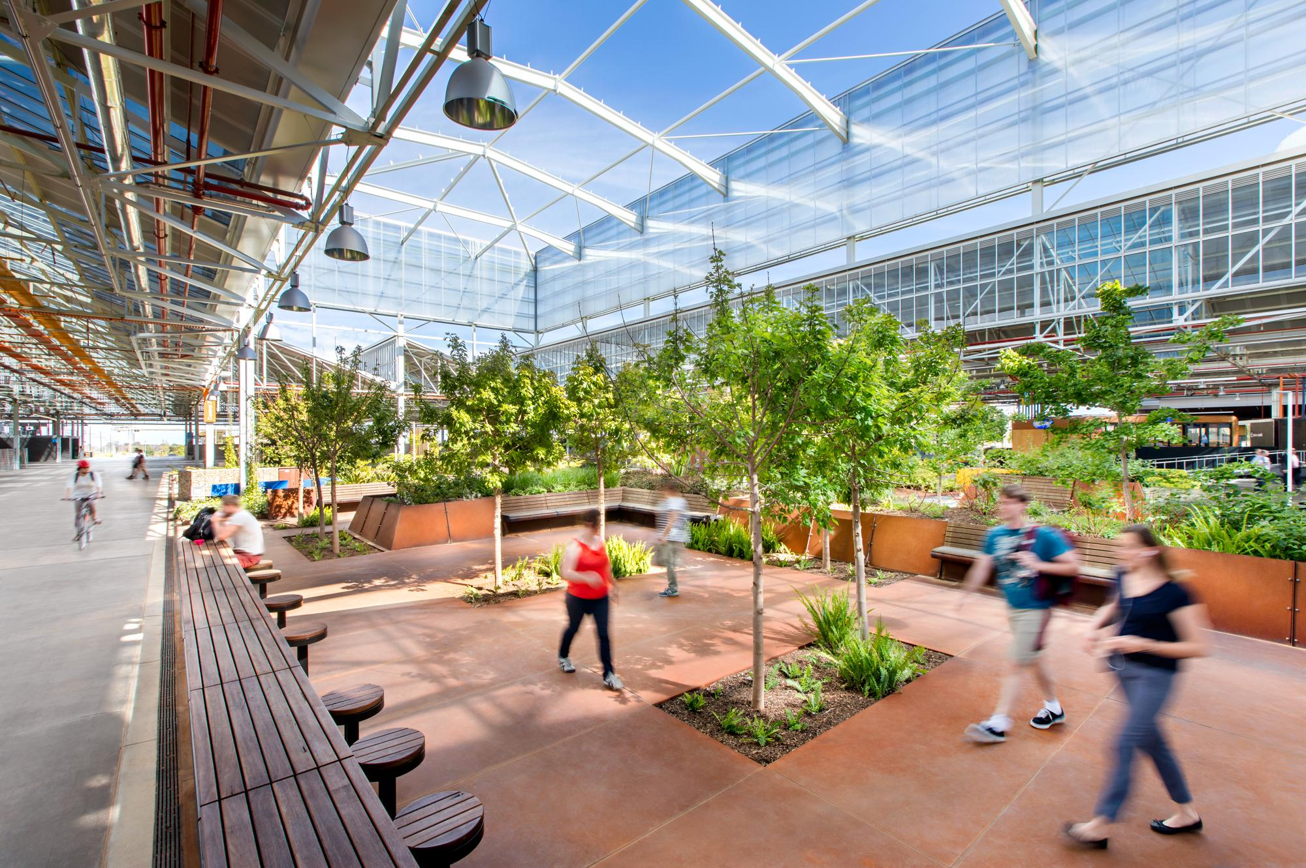

***Australian Innovation Precinct Champions:***Tonsley Innovation District has specific entry criteria to ensure businesses and organisations align with the strategic vision of the precinct and are able to build synergies. How have you managed this challenge?

### Philipp Dautel, Precinct Director, Tonsley Innovation District:

You are referring to Tonsley’s suitability criteria. Encouraging business to business collaboration through clustering activity from businesses with a shared industry focus in fields where South Australia has a comparative advantage is critical to Tonsley’s vision. In order to maximise the site’s synergies and collaboration potential we introduced a suitability assessment so that the Tonsley business community remains aligned with the precinct’s overall vision and strategic objectives.

Let me put the challenge out there first. The instances where we have had to turn down applicants we take very seriously.  It is important to be diligent and consistent in how we apply the suitability assessment.  Surprisingly however, most interest in Tonsley has been self-selecting.  Tonsley has a clear value proposition to progressive companies interested in collaborating and open innovation models and being in this kind of environment. Companies who do not buy into the vision and don’t see benefit in Tonsley’s value proposition find other, often cheaper land and office spaces elsewhere.

The reason we are so particular with this is because Tonsley is based on the related-variety concept, where greatest opportunity for innovation is between businesses where there is enough common ground to start a relationship, but there is enough differentiation to have points of difference that allow productive knowledge spill-over and rich opportunities for innovation.  Note that there are some exceptions to the suitability criteria where we think that a particular use will contribute to the overall greater good of the site such as childcare facilities, short-term accommodation or retail outlets.

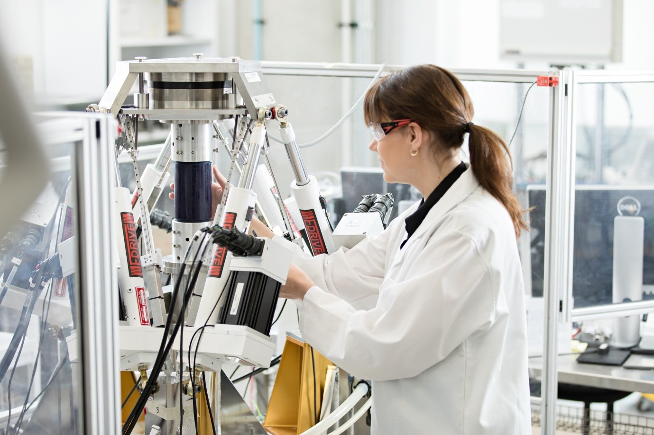

***Australian Innovation Precinct Champions:***How do you facilitate networks between organisations in the precinct? Does it occur organically or do you intervene through events?

### Philipp Dautel, Precinct Director, Tonsley Innovation District:

Both of the above and beyond. Firstly, there are no canteens in the University, TAFE or other business buildings. People need to come to the café areas in Tonsley’s Main Assembly Building (MAB) to have coffee and buy lunch. Bumping into the same person several times or queuing for the sushi roll breaks the ice, new links are formed and you have lunch together in the Central Forest. That’s why we refer to Tonsley’s characteristic MAB as the ‘collision space’.

Secondly, we actively facilitate those networks through a range of activities. Tonsley Connections, occurs bi-monthly, and is the community’s regular “after work drinks” get-together. Also, there are fitness and yoga classes or the Squash Corporate Cup competition - activities that bring you together while exercising. In addition to that, the development of a microbrewery on site will provide opportunities for building social capital and supports “organic” networking once people get to know each other.

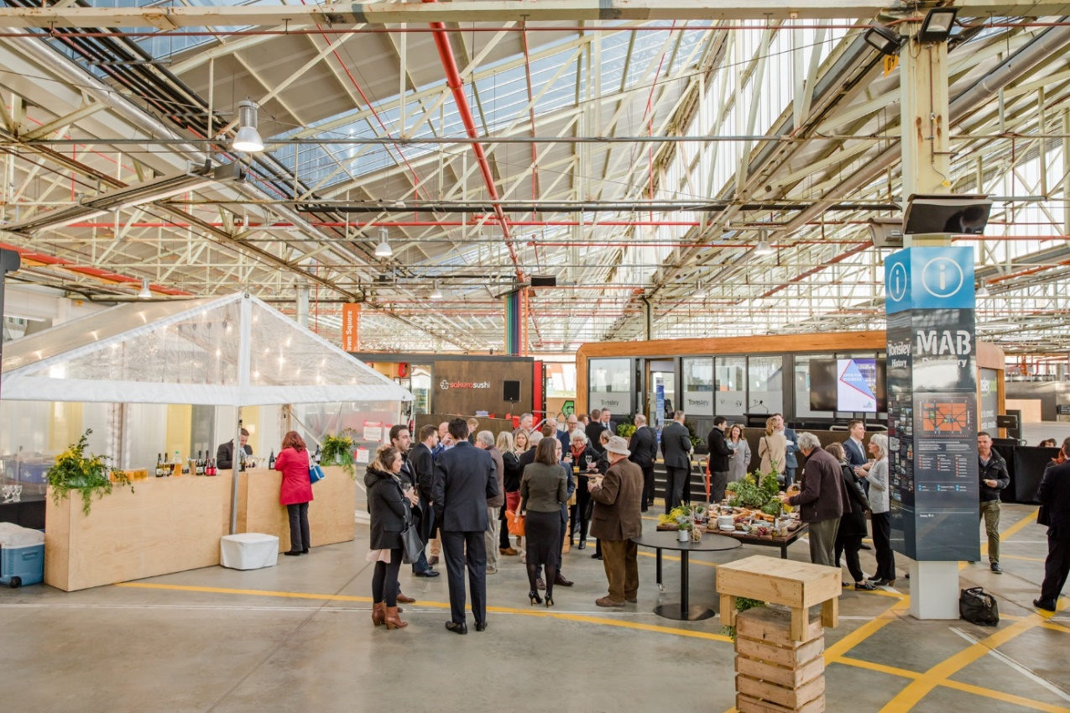

Thirdly, we drive formal facilitation, bringing a wide variety of industry relevant visitors to Tonsley, including international Ambassadors and other diplomats and groups like the Association of Superannuation Funds of Australia, or the Alibaba Investment Fund, who are looking for the next unicorn.

Lastly, Tonsley hosts a large number of events or projects like Science Alive and Maker Faire which get the broader community involved in Tonsley as well. At the moment, a Solar‑powered EV-garage is being built involving around five members of the precinct while key clean-tech businesses on site are forming a future energy consortium to leverage off each other.

***Australian Innovation Precinct Champions:***What lessons if any has Tonsley learned from national and international approaches to precinct development? As a South Australian Government led initiative, how have the strategic objectives of Tonsley aligned with Local and Federal government strategies and initiatives?

### Philipp Dautel, Precinct Director, Tonsley Innovation District:

To answer your first question in simple words, we have learned that precinct development is more than just property development a-la the old Science Park model. The networking assets and economic assets need to be curated and facilitated, for example, with dedicated resourcing.

To answer your second question, the Government of South Australia’s vision for Tonsley is very closely aligned with the Australian Federal Government’s National Innovation and Science Agenda to “embrace new ideas in innovation to drive economic growth” as well as its Smart Cities Plan for “supporting productive, accessible, liveable cities that attract talent, encourage innovation and create jobs and growth”.

The Federal Government has also committed $85.5 million in funding for the extension of the Tonsley rail line that runs from the Adelaide Railway Station in Adelaide’s CBD and terminates at the southwestern corner of the Tonsley site. Under this “Flinders Link” project, the existing Tonsley rail line, will be extended to Flinders Medical Centre, a 580 bed public teaching hospital and medical school, co-located with the 130 bed Flinders Private Hospital and Flinders University.

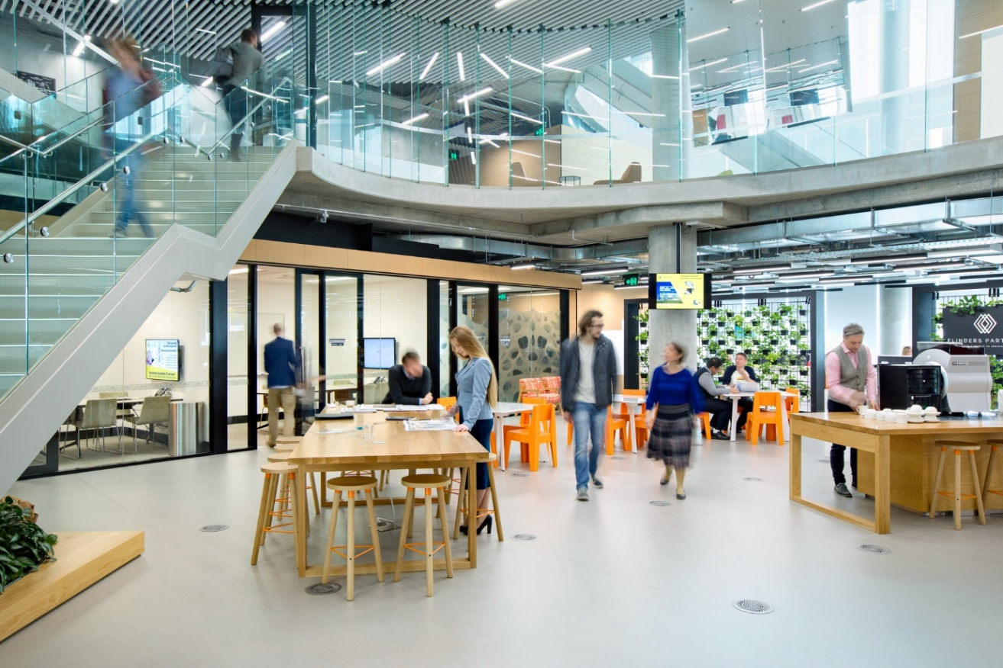

***Australian Innovation Precinct Champions:***How is success measured in the precinct, do you collect your own primary data from organisations or use a combination of other sources? What kind of data do you collect?

### Philipp Dautel, Precinct Director, Tonsley Innovation District:

It sounds very loose but the primary measure is the level of satisfaction of the members of the precinct. Everything we do, has to be linked back to them. Creating a vibrant and effective work, education and living space is what matters. The sense of community. This is our primary purpose. The Tonsley team invests a lot of time speaking to the individual tenants as a way of collecting that data.

To answer it more technically, we measure and track targets as agreed in a Cabinet submission to the State Government in 2012. From that point of view, success is measured in people and property - workers, residents, students, space leased, land sold, etc.

Additionally, we measure the impact. What impact did we make to the Tonsley brand and what impact did the Tonsley brand make to the businesses and individual tenants. For instance, we measure the number of trade missions and delegations that visit the site but equally try to understand how it benefitted the organisations such as access to new geographical markets or sectors.

Members of the precinct (business and research) also have a strong track-record of attracting Government grants. We measure this too to really shape and articulate our value proposition to drive investment attraction based on evidence.

***Australian Innovation Precinct Champions:***What is next on the agenda? Where do you see Tonsley 10 years from now?

### Philipp Dautel, Precinct Director, Tonsley Innovation District:

In 10 years’ time, the vision has become reality. Approximately 6,500 people work on site in addition to 8,500 students and 1,200 residents. The vibrant and globally-connected precinct is safeguarded by an established sustainable precinct governance model that is funded and provides for the non-physical aspects of the innovation district model. Tonsley will continue its mission to bring the future into the present for the community to experience. Today, we have autonomous vehicle trials on site, soon, the first hydrogen production facility of its kind in Australia through AGIG, Australian Gas Infrastructure Group.

Lastly, my aspiration for Tonsley is to be globally recognised and trusted for the benefit of the tenants. We already see early stage businesses highlighting the fact that they are based at Tonsley. A business operating “out of Tonsley” as a form of credibility.

***Australian Innovation Precinct Champions:***Thanks for your time.

### Philipp Dautel, Precinct Director, Tonsley Innovation District:

Pleasure – thank you for your interest. May I finish off by inviting the readers to reach out to the Tonsley team to learn more about the precinct or to participate in any form or shape.