OFFSHORE MINERALS ACT 1994

GUIDELINE FOR APPLICANTS   
Applications for Exploration Licences   
Covering Standard Blocks

# Acknowledgements

The following information has been compiled to assist applicants wishing to apply for offshore mineral exploration licences, and to provide a broad outline of the rights and obligations involved.

This document covers offshore mineral exploration licences, which are applicable in Commonwealth territorial waters adjacent to all states and the Northern Territory jurisdictions. Where there is a reference to a "State", a "State Minister" or a "state department/agency" this should be taken to include the Northern Territory.

This information should be read in conjunction with the *Offshore Minerals Act 1994* (the Act); in particular sections 50 to 72 which deal with applications for, and the potential granting of, exploration licences over standard blocks.

For convenience, where a section of the Act is referenced, a hyperlink has been created. These links redirect to the relevant section of the Act online at [www.comlaw.gov.au](http://www.comlaw.gov.au/). An internet connection is required for hyperlinks to function correctly. The *Offshore Minerals Act 1994* is accessible at [Comlaw.gov.au](http://Comlaw.gov.au) online [here](http://www.comlaw.gov.au/ComLaw/Legislation/ActCompilation1.nsf/all/search/6272CB08CD062A47CA256F71004F12BD).

## Obligations

This document has been developed as a guide only. It does not replace or amend information provided in the Offshore Minerals Legislation and associated Regulations and Guidelines. It is strongly advised that applicants read the relevant sections of the Acts and Regulations and seek independent legal advice as appropriate.

There are a number of obligations which exploration licence holders must observe and are specified in the Acts and the Regulations. All licence holders must be familiar with these obligations which include:

* work program and associated expenditure;
* data lodgement and reporting requirements;
* diving safety requirements;
* operational safety requirements;
* licences fees;
* securities;
* good working practice;
* operations can be inspected at reasonable time;
* no interference with navigation and fishing rights; and
* environmental protection and rehabilitation requirements.

Prepared by:

Exploration Section

Offshore Resources Branch

July 2010

**Contents**

Acknowledgements 2

General Information – Offshore Minerals 5

Introduction 5

Licences under the Offshore Minerals Act 1994 7

Coverage 7

Exploration licences – 4 years 7

Retention licences – maximum 5 years 7

Mining licences – maximum 21 years 7

Works licences – maximum 5 years 7

Special purpose consents – maximum 1 year 7

Offshore Minerals Exploration Licence 8

Application Area 8

Area not available for an application 8

What needs to be included in an exploration licence application 9

1. An approved application form 9

2. Technical Assessment of mineral potential of area 9

3. Details of proposed work program 9

4. Evidence of the applicant’s ability to comply 9

5. Map of application area 9

6. Company details 9

7. Other details 9

Offshore Mineral Exploration Licence application process chart 10

Lodging an exploration licence application 12

Application Fee 12

Priority of Applications 12

What is the process after the application is lodged? 13

Consultation 13

Assessment 13

Joint Authority Decision 13

Provisional Grant or Refusal of application 14

Provisional Grant 14

Conditions 14

Licence specific conditions 14

Securities 14

Negotiation of securities and licence conditions 15

Fully effective exploration licence 16

Renewal of exploration licence 16

Designated Authority Details 17

Attachment A 19

Example of Block numbering - Block 622 19

Attachment B 20

Example of approved application form 20

Attachment C 22

Work Program and Other Application Requirements 22

Introduction 22

Attachment D 24

Example of approved national advertisement 24

Attachment E 25

Schedule of Standard Conditions 25

# General Information – Offshore Minerals

## Introduction

The term ‘offshore mining’ relates to the exploration for, and mining of, minerals (other than petroleum) offshore; that is, beyond the coastal baseline, in the sea and the seabed.

Under the 1979 Offshore Constitutional Settlement, the Commonwealth and the States agreed that there would be a common mining code to apply from the territorial sea baseline (generally the low water mark) out to the edge of Australia's continental shelf. It was also agreed that this common mining code would be governed by complementary Commonwealth and State offshore minerals legislation.

The *Offshore Minerals Act 1994* (the Act) establishes a regulatory regime for the exploration (and potential production) of minerals in Commonwealth waters that adheres to the principals of the 1979 Offshore Constitutional Settlement.

Under the Act, exploration and recovery of resources found within the coastal waters of a State (that is, the first three nautical miles of the Australian territorial sea beyond the low water mark) are administered by the State. Responsibility for minerals operations in Australia’s offshore areas beyond three nautical miles (5.6 km) from the coastal baseline rests with the Australian Federal Government and is governed by the Commonwealth (Figure 1).

|  |  |
| --- | --- |
| *.* | Diagram of commonwealth and state offshore borders |

**Figure 1 - The boundary of State offshore jurisdiction**

The Act establishes two authorities to regulate and administer the industry: the Joint Authority and the Designated Authority (Figure 2). The Joint Authority comprises of the responsible Commonwealth Minister and the responsible State Minister (generally the Resources Ministers) ([section 32](http://www.comlaw.gov.au/ComLaw/Legislation/ActCompilation1.nsf/bodylodgmentattachments/CC3C5F6E7A420CD1CA256F71004F138D?OpenDocument#SECT32)). The functions of the Joint Authority include key decisions such as granting (or refusing) of titles, renewal and cancellation of titles. The Joint Authority cannot delegate powers to respective Commonwealth and state departments.

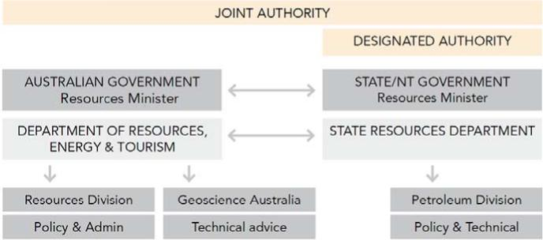

**Figure 2 - The Relationship between the Joint Authority and Designated Authority**

The Designated Authority comprises of the relevant State Minister, who is responsible for the day-to-day administration of the Act for, and on behalf of, the Commonwealth. The Designated Authority may delegate any, or all, of its functions and powers to the responsible state department ([section 419](http://www.comlaw.gov.au/ComLaw/Legislation/ActCompilation1.nsf/bodylodgmentattachments/CC3C5F6E7A420CD1CA256F71004F138D?OpenDocument#SECT419)).

The functions of the Designated Authority includes:

* receiving reports and applications
* advising title holders of determinations made under the Act
* collecting fees.

Under the Act, the Designated Authority is the first, and ongoing, point of contact with all applicants - the Joint Authority acts through the Designated Authority and the Joint Authority’s decisions are carried out by the Designated Authority.

# Licences under the Offshore Minerals Act 1994

## Coverage

The Act establishes five different authorisations to govern specific offshore mineral exploration and production activities.

### Exploration licences – 4 years

An exploration licence is designed to cover the exploration phase of a project and confers exclusive rights to the exploration for and recovery of mineral samples from the licence area and can be renewed on application.

### Retention licences – maximum 5 years

A retention licence is an intermediate form of tenure, between the exploration licence and the mining licence. It is designed to ensure the retention of rights pending the transition of a project from the exploration phase to the commercial mining phase. Its primary purpose is to allow the holder of an exploration licence to retain, for a strictly limited time, title to an area on which a significant mineral deposit has been delineated but is not commercially viable in the short term, but there is reasonable prospect for development in the longer term.

### Mining licences – maximum 21 years

A mining licence is designed to cover the commercial mining phase of a project and authorises the exploration for and full recovery of minerals from the licence area.

### Works licences – maximum 5 years

A works licence authorises operations associated with an exploration, a retention or a mining licence to be carried outside the area of the principal licence. The works licence can be issued for up to a maximum of 5 years and can be renewed on application.

### Special purpose consents – maximum 1 year

A special purpose consent authorises the holder to carry out either scientific investigations, a reconnaissance survey or collect a small amount of minerals. The reconnaissance surveys are intended to cover broad scale, short term surveys that companies may undertake to decide whether to apply for an exploration licence. The consent is different from the other licences in that it does not give the holder any exclusive rights over the area covered, nor does it give any preference when it comes to the grant of other licences for the same area.

**Table 1 - Authorisations under the Act**

# Offshore Minerals Exploration Licence

An exploration licence is designed to cover the exploration phase of a project and confers exclusive rights to explore and recover mineral samples from the licence area. The specific exploration activities are defined by the conditions of the licence

A licence is valid for four years and a licence holder may apply (at least 30 days prior to the end of the licence) to have the licence renewed. The licence holder is required to relinquish up to 50% of the area in the licence at the time of each renewal. The grant of an exploration licence does not confer on the licence holder an automatic right to a mining or retention licence. An exploration licence holder must apply for a mining or retention licence which will be considered on its merits as a separate application.

Relevant section of the Act: [Section 46](http://www.comlaw.gov.au/ComLaw/Legislation/ActCompilation1.nsf/bodylodgmentattachments/CC3C5F6E7A420CD1CA256F71004F138D?OpenDocument#SECT46)

## Application Area

Offshore areas are divided by a grid that is bounded by one minute of latitude and one minute of longitude on the *Geocentric Datum of Australia* (GDA 94), as shown on the National Topographic Map Series. Each resulting block has its own unique number (ATTACHMENT A demonstrates an example of the block numbering system). The area of one block is approximately 3.39 square km at 10 degrees south, to 2.64 square km at 40 degrees south.

The maximum area allowed under an exploration licence is **500** blocks and the minimum area is **one** block.

Where an application is for more than one block the shape of the licence area must form a single discrete area where each block has at least one side in common with that of another block in the group ([section 50 (3)(a)](http://www.comlaw.gov.au/ComLaw/Legislation/ActCompilation1.nsf/bodylodgmentattachments/CC3C5F6E7A420CD1CA256F71004F138D?OpenDocument#SECT50)) (see Figure 3 below);



**Figure 3 - Applications must form discrete areas**

Applications that form odd shapes for no apparent reason (such as doughnut shaped) will be closely scrutinised and discussions entered into with the applicant about the reason for the shape of the area.

Relevant section of the Act: [Section 17](http://www.comlaw.gov.au/ComLaw/Legislation/ActCompilation1.nsf/bodylodgmentattachments/CC3C5F6E7A420CD1CA256F71004F138D?OpenDocument#SECT17)

## Area not available for an application

An exploration licence is not normally granted over an area that is:

* outside of Commonwealth jurisdiction (in state waters or outside of Australia’s continental shelf);
* already covered by another offshore minerals exploration licence; or
* reserved or excluded (including Marine Parks and areas excluded under the Act).

The Act outlines a number of situations in which blocks are excluded from an exploration licence application. An application that is found to contain excluded blocks will be discussed with the applicant and may still be considered on the basis of the remaining blocks. An applicant may apply to the Designated Authority for a determination to included an otherwise excluded block in an application.

Relevant section of the Act: [Section 51](http://www.comlaw.gov.au/ComLaw/Legislation/ActCompilation1.nsf/bodylodgmentattachments/CC3C5F6E7A420CD1CA256F71004F138D?OpenDocument#SECT51)

## What needs to be included in an exploration licence application

An application for an exploration licence must include the following:

### An approved application form

Applications for exploration licences use standard State approved covering forms.

These forms can vary between jurisdictions but typically contain information such as the name of the applicant, block numbers, application number and fees. An example of a typical approved application form is at ATTACHMENT B.

### Technical Assessment of mineral potential of area

Applications should provide written evidence on the technical data or information the application is based on. It is expected that the applicant demonstrates a preliminary understanding of the potential resource in the area. The exploration strategy and work program should be consistent with the applicant’s technical assessment of the area. Further details on technical assessment is at ATTACHMENT C.

### Details of proposed work program

All exploration licences include, as part of their conditions, an agreed work program and expenditure requirements, which must be complied with during the term of the licence. The work program is divided into a primary term and a secondary term.

The primary term consists of year 1 and year 2 and is the minimum guaranteed work program that is to be undertaken by the applicant. The secondary term consists of year 3 and year 4. This term can be negotiated on technical grounds prior to entering year 3 or year 4. Failure to meet work program commitments may result in the cancellation of the licence. Applications must therefore include:

* details of the proposed primary and secondary work programs, including geoscientific surveys and other operations;
* proposed yearly expenditure in Australian Dollars;

Further details on work program and expenditure requirements is at ATTACHMENT C.

### Evidence of the applicant’s ability to comply

The application must also provide written evidence of the applicant's ability to comply with all of the requirements;

* financially - to meet licence conditions and work program commitments of the licence; and
* technically - qualifications of the applicant and any technical advisers.

### Map of application area

The application must include a clear map showing the location and boundaries of the area applied for, at a scale of 1:100,000. Maps must be provided in hard copy attached to the application and, where possible, electronically.

### Company details

If the exploration licence is to be held by more than one company, the percentage share of each company should be stated. If a corporate body is applying for an exploration licence it should submit a copy of the company's last annual report with the application.

### Other details

The application should include any other information the applicant wishes to be taken into account in consideration of the application.

# Offshore Mineral Exploration Licence application process chart

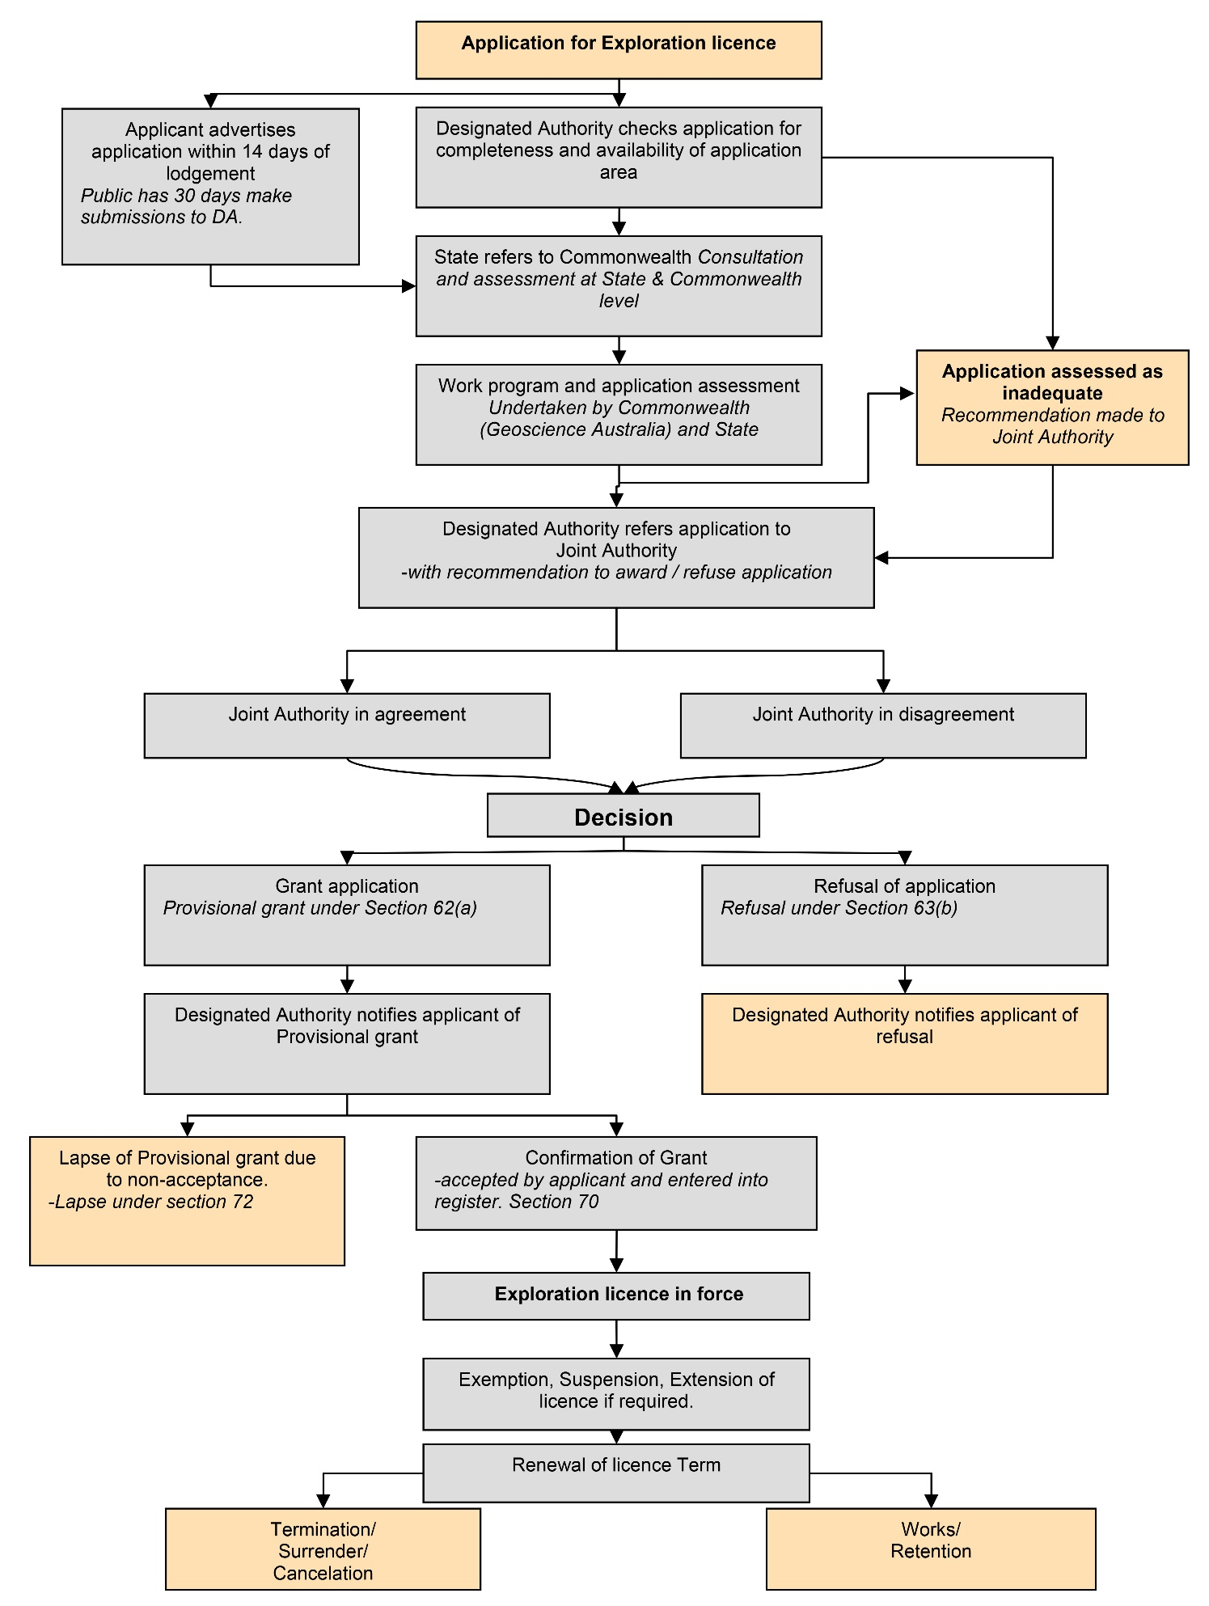

Applications for Exploration licences follow these steps:

1. Applicant advertises application within 14 days of lodgement. Public has 30 days make submissions to Designated Authority.
2. Designated Authority checks application for completeness and availability of application area. (If the application assessed as inadequate recommendation made to Joint Authority.)
3. State refers to Commonwealth. Consultation and assessment at State & Commonwealth level.
4. Work program and application assessment. Undertaken by Commonwealth (Geoscience Australia) and State.
5. Designated Authority refers application to Joint Authority with recommendation to award / refuse application.
6. Joint Authority in agreement or disagreement. Make decision.
7. If approved grant application. Provisional grant under Section 62(a). Designated Authority notifies applicant of Provisional grant. (If not approved, refuse application. Refusal under Section 63(b). Designated Authority notifies applicant of refusal.)
8. Confirmation of provisional grant accepted by applicant and entered into register. Section 70. (If not accepted, lapse of Provisional grant due to non-acceptance. Lapse under section 72.)
9. Exploration licence in force.
10. Exemption, Suspension, Extension of licence if required.
11. Renewal of licence Term.
12. Works/ Retention. (Or Termination/ Surrender/ Cancelation.

# Lodging an exploration licence application

All applications must be lodged at the head office of the relevant state department in the relevant capital city.

At least two copies of the application is required. If there is large amounts of detailed information applicants should also consider electronic copies of the application on CD/DVD.

Applications may be lodged in two ways:

* by mail; or
* by hand over the counter,

Information on where to lodge applications can be found in the sectionDesignated Authority Details.

## **Advertisements**

An applicant must advertise the details of the application in a major newspaper that circulates in the relevant State/NT within fourteen days (14) of lodging the application. The advertisement must include the salient details of the application (see ATTACHMENT A) and request that any comments be forwarded to the relevant state department in the relevant city within 30 days. An example of an approved advertisement is at ATTACHMENT D. Applicants may request an extension of the 14 day advertisement period by writing to the Designated Authority.

Any person or non-government organisation may comment on an application for an exploration licence. All comments on an application will be taken into account when an application is being considered by the Joint Authority.

Relevant section of the Act: [section 57](http://www.comlaw.gov.au/ComLaw/Legislation/ActCompilation1.nsf/bodylodgmentattachments/CC3C5F6E7A420CD1CA256F71004F138D?OpenDocument#SECT57)

## Application Fee

Each application must be accompanied by a fee payable to the *“Commonwealth of Australia*” through bank cheque or other electronic means as approved by the relevant Designated Authority. The amount of the fee is prescribed in the regulations under the Act, and is currently $A3,000[1]. Applicants should confirm the prescribed fee with the relevant Designated Authority.

## Priority of Applications

Priority of applications will be on the basis of "first received, first considered". If two or more applications are received for the same area at different times they will be dealt with in order of receipt by the State/NT Department.

Applications for the same area, which are received on the same day and within a half-hour time frame, will be considered to have been received at the same time. Priority as to which shall be considered first will be determined by ballot as established in the *Offshore Minerals (Ballot procedures) Regulations 1994*.

# **What is the process after the application is lodged?**

Once an application has been formally lodged, the Designated Authority will conduct a preliminary assessment of the application to ensure that all relevant information and data is included.

The Designated Authority may request further information in addition to what has already been provided by the applicant. If the applicant refuses, or fails to provide such additional information within the prescribed timeframe, the application may be refused. [Section 62](http://www.comlaw.gov.au/ComLaw/Legislation/ActCompilation1.nsf/bodylodgmentattachments/CC3C5F6E7A420CD1CA256F71004F138D?OpenDocument#SECT62)

## Consultation

The State and the Commonwealth departments both undertake consultation with agencies that may have an interest in the offshore area applied for. To facilitate inter-agency consultation general details of the application are forwarded to relevant agencies for their consideration.

Federal and State agencies consulted with include, (but are not limited to):

* Department of Defence . To ensure that the area covered by the application is not the subject of Defence operations (including defence practice areas and military restricted airspace).
* Maritime Authorities. To obtain comments, if any, on particular navigation hazards, shipping routes or requirements which may be specific to the area concerned.
* Department of Broadband, Communication and the Digital Economy. To ensure that the proposed operations will not interfere with submarine cables. (On behalf of Australian Communication and Media Authority)
* Department of Environment, Water, Heritage and the Arts and State/NT environment protection agencies. To give the Commonwealth environmental authorities the opportunity to comment on the environmental concerns and potential conditions that should be observed which are specific to the area.
* Australian Fisheries Management Authority and state fisheries. To obtain information on whether there are any supervised fisheries in the area and if so, what conditions should be imposed.

## Assessment

The departments undertake an assessment of the application on the basis of the information contained in the written application, identified through the consultation process, and any additional information received as a result of a request by the Designated Authority.

In assessing an application the Joint Authority must be satisfied that all of the multi-users of the area are considered and that the applicant has developed a work program that is underpinned by a sound technical assessment and is likely to advance the exploration potential of the permit area. They must also be satisfied that the applicant has the financial and technical capacity to undertake each component of the proposed work program.

## Joint Authority Decision

Once the application consultation and assessment has been completed, the application is then referred to the Joint Authority for a determination. The Joint Authority consists of the responsible State Minister and the responsible Commonwealth Minister ([section 32](http://www.comlaw.gov.au/ComLaw/Legislation/ActCompilation1.nsf/bodylodgmentattachments/CC3C5F6E7A420CD1CA256F71004F138D?OpenDocument#SECT32)). The Joint Authority may take **any** information into consideration when determining an offshore mineral exploration licence application. This may include, among other things, applicant’s past performance in exploration in Australia, the content of the written application and advice received from consultations.

A decision by the JA relating to an exploration licence is usually reached through agreement (by an exchange of correspondence) between the relevant State and Commonwealth Ministers. This process is generally initiated by the State Minister who puts a recommendation to the Commonwealth Minister for consideration and response. [Section 408](http://www.comlaw.gov.au/ComLaw/Legislation/ActCompilation1.nsf/bodylodgmentattachments/CC3C5F6E7A420CD1CA256F71004F138D?OpenDocument#SECT408)

# Provisional Grant or Refusal of application

Following a decision by the Joint Authority, the applicant will be informed by the State Designated Authority that the application has either been provisionally granted or refused. [Section 63](http://www.comlaw.gov.au/ComLaw/Legislation/ActCompilation1.nsf/bodylodgmentattachments/CC3C5F6E7A420CD1CA256F71004F138D?OpenDocument#SECT63)

Applicants should note that the Act provides that the Joint Authority may refuse to grant an exploration licence application. While the Act does not specify the grounds for refusing the application, reasons for refusal may include:

* the work proposed work program is inadequate;
* concerns with the application raised through consultations, i.e. area is in a Defence zone;
* the work program bid is not support by a sound technical assessment;
* the Joint Authority is not satisfied that the applicant poses the financial or technical capacity to comply with the conditions of the licence

## Provisional Grant

If the Joint Authority determines that the application is to be granted, the applicant will be informed by the Designated Authority that their application has been awarded a *‘Provisional Grant’*.

The provisional grant provided to the applicant will contain details of the licence conditions, dates and potential securities required. A primary payment period is established in which the provisional holder has 30 days after the day on which the applicant is given a written notice of the grant. The provisional grant will lapse unless the provisional holder, before the end of the primary payment period:

* gives the Designated Authority written acceptance of the grant [section 70](http://www.comlaw.gov.au/ComLaw/Legislation/ActCompilation1.nsf/bodylodgmentattachments/CC3C5F6E7A420CD1CA256F71004F138D?OpenDocument#SECT70); and
* lodges any security required by the Joint Authority under [section 399](http://www.comlaw.gov.au/ComLaw/Legislation/ActCompilation1.nsf/bodylodgmentattachments/CC3C5F6E7A420CD1CA256F71004F138D?OpenDocument#SECT399); and
* pays the fees that must be paid for the licence under the Exploration licence fees Act.

The date of grant will be the date on which the exploration licence was provisionally granted.

## Conditions

The Joint Authority may grant an exploration licence subject to whatever conditions the Joint Authority thinks appropriate ([section 118(1)](http://www.comlaw.gov.au/ComLaw/Legislation/ActCompilation1.nsf/bodylodgmentattachments/CC3C5F6E7A420CD1CA256F71004F138D?OpenDocument#SECT118)). A licence condition must not require the payment of money to the Designated Authority, Joint Authority or the Commonwealth ([section119](http://www.comlaw.gov.au/ComLaw/Legislation/ActCompilation1.nsf/bodylodgmentattachments/CC3C5F6E7A420CD1CA256F71004F138D?OpenDocument#SECT119)).

Licence conditions to be specified in the licence: [Section 65 (c)](http://www.comlaw.gov.au/ComLaw/Legislation/ActCompilation1.nsf/bodylodgmentattachments/CC3C5F6E7A420CD1CA256F71004F138D?OpenDocument#SECT65)

Amendment of conditions: [Section 67](http://www.comlaw.gov.au/ComLaw/Legislation/ActCompilation1.nsf/bodylodgmentattachments/CC3C5F6E7A420CD1CA256F71004F138D?OpenDocument#SECT67)

Conditions applicable to the licence on grant: [Section 71](http://www.comlaw.gov.au/ComLaw/Legislation/ActCompilation1.nsf/bodylodgmentattachments/CC3C5F6E7A420CD1CA256F71004F138D?OpenDocument#SECT71)

Obligations associated with exploration licence: [Section 117](http://www.comlaw.gov.au/ComLaw/Legislation/ActCompilation1.nsf/bodylodgmentattachments/CC3C5F6E7A420CD1CA256F71004F138D?OpenDocument#SECT117) and [Section 112](http://www.comlaw.gov.au/ComLaw/Legislation/ActCompilation1.nsf/bodylodgmentattachments/CC3C5F6E7A420CD1CA256F71004F138D?OpenDocument#SECT112)

## Licence specific conditions

Conditions specific to a particular minerals exploration licence may be imposed. These are mostly of an environment protection character designed to protect the environment of the area covered by the licence.

A schedule of standard licence conditions is at ATTACHMENT E.

## Securities

To secure compliance with the exploration licence conditions, such as site clean up and rehabilitation, an applicant may be required to lodge a security in order to have a provisional grant finalised. In such cases, if an exploration licence is terminated and the area has been left in a satisfactory condition, the security will be returned to the licence holder. If work needs to be done to restore the area, the security could be used to pay for the work.

The level of security may be varied at any time if the nature of the exploration work changes, or if the expected costs of rehabilitation change. The security would be discharged only when the licence holder has no further obligations to comply with. The security may be lodged in such form or manner as the JA may determine.

Relevant section of the Act: [Section 63](http://www.comlaw.gov.au/ComLaw/Legislation/ActCompilation1.nsf/bodylodgmentattachments/CC3C5F6E7A420CD1CA256F71004F138D?OpenDocument#SECT63)

## Negotiation of securities and licence conditions

Within 30 days of the provisional grant of the licence, the provisional licence holder may formally request an amendment to the conditions or amount of payable security before accepting a provisional grant of a licence.

The Joint Authority may make a new determination under section 67(1) and section 399 and will give the provisional holder written notice of the new amendment / determination.

Amendment of conditions: [Section 67](http://www.comlaw.gov.au/ComLaw/Legislation/ActCompilation1.nsf/bodylodgmentattachments/CC3C5F6E7A420CD1CA256F71004F138D?OpenDocument#SECT67)

Amendment of security: [Section 68](http://www.comlaw.gov.au/ComLaw/Legislation/ActCompilation1.nsf/bodylodgmentattachments/CC3C5F6E7A420CD1CA256F71004F138D?OpenDocument#SECT68)

If a provisional holder makes a request to amend / determine conditions and securities under section 67 and 68, the provisional holder may ask the Designated Authority, in writing, to extend the 30 day primary payment period. This request must be made prior to the end of the initial 30 day period.

**Note:** Applicants should be aware that the term of the licence begins from the day the provisional grant is awarded to the applicant.

# Fully effective exploration licence

Once the application has been formally accepted and registered the licence is deemed to be a ‘fully effective Offshore Minerals exploration licence’ and subject to the conditions specified in the licence under [section 65](http://www.comlaw.gov.au/ComLaw/Legislation/ActCompilation1.nsf/bodylodgmentattachments/CC3C5F6E7A420CD1CA256F71004F138D?OpenDocument#SECT65) (or amended conditions under [section 67](http://www.comlaw.gov.au/ComLaw/Legislation/ActCompilation1.nsf/bodylodgmentattachments/CC3C5F6E7A420CD1CA256F71004F138D?OpenDocument#SECT67)).

An exploration licence may be issued for an initial period of four (4) years and may be renewed subject to the satisfactory performance of licence conditions. Generally the total term of the licence would not exceed ten years.

Relevant section of the Act: [Section 88](http://www.comlaw.gov.au/ComLaw/Legislation/ActCompilation1.nsf/bodylodgmentattachments/CC3C5F6E7A420CD1CA256F71004F138D?OpenDocument#SECT88)

## Renewal of exploration licence

Renewal permit terms are for further four years. At each renewal the applicant will be required to relinquish 50% of the area.

Permit holders wishing to renew their exploration licences must have their applications for renewal received by the Designated Authority 30 days prior to the expiry of the permit term, unless otherwise agreed by the Designated Authority.

Applications lodged under section 119 of the Offshore Petroleum and Greenhouse Gas Storage Act 2006 for renewal of a permit under the work program system should be made in duplicate and include the details in respect of the blocks that the applicant wishes to retain.

The relevant fee should accompany the application. The amount of the fee is prescribed in Regulations under the *Offshore Minerals Act 1994*.

Relevant section of the Act: [sections101 to 116](http://www.comlaw.gov.au/ComLaw/Legislation/ActCompilation1.nsf/bodylodgmentattachments/CC3C5F6E7A420CD1CA256F71004F138D?OpenDocument#SECT101)

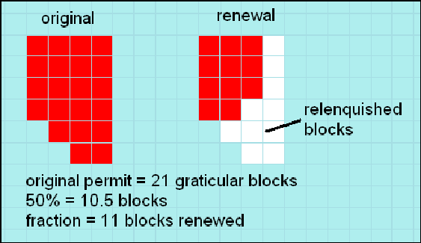

Figure 4 - Relenquishment of a renwed offshore mineral licence

# Designated Authority Details

## New South Wales

Industry Coordination  
Industry & Investment NSW  
PO Box 344, Hunter Region Mail Centre 2310  
516 High Street  
MAITLAND NSW 2320  
AUSTRALIA

Phone: +61 2 4931 6666   
Facsimile: +61 2 4931 6790   
Website: [www.minerals.gov.au](http://www.minerals.gov.au/)

## Victoria

Earth Resources Regulations  
Department of Primary Industries  
GPO Box 4440, MELBOURNE VIC 3001  
Level 16, 1 Spring Street  
MELBOURNE VIC 3000  
AUSTRALIA

Phone: +61 3 9658 4000   
Facsimile: +61 3 9658 4460   
Website: [www.dpi.vic.gov.au](http://www.dpi.vic.gov.au/)

## Queensland

Queensland Mines and Energy   
Department of Employment, Economic Development and Innovation   
PO Box 15216, City East QLD 4002   
80 Meiers Road  
INDOOROPILLY QLD 4002   
AUSTRALIA

Phone: +61 7 3362 9340   
Website: [www.deedi.qld.gov.au](http://www.deedi.qld.gov.au/)

## Western Australia

Department of Mineral and Petroleum Resources  
Mineral Titles Division  
Mineral House  
100 Plain Street  
EAST PERTH WA 6004  
AUSTRALIA

Telephone: (08) 9222 3333   
Facsimile: (08) 9222 3430

## South Australia

Department of Primary Industries and Resources  
Minerals Policy and Registration Branch  
101 Grenfell Street   
ADELAIDE SA 5000   
GPO Box 1671  
ADELAIDE SA 5001

Telephone: (08) 8463 4154   
Facsimile: (08) 8463 4155

## Tasmania

Mineral Resources Tasmania  
PO Box 56, ROSNY PARK TAS 7018  
30 Gordons Hill Road  
ROSNY PARK TAS 7018  
AUSTRALIA

Phone: +61 3 6233 8333   
Facsimile: +61 6233 8338   
Website: [www.mrt.tas.gov.au](http://www.mrt.tas.gov.au/)

## Northern Territory

Department of Resources  
GPO Box 3000, DARWIN NT 0801  
Level 5, Centrepoint Building  
48-50 Smith Street Mall  
DARWIN NT 0800  
AUSTRALIA

Phone: +61 8 8999 5357   
Facsimile: +61 8 8981 7106  
Website: www.nt.gov.au/d

# Attachment A

## Example of Block numbering - Block 622

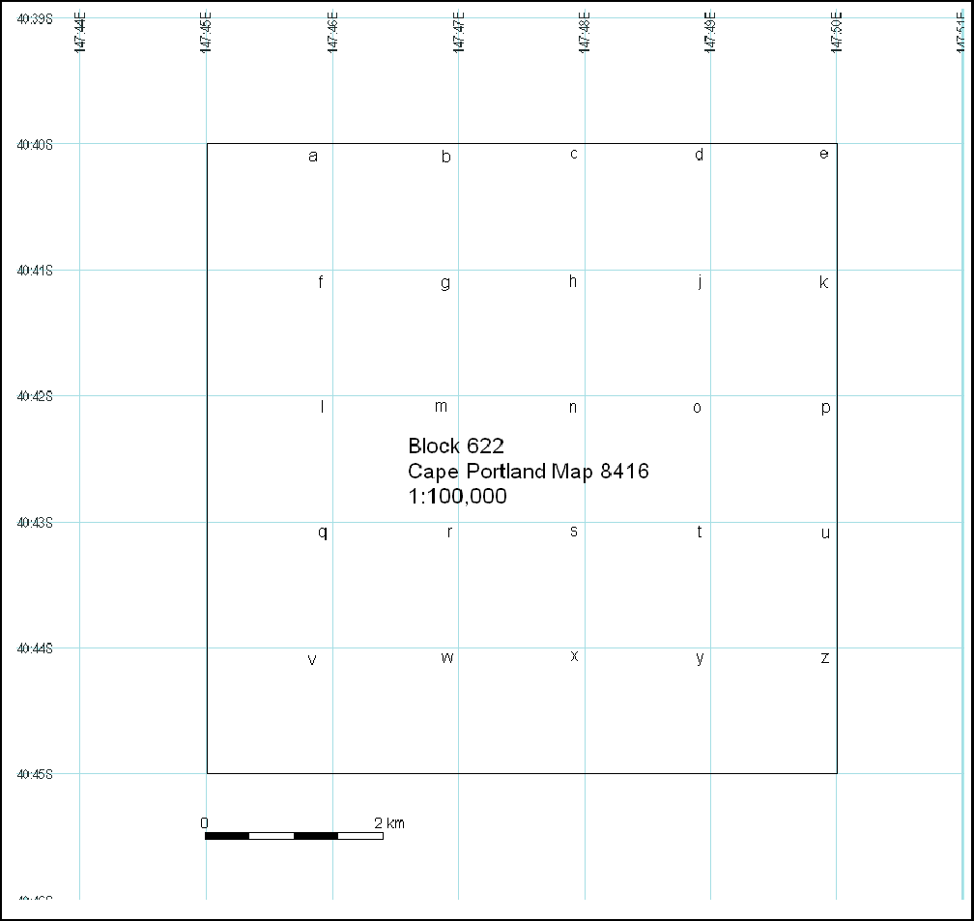

**Figure 5 - Example of Block numbering - Ringarooma Bay Block 622**

The boundaries of blocks are defined under Australian Geodetic Datum 1994 (AGD 94). For more information on Australian Datum visit Geoscience Australia ‘Datums explained’ at <http://www.ga.gov.au/geodesy/datums/aboutdatums.jsp>

### Worked example of application form for 11 blocks:



# Attachment B

## Example of approved application form

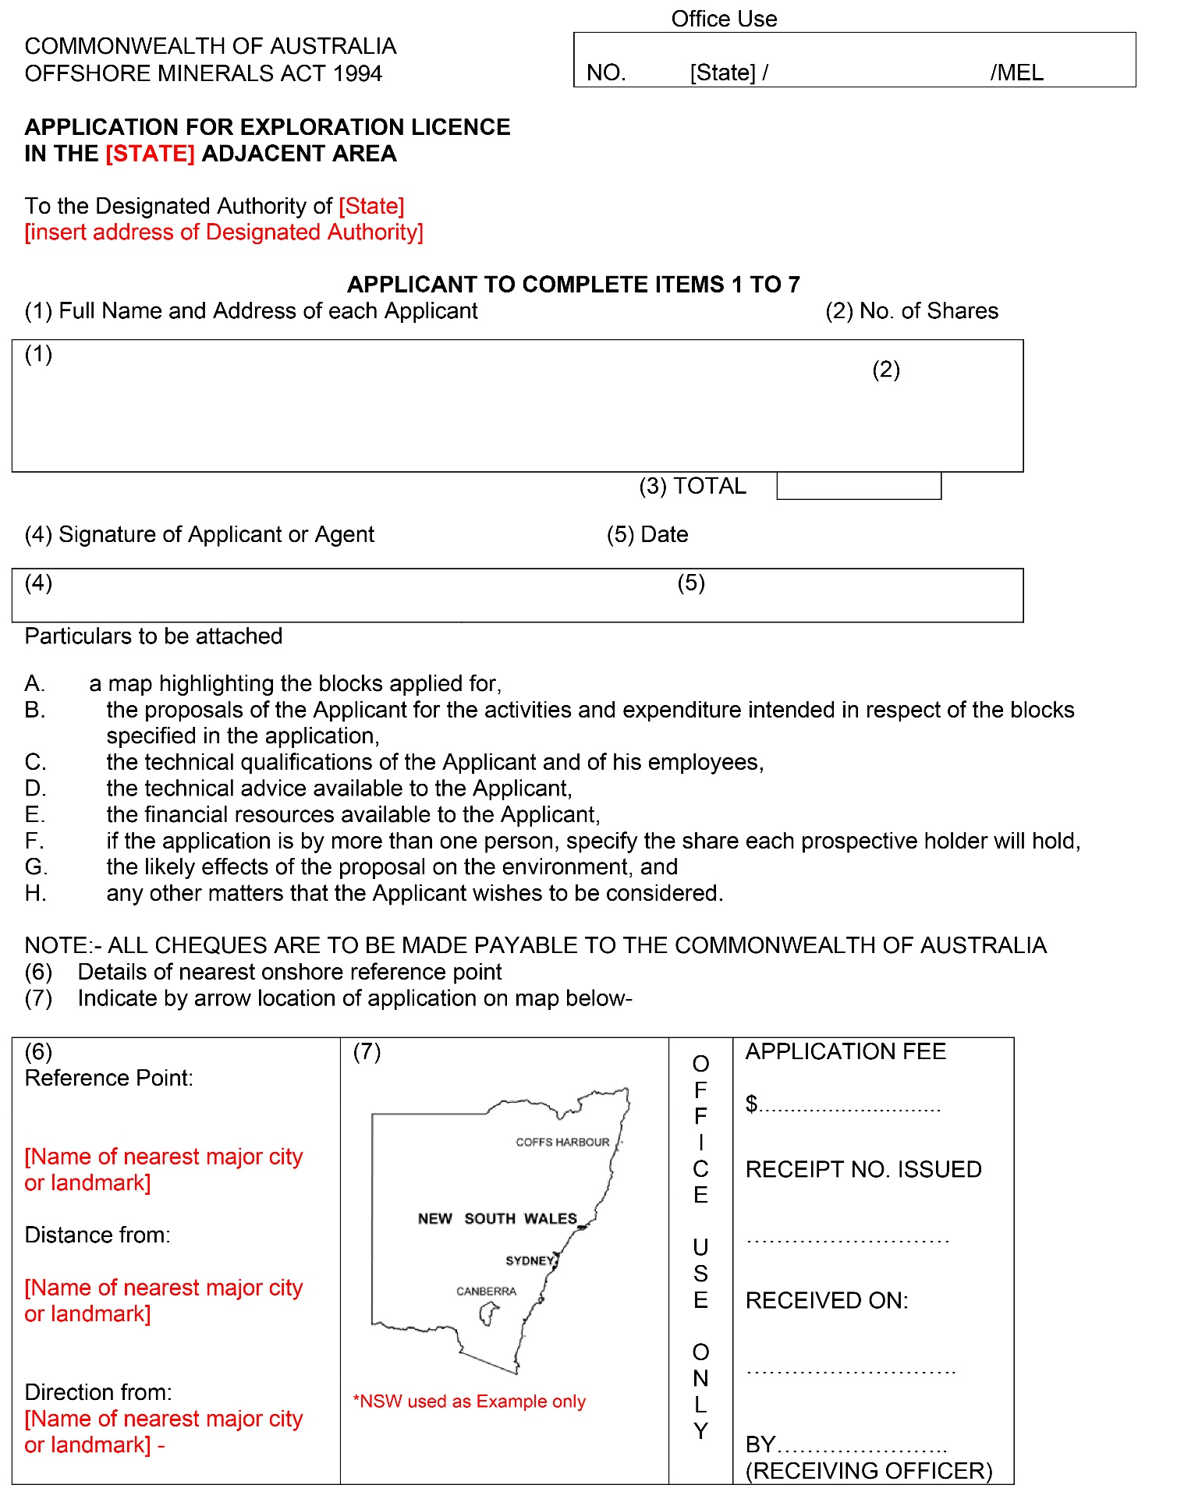

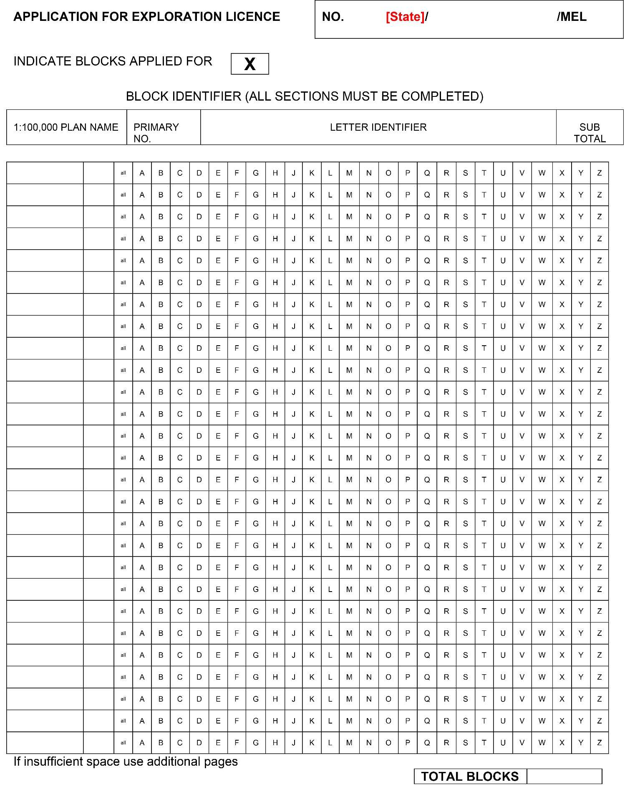

# Attachment C

## Work Program and Other Application Requirements

### Introduction

In order for the authorities established under the *Offshore Minerals Act 1994* to determine whether a proposed work program is acceptable, applicants should include the following details in support of their applications for an offshore minerals exploration licence. Each of the various components of the work program should be accompanied by a detailed breakdown of estimated expenditure, particularly for the primary term in the first two years. An indicative costing for the secondary remaining two years will be initially acceptable, but applicants should provide a detailed breakdown of estimated expenditure well before the commencement of exploration programs for the last two years.

### Requirements

Applications **must** contain the applicant’s proposed exploration strategy that will enhance the existing geological knowledge of the area. The work activities underpinning the proposed exploration strategy for the area should be unambiguously stated and supported by a technical assessment, which is based on relevant geophysical and geological information and data.

The applicant's technical assessment should include the concepts underlying its proposed exploration work program with sufficient detail to support that program. A sound technical assessment would include an assessment of relevant data and support the amount and type of seismic surveying or other exploration techniques proposed, for example:

#### Preliminary Studies

Details of the extent of literature research to be undertaken, if any, and the reprocessing and interpretation of records held on departmental open files.

#### Remote Sensing

An indication of the scope and scale of any remote sensing studies to be carried out and the type of equipment to be used, as well as, aeromagnetic purchase and interpretation.

Seismic SurveysDetails of:

* the type of seismic surveys to undertaken;
* the type of sensing equipment to be used;
* the amount of line kilometres proposed;
* a map of the proposed seismic traverse lines in the area under application.

#### Sampling and Processing

Details of:

* the sampling techniques to be adopted;
* the type and size of equipment to be used, including;
* type of drill, diameter of bit, and drill metres; and
* the number, spacing and size of samples to be taken.   
  An estimate of:
* the plume deposition of drilled sediments after processing and return of waste material to the seabed;
* the proportion of the area under application likely to be subject to disturbance from drilling, bulk sampling and processing of seabed material.

**Guidelines for Applicants**

Offshore Minerals Exploration Licence applications **Page 18**

**Note:** It is recognised that it may not be possible for an applicant to be precise about the finer details of the sampling program, which may depend on the results of the seismic surveys. Nevertheless, applicants should indicate as far as possible the likely sampling program to be adopted.

Depending on the manner in which the applicant proposes to conduct the bulk sampling program and which technique it will adopt, the applicant may feel it needs to refer its plans to the Commonwealth Minister for Environment and Heritage for approval under the *Environment Protection and Biodiversity Conservation Act 1999*. The EPBC Act places the onus on the proponent for ensuring an action is either approved or does not affect a matter of NES. The Commonwealth can, however, trigger the process itself. If an applicant is unsure whether approval is required, they may refer the action to the Commonwealth Minister for Environment and Heritage for clarification as to whether the action would be a ‘controlled action’ under the EPBC Act. For more information on the EPBC Act and the referral process see the Environment Australia web page: <http://www.environment.gov.au/epbc/about/index.html>

In the event that an applicant is not able to provide a definite sampling program (because its nature will depend on seismic surveys etc.), and a licence is granted, the licence holder will be advised that when it submits its bulk sampling program for approval, that it may need to consider referring its action to the Commonwealth Minister for Environment and Heritage as outlined above.

#### Baseline Studies

Details indicating the scope and scale of any baseline data to be collected such as:

* environmental studies on the effects of sampling (bulk) and testing procedures on local aquatic flora and fauna;
* hydrographic studies to report on tidal, current and wave action in the region

#### Particulars of the Applicant

An applicant must also satisfy the Joint Authority of its capacity to undertake its proposed work program, particularly in relation to:

* the adequacy of financial resources and technical expertise available to the applicant;
* the likelihood that the applicant will continue to have access to sufficient resources to meet the requirements of the proposed work program;
* the future viability of any consortium lodging an application, including evidence that a satisfactory Joint Operating Agreement has been or can be reached; and
* the applicant's past performance in other exploration titles areas in Australia or, if relevant, elsewhere.

To facilitate this assessment, the application should include details on:

* the financial resources available to the applicant, including evidence of the applicant's ability to fund the proposed work program, a statement of other exploration commitments over the perior of the permit, and a copy of the latest annual and quarterly reports for each applicant company;
* the technical qualifications of the applicant’s key employees who will facilitate the work program **or** the technical resources available to the applicant; and
* where relevant, details on the percentage participating interest of each party to the application, identification of the ‘Operator’ on behalf of the applicants, and evidence of the viability of the consortium lodging the application, including confirmation that a satisfactory settlement has been, or can be, reached on the Joint Operating Agreement (a copy of a signed Heads of Agreement dealing will generally suffice).

# Attachment D

## Example of approved national advertisement

The aim of the advertisement is to notify the general public that an application has been applied for in the area.

The diagram:

* Should be a minimum of approximately 6cm in width and a minimum of 6cm in length.
* The minimum resolution should be 300 dpi at final size
* Should be based on an accepted standard map.
* Should identify any major geographic features and towns (e.g. rivers and localities).
* Should clearly define the external boundaries of the area (use latitude and longitude if graticular).Use a bolder line than other lines shown on the map.
* Should have a north point and appropriate bar scale.
* Should contain lettering that is legible at the publication size (minimum 7pt font).
* Should show the distance and by arrow the direction to the reference point stipulated in the application

OFFSHORE MINERALS ACT 1994
Notice is hereby given pursuant to section 140 of the Commonwealth Offshore Minerals Act 1994 that [Company name] [ACN number of Company] [address] has lodged an application for a Mineral Exploration Licence [Application number] over the area shown below.

Comment is invited from the public on this application, such comments to be sent to the Designated Authority, [address of Designated Authority] within 30 days of this notice.

For further information on this application contact [contact of Designated Authority officer]

INSERT IMAGE

Reference point:
Distance from:
Bearing from:
Block identifier:
Plan name:
Primary number:
Identifier
primary number
Identifier
Total number of blocks:

# Attachment E

## Schedule of Standard Conditions

# OFFSHORE MINERALS EXPLORATION LICENCES

## GENERAL OBLIGATIONS

1. The licence holder shall not recover any minerals from the licence area except for sampling purposes as authorised by this licence or otherwise authorised by the Designated Authority.
2. Unless otherwise approved by the Designated Authority, the licence holder shall carry out operations in accordance with the approved exploration work program dated ……….. and the approved environment management plan dated ……… which are retained by the relevant State Department.
3. No significant alteration or expansion to the approved exploration program shall commence until a plan of the proposed activities and a program to safeguard the environment are submitted to the Designated Authority for assessment and until a written approval to proceed has been obtained.

## EXPENDITURE REQUIREMENTS

1. Unless otherwise directed by the Designated Authority, the licence holder shall:
   1. as set out in the approved exploration work program, expend on operations conducted in the licence area not less than $X,000 per annum during the first two years of the licence; and
   2. submit to the Designated Authority, at least 60 days before the expiry of the 2nd anniversary, a proposed annual expenditure program for the next two years.

## EXPLORATION REQUIREMENTS

1. Unless the prior written approval of the Designated Authority is first obtained exploration operations within the licence area are to be restricted to the following activities:

* reconnaissance by aircraft, helicopter, hovercraft, boat and amphibious vehicle;
* bathymetric sounding and side scan sonar profiling, airborne radiometric and magnetic surveys, sea floor mapping, imagery and photography;
* seismic survey (non-explosive) subject to whale, turtle watch and fishery protection procedures prescribed by the Department of Conservation and Land Management (CALM) and the Department of Fisheries.

1. Explosives shall not be used in connection with exploration operations without the prior written approval of the Designated Authority.
2. Prior to any activity involving environmental disturbance to the seabed and general marine environment including:

* vibro and shallow coring;
* drilling;
* sampling (grab, siphoning, etc.);
* sampling (grab, siphoning, etc.); and
* dredging;

the licensee is to provide an exploration and environmental management program for written approval of the Designated Authority in consultation with the Environment Protection Authority.

## ENVIRONMENTAL REQUIREMENTS

1. All drilling muds and additives and all drill cuttings used in or obtained as a result of offshore drilling operations shall be retained and not be discharged to the marine environment.
2. Spillages of fuel, oil or other pollutants of an amount greater than 80 litres to be reported to the Designated Authority and to the State Environment Protection Authority within 12 hours of any such spillage occurring.
3. The licence holder shall at no time allow the dumping of rubbish; the discharge of fuel, oil or other pollutants (including potentially toxic drilling compounds) into the marine environment.
4. The licence holder shall not undertake any activities within 100 metres of any coral reefs or seagrass areas without the prior written permission of the Designated Authority.

## MISCELLANEOUS

1. The licence holder shall carry out exploration activities in such a manner as not to damage any pipeline, wellhead, capped well or other equipment associated with seabed exploration and mining.
2. The licence holder shall permit officials and agents of the Designated Authority to have at all times the right of unlimited access to the licence area, including installations, to carry out geoscientific investigations.

1. at 1 July 2010