



Innovation and Science Australia Annual Report 2017-18

**Online version**

The online version of this report can be accessed: [www.industry.gov.au/ISA](http://www.industry.gov.au/ISA)

**Contact**

Department of Industry, Innovation and Science,

GPO Box 2013, Canberra ACT 2601

Email: [office@isa.gov.au](mailto:office@isa.gov.au)

© Commonwealth of Australia 2018

This work is copyright. Apart from any use permitted under the *Copyright Act 1968*, no part may be reproduced by any process without prior written permission from the Commonwealth.

Requests and enquiries concerning reproduction and rights should be addressed to the Department of Industry, Innovation and Science, GPO Box 2013, Canberra, ACT 2601.

Designed and typeset by Digital Design Team, Corporate Network, **Department of Industry, Innovation and Science** Canberra.

This publication is identified as:   
*Innovation and Science Australia Annual Report 2017-18*.

ISSN 1030-3316

ISBN: 978-1-922125-54-5 (print)

ISBN: 978-1-922125-55-2 (online)

Letter of Transmittal



**Chair**

The Hon Karen Andrews MP

Minister for Industry, Science and Technology

Parliament House

CANBERRA ACT 2600

Dear Minister

I am pleased to present the Innovation and Science Australia Annual Report on its activities for the financial year ended 30 June 2018, prepared in accordance with section 46 of the *Industry Research and Development Act 1986*.

Innovation and Science Australia was established on 20 October 2016, prior to then it was known as Innovation Australia. The 2017-18 Annual Report covers activities undertaken by Innovation and Science Australia.

Sincerely,



Bill Ferris AC

25 October 2018

**Phone:** 02 6213 7400 - [**Email:**](mailto:secretariat@isa.gov.au) secretariat@isa.gov.au - [www.industry.gov.au/ISA](http://www.industry.gov.au/ISA)

10 Binara Street, Canberra City, ACT 2601 - GPO Box 2013 Canberra ACT 2601 - ABN: 74 599 608 295

Contents

Innovation and Science Australia’s strategic objectives 6

Chair’s Report 7

CEO’s Report 10

Section One – Activities in 2017-18 13

Overview of Innovation and Science Australia 14

Strategic advice 16

Australia 2030: Prosperity through Innovation 16

A key challenge: Increasing business investment in innovation 20

Case Study —Accessing overseas talent 22

Early impacts of the 2030 Plan 23

Advocacy 26

Program oversight 29

Program Overview – R&D Tax Incentive Program 30

R&D Tax Incentive Program 30

Case Study — Industry leading aeronautical technologies developed in Australia 33

Program Overview – Cooperative Research Centres Program (CRC) 35

Cooperative Research Centres Program 35

Case Study — Solafast – solar energy for businesses 39

Case Study — Revolutionary Australian mining innovation steps closer to market 41

Program Overview — Venture Capital Programs 42

Venture Capital Programs 42

Case Study — Tech start-ups benefit from more than just money 45

Case Study — Embracing disruption with confidence 47

Program Overview — Biomedical Translation Fund (BTF) 49

Biomedical translation Fund 49

Case Study — Finding the first treatment for kidney scarring 51

Case Study — Rex Bionics exoskeleton getting people back on their feet 52

Program Overview — Entrepreneurs’ Programme 53

Entrepreneurs’ Programme 54

Case Study — Makinex Construction Products — exporting award-winning Australian designs to break into the US market 56

Case Study — Paspalis Enterprise Trust – propelling the best Northern Territory start-ups to success 57

Case Study — JAG Mayer home grown innovation – a safe and independent feeding device taking the baby product market by storm 58

Case Study — TAE Aerospace – a business research collaboration utilising augmented reality to globalise tech support 60

Program Overview — Business Research Innovation Initiative (BRII) 62

Case Study — Likely Theory 66

Case Study — Atamo 67

Legacy programs 69

Section Two – Governance 70

Innovation and Science Australia 71

Legislation 71

The Industry Research & Development Act 1986 71

Organisation and management 72

Membership 74

Conduct of Board 74

Office of Innovation and Science Australia 74

Partners in delivery 75

Board members as at 30 June 2018 76

Committee members as at 30 June 2017 79

Structure of Innovation and Science Australia as at 30 June 2018 83

Meetings 85

Legal matters/litigation 86

Acronym list 88

# Innovation and Science Australia’s strategic objectives

Objective 1: Inform Australian Government policy on Australian innovation, science and research.

Objective 2: Oversee innovation programs to ensure effectiveness and efficiency of delivery.

Objective 3: Advocate and champion for Australia’s innovation, science and research system.

# Chair’s Report

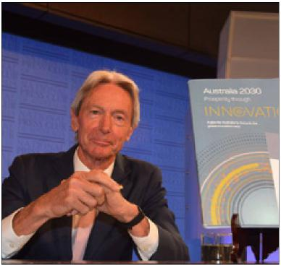

I am pleased to present the *Innovation and Science Australia Annual Report for 2017–18* - my third report as Chair of Innovation and Science Australia (ISA). It is now just over two and half years since the formation of ISA was announced as part of the National Innovation and Science Agenda, and in that time we have cemented our position as a key source of whole-of-government advice on innovation, science and research matters, in addition to our oversight and advocacy roles.

This annual report shows that 2017–18 was a particularly productive and rewarding year for ISA. On Tuesday 30 January 2018, we launched *Australia 2030: Prosperity through Innovation* (the 2030 Plan) alongside the former Minister for Jobs and Innovation, Senator the Hon Michaelia Cash and the former Assistant Minister for Science, Jobs and Innovation, Senator the Hon Zed Seselja at the Astor Industries facility in Lakemba, Western Sydney. Delivering this report was the second of the two key roles ISA was tasked with when first established. This followed our *Performance Review of the Innovation, Science and Research System* which we released in November 2016.

Of the 30 recommendations made in the 2030 Plan, 17 have been supported by Government in their response, with a further ten receiving support in principle. The remaining three recommendations were noted. Recommendations that received support included those for a Genomics National Mission, a review of the Australian Public Service (APS), funding for National Research Infrastructure, and a commitment to develop a strategy for achieving greater gender diversity in science, technology, engineering and mathematics (STEM).

As innovation practitioners ourselves, ISA Board members are conscious of the importance of effective implementation to the success of any innovation strategy, and we therefore look forward to contributing to this next phase of the 2030 Plan’s rollout.

The process of developing the 2030 Plan afforded me the opportunity to engage with ministers from across the Government, as well as senior figures in the Opposition and leaders from the Australian Public Service. I was also pleased to be able to engage extensively with industry bodies, including the Business Council of Australia, the Australian Industry Group (AiGroup), Australian Institute of Company Directors (AICD), the Australian Private Equity & Venture Capital Association Limited

(AVCAL), and Universities Australia (UA). I came away from those interactions buoyed both by the commitment to innovation shared by so many sectors of society, and also by the emerging examples of progress that were evident in many of the case studies we reviewed. However, these conversations highlighted that innovation is constantly battling with other priorities for the attention of managers and policymakers, many of which may appear at first glance to be more pressing.

Indeed, these stakeholder engagements reinforced for me the need for ISA to provide a compelling, strategic, and long term voice for the vital role that innovation must play in delivering a prosperous future for Australia.

In addition to the 2030 Plan, in this report you will find more details of the advice we have provided to Government through a range of mechanisms, on topics ranging from visa and trade policy to considerations around data and artificial intelligence. You will also find details of our oversight of key Government programs that support the innovation and science system, including reports from each of our committee chairs. Finally, you will find details of how we have continued to advocate for Australia’s innovation, science and research system in public and private fora.

I would like to thank all members of the Board and its committees for their contributions in the past year. In particular, I would like to thank Ms Elizabeth Comstock, Dr Rufus Black, Dr Marlene Kanga AM and Ms Glenys Beauchamp PSM (ex officio) who moved on from the Board this past year.

The work of the Board has been enabled by the dedication and leadership of our CEO Dr Charles Day, supported by his small but productive team in the Office of Innovation and Science Australia (OISA), I thank them all.

I welcome the Secretary of the Department of Industry, Innovation and Science (DIIS), Dr Heather Smith PSM, as the new ex officio member to the Board and Dr Marlene Kanga AM as Special Advisor to the Board for a period of two years. I would also like to thank the Board’s international members, Ms Elizabeth Comstock and Mr Saul Singer for the time they have given in the past year to visit Australia and engage with stakeholders.

As I pen this report the major challenge to the realisation of our 2030 ambitions remains the continued decline in business investment in innovation. My Board has identified the urgency of this challenge and in particular, has recommended the need for Government to rebalance its business support measures from indirect research and development (R&D) tax incentives to a suite of direct incentives with much greater multiplier impacts.

In 2018–19, the Board will continue to work with Government as it moves to the implementation phase on the many recommendations it has supported outright or in principle, as well as continuing to engage with stakeholders across the ecosystem to address remaining challenges. We welcome your ongoing support.

Bill Ferris AC

Chair

# CEO’s Report

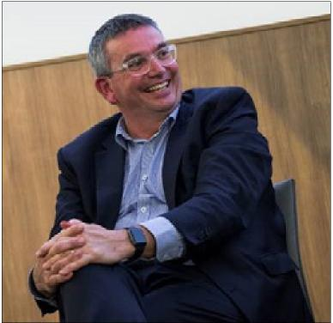

Launching a new plan which aims to plot a course for our innovation system for the dozen years to 2030 is both an exciting and a daunting task, but it is one which ISA took to with relish in the year just passed. The 2030 Plan was over a year in the making, and drew on the collective wisdom and experience of all members of the ISA Board. It also brought together a broad-ranging public consultation, advisory groups from the public and private sectors, and a lot of hard work from the core team in the OISA supported by secondees and consultants from across the Government and private sectors. As we had hoped, the 2030 Plan spurred a vigorous and sustained public conversation about Australia’s innovation future, and has already had a significant influence on the relevant policy settings.

It was a major milestone for ISA after less than two years of existence in its current form, but in Winston Churchill’s words it was really only “the end of the beginning”. We have an ongoing role to ensure continuing improvement in the innovation system, and so our work has swiftly switched from developing the 2030 Plan to assisting Government with the implementation of many of our recommendations, whilst also responding to the ongoing developments in the ever-changing Australian innovation system.

It is an innovation system which continued to show some very encouraging trends in the 2017-18 year. New investment continued to flow into the venture capital sector at a healthy rate, whilst existing funds, including those established as part of the Government-backed Biomedical Translation Fund (BTF) steadily expanded their portfolios. Importantly, a number of previously venture-backed businesses proved their worth by achieving substantial exits. Many of our established businesses also achieved significant innovation milestones, with Rio Tinto’s autonomous train technology moving into operational use, and the financial sector’s New Payments Platform being made available to the public for the first time. We also saw significant foreign investment in developing new technology in Australia, exemplified by the Kawasaki Heavy Industries-led investment in developing coal-to-hydrogen technology in Victoria’s Latrobe Valley. The Australian and Victorian Governments provided a combined $100 million in funding to the $496 million pilot project.

Our universities continued to shine in a number of international rankings, with many individual and team honours awarded to our researchers, and their commitment to driving innovation was exemplified by Universities Australia’s publication of the *Clever Collaborations* report. Our publicly funded research agencies also made major contributions, ranging from the continuing growth of CSIRO’s ON program through to AIMS’ work to ramp up efforts to save the Great Barrier Reef.

The all-too-persistent myth that Australians don’t celebrate their scientists enough took a triple-hit when quantum physicist Professor Michelle Simmons was named Australian of the Year, biophysicist Graham Farqhar AO was named Senior Australian of the Year, and YouTube sensation (and maths teacher by day) Eddie Woo was named as Australian Local Hero, all in one day. And the public’s enthusiasm for science was also strongly on display in the national discussion leading up to the announcement of the formation of an Australian Space Agency in the 2018 Federal Budget, which has already captured the imagination of citizens across the country.

However, against this backdrop of encouraging signs there remain several ongoing challenges for the system, including the decline in levels of investment by business in innovation, and increasing concerns about access to specialist skills as the global competition for talent strengthens.

ISA has therefore continued to work with stakeholders from across several parts of the Federal Government, along with external stakeholders, to progress relevant policy reforms that can tackle these challenges, among others. This work requires careful research and analysis, combined with strong stakeholder engagement, and I thank the OISA team for their continued commitment to the highest standards in this work.

I am also grateful to my team for their support of public engagement efforts by me and several of our Board members, most notably our Chair, which have helped to keep the public conversation about innovation vibrant and active in the mainstream media and on social media. At a time when some parts of the Australian community are apprehensive about the implications of innovation for their job security and the pace of societal change, it is vital that ISA is making the case for innovation’s importance in driving improved standards of living and a prosperous future for the next generation.

With two years of work now under our belt, the DIIS is undertaking the planned post-commencement evaluation of ISA. We look forward to receiving the findings of this review, and working with the Minister to develop a shared pathway forward for ISA to have maximum impact in improving our national innovation system.

I would like to take this opportunity to thank the ISA Board, and particularly the Chair, Bill Ferris, for their leadership in shaping the 2030 Plan, and the work that has followed. I would also like to reiterate my thanks to the OISA team for their commitment and their camaraderie.

And finally I would like to thank all the

stakeholders across the country that I have had the good fortune to engage with over the past year – you have sometimes congratulated me, and sometimes challenged me, but you have always left me filled with optimism that Australian innovation has a bright future ahead of it.

Dr Charles Day

CEO

# Section One – Activities in 2017-18

Overview of Innovation and Science Australia

Strategic advice

Early impacts of the 2030 Plan

Advocacy

Program oversight

## Overview of Innovation and Science Australia

ISA is an independent Board that provides strategic whole-of-government advice to Government on all innovation, science and research matters. It also monitors and oversees a number of innovation programs through several sub-committees.

ISA was originally announced as part of the Australian Government’s National Innovation and Science Agenda (NISA) in December 2015, and formally established on 20 October 2016 through amendments to the Industry Research Development Act 1986 (IR&D Act). Upon its establishment, ISA was tasked with two key roles: to undertake a performance review of the Australian innovation, science and research system, and from these findings to produce a strategic plan for Australia’s innovation system out to 2030. The Performance Review of the Australian Innovation, Science and Research System was delivered to Government in November 2016, and the 2030 Plan was delivered to Government in November 2017.

On its formation, the Board inherited the roles of the body formerly known as Innovation Australia which had been established under the IR & D Act to assist with the administration and oversight of the Government’s industry, innovation and venture capital programs.

ISA’s role and responsibilities are defined by the IR & D Act, the Government’s Statement of Expectations issued to ISA and any directions issued by the portfolio Minister to ISA. The Government’s current Statement of Expectations, and ISA’s Statement of Intent in response are published on [https://www.industry.gov.au/strategies-for-the-future/](https://www.industry.gov.au/strategies-for-the-future/innovation-and-science-australia)innovation-and-science-australia.

The Board has crystallised its various roles under three strategic objectives in order to guide its activities:

1. Inform Australian Government policy on Australian innovation, science and research.
2. Oversee innovation programs to ensure   
   effectiveness and efficiency of delivery.
3. Advocate and champion for Australia’s innovation, science and research system.

In addition to the advice contained in its publication the 2030 Plan, ISA has also provided advice on a number of matters that the Government has publicly consulted on during 2017–18 including: the Global Talent Scheme, a new visa scheme to attract highly skilled global talent to deliver innovation to Australia, My Health Record data and the Digital Economy Strategy.

## Strategic advice

### Australia 2030: Prosperity through Innovation

ISA’s major piece of advice for the year was the landmark report, the 2030 Plan. ISA undertook an extensive consultation process to support the development of this plan. This involved engaging widely with businesses, industry, researchers, teaching institutions, all levels of government, non-government entities, and the broader community, as shown below.

Figure 1: Consultation process for the 2030 Plan

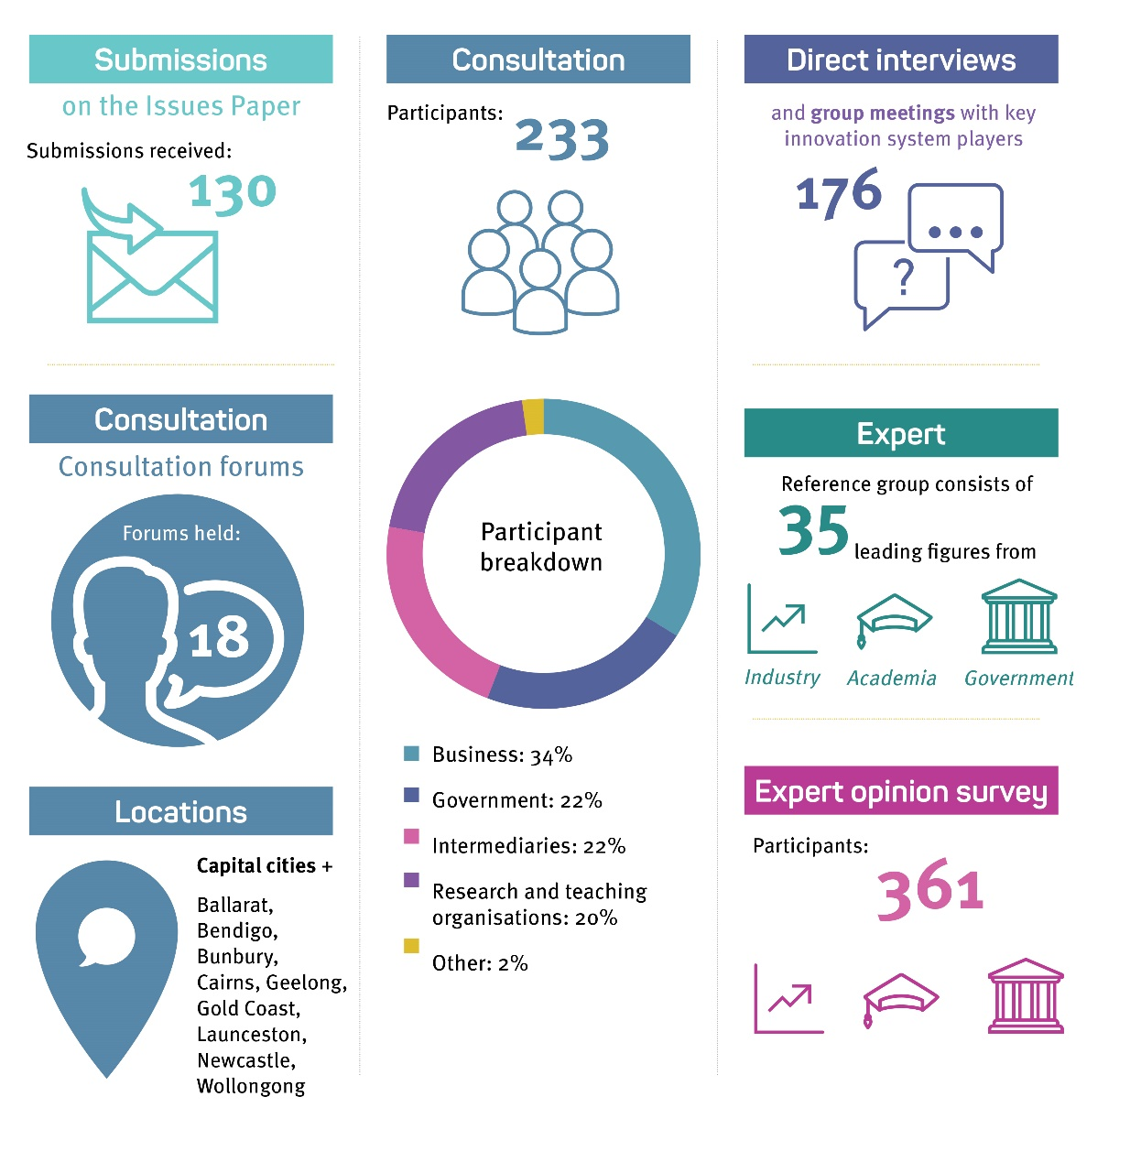

Highlights of the consultation process:

* 130 submissions received on the Issues Paper
* 18 consultation forums held in capital cities plus Ballarat, Bendigo, Bunbury, Cairns, Geelong, Gold Coast, Launceston, Newcastle and Wollongong
* 233 participants consulted: 34% business, 22% government, 22% intermediaries, 20% research and teaching organisations, 2% other
* 176 direct interviews and group meetings with key innovation system players
* Expert reference group consisting of 35 leaders from industry, academia and government
* 361 participants in an expert opinion survey

The 2030 Plan was delivered to Government in the final quarter of 2017 and publicly launched on Tuesday 30 January 2018 at the Astor Industries facility in Lakemba, Western Sydney.

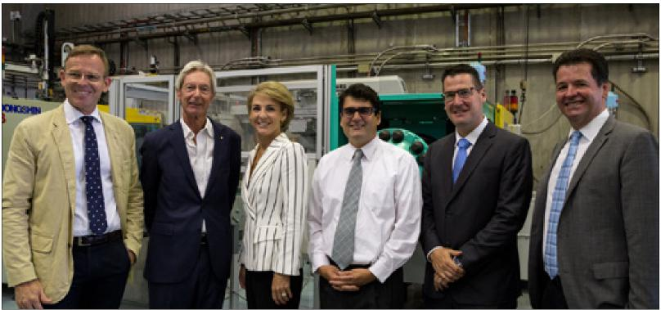

ISA launch of the 2030 Plan at Astor Industries in Sydney (from left to right): Advanced Manufacturing Growth Centre, CEO, Dr Jens Goennemann; ISA Chair, Mr Bill Ferris; Minister Michaelia Cash; Dresden co-founder, Mr Bruce Jeffreys; Assistant Minister Zed Seselja; Advanced Manufacturing Growth Centre (NSW/ACT) State Director, Mr Michael Sharpe.

The 2030 Plan outlined a vision for Australia to become a top-tier innovation nation, which takes pride in its global reputation for excellence in science, research and commercialisation. To achieve this ambition, the 2030 Plan outlined five strategic imperatives which addressed specific aspects of the national innovation system, with several opportunities identified under each imperative. Thirty specific and actionable recommendations were included, with a mixture of near and medium term action horizons. Highlights from the recommendations, and the subsequent Government response, are discussed in more detail on the following page.

ISA coordinated a range of media and communications activities to promote the launch of the 2030 Plan, its vision, content and recommendations to Government.

Highlights in the week of the official launch of the report included:

* 10 newspaper interviews
* Four radio interviews
* Two television interviews
* 22 newspaper articles, including in *The Australian* and *Australian Financial Review*
* Twitter followers increased by 55 per cent
* Facebook followers increased by 25 per cent
* 11,500 total website visits

On 22 May 2018, the Government provided its formal response to the 2030 Plan which noted and supported key recommendations that are important for the acceleration of innovative activity nationally out to 2030.

ISA looks forward to continuing to work with the Government as it moves to the implementation phase on the recommendations it has supported outright or in principle.

Figure 2: Summary of Australia 2030: Prosperity through Innovation

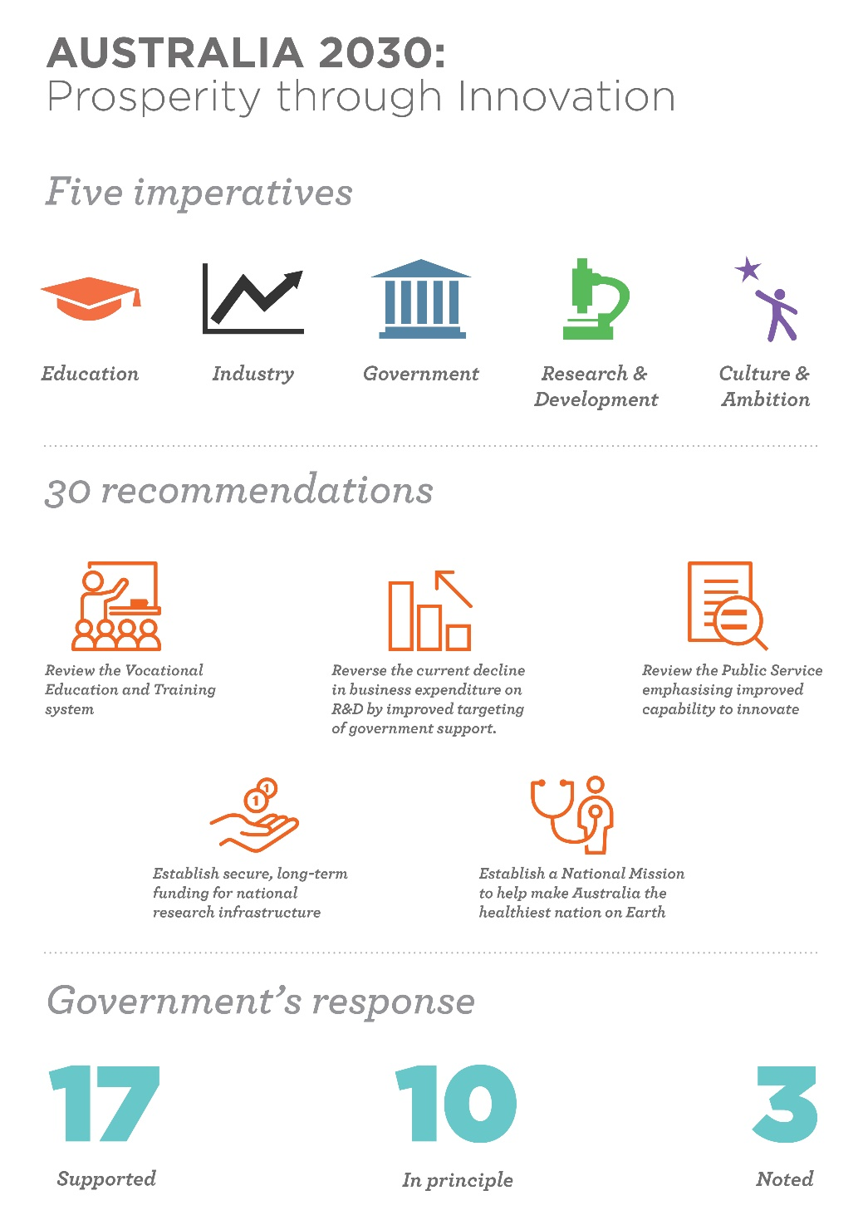

Highlights of Australia 2030: Prosperity through Innovation:

* 5 imperatives for education, industry, government, research and development, culture and ambition
* 30 recommendations
* Government’s response: 17 supported, 10 in principle and 3 noted

### A key challenge: Increasing business investment in innovation

One long term trend of particular concern to the Board is the declining level of investment in R&D across the economy. This has also been highlighted by a range of other economic observers including the Reserve Bank of Australia. The chart below shows the increasing divergence between Australia and the Organisation for Economic Co-operation and Development (OECD) as a whole on gross (all-economy) expenditure on R&D.

See text for description of key data.

Sources: ABC, OECD

A major driver of this decline is the Australian context is the component of this investment made by the business sector. The 2030 Plan therefore recommended as a top priority the reversal of the current decline in business expenditure on research and development (BERD). Whilst BERD as an indicator cannot measure all forms of innovation, it is an important indicator of business commitment to generating value from fresh thinking. Research from the OECD shows a correlation between R&D spending and productivity growth.

For example, in 2003, OECD research[1] indicated that 0.1 per cent increase in a country’s BERD to GDP ratio translates to a 1.2 per cent increase in GDP per capita.

Key trends of concern include:

* BERD decreased by 12 per cent from $18.8 billion (2013–14) to $16.7 billion (2015–16).
* Business human resources devoted to R&D decreased by 11 per cent from 2013–14.
* BERD as a proportion of GDP decreased from 1.4 per cent in 2008–09, 1.19 per cent in 2013–14 to 1.01 per cent in 2015–16.

Figure 3: Business expenditure on research and development as a percentage of GDP.

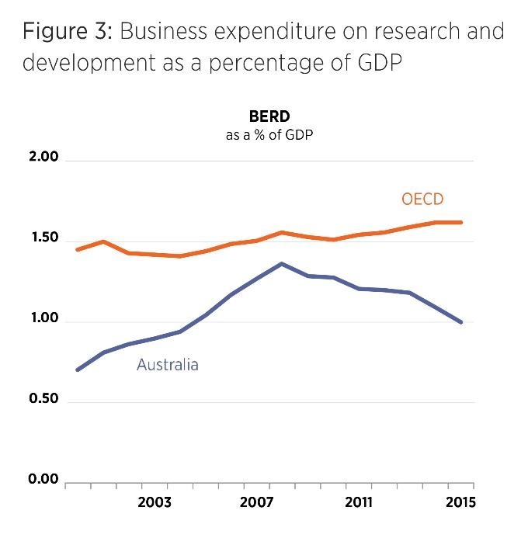

Throughout 2018–19 ISA will continue to champion strongly and provide policy advice to Government on options to turn around this negative trend in business investment in innovation.

### Case Study —Accessing overseas talent

We recognise that the ability to access leading-edge global talent is a key driver of growth in Australia’s innovation, science and research system. At the same time, it is clear that the national conversation around immigration is complex and contested. Following the Australian Government’s reforms to the skilled migration program in April 2017, we identified a need to leverage the ISA Board’s intimate experience of our innovation system to provide advice to the Government on how to ensure Australia’s ability to compete on the world stage for global talent was not inadvertently compromised.

We highlighted this issue in the 2030 Plan, and continued to engage with the Government following its release. Our advocacy took the form of direct engagements with government and business, supported by policy submissions. OISA’s CEO, Dr Charles Day also participated on the Industry Advisory Group to the Global Talent Scheme (GTS) pilot.

The GTS pilot, announced in March 2018 and launched on 1 July 2018, has been designed to deliver a more flexible future-focused visa for business and signals that Australia is an attractive destination for niche talent from around the world.

The GTS pilot is an important step forward in ensuring that Australia’s business and research sectors are only constrained by their own imagination. We will continue to advocate for and provide advice to Government on related issues such as encouraging foreign investment in Australian businesses and supporting the development of home-grown skills in STEM for jobs of the future.

## Early impacts of the 2030 Plan

As noted above, the 2030 Plan was released in January 2018, and the Government’s formal response followed approximately four months later, with several measures addressing key recommendations included in the 2018 Federal Budget. Although the 2030 Plan was conceived with a long term horizon, the Board was pleased to see early action in several areas, and ISA has continued to augment its work in the 2030 Plan with additional submissions to government in several areas. Some highlights of the early impacts are detailed below.

**Imperative 5: Culture and Ambition**

**National Missions:** The 2030 Plan recommended a Genomics and Precision Medicine National Mission, and identified future candidate national missions to restore the Great Barrier Reef and develop hydrogen technology. It also recommended that a framework should be developed to identify future national missions that are robust, achievable and in the national interest. The Government’s response to these recommendations included:

* $500 million over 10 years for the Australian Genomics Health Futures Mission to provide a step-change in the integration of Australia’s genomics and precision medicine capabilities into our broader health care system.
* $6 million funding for a feasibility study into a Great Barrier Reef Restoration and Adaptation program. This was followed by a further announcement of $100 million for the Reef adaption science informed by the study. Development of this program will be led by the Australian Institute of Marine Science (AIMS) and the CSIRO.
* Development of a framework to scope out the intent of a National Mission policy platform is now underway in the DIIS.

**Imperative 4: Research and Development**

**Endorsement of national research infrastructure roadmap:** The 2030 Plan recommended securing long term funding for national research infrastructure. In the 2018 Budget, the Government announced additional long term funding of $1.9 billion over 12 years for national research facilities that will allow Australian researchers to access the tools necessary for the pursuit of world-leading research and provide the foundation for ongoing national prosperity.

**Support for STEM gender diversity:** The 2030 Plan recommended maintaining a long term policy commitment to achieving greater gender diversity in the STEM workforce, including by raising awareness of gender diversity in government programs. In February 2018, ISA put forward a submission to the STEM Partnership Forum’s issues highlighting the 2030 Plan STEM-related recommendations. In the 2018 Budget the Government announced $4.5 million over four years to support long term strategic approaches to encourage more women to pursue STEM education and careers, including developing a Women in STEM Strategy to help coordinate the government’s efforts to increase women’s participation in STEM.

**Venture Capital:** The 2030 Plan highlighted the recent healthy growth in investment into venture capital in Australia, supported in part by the $500 million Biomedical Translation Fund (BTF) which was established in early 2016 with advice from ISA Chair Mr Bill Ferris. During 2017–18 ISA continued to work with the Department of Health and DIIS, through its BTF Committee, to ensure the Fund’s impact was fully recognised. ISA also provided advice to Government on fintech legislation through an ISA submission to the Treasury’s consultation on technical amendments to tax measures. ISA will continue to monitor developments in the venture capital market, as recommended in the 2030 Plan.

**Imperative 3: Government**

**APS Review:** In May 2018 the Government announced the Review of the Australian Public Service (APS). This responded to ISA’s recommendation in the 2030 Plan to “conduct a review of the Australian Government Public Service with the aim of enabling a greater role and capability for innovation in policy development, implementation and service delivery.” ISA Board Member Ms Maile Carnegie was appointed to the expert panel overseeing this review, and ISA will make a formal submission in due course.

**Access to Government data:** The 2030 Plan welcomed the Productivity Commission’s (PC) recommendation for comprehensive reform of Australia’s data sharing and release arrangements. As part of the Government’s response to the PC report, the Department of the Prime Minister and Cabinet released an issues paper seeking comment on the proposed scope and key principles for the anticipated Data Sharing and Release Act.

**Imperative 2: Industry**

**Research and Development Tax Incentive (RDTI) reforms:** The 2030 Plan made recommendations that supported and refined many of the recommendations made by the Ferris, Finkel, and Fraser 2016 *Review of the Research & Development Tax Incentive* (the 3Fs review). The thrust of these recommendations was to maintain the Government’s support for business sector R&D, but shift its allocation away from indirect tax-based measures such as the RDTI and towards more direct forms of support. The Board sees this as a key step in reversing the current declining trend in BERD. The Government noted this recommendation, and has moved forward with reforms to the RDTI which pick up some but not all of its elements. ISA continues to support this process through the provision of advice in addition to its legislated oversight role in the RDTI program.

**AI capabilities:** The 2030 Plan recommended that the Government prioritises investment in artificial intelligence (AI) and machine learning (ML) in order to develop advanced capability in the research, development and exploitation of AI/ML across the digital economy. The Government’s response to this recommendation included $29.9 million to enhance national capabilities in AI and ML, including $25 million for a Cooperative Research Centres Projects (CRC-P) round and provision for the development of a longer-term AI roadmap to be led by CSIRO’s Data61.

ISA has also advised Government on the role of AI and ML in the Government’s forthcoming Digital Economy Strategy in the form of a public submission to the digital economy consultation led by DIIS.

**Imperative 1: Education**

**Endorsement of STEM industry-school partnerships**: The 2030 Plan recommended a number of steps to better prepare students for post-school STEM qualifications and occupations. In line with this, ISA made a submission to the STEM Partnerships Forum and has undertaken additional consultations with the Forum.

**Innovation Metrics**

A further recommendation in the 2030 Plan was the development of suite of innovation metrics and methodologies to fully capture innovation and link it to economic, social and environmental benefits. In the 2018 Federal Budget the Government identified funding to support this project, and the project is expected to commence in the first half of the 2018–19 year.

## Advocacy

Another of ISA’s strategic objectives is to ‘advocate and champion for Australia’s innovation, science and research system’. This objective encompasses a range of activities for ISA, from speeches and presentations by the Chair, Board members and CEO at conferences and public events, to participation in and convening of roundtable forums and meetings with stakeholder groups from industry and government. ISA’s broad engagement strategy ensures that ISA can proactively target messages to the innovation, science and research communities and the wider Australian public, as well as work directly with stakeholder groups to address issues that impact on Australia becoming a leading innovation nation.

During the reporting period, the ISA Chair and Board members presented at over **45** events, and the CEO of OISA presented and/or participated in over **60** events.

Keynote speeches made by the Chair in the reporting period include:

* AFR Innovation Summit 2017: *National Innovation Strategy to 2030 – What should we expect*
* Committee for Economic Development of Australia (CEDA) Sydney: *Innovation should be celebrated not hidden as an ‘Elephant in the Room’*
* National Press Club of Australia: *ISA’s Strategic Plan for Australia to thrive in the global innovation race*
* Committee for Economic Development of Australia (CEDA), Melbourne: *What will it take for Australia to be counted as a top tier innovative nation?*
* Australian Institute of Company Directors: *How company directors can accelerate prosperity through innovation*
* QUT Grand Lecture Challenge: *Innovation must become the core of national priority settings*

Interviews in the reporting period on the topic of the 2030 Plan included: the ISA Chair on ABC’s *The Business*, ABC’s AM, ABC’s *Saturday Extra* and ‘Politics with Michelle Grattan’ podcast. Dr Charles Day, CEO of OISA was also interviewed on 2GB. Opinion pieces in the reporting period included: ISA’s Chair in the *Daily Telegraph*, and ISA Board member Mr Saul Singer in the *Australian Financial Review*.

Transcripts of these speeches and opinion pieces, and footage/audio of the interviews are available at [**www.industry.gov.au/isa**](http://www.industry.gov.au/isa).

Speeches, presentations and participation by the CEO of the OISA, in the reporting period include:

* Creative Innovation 2017 Asia Pacific – plenary address
* Business Group Leaders: Business Council of Australia, Australian Commerce and Industry Group and Ai Group – presentation
* AusBiotech 2017 Conference – keynote speech
* Launch of the Chrysos mining analysis technology – keynote speech
* Australia New Zealand Leadership Forum
* Australian Institute of Company Directors (AICD) Technology Governance & Innovation Panel – panel member
* Wyndham City’s Inaugural Innovation Summit – conference speaker
* ASEAN CEO Forum
* German-Australian Fraunhofer Health Innovation Platform – keynote speech
* Murdoch Children’s Research Institute Seminar – keynote speech
* Swinburne University’s Research led Innovation Conference – keynote speech
* CRC Conference 2018 Awards for Excellence in Innovation

Board member engagement – Start-ups

Israel-based ISA Board member Mr Saul Singer, best known as a co-author of the best-selling book “Startup Nation” about Israel‘s remarkable story of development, commenced his 10 day trip to Australia in Sydney by attending the May ISA Board meeting.

Mr Singer also delivered a public lecture at the University of Technology Sydney (UTS) which was followed by a meeting with UTS Vice Chancellor and President, Professor Attila Brungs.

Next stop was the Sydney Startup Hub where Mr Singer touched in with Sydney’s blossoming start-up community and participated in a public Q&A event with StartupAus CEO, Mr Alex McCauley. He also met up with a range of key stakeholders from the sector including Mr Ben and Toby Heap, the Founding Partners of H2Ventures; CEO of CSIRO’s Data61, Mr Adrian Turner; and Dr Chris Roberts from the Macquarie Park Innovation District.

The final few days of Mr Singer’s trip to Australia were spent in Cairns where he met with representatives from various organisations working to save the Great Barrier Reef, including Australian Institute of Marine Science (AIMS) and the Reef and Rainforest Research Centre. A Reef Restoration and Adaptation program was one of two candidate National Missions outlined in ISA’s 2030 Plan.

# Program oversight

Another of ISA’s strategic objectives is to ‘oversee innovation programs to ensure effectiveness and efficiency of delivery’. As at 30 June 2018, the programs and initiatives that the Board supported the administration of and provided oversight for included:[2]

**R&D Tax Incentive program**

**Cooperative Research Centres program**

* Cooperative Research Centres (CRCs)
* Cooperative Research Centres Projects (CRC-Ps)

**Venture Capital programs**

* Early Stage Venture Capital Limited Partnerships (ESVCLPs)
* Venture Capital Limited Partnerships (VCLPs)

**Biomedical Translation Fund (BTF) Entrepreneurs’ Programme (EP)[3]**

* Accelerating Commercialisation (AC)
* Incubator Support (IS)

**Business Research Innovation Initiative (BRII)**

A committee structure assisted the Board to oversee these programs. The programs were delivered by AusIndustry, within the DIIS. The Australian Taxation Office (ATO) assists DIIS with the administration of the R&D Tax Incentive and both the Venture Capital programs.

## Program Overview – R&D Tax Incentive Program

“An increasing number of start-ups and small and medium enterprises are using the R&D Tax Incentive to support their research and development activities. The program continues to be important in supporting these companies in their critical early years.

The committee consulted widely on improved guidance for businesses registering R&D activities in the software sector. Further engagement is anticipated following the implementation of changes to the RDTI legislation that will provide improved targeting and effectiveness of the program.”

CHAIR, R&D TAX INCENTIVE COMMITTEE

### R&D Tax Incentive Program

The R&D Tax Incentive program is the Government’s principal measure to encourage industry investment in R&D. The program provides benefits in the form of tax offsets to eligible entities undertaking eligible R&D activities. To access the incentive, companies are required to self-assess the eligibility of their R&D activities, register them with DIIS, and then claim a tax offset in their company tax return with the ATO.

During 2017–18, DIIS continued to promote the R&D Tax Incentive and inform stakeholders through:

* the development and release of new guidance, including videos, to assist customers to better understand eligibility requirements of the R&D Tax Incentive program
* almost 700 engagement events with customers around the country
* more than 10,000 businesses and program stakeholders engaged through information sessions and bulletins.

These activities help customers to self-assess their R&D activities correctly, and provide a strong foundation on which to achieve the program’s objectives.

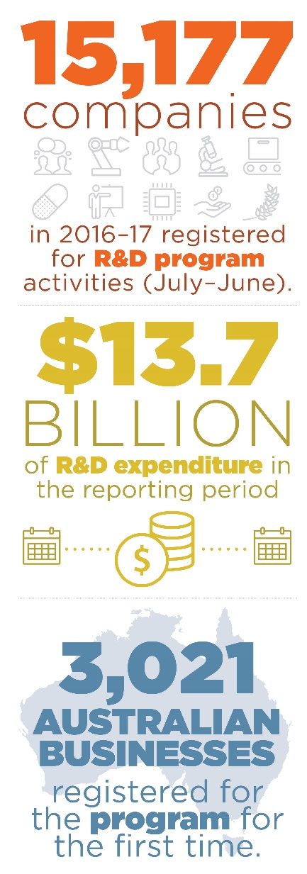Key outcomes[4] in relation to the R&D Tax Incentive income year 2016–17, at the end of June 2018, include:

* 13,346 registrations (representing 15,177 R&D performing entities). This is largely unchanged compared to the previous income year measured at the same time last year.
* 12,123 small-to-medium companies registered (80 per cent of program participation).
* 3,021 companies registered that were new to the program (21 per cent of program participation).
* Total registered R&D expenditure of $13.7 billion for income year 2016–17. The downward trend in registered R&D expenditure (when compared year-on-year) is particularly notable for the mining, construction and manufacturing sectors. This corresponds broadly to the structural transformation of the Australian economy towards the services sectors since the Global Financial Crisis (GFC). The introduction of the $100 million threshold from 1 July 2014 may also have contributed to this reduction.
* R&D expenditure of $6.1 billion by entities with a turnover of less than $20 million in 2016–17.
* The year-on-year participation by small and medium businesses (with an aggregated turnover of less than $20 million) in the program is on par with the 2015–16 income period.

On 8 May 2018, the Government announced reforms to the R&D Tax Incentive as part of the 2018 Federal Budget. The changes respond to the 2016 review and ISA’s 2030 Plan and have been informed by extensive industry consultation. The reforms reward additional investment in R&D while also ensuring the integrity of the program by including a series of compliance, enforcement and administration changes (www.budget.gov.au/2018-19).

Further information and details on the performance of the R&D Tax Incentive program are available on DIIS’ website ([www.industry.gov.au](http://www.industry.gov.au)).

### Case Study — Industry leading aeronautical technologies developed in Australia

**With the help of the R&D Tax Incentive, Boeing Australia is developing industry leading technologies and the most modern production processes in the aeronautical industry as their largest presence outside of the United States continues to grow here in Australia.**

In March 2008 Boeing established an Australian branch of Boeing Research & Technology (BR&T) - its advanced research and development unit - to better support its businesses in Australia. BR&T provides a focal point for collaboration with research and development organisations, including universities, private sector providers, the CSIRO and the Defence Science and Technology Group.

BR&T has been developing novel approaches to curing composite structures using resin infusion technology. The first generation of this technology has been used for the production of 787 Dreamliner ailerons and flaps since the mid-2000s at Boeing Aerostructures Australia (BAA). As well as researching the resin infusion technology itself, BR&T is also developing the tools and manufacturing processes needed to make the second generation of its application in a production environment a reality. So far, BR&T has been able to apply their technology to trailing edge structures such as the ailerons and flaps they produce for the Boeing 787.

Robotics is also an important area where BR&T is focusing its R&D efforts; Boeing is using targeted automation to work smarter, allowing its skilled labour force to spend their valuable time where it is needed most. Across the BAA factory, there are numerous examples of robotics and automation cells supporting the production of components for both 787 and 737 airplanes. The results of the R&D in robotics and composite materials has contributed to an increase in productivity over the past few years. For the parts produced for the 787 Dreamliner’s, Boeing has been able to go from delivering 10 shipsets per month to fourteen. Further, the components produced for the 737 have increased from 40 to over 50 shipsets per month. These production increases have been achieved using the same factory floor space and with the same amount of labour. R&D activities carried out by BR&T have contributed to this increased production capacity and efficiency because the company has adopted smarter manufacturing techniques and applies the latest technologies.

The R&D Tax Incentive (RDTI) has allowed BR&T to get the most out of their research investment. Not only is it maximising effectiveness of their research programs, but it is also a great selling point when trying to win investment. Improved cash flow thanks to the RDTI has allowed Boeing’s R&D activities to move ahead at an accelerated rate.

R&D carried out by Boeing has led to more employment opportunities in exciting roles working on cutting edge technologies that BR&T is developing. BR&T has grown their workforce from 20 to 85 across three sites in Australia over the last 10 years; in turn, BR&T offers rewarding careers for high tech scientists and engineers at the forefront of the Australian aerospace industry. This has been underpinned by growing their graduate program and offering more scholarships over recent years, which has increased from 23 PhD and postdoc scholarships across seven universities, to 28 scholarships across 10 universities in just the last year.

“The R&D Tax Incentive enhances our overall investment in Australia and has encouraged the start-up of our smaller suppliers from various industries.”

MR ROBERT MARXEN, BOEING AUSTRALIA DIRECTOR, INTERNATIONAL TAXATION

## Program Overview – Cooperative Research Centres Program (CRC)

“The CRC Advisory Committee has been pleased with another strong year for the CRC Program. CRC-Ps continue to be well supported by industry. As awareness of this scheme has grown, so too has the number of high quality applications, and the scheme is already highly competitive. The committee encourages potential applicants to make full use of the experience of previous grant winners when building their applications. The earliest collaborators will start to complete projects in the near term, and it is hoped that for many, the CRC-P scheme will have been an introduction into industry-academia collaborations, to be further explored with other projects and programs.

The CRCs also continue on a strong trajectory, with a large number of applications received in the 20th CRC selection round. CRCs that were successful in the 19th selection round have commenced operations and the committee looks forward to their achievements.

This period has also seen the closure and transition of a number of CRCs. This challenge has been addressed well in a variety of different ways by individual CRCs.”

CHAIR, CRC ADVISORY COMMITTEE

### Cooperative Research Centres Program

The CRC Program is a competitive, merit-based grants program that supports industry-driven multi-year research collaborations. The program has supported the development of important new technologies, products and services to solve industry problems and improve the competitiveness, productivity and sustainability of Australian industries.

The CRC Program has two streams:

* CRCs which undertake medium to long term industry-led high quality collaborative research for up to 10 years. There is no set limit on funding for CRCs and they must have at least one Australian industry entity and one Australian research organisation as participants.
* CRC Projects (CRC-Ps) which undertake short term, industry-led collaborative research for up to a maximum of three years. CRC-P grants have a minimum limit of funding of $100,000, are capped at $3 million and must have at least two Australian industry entities (at least one must be a subject matter expert) and one Australian research organisation as participants.

All grant funding for CRCs and CRC-Ps is required to be matched by participants through cash and in-kind contributions. CRCs and CRC-Ps work with relevant Growth Centres to address the strategic priorities of industry. International engagement and collaboration has been a core element of the program since its inception. CRCs and CRC-Ps are encouraged to collaborate and co-invest with international organisations and businesses to assist industry participants to engage with global supply chains and access new markets.

Since the CRC Program commenced in 1991, the Government has committed over $4.6 billion in funding to support the establishment of 221 CRCs and 63 CRC-Ps. Participants have further committed over $14.4 billion in cash and in-kind contributions. The program is ongoing and Government has committed $731 million over the next four years.

**Program performance**

Major highlights

During the 2017–18 reporting period:

* There were 32 CRCs and 59 CRC-Ps operating across a variety of sectors, including manufacturing, mining, healthcare, agriculture, and the environment.
* The total Government commitment for new CRCs (5) and CRC-Ps (22) in 2017–18 was $255 million. Participants have further committed over $757 million in cash and in-kind contributions.
* Of the six CRCs that completed their funding terms in 2017–18, two established commercial spin out companies as legacy vehicles.
* The number of active CRCs and CRC-Ps headquartered in each state, including their Commonwealth grant funding is shown below:

| STATE | NUMBER  OF CRC-PS | TOTAL CRC-P  GRANT FUNDING  (GSTEXCL)  (MILLION) NUMBER | NUMBER  OF CRCS | TOTAL CRC  GRANT FUNDING  (GST EXCL)  (MILLION) |
| --- | --- | --- | --- | --- |
| ACT | 2 | $4.81 | 2 | $49.48 |
| NSW | 18 | $41.67 | 7 | $211.93 |
| NT | 3 | $4.02 | 0 | 0 |
| QLD | 7 | $14.23 | 4 | $168.38 |
| SA | 2 | $4.58 | 4 | $92.86 |
| TAS | 2 | $3.63 | 1 | $25.00 |
| VIC | 19 | $39.26 | 12 | $390.04 |
| WA | 6 | $13.71 | 2 | $57.00 |
| Grand total | 59 | $125.92 | 32 | $994.69 |

Other highlights include:

* On 22 September 2017, funding of $50 million over seven years was announced for the Cyber Security CRC.
* On 17 October 2017, the CRC for Developing Northern Australia CRC Project funding round outcomes were announced, with seven successful applicants offered grant funding of $13.9 million across a range of industry problems affecting northern Australia from reducing infant pearl oyster deaths to ensuring crocodile skin is lesion free.
* On 6 December 2017, the fourth CRC-P selection round funding outcomes were announced, with 15 successful applicants offered grant funding of $33.1 million across a range of industry problems from a portable, non-invasive brain scanner for early stroke detection to improving Australia’s barramundi breeding stocks. Within this selection round eight of the projects were supported by the additional $20 million allocated to the CRC-P Program from the $100 million Advanced Manufacturing Fund for larger scale advanced manufacturing research projects, which was announced in the 2017 Budget.
* In March and April 2018, the 19th CRC selection round outcomes were announced, with four successful applicants offered grant funding of $161.2 million to tackle a range of industry problems including reducing food waste, addressing declining mineral exploration, the adoption of future fuels and the development of digital health solutions.

### Case Study — Solafast – solar energy for businesses

With the help of $1.6 million in Cooperative Research Centres Project (CRC-P) funding Solafast, a roll-formed steel cladding manufacturer based in country NSW, has teamed up with CSIRO and high-tech Melbourne printing company Norwood to develop a roofing product that will generate low-cost solar power. Through this project, Solafast has a new value-added building product in their repertoire, and Norwood has expanded their considerable printing know-how to include printed solar films.

Solafast’s building integrated photovoltaic (BIPV) product merges conventional cladding with a printed solar film. The BIPV product sees printed solar films transformed into a giant roll of ‘solar stickers’ to seamlessly integrate it into the steel roll-forming process. The project used the flexibility afforded by printing to design a way to make electrical connections safe and easy. The result is a secure and affordable solar energy source for large-span commercial structures.

The printed solar films are flexible, lightweight and low cost. Due to their lightweight nature, the product from this project is especially suited to buildings with minimal underlying support structures such as factories, aircraft hangers or sporting venues. The printed solar film has achieved efficiencies greater than six per cent.

Norwood brought to the collaborative project the capacity to up-scale printed electronics for industrial volumes, while CSIRO brought a wealth of technical knowledge and IP in flexible solar. CSIRO has been working on the development of printed solar films for several years, first through the Victorian Organic Solar Cell Consortium with academic partners from Monash University and University of Melbourne, and now through this project with Solafast and Norwood.

“Our partnership with Solafast and Norwood has helped transition our printed solar film expertise out of the laboratory and into commercial applications,” said CSIRO Group Leader in Manufacturing, Dr Fiona Scholes.

“The low barrier to entry of this technology means there is potential to provide new opportunities for Australian manufacturing, creating new markets, value adding to existing markets and generating jobs.”

Conventional solar panels in commercial settings have been more limited than domestic rooftop solar in Australia because of prohibitive costs of installation and solar panel hardware. Printed solar films integrated with locally manufactured building products – such as Solafast’s BIPV product - promise significantly lower installation costs, elimination of solar workplace safety.

“Incorporating solar films into building materials prior to construction results in significant savings in terms of installation costs,” said Solafast co-founder, Ms Leesa Blazley.

The project’s reach has extended to other Australian subject matter experts through Emseal (lamination equipment), FSK Engineering (roll-forming equipment), Prismatic Inks (ink supply and manufacture), Energy Connections (pre-wired off-grid power systems for monitoring solar performance) and KCS Australia (injection moulding and tooling services to deliver a novel junction box solution).

The inherent low cost of manufacturing infrastructure and ability to be fabricated with existing printing equipment makes this an attractive prospect for the Australian manufacturing sector.

### Case Study — Revolutionary Australian mining innovation steps closer to market

A revolutionary new drill rig - The RoXplorer® coiled tubing (CT) rig developed by the Deep Exploration Technologies CRC (DET CRC) has been licenced to one of the world’s leading global mining equipment, technology and services (METS) companies, IMDEX.

A prototype of the Australian innovation, the RoXplorer® CT rig is undergoing final preparations for a drilling trial on a Barrick Gold exploration site in Nevada, USA.

The RoXplorer® CT rig is a revolutionary change in mineral exploration drilling where individual drill rods have been replaced by a continuous steel coil. The steel coil is wound from the spool while drilling and wound back as the drill string is recovered from the hole. Drilling and tripping into and out of the hole proceeds without the need to connect and disconnect rods, making drilling safer, faster and cheaper. It is a technology that could be disruptive to conventional drilling methods with the promise of significant increases in productivity, safety and environmental performance.

The rig is driven by downhole (as opposed to conventional surface) motors and is smaller, has lower fuel consumption and a smaller footprint than equivalent conventional drill rigs. It drills to depths of up to 500 metres and weighs only 15 tonnes (including the coiled-tubing drill string). It can be easily transported by road without the need for special permits. Additional environmental benefits stem from its deployment with a solids removal unit meaning no sumps are dug and no drilling fluids released to the surface.

IMDEX will work closely with Barrick Gold on the Nevada trial, deploying the RoXplorer® coiled tubing drilling system and trialling the capability of this revolutionary drill rig. It will also be identifying the appropriate commercial model by which the technology will be brought to market.

The Nevada trial will also incorporate IMDEXs Lab-at-Rig® technology (licenced from DET CRC in 2015) providing real-time geochemistry from the drill cuttings.

## Program Overview — Venture Capital Programs

“This year has seen continued strong growth in venture capital through the ESVCLP program and ongoing steady growth in private equity though the VCLP program. It is noteworthy that investors in new ESVCLPs are predominantly Australian with a significant and growing amount coming from superannuation funds. The committee sees these as strong signs that the venture capital market in Australia is maturing and that fund managers are able to demonstrate solid returns to their investors. Changes introduced in the 2016 NISA reforms have also contributed. This growth also means that more high-growth companies established in Australia with access to global markets are able to source capital without moving offshore.”

CHAIR, INNOVATION INVESTMENT COMMITTEE

### Venture Capital Programs

The Australian Government has a suite of programs that have been designed to cultivate innovation and encourage venture capital investment in entrepreneurial start-up and early stage companies.

**Tax programs: Venture Capital Limited Partnerships (VCLPs) and the Early Stage Venture Capital Limited Partnerships (ESVCLPs)**

The VCLP and ESVCLP programs are designed to stimulate the Australian venture capital sector by attracting both domestic and foreign capital into Australian venture capital markets. Through these programs VCLPs and ESVCLPs (which are venture capital funds structured as limited partnerships) are registered under the *Venture Capital Act 2002* (VC Act). VCLPs and ESVCLPs are required to operate in accordance with the VC Act and the relevant Income Tax Assessment legislation.

The VCLP program aims to stimulate Australia’s venture capital sector by attracting foreign investors. The program is also open to domestic investors. A VCLP is entitled to flow-through tax treatment and its foreign investors do not pay capital gains tax on their share of returns the VCLP makes from eligible venture capital investments. VCLPs benefit Australian businesses as they increase the level of foreign investment in the Australian venture capital sector.

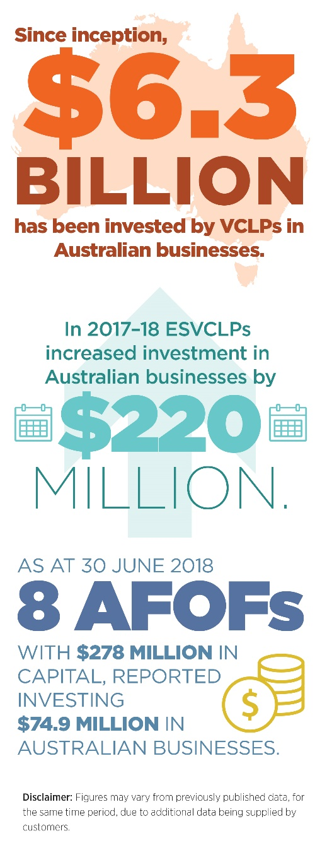Since inception, $6.3 billion has been invested by VCLPs in Australian businesses. This figure represents an increase of $1.1 billion since 2016–17, at which time VCLPs had invested $5.2 billion.

* As at 30 June 2018 there were 82 registered VCLPs. The registration rate had an 83 per cent increase in 2017–18 with 33 VCLPs being registered compared to 18 registrations over the same period in 2016–17.
* Committed capital, which is the amount investors have agreed to contribute to a partnership, increased by $3.7 billion to $10.9 billion in 2017–18. This is highest level of committed capital in VCLPs ever achieved.

The ESVCLP program aims to stimulate the Australian early stage venture capital sector by increasing investment into start-ups and early stage companies. The program assists fund managers attract pooled capital as ESVCLPs are entitled to flow-through tax treatment and for investors, tax exemptions apply to their share of returns. In addition, investors in ESVCLPs receive a 10 per cent investor tax offset on capital invested during the year. ESVCLPs encourage investment in start-up enterprises with a view to commercialisation of activity and company growth.

Since inception, $665 million has been invested by ESVCLPs in Australian businesses. This is an increase of $220 million since 2016–17, when ESVCLPs had invested a total of $445 million.

* As at 30 June 2018 there were 79 registered ESVCLPs. The registration rate had a 15 per cent decrease in 2017–18 with 34 ESVCLPs being registered compared to 40 registrations over the same period in 2016–17.
* The amount of committed capital in ESVCLP partnerships increased from $1.39 billion in 2016–17 to $1.62 billion in 2017–18.

**Other types of registration under the Venture Capital Act 2002**

The VC Act also provides for two other types of registration:

**Australian Venture Capital Fund of Funds (AFOF):** AFOFs are available to Australian resident general partners to pool capital from limited partners for investment into VCLPs and ESVCLPs. The AFOF may also invest directly into eligible venture capital investments that the VCLP or ESVCLP (in which the AFOF is a partner) also holds an investment. AFOFs are limited partnerships registered under the VC Act. As at 30 June 2018, there were 8 AFOFs with a total of $278 million in capital. At 30 June 2018 the registered AFOFs reported investing $74.9 million.

**Eligible Venture Capital Investor (EVCI):** For tax–exempt foreign residents, registration is available as an EVCI under the VC Act. Under the incentive, EVCIs disregard their capital gains or capital losses from eligible investments they have held for at least 12 months. EVCIs are also exempt from income tax on profits and denied deductions for losses arising from the disposal or realisation of such investments. To date, one EVCI has been registered.

### Case Study — Tech start-ups benefit from more than just money

**Rampersand exists to back the world’s best technology start-ups in Australia, and help create a world class innovation ecosystem.**

**Rampersand Venture Capital Fund**

Rampersand’s first investment fund was established in 2013, investing in 10 early stage technology companies. The second fund, launched in 2016, has so far made 11 further investments, some of which are new and others, follow-on investments. A number of additional investments are still in the pipeline.

Rampersand consists of five General Partners and 61 Limited Partners, who are primarily Australian based High Net Worth Individuals or families.

The fund invests in new technology companies including financial technology (fintech), mobile, Software as a Service (SaaS), artificial intelligence (AI) and robotics. It looks for companies establishing themselves in big markets or niches that can be owned. Primarily Rampersand invests in companies that do business with other businesses (b2b) but also invests in business to customer (b2c) companies.

Rampersand not only invests in early stage companies but also provides mentorship to company founders and their teams. As every company is different, the mentorship may take the form of advice regarding growth, international expansion, team structure and development, specific sales, marketing and communication initiatives, or simply Rampersand may provide a ‘shoulder to cry on’.

**Features**

* Rampersand Venture Capital Fund invests in early stage Australian technology companies.
* Rampersand focuses on companies establishing themselves in big markets or niches that can be owned.
* Rampersand invests capital and knowledge, helping to grow world class companies.

**Assembly payments platform**

Assembly Payments, a fintech payment company, was the first company of its kind in Australia. It provides innovative payment solutions to marketplaces, platforms and financial institutions. It has raised more than AU $41 million investment from a range of investors including Rampersand.

Assembly Payments was seen as an attractive company to invest in by Rampersand because of its very strong founders, its approach to solving a big global problem, and demonstrated grit and resilience.

Rampersand has seen its investment contribute to Assembly Payments’ growth, including a staff team increase from 3–4 people at the start to approximately 110 people now.

Rampersand has also seen Assembly Payments drive material revenue growth and customer base four to fivefold. Assembly Payments has developed world-leading new technology, created new processes and skills, built new intellectual property, collaborated with other businesses, expanded nationally and internationally and achieved recognition in its field. Rampersand; co-managing partner, Paul Naphtali, sees significant benefit for Australia in the tax concession programs.

“The ESVCLP has been an effective structure that has helped introduce additional capital into the venture and innovation marketplace. The tax concessions opened up new discussions and drew attention to the industry.”

Mr Naphtali believes this is a critical industry to develop as it supports local investment, attracting high quality people to Australia. It also supports opportunities for interesting careers for our young people, retaining high quality talent and in Paul’s words “stemming some of the brain drain.”

### Case Study — Embracing disruption with confidence

**Square Peg Capital invests in technology entrepreneurs and smooths the path for early stage venture capital investors.**

Square Peg Capital’s first Early Stage Venture Capital Limited Partnership (ESVCLP) was registered in 2016 with an investment fund of AU $40 million. Square Peg Capital’s experienced investment partners include, Mr Paul Bassat[5] (Seek co-founder), Mr Justin Liberman (Jagen Pty Ltd), Mr Barry Brott (Jagen Pty Ltd), Mr Tony Holt (Investment banker) and Mr Tushar Roy (former Boston Management Group).

Square Peg Capital’s Chief Operating Officer, Ms Amanda Hjorring explains:

“A lot of investors still don’t have the confidence to invest in venture...and the skillset that you need to assess venture is quite unique.”

Square Peg takes the hard work and uncertainty out of venture capital investment for its limited partners and provides opportunity for entrepreneurs in the disruptive technology industry to grow their early stage companies through capital investment and mentorship.

Features

* Square Peg Capital established its first ESVCLP in 2016 with an AU $40 million investment fund.
* Square Peg has a significant portfolio of Australian investments, with four of the early stage disruptive technology companies having received mentorship and capital from Square Peg’s 2016 ESVCLP fund.
* Square Peg have a presence in the US, Israel, South East Asia and Australia.
* A second Square Peg ESVCLP is currently conditionally registered.

**The investee companies**

Square Peg’s investment portfolio focuses on enterprise software, software as a service, marketplaces, the tech storage and data space and fintech. Square Peg also invests in exceptional companies with outstanding entrepreneurs in other areas of tech. Square Peg’s investment portfolio is influenced by the skills and interests of the investing partners in Australia and globally.

Square Peg’s 2016 ESVCLP investment companies are recent investments with three occurring in mid to late 2017. Square Peg’s investment recipients are enterprise software and platform or market place companies.

Square Peg typically invests in Series A – early sales and manufacturing – and B – early stage selling product but not yet turning a profit – companies. These companies typically have early revenue but, in some cases, may be pre-revenue or pre-product launch.

Ms Amanda Hjorring, sees the Government’s tax concession programs as “...stimulating the venture capital ecosystem by encouraging more capital into venture assets which in turn encourages innovation and entrepreneurship.”

Ms Hjorring also believes the advantage of the ESVCLP for investee companies is significant. “With more capital invested in Australia, entrepreneurs don’t have to look offshore to try and source capital which will typically be more time consuming, costly and difficult to navigate than looking for investment locally.”

## Program Overview — Biomedical Translation Fund (BTF)

“The Biomedical Translation Fund has had a very successful 2017–18, with investments made in a range of ventures bringing the number of investee companies to ten. Investments range from a project to develop an artificial heart through to a device to assist people with severe disability to walk. The committee has been very impressed with the professionalism of the fund managers as well as the dedication and innovation on display in Australia’s biomedical industry. While it is still early days for the program, the committee is confident the program is on track and will continue to assist innovation in the biomedical field and long term health benefits and national economic outcomes for all Australians.”

CHAIR, BFF COMMITTEE

### Biomedical translation Fund

The Biomedical Translation Fund (BTF) program was announced in December 2015 as a key initiative under the National Innovation and Science Agenda. It is an equity co-investment venture capital program that:

* supports commercialisation of biomedical discoveries in Australia; and
* assists in translating biomedical discoveries into high growth potential companies to deliver long term health benefits and national economic outcomes.

The BTF focuses on supporting early stage companies that are, or will be, developing and commercialising biomedical discoveries, for the long term health and economic wellbeing of Australians.

Biomedical discoveries include: therapeutic, medical or pharmaceutical products, processes, services (including digital health services), technologies or procedures that represent the application and commercialisation of the outcomes of research that serve to improve health and wellbeing. It does not include alternative or complementary medicine, or traditional medicine.

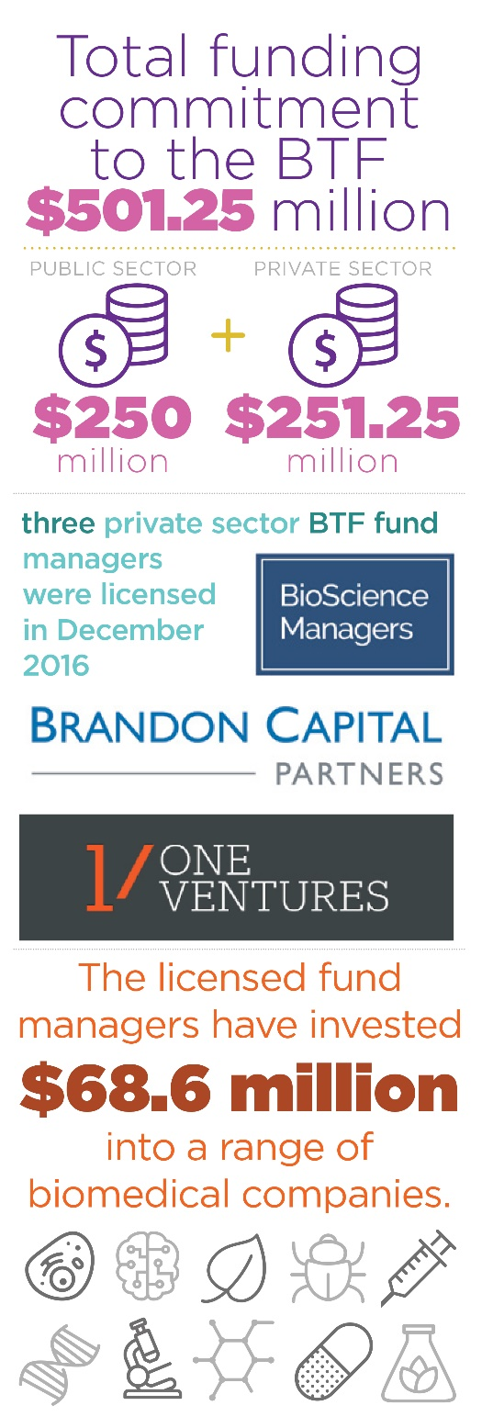The Department of Health has policy responsibility for the BTF. DIIS administers the BTF.

Australian Government funding ($250 million) has been slightly more than matched by private sector capital commitments ($251.25 million) to provide a total funding commitment of $501.25 million to the BTF.

Following a competitive, merit-based selection process, three private sector BTF fund managers were licensed in December 2016. This process was conducted by the BTF Committee under the auspices of the ISA Board. The licensed BTF managers are: Brandon Capital Partners, OneVentures Management and BioScience Managers.

Licensed BTF fund managers invest in promising biomedical discoveries and assist in their commercialisation. These fund managers also encourage the development of companies which are commercialising biomedical discoveries, by addressing capital and management constraints.

All BTF investment decisions are made by the selected fund managers. The Government has no role in selecting investments, technologies or markets, but ensures that all investments are consistent with the requirements of the program guidelines. This approach has been taken to ensure that the venture capital expertise required to invest in commercialisation opportunities is provided by those most qualified.

As at 30 June 2018, the licensed fund managers have made ten investments totalling $68.6 million into a range of biomedical companies. The largest commitment to date has been $22 million to Certa Therapeutics (Certa) to progress the clinical development of a drug to treat kidney disease. The funding will help commercialise Certa’s cutting edge kidney disease treatment, providing Australian patients with direct access to this medicine through clinical trials, while giving taxpayers an opportunity to maximise their investment. By taking the drug, the patient is less likely to suffer from kidney failure and a shortened life on dialysis.

### Case Study — Finding the first treatment for kidney scarring

**Certa Therapeutics is leading a breakthrough which is helping people with kidney disease and reducing the enormous cost of dialysis and kidney transplants.**

There are currently no treatments available for kidney fibrosis and given the enormous cost of dialysis and kidney transplants to the healthcare system, finding an effective treatment for these patients remains one of the global healthcare industry’s largest unmet needs.

Typically, fibrosis leads to end-stage kidney failure. Preventing the development of fibrosis will help avert or delay the need for more costly treatments, such as dialysis or transplantation.

Certa’s kidney drugs block a receptor that is a key driver of scar tissue in kidneys, and will be used in conjunction with DNA advancements to accurately speed up the clinical trial and make it more efficient.

About 1.7 million Australians suffer from kidney disease but not all develop fibrosis. Innovations in DNA can identify those more likely to suffer kidney scarring.

Features:

* Certa is able to use genetic analysis to identify those patients that are most likely to benefit from therapy.
* New drugs and DNA testing could be worth more than $6.7 billion a year if the clinical trials confirm their success.
* The technology being developed by Certa originated from the University of Melbourne, Bio21 and St Vincent’s Institute for Medical Research.

The $22 million BTF investment is from the Medical Research Commercialisation Fund, which is being managed by Brandon Capital Partners, with equal parts of Australian Government and industry funding. The investment into Certa will allow the Melbourne-based biotech company to advance its use of DNA testing and novel ‘precision’ drugs to best identify and treat patients with kidney fibrosis, also known as kidney scar tissue or scarring.

The Minister for Health, the Hon Greg Hunt MP announced the Certa investment at the Biotechnology Innovation Organization 2018 (BIO18) Convention in Boston, USA in early June 2018 promoting to the world Australian’s research and business capabilities.

“It is the most exciting time to be a medical scientist in Australia in the biotechnology sector. The BTF means we can finally develop technologies in our own country,” said Certa, CEO, Professor Darren Kelly.

### Case Study — Rex Bionics exoskeleton getting people back on their feet

**Rex Bionics’ mission is to establish Robot-Assisted Physiotherapy – in the clinic and at home – as a standard of care for people with neurological injury or illness.**

REX is currently the only free-standing robotic mobility aid and allows several rehabilitation angles to be addressed separate from gait training. Trials proved REX is feasible for people with spinal cord injury, those who have suffered a major stroke or traumatic brain injury, or people with multiple sclerosis - to carry out a functional exercise program.

Wheelchair users are at risk of developing numerous medical complications from extended periods of sitting. By enabling them to spend more time standing, walking and exercising, REX can offer significant health benefits.

“Rex is being enthusiastically embraced by clinicians and their clients in Australia and New Zealand. The endless ways to make exercising more interesting while delivering repetitive, perfectly aligned static and dynamic movement is the key to providing a tailored rehabilitation program for clients,” says Rex Bionics Australia General Manager, Holly Simmonds.

“Clinicians benefit as the heavy lifting of intense neuro rehabilitation is significantly reduced when using REX. Most sessions can be provided by just one trained clinician.”

Features

* Clinical trials to date have shown that REX is safe and stable and is simple to operate with very limited user training.
* Rex Bionics’ exoskeleton work will play a significant role in the growth of the Australian capability in medical robotics and manufacturing.
* A first-generation exoskeleton product developed in New Zealand has been sold or leased in limited quantities in the US, EU, UAE, China, Australia and New Zealand.
* Australia’s first exoskeleton was bought by the Australian Institute of Neuro-rehabilitation (AINRehab) in 2016 for the Hunter, NSW and community.

The $7.5 million in BTF investment is being managed by the BioScience Managers, with equal contributions from the Australian Government and industry.

## Program Overview — Entrepreneurs’ Programme

“The innovation and entrepreneurship demonstrated by participants and applicants to the Accelerating Commercialisation (AC) element of the Entrepreneurs’ Programme continues to improve. The direct impact of Accelerating Commercialisation is evidenced by the success of many new businesses in terms of new employment, additional exports and ongoing matching investment by private sector investors.

Commercialisation is a challenging process because good ideas are not enough in an intensely and increasingly disrupted competitive world. Entrepreneurship is essential to both transform and develop the Australian economy.

Invention, research, innovation and technical development needs to be matched with both adaptive and new business models, insightful and mature management and a bold determination to succeed.

Accelerating Commercialisation delivers tangible and timely services to early stage businesses through extensive diligence, selection and a hands-on approach to mentoring and management assistance. This is delivered to all applicants and participants in the program and in particular through experienced Commercialisation Advisers across Australia. The companies supported are commercialising some of the best emerging technologies coming out of Australia and are in close alignment with the national Growth Centres.

The integration of government strategy and policy, departmental staff and the Entrepreneurs’ Programme Committee has driven material improvement in the processes of both Accelerating Commercialisation and Incubator Support initiatives. There is a meaningful improvement in the quality of applications and a sharper focus on the performance metrics of the programs.”

CHAIR, , ENTREPRENEURS’ PROGRAMME COMMITTEE

### Entrepreneurs’ Programme

The Entrepreneurs’ Programme is an Australian Government initiative to improve business competitiveness and productivity. It forms part of the Government’s industry policy outlined in the National Innovation and Science Agenda. The program uses a national network of more than 130 experienced Advisers and Facilitators drawn from industry, to ensure businesses get the advice and support they need to improve their capability and to maximise their growth potential. Support may also include funding through matched grants.

The primary focus of the Entrepreneurs’ Programme is on providing access to tailored advice, and connection and networking opportunities to grow their business and capitalise on opportunities. This is done through four elements:

* Accelerating Commercialisation provides access to expert guidance and competitive grants to help businesses to commercialise their novel products, processes and services.
* Business Management helps businesses grow by building management capability and supply chain connections, providing each with a tailored plan to embed change and generate sustainable growth.
* Innovation Connections provides unbiased expert advice and technology solutions on knowledge-related issues, and connection with knowledge providers and publicly funded research organisations.
* Incubator Support provides grant assistance to develop Australia’s innovation ecosystem and assist Australian start-ups to develop the skills to succeed in international markets.

There is a strong focus on supporting businesses in growth sectors, including advanced manufacturing, medical technology and pharmaceuticals; energy oil and gas, food and agribusiness, and mining technology and services.

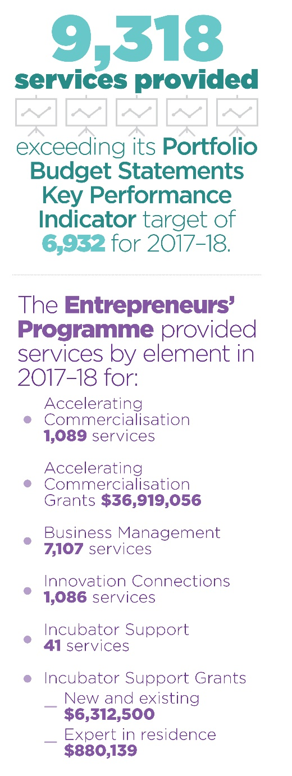The Entrepreneurs’ Programme Committee plays a key role in advising DIIS in selection for Accelerating Commercialisation and Incubator Support grants.

Under the Entrepreneurs’ Programme 9,318 services were provided exceeding its Portfolio Budget Statements Key Performance Indicator target of 6,932 for 2017–18.

The Programme provided services by element in 2017–18 for:

* Accelerating Commercialisation 1,089 services
* Accelerating Commercialisation Grants $36,919,056
* Business Management 7,107 services
* Innovation Connections 1,086 services
* Incubator Support 41 services
* Incubator Support Grants
  + New and existing $6,312,500
  + Expert in residence $880,139

### Case Study — Makinex Construction Products — exporting award-winning Australian designs to break into the US market

The Entrepreneurs’ Programme has assisted Makinex to achieve its vision to make an impactful difference on the global construction industry through the provision of truly unique and innovative Australian-designed solutions to industry-wide problems.

For instance, the ergonomic design of the Makinex Jackhammer Trolley minimises vibration impact on the user and provides safer jackhammer operation by reducing back strain and operator fatigue. It is an innovative demolition tool for the removal of floor tiles, vinyl and cork from concrete and wooden surfaces. Customers claim they can do their demolition job up to six times faster than when using a jackhammer alone. In addition, a focus on health and safety in design helps eliminate hazards and risks before they enter the workplace. Good work design can radically transform the workplace in ways that benefit the business, workers, clients and others in the supply chain.

The Entrepreneurs’ Programme has assisted Makinex to take its product range of Australian-designed solutions into the North American market and increase its export revenue by over 300 per cent – a growth transformation which began just over two years ago. The business has since established an office in Los Angeles with a full-time operations manager.

Translating the businesses goals into reality at a critical time came in the form of a Growth Plan developed by the Entrepreneurs’ Programme’s Business Adviser, Mr John Mills.

”When I reached out to John Mills to find out if our business qualified for any growth services grants he was more than happy to assist,” said Makinex Managing Director, Mr Paul Weaver. “I was impressed with his knowledge of the Programme along with how organised he was with facilitating the process.”

By implementing Mr Mills’ recommendations, Makinex has achieved a dramatic increase in revenue and profitability and increased its staff numbers while continuing to introduce new products to its range.

“The Entrepreneurs’ Programme is a great initiative by the Government which contributed not only to the growth in our numbers but also helped to improve some of our processes,” said Mr Weaver.

Makinex products have won innovation and design awards in Australia, UK, USA and China including the 2016 and 2017 Australian Design Award and a Gold Award in the USA Innovative Products Awards. Makinex Construction Products were the winner of the inaugural Safe Work Australia Award for Good Design in 2016.

### Case Study — Paspalis Enterprise Trust – propelling the best Northern Territory start-ups to success

In 2017, Paspalis Enterprise Trust was awarded $500,000 under the Entrepreneurs’ Programme Incubator Support initiative to create Darwin’s first Innovation Hub (DIH). Working in partnership with the Northern Territory Government and Charles Darwin University, the hub is delivering a range of incubator services to local and regional start-ups to help them access opportunities to commercialise in international markets.

The DIH delivers a structured incubator program which includes a series of workshops that bring industry partners and start-ups together to identify and solve industry challenges. DIH’s incubator program includes: innovation scholarships and investment, early stage mentorship, industry workshops and networking events, Indigenous innovation, and Asia readiness. The hub houses a number of skilled and experienced mentors and coaches from the local community.

A key focus of the program is to develop commercialisation opportunities in the Asia Pacific and China. The DIH is drawing on established networks with countries such as Singapore, China, India, Sri Lanka and Vietnam to help launch Australian innovations throughout the world. Top performing start¬ups will also have the opportunity to travel to China in late 2018 as part of the project.

DIH also offers a purpose built co-working hub which has been constructed to provide up to 25 entrepreneurs with 24 hour access to office space in a hot-desk environment. Board rooms, a business lounge, training rooms and office facilities are also available to resident start-ups.

The DIH already has 25 active start-ups in residence, with another 31 in the pipeline soon to come on board. These include Indigenous entrepreneurs and start-ups located in remote areas of the Northern Territory. The DIH expects to attract 75 start-ups in its first two years of operation, with 25 of those anticipated to commercialise.

One of the hub’s first start-ups, Uber Air Pty Ltd, is central Australia’s key emerging business in aerial survey and asset inspection photogrammetry. The innovative company is providing services to a broad range of public and private organisations and also won the 2017 Chief Minister’s Industry Innovation award.

The DIH has been further boosted by the establishment of the Northern Territory’s first venture capital fund. The Paspalis Innovation Investment Fund has already raised $20 million, with another $30 million of investment capital committed from private investors across the Asia Pacific region.

In June 2018, Paspalis was awarded $100,000 in Incubator Support Expert in Residence funding to second three experts to deliver events, mentoring and workshops to Northern Territory start-ups.

Paspalis Chief Executive Officer and Fund Investment Manager Mr Harley Paroulakis said the fund is ready to propel the best Northern Territory start-ups forward.

“Our investment range is between $50,000 for early stage start-ups and $2,500,000 for larger projects, all of which can demonstrate potential growth of at least 15 per cent per annum,” said Mr Paroulakis.

“The fund will look to invest in Northern Territory start-ups and companies seeking growth in the Asia Pacific region and Asia Pacific companies looking to do business in the Northern Territory.”

### Case Study — JAG Mayer home grown innovation – a safe and independent feeding device taking the baby product market by storm

After experiencing first-hand the mess and waste associated with feeding young children on the go, Julie-Anne and Glen Mayer came together as JAG Mayer and set out to create a mess free feeding dispenser that allowed young children to safely feed themselves independently. In 2015 JAG Mayer was awarded an Accelerating Commercialisation grant of $247,380 under the Entrepreneurs’ Programme which they used to invent Subo - The Food Bottle.

Subo was launched in late 2016, with the product being sold online and at pregnancy and children’s expo shows across Australia. “From the get go, we received great feedback from the market place,” said Ms Mayer. “Parents were excited by the discovery of this new product and could straight away see the benefits of Subo. Word of mouth spread and sales have grown steadily.”

Subo (meaning ‘morsel of food’ in Filipino), has a patented design that requires the contents to be sucked rather than squeezed. In just two years the invention has taken the baby feeding product market by storm.

“Kids mealtime can be very stressful, even more so when feeding on the go! Recently, many parents have turned to expensive squeeze pouches that can be dangerous and messy,” said Ms Mayer. Competitor products are squeezable, often single-use containers, that allow contents to be squeezed out, which creates mess and environmental waste. It is estimated that 1 billion squeeze pouches hit landfill around the globe each year.

At the heart of Subo’s clever design is the non-squeezable cylindrical body, a moving platform and a one-way valve. Foods such as yoghurt, purees, soft cereals and even tinned spaghetti are filled into the tube on top of the platform. As the child sips the food through the spout, the platform automatically moves up the tube dispensing the food directly into the user’s mouth reducing the risk of a mess. The re-useable Subo is easily disassembled making it easy to clean and refill. “Imagine feeding kid’s yoghurt on the go, like in the pram when you’re shopping without having to clean up a mess!” said Mr Mayer.

The Melbourne-based company manufacture locally, and is a proud licensee of the Australian Made campaign. According to Mr Mayer, “Manufacturing locally allows us to ensure the highest quality materials and safety measures are met” Subo has been tested to Australian and European standards to ensure safe use without choking or entrapment hazards.

The Accelerating Commercialisation funding was used to develop manufacturing tools, further intellectual property strategies and achieve international standards certification. “Bringing Subo to life has been a difficult but rewarding journey that would not have happened without the support of the Government,” said Mr Mayer. “We are very grateful to have received the funding and advice from the expert networks.”

The experience and networks of JAG Mayer’s Commercialisation Adviser, Ms Elane Zelcer have been of tremendous help to JAG Mayer. Glen and Julie-Anne say that without Ms Zelcer’s advice and support from back when Subo was only an idea, the product would not have been commercialised.

In June 2018 a private investor was amazed by “the incredible design” and offered to provide funding to JAG Mayer. The company is currently focused on adding to their stockist list in Australia, now over 50, and capitalising on the interest from overseas distributors.

### Case Study — TAE Aerospace – a business research collaboration utilising augmented reality to globalise tech support

The Entrepreneurs’ Programme has teamed up with CSIRO and TAE Aerospace to assist the development of a world leading technology which uses augmented reality to repair and maintain aircraft remotely. The technology was made possible by Innovation Connections, an element of the Entrepreneurs’ Programme, which brokered a collaboration between TAE Aerospace and the CSIRO – resulting in the creation of a new technology company – Fountx.

Fountx is a headset and wearable PC in a backpack form which connects to another PC somewhere in the world via internet and video conferencing. The headset gives the end user or the remote technical person access to expert knowledge from across the globe. Fountx is suitable for use in areas with restricted access and in hazard-filled workplaces, improving safety while the user performs complex tasks. It is a hands-free system comprising a head mounted display and camera.

Just over two years ago TAE Aerospace was looking for an innovative solution to overcome vast distances and provide expert knowledge and skills for its clients anywhere in the world at a moment’s notice. They became aware of advanced research being conducted at CSIRO to develop a next generation real-time telepresent interaction between individuals and teams. Under a licensing agreement and working alongside CSIRO, Fountx has commercialised this world-leading assisted reality system which is now available globally.

“Having the product actually reach the market place is just amazing,” said CSIRO Energy Senior Projects Research Officer, Mr Craig James. “You work on these pieces of technology for years and you think you know how it’s going to be applied... the science and the industry together is really important and that’s actually where we find we have the most impact, by bringing technologies through to actual use. That’s where innovation occurs.”

Fountx will initially service the aerospace and defence industries, however it is rapidly gaining momentum in other industries.

“What really surprised us was the different applications that came out of this in medical, in construction, mining, power and utilities. Suddenly it broadened what we could do with this product,” said Fountx Head of Sales, Mr Andy Jones.

“We would absolutely recommend the Entrepreneurs’ Programme,” said Mr Jones. “It is a perfect way to get access to the right people. To help speed with development of projects and to take away a little bit of that risk”.

## Program Overview — Business Research Innovation Initiative (BRII)

The *Business Research and Innovation Initiative* (BRII) is a pilot program that was announced in December 2015 as part of the ‘Government as an exemplar’ pillar of the National Innovation and Science Agenda.

The BRII is a competitive grant program that aims to drive innovation within small to medium enterprises (SMEs) and government. It offers competitive grants to encourage SMEs to develop solutions to public policy and service delivery challenges nominated by Australian Government agencies. It seeks to:

* Stimulate the innovative capacity of SMEs and Australian Government agencies
* Improve business capability to access national and international markets
* Develop SME’s confidence and awareness when working with government as a possible customer
* Encourage Australian Government agencies to source innovative solutions

Each round provides up to $2 million for feasibility studies and up to $10 million for proofs of concept across five challenges. The SMEs with the best proposals for each challenge receive grants of up to $100,000 to test the feasibility of their ideas over three months, and they may then apply for up to $1 million to develop a prototype or proof of concept over a period of up to 18 months.

At the conclusion of the proof of concept, Australian Government agencies can consider purchasing the solutions developed through the program, but are under no obligation to do so.

The SMEs retain full rights to their solution and any intellectual property, and are then able to pursue further commercialisation opportunities domestically and worldwide.

The BRII is administered by the DIIS- and is delivered by AusIndustry. The BRII is delivered in three stages:

* Challenge Selection

1. Australian Government Agencies submit challenges
2. Innovation and Science Australia shortlist challenges through assessment process
3. Minister approves shortlisted challenges
4. Challenges are announced by the Minister

* Feasibility Study

1. SMEs apply to respond to a challenge
2. Innovation and Science Australia assess applications
3. Minister approves recommended applications for funding
4. Successful SMEs conduct feasibility studies

* Proof of Concept

1. Successful SMEs apply for proof of concept grant
2. Innovation and Science Australia assess applications
3. Minister approves recommended applications for funding
4. Successful SMEs conduct proof of concepts

The BRII Round 1 pilot officially launched with five challenges from Australian Government agencies:

* On-the-spot technology for measuring pyrethroid surface residue: *Department of Agriculture and Water Resources* (DAWR)
* Tracking the effect and value of information products: *Australian Transaction Reports and Analysis Centre* (AUSTRAC) and the *Australian Criminal Intelligence Commission* (ACIC)
* Digitally enabled community engagement in policy and program design: *Departments of Industry, Innovation and Science* (DIIS) and *Social Services* (DSS)
* Improve transparency and reliability of water market information: *Department of Agriculture and Water Resources* (DAWR)
* Sharing of information nationally to ensure child safety: *Department of Social Services* (DSS)

All 20 grant recipients who had previously completed feasibility studies in June 2017 submitted applications for proof of concept grants. In September 2017, nine applicants were awarded proof of concepts grants by the Minister. The list of grant recipients is available at [**www.business.gov.au/BRII**](http://www.business.gov.au/BRII).

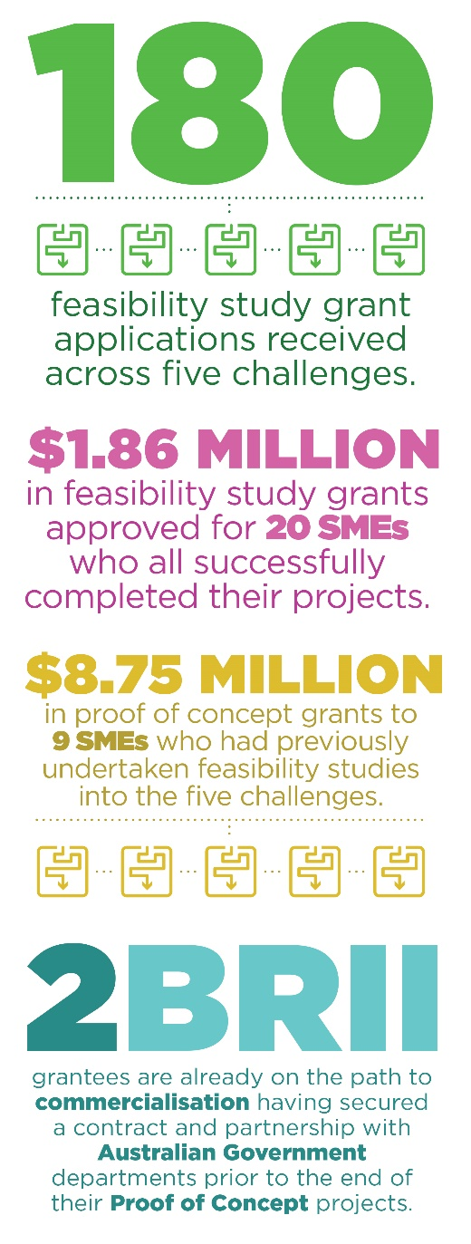The nine recipients are now working with their respective Australian Government agency to develop prototypes of their proposed solutions to the challenges. Final concepts will be presented by April 2019.

An evaluation of the program commenced in early 2018. The Post-Commencement Evaluation is focusing on the need, design, implementation, short-term outcomes and performance measurement of the program to date. The evaluation suggests SME participants are undertaking new R&D, commercialising IP, and developing new collaborations. On the Government side, it is already acting as a catalyst for innovation within some of the participating agencies. The evaluation will be finalised in September 2018.

Program results include:

* 180 feasibility study grant applications received across five challenges.
* $1.million in feasibility study grants approved for 20 SMEs who all successfully completed their projects.
* $8.75 million in proof of concept grants to 9 SMEs who had previously undertaken feasibility studies into five challenges.
* 2BRII grantees are already on the path to commercialisation having secured a contract and partnership with Australian Government departments prior to the end of their Proof of Concept projects.

Some examples of the grant recipients who have participated in the program are outlined on the following pages.

### Case Study — Likely Theory

Likely Theory, established in 2015, is an experienced team of entrepreneurs, engineers, psychologists and policy officers that focus on tackling complex organisational decision making and policy analysis issues in both the public and private sectors.

Converlens, Likely Theory’s proposed solution to the *digitally enabled community engagement in policy and program design* challenge, allows communities and stakeholders to collaborate on policy and program design. It includes modern information collection and engagement techniques that enable communities to build and to continue to participate.

The proof of concept stage has allowed Likely Theory to develop a platform that combines existing technologies and new data processing methods to produce a cost-effective and easy-to-use web-based consultation platform. The platform includes natural language and automated data processing to analyse input and better harness social media to reach more stakeholders. They are scheduled to complete their project in late 2018.

As a result of participating in the BRII, Likely Theory has achieved early commercialisation success by having their Converlens platform selected by the Department of the Prime Minister and Cabinet to support the APS Review that was announced by the Government on 4 May 2018. They have also identified other viable applications for their technology and are pursuing further commercialisation opportunities.

“BRII has enabled us to significantly investigate, model and analyse approaches to digitally enabled community policy engagement, specifically within in the context of public service requirements.

The BRII provided an exciting platform for us to engage in dialogue with the agencies, with direct access to staff which provided critical and invaluable guidance during our research into a wide variety of techniques and methodologies related to the challenge.

The high level of stakeholder access and support offered throughout BRII has helped inform our product development and ultimately led to our commercial success. We have found the program highly valuable and engaging and would encourage any business considering participation in future rounds of BRII to apply.”

MR TOM WORKMAN, LIKELY THEORY PTY LTD

### Case Study — Atamo

Atamo was established in 2003 and specialises in developing professional electronic engineering solutions. Over the course of the feasibility and proof of concept stages for the *On-the-spot technology for measuring pyrethroid surface residue* challenge, Atamo has developed a hand-held portable automated spectrometer system to measure pyrethroid residues on various internal aircraft surfaces. Atamo has collaborated with several individuals and companies to develop this solution, including researchers who helped to test and refine technical elements of the initial design, and several businesses that helped to produce the prototype.

As a result of BRII, Atamo has been able to expand its innovative capacity and access new commercial opportunities. The proof of concept funding has enabled Atamo to fund its R&D at a scale they wouldn’t have been able to achieve without the grant, and has provided the company the certainty needed to employ three graduates. Atamo has identified several applications of their solution beyond the scope of the BRII challenge, for which it has already started to pursue commercialisation pathways.

The company has joined with the Innovative Vector Control Consortium (IVCC) in a Product Development Partnership funded by the Department of Foreign Affairs and Trade to develop and disseminate vector control technologies for malaria and other vector borne diseases.

Atamo has also negotiated a Memorandum of Understanding (MoU) with a speciality chemical manufacturer for global aviation. The MoU establishes a basis to collaborate in commercialising the product. Atamo has registered one patent and expects to develop an additional two patents. Atamo has engaged an intellectual property law firm to provide advice regarding the intellectual property strategy and implementation.

“BRII has provided the opportunity to identify and address a market opportunity we would not otherwise have identified.

The evaluation process to be awarded the funding for the Feasibility Study and the Proof of Concept has added credibility in our dealings with potential commercial partners, allowing us to progress commercial arrangements more rapidly than would otherwise be possible.

Ongoing communications facilitated by the BRII team with DAWR has helped us ensure we are developing the technology in a way that will be readily adopted by DAWR and meet their requirements for a solution. BRII has initiated planning for procurement processes post the Proof of Concept phase enabling us to plan the business case for commercialisation with more certainty that would otherwise have been possible.”

MR STEWART SNELL, CHIEF EXECUTIVE OFFICER – ATAMO PTY LTD

## Legacy programs

As at 30 June 2018, ISA continues to monitor the following programs which are closed to applications:

* Innovation Investment Follow-on Fund
* Innovation Investment Fund
* Pooled Development Funds
* Pre-Seed Fund

AusIndustry (a division of DIIS) will continue to work with legacy program customers.

# Section Two – Governance

Innovation and Science Australia

Legislation

Organisation and management

Board and committee membership in 2017-18

Structure of Innovation and Science Australia

Meetings of Innovation and Science Australia in 2017-18

Legal matters/Litigation

## Innovation and Science Australia

In 2017–18, ISA delivered the 2030 Plan; provided advice to Government on innovation, science and research matters; assisted with the administration of the Government’s industry research and development, innovation and venture capital programs; and engaged with stakeholders across Government and the innovation, science and research communities. Through these activities, ISA sought to encourage a more entrepreneurial Australian innovation, science and research system, with an increased level of investment and commercial success in Australian industry.

In 2017–18, ISA reported to the Minister for Industry, Innovation and Science and subsequently the Minister for Jobs and Innovation.

## Legislation

### The Industry Research & Development Act 1986

ISA operates under the authority of the *Industry Research and Development Act 1986* (IR & D Act). The aim of the IR & D Act is to facilitate provision of independent strategic advice about industry, innovation, science and research, and to promote the development, and improve the efficiency and international competitiveness, of Australian industry by encouraging research and development, innovation and venture capital activities.

**Functions and powers of ISA**

ISA’s functions are set out in the IR & D Act and associated Ministerial Directions. The Board’s responsibilities include:

* provision of independent strategic whole-of-government advice to Government in relation to industry, innovation, science and research matters
* promote investment in industry and Australia’s innovation, science and research system
* co- administration, monitoring and operation of the R&D Tax Incentive
* registering, monitoring and revoking the registrations of Venture Capital Limited Partnerships and Early Stage Venture Capital Partnerships
* co-administration and oversight of the Cooperative Research Centres Program
* strategic oversight of the Entrepreneurs’ Programme, which includes administration and monitoring of Accelerating Commercialisation and Incubator Support Initiative
* monitoring ongoing projects under programs which are now closed to applications (see list of legacy programs on page 70)
* advising the Minister about the operation of the IR & D Act, the *Pooled Development Funds Act 1992* and the *Venture Capital Act 2002*, and the Commonwealth’s income tax laws as they operate in relation to those Acts.

Ministerial Directions issued to the former Innovation Australia Board and the ISA Board also provided additional functions. In the 2017–18 reporting period ISA continued to undertake these additional functions as they relate to the Government’s innovation programs.

In December 2016, the Government provided ISA with a Statement of Expectations regarding how ISA would support the Government to transform Australia into a leading innovation nation that is capable of continued economic prosperity and creation of new job opportunities. ISA has delivered the two priority tasks set out in this Statement of Expectations: the Performance Review of the Australian Innovation, Science and Research System, and the 2030 Plan. A revised Statement of Expectations is expected to be provided to ISA in the 2018–19 reporting period.

**Financial responsibilities of ISA under the IR&D Act**

ISA has no financial responsibility for program-related grants, loan or licence agreements entered into after 10 September 2004. This follows amendments to the IR & D Act which came into effect on 11 September 2004, and removed powers of the former Innovation Australia to commit, approve or recommend expenditure of Government funds and further safeguard members from any personal liability stemming from Board membership.

## Organisation and management

ISA uses a committee structure to help support the administration and provide expert advice on innovation and venture capital programs. As at 30 June 2018, five committees report to ISA; each committee has the following specific functions:

* **R&D Tax Incentives Committee** – responsible for advising the Board about the operations of the R&D Tax Concession program for income years commencing before 1 July 2011 and the R&D Tax Incentive program for income years commencing on or after 1 July 2011. In particular, it is responsible for assessing activities registered across all sectors, including providing certificates to the Commissioner for Taxation about the eligibility of activities registered for the concession and the incentive. The committee also advises on operational policy aspects of the R&D Tax Concession program and the R&D Tax Incentive program. The R&D Incentives Committee met eight times in 2017–18.
* **Cooperative Research Centres Advisory Committee** – established to implement the recommendations of the *Growth through Innovation and Collaboration: A review of the Cooperative Research Centres* (CRC) Program Report. The committee’s ongoing role is to provide advice and recommendations on applications for funding, the progress and performance of individual CRCs, and the operation of the CRC Program. The CRC Advisory Committee met five times in 2017–18.
* **Innovation Investment Committee** – responsible for activities relating to the Government’s venture capital programs. Enhancements to the *Venture Capital Limited Partnerships* (VCLP) regime announced in the National Innovation and Science Agenda has led to additional program interest. The committee is responsible for meeting the legislated requirements to consider VCLP and Early Stage Venture Capital Limited Partnerships (ESVCLP) registrations within 60 days. The Innovation Investment Committee met ten times in 2017–18.
* **Biomedical Translation Fund Committee** – administers the *Biomedical Translation Fund* (BTF) program and guides the DIIS throughout the lifecycle of the program. The BTF Committee met four times in 2017–18.
* **Entrepreneurs’ Programme Committee** – responsible for providing merit assessments and merit ranking recommendations on applications under the *Accelerating Commercialisation* and the *Incubator Support Initiative*. Elements of the *Entrepreneurs’ Programme*, the Australian Government’s flagship initiative for business competitiveness and productivity at the firm level. The committee also provides merit assessments for the *Business Research Innovation Initiative* which supports Australian businesses to develop innovative solutions that address persistent Government challenges. The Entrepreneurs’ Programme Committee met eight times in 2017–18.

### Membership

Members of ISA are appointed by the portfolio Minister in writing. The IR & D Act provides for a maximum of 15 members, including the Chair, Deputy Chair and an ex-officio member. Four members of ISA constitute a quorum.

ISA committee members are appointed by the portfolio Minister and operate under delegation from ISA. Committees comprise a Chair and up to six members, with three committee members constituting a quorum.

ISA Board and committee members are individuals with an appropriate mix of professional and technical expertise across a broad section of industries, technologies and capital markets, as well as experience in commercialisation of industry innovation, corporate governance and business finance.

ISA and its committee members, other than the ex-officio members, are remunerated in accordance with determinations set by the Remuneration Tribunal.

### Conduct of Board

ISA’s primary policy setting out requirements for board and committee member conduct and the disclosure and management of member’s pecuniary and non-pecuniary interests is the Disclosure of Interest Guidelines. As statutory office holders, board and committee members are also bound by the Australian Public Service Code of Conduct as per sections 13 and 14 of the *Public Service Act 1999*.

More details on Disclosure of Interest Framework and Code of Conduct are published on the [www.industry.gov.au](http://www.industry.gov.au) website.

### Office of Innovation and Science Australia

While ISA is independent of Government by virtue of its founding statute, ISA is supported by OISA, which is located within, and supported by, DIIS. OISA supports ISA in providing advice to the Government. As part of the development of its advice to Government, ISA, (through OISA), undertakes consultation with relevant government portfolios, industry, the innovation community, and the research and science communities.

OISA is headed by Dr Charles Day, Chief Executive Officer, an appointment approved by the Board and engaged through DIIS. OISA also has a dedicated Board Manager. Resources in the OISA as at 30 June 2018 were: the CEO, 11 full time staff and one graduate.

To successfully deliver the 2030 Plan, OISA established a multidisciplinary taskforce from across the innovation, science and research system, comprising of secondees from; the Department of Defence, Austrade, the Department of Health, Geoscience Australia, National Health & Medical Research Council, the Australian National University, ANSTO, CSIRO’s; Data 61, and the Australian Research Council.

### Partners in delivery

AusIndustry is the program delivery division of DIIS. AusIndustry staff in the national, state, territory and regional offices provide project reporting services, technical assessment and promotional services for the programs that ISA oversees. AusIndustry officers also advise customers about the range of government industry support programs.

AusIndustry (on behalf of ISA) and the ATO jointly administer the R&D Tax Incentive, the R&D Tax Concession, the venture capital tax programs and Pooled Development Fund. AusIndustry manages the registration of research and development activities and conducts compliance reviews related to the eligibility of these activities. The ATO determines if the expenditure that is claimed in a tax return for research and development activities is eligible.

The Department of Health has policy responsibility for the Biomedical Translation Fund (BTF) and DIIS. AusIndustry administers the Fund.

### Board members as at 30 June 2018

| NAME | TITLE | PHOTO | TERM OF APPOINTMENT |
| --- | --- | --- | --- |
| Mr Bill Ferris AC  CHAIR | Co-Founder and Co-Chair  CHAMP Private Equity | Photo of Bill Ferris | 12 November 2015 to 11 November 2018 |
| Dr Alan Finkel AO | Australia’s Chief Scientist | Photo of Dr Alan Finkel | 10 March 2016 to  24 January 2019 |
| Dr Bronte Adams AM | Managing Director,  Dandolo Partners  International | Photo of Dr Bronte Adams | 24 October 2016 to  16 August 2019 |
| Dr Michele Allan | Chancellor Charles Sturt University | Photo of Dr Michele Allan | 10 March 2016 to 27 October 2018 |
| Mr Paul Bassat | Co-Founder Square Peg Capital | Photo of Paul Bassat | 10 March 2016 to 27 October 2018 |
| Ms Maile Carnegie | Group Executive, Digital Banking, ANZ Bank | Photo of Maile Carnegie | 10 March 2016 to 24 January 2019 |
| Mr Scott Farquhar | Co-founder and Co-CEO, Atlassian | Photo of Scott Farquar | 10 March 2016 to 27 October 2018 |
| Professor Bronwyn Harch | Executive Director, Institute for Future Environments, QUT | Photo of Professor Bronwyn Harch | 24 October 2016 to 16 August 2019 |
| Mr Daniel Petre AO | Partner, Air Tree Ventures | Photo of Daniel Petre | 10 March 2016 to 27 October 2018 |
| Dr Christopher Roberts AO | Non-Executive Director, ResMed | Photo of Dr Christopher Roberts | 10 March 2016 to 24 January 2019 |
| Mr Saul Singer | (International member)  Editorial Board member, Times of Israel; Author | Photo of Saul Singer | 5 May 2016 to 24 January 2019 |
| Dr Heather Smith PSM | (ex-officio)  Secretary, Department of  Industry, Innovation and  Science | Photo of Dr Heather Smith | Ex-officio 18 September  2017 to 30 June 2018 |
| Dr Marlene Kanga AM | Director, iOmniscient Pty Ltd | Photo of Marlene Kanga | 15 September 2017 to 12  September 2019 (past Board  member 3 August 2013 to 4 August 2016*; 15 September 2016 to 14 September 2017) |

Members who retired from the Board in 2017–18

| NAME | TITLE | PHOTO | TERM OF APPOINTMENT |
| --- | --- | --- | --- |
| Ms Glenys Beauchamp | PSM (ex-officio)  Secretary, Department of  Industry, Innovation and Science | Photo of Glenys Beauchamp | Ex-officio 1 July 2017 to 17 September 2017 |
| Dr Rufus Black | Master Ormond College, President Museum of Victoria, Deputy Chancellor of Victoria University | Photo of Rufus Black | 24 October 2016 to  31 December 2017 |
| Ms Elizabeth Comstock | Vice Chair, GE President  and CEO, GE Business  Innovations | Photo of Elizabeth Comstock | 17 August 2016 to  9 January 2018 |

### Committee members as at 30 June 2017

**R&D Incentives Committee**

| NAME | TITLE | TERM OF APPOINTMENT |
| --- | --- | --- |
| Dr Marlene Kanga AM  CHAIR | Director, iOmniscient Pty Ltd | 5 August 2013 to 4 August 2016,  16 August 2016 to 15 August 2019 |
| Ms Kathryn Adams | Senior Research Fellow, Griffith University | 4 September 2014 to 3 September 2015,  14 September 2015 to 13 September 2018 |
| Mr Marty Gauvin | President and CEO, Virtual Ark Pty Ltd | 14 September 2015 to 13 September 2018 |
| Mr Stevan Green | Principal, GreenEng Consulting | 4 September 2014 to 3 September 2015,  14 September 2015 to 13 September 2018 |
| Ms Julie Phillips | CEO, BioDiem Ltd | 14 September 2015 to 13 September 2018 |
| Ms Joanne Mulder  EX-OFFICIO | DIIS | N/A |

**Cooperative Research Centres (CRC) Advisory Committee**

| NAME | TITLE | TERM OF APPOINTMENT |
| --- | --- | --- |
| Mr Philip Clark AM  CHAIR | Director | 18 June 2015 to 17 June 2018 |
| Ms Kylie Sproston  CHAIR | CEO, Bellberry Ltd | 20 October 2016 to 19 October 2019 (member)  18 June 2018 to 17 June 2021 (Chair) |
| Dr Michele Allan | Chancellor, Charles Sturt University | 18 June 2015 to 17 June 2018 |
| Professor Ian Chubb AC | Former Australian Chief Scientist | 18 June 2015 to 17 June 2018  18 June 2018 to 17 June 2021 |
| Professor Christobel Saunders AO | Professor of Surgical Oncology, School of Surgery, The University of Western Australia | 20 October 2016 to 19 October 2019 |
| Mr Douglas Stuart | Chief Marketing Officer, Instaclustr | 20 June 2017 to 19 June 2020 |
| Ms Sue Weston  EX-OFFICIO | DIIS | N/A |

**Innovation Investment Committee**

| NAME | TITLE | TERM OF APPOINTMENT |
| --- | --- | --- |
| Mr Marty Gauvin  CHAIR | President and CEO, Virtual Ark Pty Ltd | 20 April 2016 to 19 April 2019 |
| Professor Stephen Barkoczy | Professor, Faculty of Law, Monash University | 20 April 2016 to 19 April 2019 |
| Ms Jan Bingley | Founder & Principal, UCX Consulting Pty Ltd | 20 April 2016 to 19 November 2018 |
| Ms Amanda Heyworth | Non-executive Director | 20 April 2016 to 19 November 2018 |
| Ms Jennifer Kay  EX-OFFICIO | DIIS | N/A |

**Biomedical Translation Fund Committee**

| NAME | TITLE | TERM OF APPOINTMENT |
| --- | --- | --- |
| Mr Peter Wills AC  CHAIR | Director, Wills Advisory | 2 May 2016 to 1 May 2019 |
| Professor Melissa Little | Professor, NHMRC Senior Principal Research Fellow Murdoch Children’s Research Institute | 2 May 2016 to 1 May 2019 |
| Ms Fiona Pak-Poy | Non-executive Director, Securities Industry Research Centre of Asia | 2 May 2016 to 1 May 2019 |
| Dr Deborah Rathjen | Chief Executive Officer & Managing Director, Bionomics Ltd | 2 May 2016 to 1 May 2019 |
| Dr Leanna Read | Chief Scientist for South Australia | 2 May 2016 to 24 January 2019 |
| Dr Christopher Roberts AO | Chair, OncoSil Medical Limited | 2 May 2016 to 24 January 2019 |
| Mr Jeremy Samuel | Founder & Managing Director, Anacacia Capital | 2 May 2016 to 24 January 2019 |

**Entrepreneurs’ Programme Committee**

| NAME | TITLE | TERM OF APPOINTMENT |
| --- | --- | --- |
| Mr Chris Farquhar  CHAIR | CEO and Director, iCetana Pty Ltd | 1 July 2015 to  30 June 2018 |
| Ms Teresa Engelhard | Non-executive Director, (GAICD) Origin Energy, Planet Innovation, StartupAus and Redkite Charity | 1 July 2015 to 30 June 2018 |
| Dr Carrie Hillyard | Chair, Fitgenes Australia Ltd  Chair, FizzioFit Pty Ltd  Deputy Chair, Mater Medical Research Institute (MMRI) Pty Ltd  Chair, Hawaii Biotech Australia Pty Ltd | 1 July 2015 to 30 June 2018 |
| Mr Anthony Surtees | Co-founder and Director of Marketing and Strategy, Zeetings Pty Ltd | 1 July 2015 to 30 June 2017  1 July 2017 to 30 June 2020 |
| Mr Steve Telburn | Managing Director, Secret Sauce IP Ventures | 1 July 2015 to 30 June 2018 |

### Structure of Innovation and Science Australia as at 30 June 2018

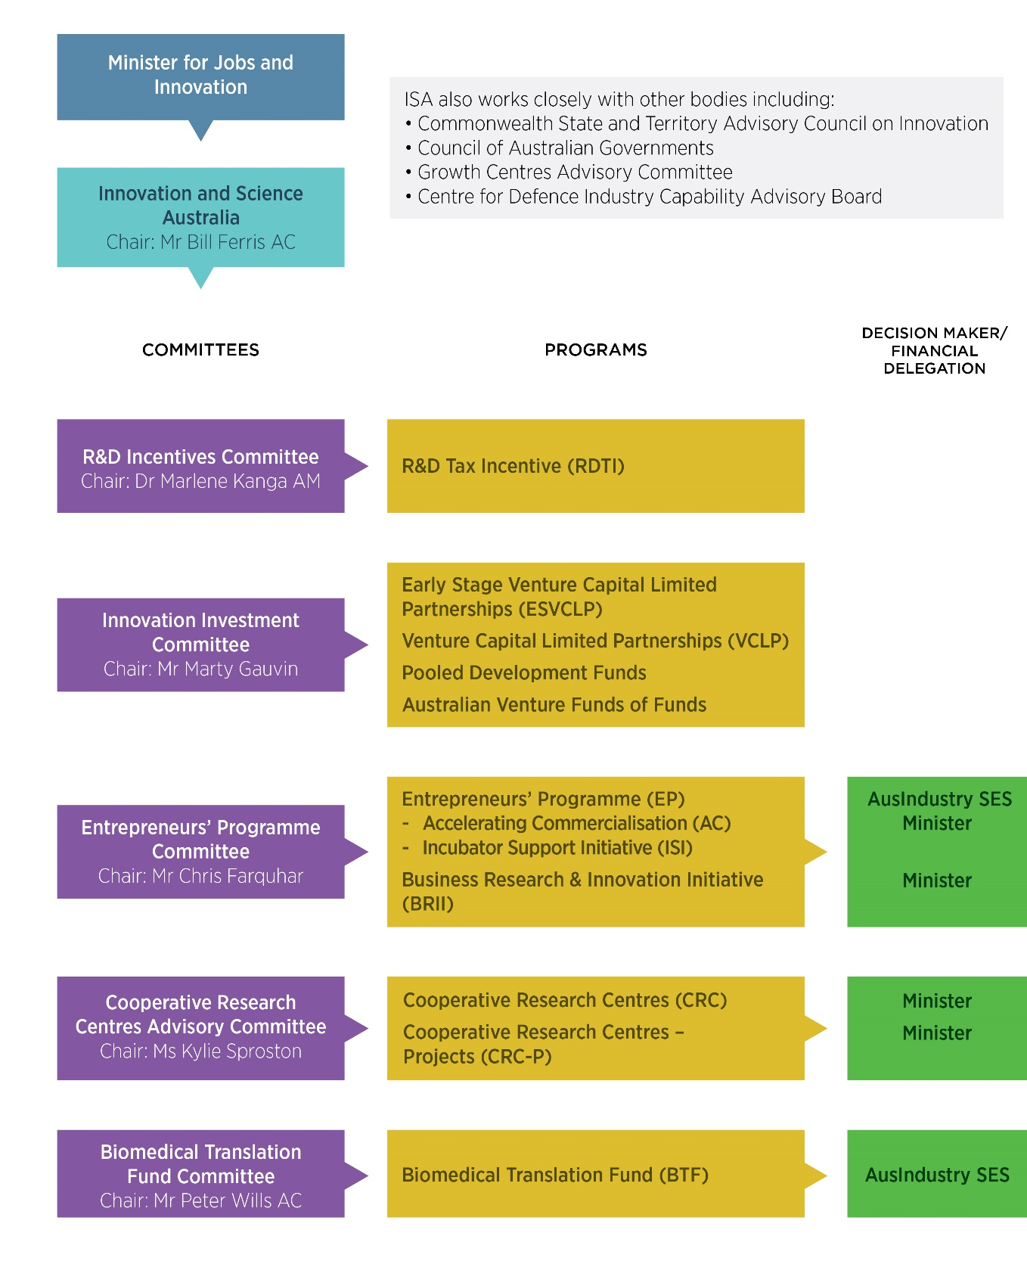

ISA leadership:

* Minister for Jobs and Innovation
* Innovation and Science Australia, Chair Mr Bill Ferris AC

ISA also works closely with other bodies including:

* Commonwealth State and Territory Advisory Council on Innovation
* Council of Australian Governments
* Growth Centres Advisory Committee
* Centre for Defence Industry Capability Advisory Board

ISA committees, programs and delegated decision makers are outlined below.

| COMMITTEES | PROGRAMS | DECISION MAKER / FINANCIAL DELEGATION |
| --- | --- | --- |
| R&D Incentives Committee  Chair: Dr Marlene Kanga AM | R&D Tax Incentive |  |
| Innovation Investment Committee  Chair: Mr Marty Gauvin | Early Stage Venture Capital Limited  Partnerships  Venture Capital Limited Partnerships  Pooled Development Funds  Australian Venture Funds of Funds |  |
| Entrepreneurs’ Programme Committee  Chair: Mr Chris Farquhar | Entrepreneurs’ Programme  - Accelerating Commercialisation  - Incubator Support Initiative  Business Research & Innovation Initiative | AusIndustry SES Minister  Minister |
| Cooperative Research Centres Advisory Committee  Chair: Ms Kylie Sproston | Cooperative Research Centres  Cooperative Research Centres – Projects | Minister  Minister |
| Biomedical Translation Fund Committee  Chair: Mr Peter Wills AC | Biomedical Translation Fund | AusIndustry SES |

### Meetings

ISA held five meetings during 2017–18:

* 4 August 2017, Sydney
* 5 October 2017, Melbourne
* 7 December 2017, Canberra
* 15 February 2018, Canberra
* 3 May 2018, Sydney

Innovation and Science Australia also considered a number of matters via teleconference and out of session.

### Legal matters/litigation

During 2017–18, ISA was involved in one matter before the Federal Court of Australia. That application was made in 2017–18 and resolved by agreement with the applicants.

In the same period, ISA was involved in a total of 43 matters before the Administrative Appeals Tribunal (AAT).

Seventeen new applications for external review were received during the year. One further application was made to the AAT for an extension of time to make an application for external review. That extension of time was granted but the applicant did not subsequently make an application for external review. Twenty-five matters continued in 2017–18 from applications made in earlier years: of these, four matters were initiated in 2014–15, three matters were initiated in 2015–16 and 18 matters were initiated in 2016–17.[6]

The AAT handed down decisions on two applications. It affirmed ISA’s decision on two applications. In the third application, the AAT set aside ISA’s decision to refuse an applicant an extension of time to register activities for the Research and Development Tax Incentive, and substituted a decision allowing that extension of time.

Thirteen matters were discontinued or withdrawn by applicants. Four matters were resolved by agreement with the applicants.

As at 30 June 2018, there were 22 active matters before the AAT involving ISA. Some matters are heard together by the AAT as they are related to each other. Accordingly, there were 20 separate proceedings before the AAT involving ISA as at 30 June 2018.

*Current litigation matters*

| Current cases as at 30 June 2018 | Federal Court | Administrative Appeals Tribunal |
| --- | --- | --- |
| Board as appellant/applicant | 0 | 0 |
| Board as respondent | 0 | 22 |

| Resolution of matters 2017-18 | Federal Court | Administrative Appeals Tribunal |
| --- | --- | --- |
| Decision | 0 | 3 |
| Withdrawal | 0 | 13 |
| Agreement | 1 | 4 |
| Other finalisation | 0 | 1 |

# Acronym list

**A**

AAT Administrative Appeals Tribunal

AC Accelerating Commercialisation

ACIC Australian Criminal Intelligence Commission

AFOF Australian Venture Capital Fund of Funds

AFR Australian Financial Review

AI Artificial intelligence

AICD Australian Institute of Company Directors

AiGroup Australian Industry Group

AIMS Australian Institute of Marine Science

AINRehab Australian Institute of Neuro-rehabilitation

ANSTO Australia’s Nuclear Science and Technology Organisation

APS Australian Public Service

ASEAN Australian Private Equity and Venture Capital Association Limited

ATO Australian Taxation Office

AUSTRAC Australian Transaction Reports and Analysis Centre

AVCAL Australian Private Equity and Venture Capital Association Limited

**B**

BAA Boeing Aerostructures Australia

BERD Business Expenditure on Research and Development

BIPV Building Integrated Photovoltaic

BRII Business Research Innovation Initiative

BR & T Boeing Research & Technology

BTF Biomedical Translation Fund

**C**

CEDA Committee for Economic Development of Australia

CRC Cooperative Research Centres

CRC-P Cooperative Research Centres-Projects

CSIRO Commonwealth Scientific and Industrial Research Organisation

CT Coiled Tubing

**D**

DAWR Department of Agriculture and Water Resources

DET CRC Deep Exploration Technologies CRC

DIH Darwin Innovation Hub

DIIS Department of Industry, Innovation and Science

DSS Department of Social Services

**E**

EP Entrepreneurs’ Programme

ESVCLP Early Stage Venture Capital Limited Partnership

EVCI Eligible Venture Capital Investor

**G**

GDP Gross Domestic Product

GFC Global Financial Crisis

GTS Global Talent Scheme

**I**

IR&D Industry Research and Development

IR&D Act *Industry Research and Development Act 1986*

ISA Innovation and Science Australia

IS Incubator Support

ISI Incubator Support Initiative

IVCC Innovative Vector Control Consortium

**M**

METS Mining Equipment Technology and Services

ML Machine Learning

MoU Memorandum of Understanding

**N**

NISA National Innovation and Science Agenda

**O**

OECD Organisation for Economic Co-operation and Development

OISA Office of Innovation and Science Australia

**P**

PC Productivity Commission

**Q**

QUT Queensland University of Technology

**R**

R&D Research and Development

RDTI Research and Development Tax Incentive

**S**

SaaS Software as a Service

SME Small to Medium Enterprise

STEM Science, Technology, Engineering and Mathematics

**T**

The Board Innovation and Science Australia

The 2030 Plan Australia 2030: Prosperity through Innovation

The 3 Fs Ferris, Finkel, and Fraser 2016 Review of the Research & Development Tax Incentive

**U**

UA Universities Australia

UTS University of Technology Sydney

**V**

VC Act *Venture Capital Act 2002*

VCLP Venture Capital Limited Partnerships

1. *The Sources of Economic Growth in OECD Countries* (Paris: OECD, 2003).
2. Legacy programs which are no longer open to new applicants and which Innovation and Science Australia maintains oversight are listed at page 70.
3. Note that there are two other components of the Entrepreneurs’ Programme, the Business Management component and the Innovation Connections component, which are not included here because ISA does not have a formal role in overseeing them.
4. All data as at 30 June 2018.   
   Please note that income year 2016–17 is still incomplete. Companies with a substituted accounting period (SAP), ending after 30 June 2017 (but before 31 December 2017) may continue to register for the R&D Tax Incentive until 30 September 2018. There are around 200 of these R&D-performing entities, which are often referred to as ‘late balancers’.
5. Mr Paul Bassat is a ISA Board member.
6. The 2016–17 Innovation and Science Australia Annual Report stated that 17 applications had been made in that financial year. That figure did not include three applications that were joined to matters initiated in prior years. A total of 20 applications were made in 2016–17, of which two were withdrawn by the applicants prior to 30 June 2017 and 18 continued into 2017–18.