Marine science: a story for Australia
  - Final report
Prepared by the Inspiring Australia Expert Working Group on Engaging Australians in the Marine Sciences
November 2012

Prepared by the Expert Working Group on Engaging Australians in the Marine Sciences
Chaired by Dr Ian Poiner
Convened by Steve Clarke
Science Communication Manager
Australian Institute of Marine Science
as part of Inspiring Australia.
For more information about Inspiring Australia, please contact:
Manager
Inspiring Australia Strategy
Questacon – The National Science and Technology Centre
Department of Industry, Innovation, Science, Research and Tertiary Education
PO Box 5322
Kingston ACT 2604
Telephone: +61 2 6270 2868
Email: Inspiring.Australia@innovation.gov.au
You can access this report from the Department’s Internet site at:
http://www.innovation.gov.au/InspiringAustralia
Copyright
With the exception of material that has been quoted from other sources and is identified by the use of quotation marks ‘ ’, or other material explicitly identified as being exempt, material presented in this report is provided under a Creative Commons Attribution 3.0 Australia licence.

The details of the relevant licence conditions are available on the Creative Commons website at http://creativecommons.org/licenses/by/3.0/au/deed.en.
ISBN 978-0-642-32271-5 (print)
978-0-642-32277-7 (electronic)
The document should be attributed as Marine science: a story for Australia.

Contents
Acknowledgments v
Executive summary vii
Summary of recommendations x
Resourcing xi
Introduction 1
Our scope: marine, marine science and its communication 1
About the expert working group 2
Inspiring Australia 3
Background 4
Report and recommendations 13
Developing a national approach to marine science communication 13
Bringing marine science into the community 19
Getting marine science into the media 32
Using marine science to inform national and international policy 34
Putting marine science to work 37
Showcasing Australia’s marine science 40
Appendix 1 Membership of the Marine Expert Working Group 43
Appendix 2 Terms of reference 44
Appendix 3 Project methods 46
Appendix 4 Review of marine science communication activities 47
Appendix 5 Organisations involved in marine science 56

Acknowledgments
The Australian Government Department of Industry, Innovation, Science, Research and Tertiary Education commissioned this work as part of its Inspiring Australia strategy. Members of the Inspiring Australia program (particularly Simon France, Brenton Honeyman and Milli Styles) provided excellent support and guidance for the expert working group throughout its work program.
We thank all who responded to the various surveys used to inform this report and the leaders of the concurrent expert working groups on tropics, deserts and Indigenous science communication issues, who acted as sounding boards during the process. Susannah Elliott of the Australian Science Media Centre provided valuable insights during development of this group’s report. Paul Irving at the Australian Maritime Safety Authority provided insights into the shipping industry and Lyndon Llewellyn at the Australian Institute of Marine Science contributed to the group’s understanding of the nation’s system of container and commodity ports.
Sarah Brooker (Science in Public) provided expert facilitation services to the group, and Janet Salisbury and Julie Irish (Biotext) produced the first draft of the report. Their professionalism and commitment has been a cornerstone of the project.
This report has built on the work of the Oceans Policy Science Advisory Group (OPSAG) and the Ocean and Coastal Communicators Network (OCCN).

Executive summary
Australia is an island nation. Most of us live near the coast and Australian society has deep cultural, economic, even spiritual connections with the oceans that surround us. Our oceans and seas deliver valuable ecosystem benefits—particularly through climate regulation. They provide food and energy, carry most of our imports and exports, support national security, and provide opportunities for recreation, sport and the arts. Marine industries employ thousands of Australians and contribute more than $40 billion annually to the national economy.
Australia’s marine territory extends from the tropics to the Antarctic and covers an area roughly equal to our land mass, making it the third largest marine jurisdiction in the world. It extends hundreds of kilometres from our coast in most places, and down into the deep oceans. The United Nations Convention on the Law of the Sea confers on Australia an obligation to protect and preserve the marine environment while ensuring that marine resources are sustainably developed. The development and conduct of marine scientific research is an additional responsibility under the Convention.
Marine science is essential to our understanding of the marine environment and unlocking the opportunity it offers. It is a fundamental tool for the industries that develop marine resources; the managers that oversee them; and the policy makers that decide their future. Effectively communicated, it can guide, educate, and even entertain us. It can help all Australians to participate in preserving, respecting and continuing to value the benefits that our marine endowment provides.
The report Public opinion about science revealed that more than ninety per cent of Australians are either moderately or very interested in new scientific discoveries and/or environmental issues. However, the same poll found that around forty-five per cent of respondents felt either not very well informed or not informed at all, about science. These statistics suggest that there is a potentially large untapped audience in Australia interested in hearing about science—including marine science.
The primary objective of the Inspiring Australia strategy is the creation of ‘a scientifically engaged Australia’. The Expert Working Group on Engaging Australians in the Marine Sciences was formed to deliver a series of recommendations for the science community aimed at increasing awareness of the importance of our marine domain and building support for increased investment in marine science, technology and innovation in Australia.
The working group recognised that the diversity and geographical distribution of the population requires communication approaches tailored to the needs of sub-groups within the broader audience. In order to accommodate this issue the working group identified six key themes for marine science communication activities:
- developing a national approach
- bringing marine science into the community
- getting marine science into the media
- using marine science to inform national and global policy
- putting marine science to work
- showcasing Australia’s marine science research.
Effective communication requires clear and consistent messaging. A series of nine key messages was agreed by the working group as the starting point for planning marine science engagement activities:
- Australia is a marine nation.
- Australia’s oceans present enormous economic opportunities.
- Australia’s marine environment supports substantial biodiversity, including much that does not exist anywhere else in the world.
- We have an international responsibility for the good stewardship of our marine resources.
- Oceans drive Australia’s climate.
- The ocean is largely unknown and unexplored.
- Marine science is the key to understanding, accessing, using and protecting the marine environment.
- Australia is an international leader in marine research and marine resource management.
- Marine science is exciting and offers a gateway for students and the public to the world of science.
Excellent marine science communication is currently being done at many levels in the Australian community. The working group’s recommendations are designed to build on what currently exists and facilitate coordination and collaboration to achieve the full potential of current and future efforts. The working group concluded that developing an understanding the current level of community awareness of the importance of our marine domain, and building on that platform through coordinated and collaborative action, are essential first steps toward building greater engagement with the marine sciences. Doing this will ensure increase awareness of, and engagement with, the science that supports our marine environment.
There are 26 recommendations contained in this report but some require priority implementation including:
- recommendation 1 (establishment of a working group to facilitate development of a nationally coordinated approach to marine science communication)
- recommendation 2 (appointment of a marine science communicator to lead the implementation of recommendations of this report)
- recommendation 3 (development of a national marine science communication strategy)
- recommendation 7 (research into current awareness of the marine environment, and the science that supports it, amongst the Australian community).
The proposed coordinator would be formally aligned with the Oceans Policy Science Advisory Group (OPSAG); work toward marine science being represented within broader existing science communication networks; and position collective action on marine science communication as a model for other areas of science to follow.
This report and the implementation of its recommendations will be the catalyst for the marine science community to increase national awareness of, and engagement with, marine science, and by doing so, ensure that good science is used to inform local, state and national policy decisions.

Summary of recommendations
Theme | Recommendation
Developing a national approach to marine science communication | - That a working group be established to facilitate development of a nationally coordinated approach to marine science communication. The working group should be formally aligned with the Oceans Policy Science Advisory Group (OPSAG).  - That a marine science communicator be appointed to facilitate the activities of the working group and to commence implementation of recommendations of this report.  - That a national strategy for collaboration in, and coordination of, marine science communication be developed.  - That a broad-based network of marine science communicators should be established and that employers should encourage the participation of their communicators in activities that contribute toward the national approach, strengthen connections, facilitate the sharing of news and information, and encourage collaboration.  - That all activities undertaken in the context of the proposed national strategy (Recommendation 3) should align with the principles expressed in the Inspiring Australia Framework of Principles for Science Communication Initiatives.  - That marine science communication activities and events should be benchmarked against successful national and international projects and that marine science communicators should be encouraged to participate in such projects.  - That research be conducted to ascertain current awareness of the marine environment, and the science that supports it, amongst the Australian community.
Bringing marine science into the community | - That a national promotional campaign aimed at increasing awareness of the marine environment and illustrating the importance of marine science should be developed and implemented.  - That marine science organisations should make greater use of existing channels such as museums, zoos, aquariums, science education centres, marine discovery centres, and marine-based events in the efforts to engage with the public.  - That marine science organisations involve the community in suitable research projects. A first step is to showcase successful community involvement programs and promote this to marine science organisations as a way to encourage and facilitate more community involvement. These case studies can be profiled at marine science conferences, used for the media and used to promote and showcase marine science engagement with government and stakeholders.  - That a grant round be established to fund collaborative projects between marine scientists and artists.  - That marine science educators be provided with a forum in which they can develop and share marine science resources and information. Identify the best space in which to create this forum e.g. online or in person. Facilitate the first stage of interaction for this group and, if valued, raise funds for its continued function.  - That existing mechanisms that promote interaction between research organisations and schools e.g. Scientists in Schools should be promoted vigorously and that 20% of all marine scientists play an active role in school education by 2015.  - That over the next five years Australia’s leading marine science organisations develop new curriculum-based resources for teachers and students on unique but important aspects of the marine environment.  - That marine science research organisations support professional development opportunities for local teachers where possible and appropriate; with the goal of having organisations in Australia provide opportunities for at least three local teachers a year.  - That an annual marine science engagement activity be established to enable science agencies to present updated facts about marine research, achievements and outcomes to NGOs. The activity should be in a format that encourages dialogue with these organisations but where advocacy issues and government policy are not discussed.  - That marine science research organisations should engage closely with the Indigenous communities that live on or near sea country that hosts research activities.
 | - That a directory of marine-focused charities, trusts and non-profit organisations be developed, maintained and made accessible. That a connection be established with Philanthropy Australia, the Australian Directory of Philanthropy, and similar mechanisms to provide access to the directory in order to identify marine science and marine science communication activities as an option for philanthropic endowment.
Getting marine science into the media | - That marine science organisations empower their researchers to engage with the media either directly or through networks such as the Australian Science Media Centre and provide them with appropriate media training.  - That marine scientists learn about and use new media (e.g. blogs, Facebook and Twitter) to communicate with the public, guided by successful examples from other fields of science.
Using marine science to inform national and international policy | - That the relationships between marine science organisations and key advisers and decision makers in government circles should be used as a channel for delivery of consistent messages about marine science issues.  - That marine science organisations provide researchers and communicators with appropriate opportunities to develop skills in engagement with politicians, policy makers and advisers. This could involve any or all of the following: supporting marine scientists to attend science meets parliament events; inviting local, state and federal political representatives to appropriate events such as open days, field days, media launches; supporting workshops or training in policy; and supporting internships where scientists spend time working in political environments.
Putting marine science to work | - That marine scientists and communicators with significant experience in industry consultation be identified and that they be encouraged to share their expertise and networks with other marine researchers.  - That mechanisms be developed to increase awareness of Australian marine science capability amongst potential industry partners.
Showcasing Australia’s marine science | - That communication and outreach learning opportunities be incorporated into the program at existing marine science conferences and events.  - That marine science researchers and communicators build relationships with the agencies that promote Australia internationally and encourage them to incorporate marine science in their marketing activities.

Resourcing
As a starting point, the working group recommends an initial investment of $570,000 over two years to enable the appointment of an individual to develop, coordinate and oversee the delivery of a communication strategy and program aimed at increasing the visibility of, and support for, marine science.
This figure is based on the cost of:
- indicative salary, administration and on-costs of $300,000 for two years
- development of a national marine science communication strategy $120,000
- research into current awareness of the marine environment $100,000
- an annual operational budget of $50,000 allowing a national marine science communication stream to be added to an existing conference.

Introduction

Our scope: marine, marine science and its communication
As Australians, we have deep cultural, even spiritual, connections with the oceans and seas that surround us. Most of us live near the coast and we rely on the marine environment for food, energy and international trade. Whether travelling over them, living and socialising near them, working and playing in them, being sustained by them, or simply looking at them, we have a relationship with the marine environment that is central to our being.
But it is as easy to overlook the essence of that relationship as it is to see only the waves on the surface when looking out to sea. We need to better understand this complex world—the way it works, the opportunities it presents and the pressures it is facing—to be able to sustain these important connections.
Marine science is the key. It can inform, educate, and even entertain us. In so doing, it can help all Australians to participate in preserving, respecting and continuing to value the benefits that our marine environment provides.
Effective marine science communication is an essential element of any program aimed at increasing awareness of, and engagement with, the science that supports our marine environment. Genuine community engagement requires a coordinated, collaborative and clear marine science communication strategy at the national level.
To this end the Marine Expert Working Group explored aspects of marine science communication and identified a series of themes for broad-based communication activities. In order to discuss marine science communication, the group also defined ‘marine’ and ‘marine science’, and identified key engagement groups and issues.
The Australian Government’s Oceans Policy Science Advisory Group (OPSAG) promotes coordination and information sharing between Australian Government marine science agencies and the broader Australian marine science community.
This report draws on previous work of OPSAG; in particular, A Marine Nation: National Framework for Marine Research and Innovation (currently under revision). In its report, OPSAG identified four elements of a proposed national marine research and innovation framework.
The three core elements—exploration, discovery and sustainability; observations, modelling and predictions; and marine industries development—are interlinked and highly complementary. The fourth element—engagement and knowledge transfer—underpins the entire framework to support effective engagement, close collaboration and technology transfer to ensure maximum effectiveness of the programs.
In 2009, the Ocean and Coastal Communicators Network (OCCN) was established by a group of marine-focused communicators representing the core OPSAG agencies. The OCCN aimed to establish a network of contacts and a community of practice for marine science communicators to coordinate activity and provide support. The OCCN’s objectives overlap significantly with those of the working group.

About the expert working group
This report presents a snapshot of the current approach to marine science communication in Australia, identifies some of the key issues and areas of opportunity, and makes a series of recommendations to help people involved in the marine sciences to build greater community awareness of the important role their work plays in our marine future.
The report has been prepared by the Expert Working Group on Engaging Australians in the Marine Sciences (Marine EWG). The working group was established by the Australian Government’s Inspiring Australia Program, with the Australian Institute of Marine Science (AIMS) as the nominated lead agency. Inspiring Australia—a national strategy for engagement with the sciences—is part of the Australian Government Department of Industry, Innovation, Science, Research and Tertiary Education (formerly the Department of Innovation, Industry, Science and Research).
Members of the group represented a broad range of perspectives (professional science communication, scientific research, industry, media and indigenous interests, advocacy and philanthropy, teaching and marine education) and were drawn from both the private and public sectors (including industry bodies, professional societies, state and federal government departments, science agencies, museums and universities). The working group gathered input, in the form of survey responses, from more than 100 currently active marine science communicators, agencies that employ marine science communicators, bodies that represent the interests of marine scientists, communicators and educators, and individuals having an interest in marine science communication and education.
The working group had the following objectives:
- to deliver a series of recommendations for the science community that provide a clear focus and encourage consistent messaging for engaging Australians in the marine sciences
- to facilitate collaboration and increase coordination of marine science communication activities across Australia
- to develop a platform upon which to base activities aimed at
  - increasing awareness of the importance of our marine domain
  - building support for increased investment in marine science, technology and innovation
- to ensure activities of the group align with the Inspiring Australia Framework of Principles for Science Communication Initiatives and the elements outlined in the Marine EWG Terms of Reference.
Details about the membership of the working group and its terms of reference; project background and methods; results of the survey of marine science communicators seeking information about current activities; and a listing of organisations involved in marine science in Australia, are available in the appendices.

Inspiring Australia
The report Inspiring Australia: A National Strategy for Engagement with the Sciences was released on 8 February 2010 by the then Minister for Innovation, Industry, Science and Research, Senator the Hon Kim Carr. It was developed through consultations with a wide range of scientists, science communicators, educators, journalists, academics and government officers in all states and territories. The Inspiring Australia Strategy is continuing to receive support by the current Minister for Tertiary Education, Skills, Science and Research, Senator the Hon Chris Evans.
Inspiring Australia is a high-level national strategy for public engagement with the sciences and a key element of Australia’s innovation agenda. It aims to build strong, open relationships between science and society, underpinned by effective communication of science and its benefits.
The primary objective is to encourage development of ‘a scientifically engaged Australia’, which is defined as a society that:
- is inspired by and values scientific endeavour
- attracts increasing national and international interest in its science
- critically engages with key scientific issues
- encourages young people to pursue scientific studies and careers.
At its broadest level, the strategy calls for a partnership approach among governments, agencies, organisations and communicators throughout Australia.
The Inspiring Australia Strategy identified 15 key principles upon which activities in support of the program are based. This report recommends activities that align with Principles 4 (Coherent action), 8 (Engaging Australian Communities), 9 (Building Partnerships—Using Networks), 12 (Unlocking Australia’s Full Potential) and 13 (National Framework—Local Action) of the strategy.

Background
In his preface to the December 2010 ANUPoll Public opinion about science Australia’s Chief Scientist, Dr Ian Chubb, stated that ‘Australians have a diverse and complex relationship with science’. The poll showed that the Australian public is ‘more interested in science (in particular health issues, medical discoveries and environmental issues) than news about sport, films or politics’.
More than 92% of those surveyed indicated that they were either moderately or very interested in new scientific discoveries and over 94% were similarly interested in environmental issues. Around 45% of respondents felt either not very well informed or not informed at all, about science. While the survey did not attempt to determine what proportion of those who considered themselves to be ill-informed about science actually wanted to be better informed, these data suggest that there is a potentially large untapped audience in Australia interested in hearing about environmental sciences—presumably including marine science.
The Marine EWG was established to develop a series of recommendations that might help to increase the level of engagement of Australians in, and their support for, the marine sciences. The working group took the view that raising community awareness and understanding of the function and value of Australia’s marine estate is the essential first step toward such a goal.
This observation does not represent new thinking in Australian marine science circles. The Australian Marine Sciences Association (AMSA), in Toward a Marine Science Policy for Australia (1997), noted that:
In Australia it is important that the general community has a broad knowledge of the marine environment, awareness of how activities on land affect the marine environment, and involvement in debate of the issues involved in the sustainable management of Australia’s Marine Jurisdictional Area. These issues are vital for the acceptance and appropriate development of important national marine science programs.
The Working Group that authored Australia’s Marine Science and Technology Plan (1999) stated that:
Projects designed to disseminate [marine science] knowledge in schools and communities can generate a greater public awareness of the value and importance of marine environments, and of the role of marine science, technology and engineering …
While this report has not been produced as a direct response to these earlier works, it is useful to note the long-standing philosophical commitment to the need for collective action in this area.
The Inspiring Australia report noted that, in 2003, the Prime Minister’s Science, Engineering and Innovation Council (PMSEIC) Working Group on Science Engagement and Education recommended a national framework—local action model for coordinated outreach activities. This recommendation was picked up as Recommendation 13 of the Inspiring Australia report:
Australia requires a ‘national framework—local action’ approach to deliver an effective and efficient national initiative that mobilises and connects otherwise uncoordinated, overlapping and fragmented activities.
This report recognises that excellent marine science communication is currently being done at many levels of the Australian community. The recommendations put forward here are designed to build on what currently exists and to encourage coordination and collaboration as a way of achieving the full potential of current and future efforts.

What does ‘marine’ cover?
The following definition of ‘marine’ was agreed by the working group to inform this report and its recommendations:
Our marine environment comprises the oceans, seas, seabed, coasts, close catchments, traditional sea country, and the living and non-living resources they contain. It sustains our communities, commerce, security, recreation and cultures, and we, in turn, have a responsibility to sustain it.

Rationale for this definition
The marine environment is dynamic and multidimensional, with complex and interrelated living and non-living components in the water column, and on and under the seabed. Although we usually measure marine areas in square kilometres, they actually occupy a volume, and further dimensions in time and space are added by the movement of water and marine life from one area to another, changes to coastlines, and the renewal of some resources over time.
The social and cultural aspects of the marine environment are also critical, as shown by the long-term interests of Indigenous and non-Indigenous people in Australia’s coasts and coastal waters.
It was challenging to capture all these components in a definition of ‘marine’. The working group appreciated the Indigenous concept of ‘sea country’, which includes the sea off the coast and the land areas that are influenced by the sea (e.g. salt marshes and mangroves).
The term ‘close catchments’ indicates estuaries, rivers or other water areas that are in close contact with the coast, but not those that form Australia’s large inland water systems (which are not part of the marine environment). Like ‘sea country’, the inclusion of ‘close catchments’ in the definition highlights the connection between the ocean and the land.
The working group recognised that different people place different values on the marine environment, and that it is a shared space with multiple resources and uses. The marine environment is valued for food, energy, recreation, trade, security (both defence and biosecurity), culture and conservation. The group agreed that the definition of ‘marine’ should indicate these different values in an inclusive way to ensure that all people could feel ownership of Australia’s marine estate.
Australia has ownership of its marine estate by international agreement, but with this ownership comes responsibility. The definition therefore includes an indication of stewardship and our shared responsibility for the marine environment.
Australia’s marine environment is managed by a complex network of administrative zones (Figure 1).
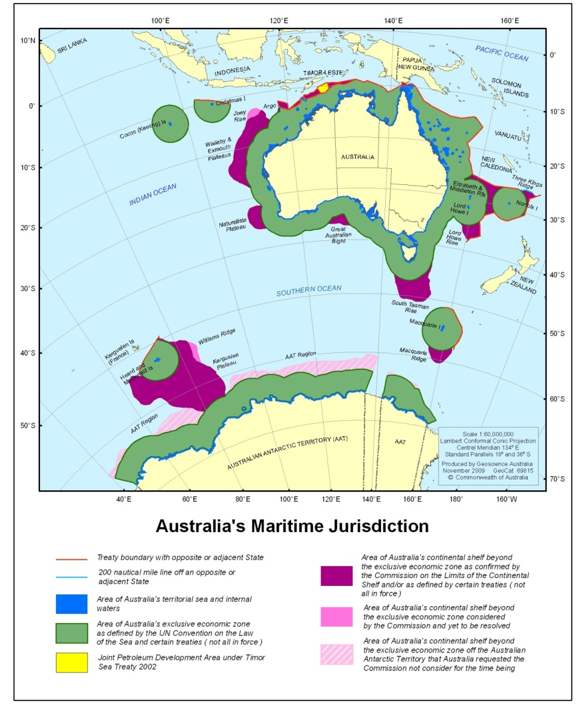
Source: Geoscience Australia, adapted from Symonds et al. (2009).
Figure 1 Australia’s marine estate is nearly double the size of our continental land area and is divided into a number of zones

What is marine science?
For the purposes of this document and the working group, marine science encompasses the broad range of ocean and coastal research conducted across fields of marine-based study including, but not limited to:
- observation and measurement
- modelling and prediction
- understanding biodiversity and ecological processes
- species identification, diversity, distribution and evolution
- resource assessment and management
- technology, engineering and infrastructure development.
The Oceans Policy Science Advisory Group (OPSAG), in its report A Marine Nation: National Framework for Marine Research and Innovation, identified more than a hundred state and federal departments, agencies, universities, museums, and other bodies having an interest in ‘understanding, managing and protecting Australia’s coasts and oceans’. Many of these organisations conduct or contribute to marine research activities.

Building a marine science communication platform
The marine environment is an unfamiliar place for many who come into contact with it and the task of unravelling its mysteries has occupied the minds of scientists since the time of Aristotle (descriptions of over 100 species of fish and his observation that whales are mammals rather than fish are examples of his work). The scientific voyages of James Cook and Charles Darwin attracted considerable public interest. Henry Nottidge Moseley, a British naturalist on the 1870s HMS Challenger expedition, noted in regard to his dredge sampling of marine life that ‘At first when the dredge came up, every man and boy who could possibly slip away, crowded round it, to see what had been fished up’. A documentary about the March 2012 ‘Deepsea Challenge’ expedition to the deepest point in the world’s oceans (the ‘Challenger Deep’ in the Mariana Trench) is to be released as a 3-D feature film for theatrical and broadcast television audiences. Such long-standing fascination about the marine world must surely suggest, when considered in the context of the strong interest in science amongst the Australian public5, that a coordinated program of marine science communication activity has a ready-made audience in Australia.
Effective communication programs require careful planning—communicators need to develop a strategy that defines what they are trying to say and why. They need to know their audience, or audiences, and develop a series of clear and consistent messages that present information in a form that is relevant and readily understood by those audiences. It is necessary to create appropriate tools to be used to convey messages and to identify potential leaders, or drivers, of communication activities.
The potential audiences for marine science communication activities include the public (both individuals and the broader community) and those operating in the government, industry, resource management, media and education sectors. Peer-to-peer communication between members of the marine research community is another important area of communication activity.
Tools might include publications, events and education programs, various forms of media activity (e.g. broadcast, print and web—including social media), lectures, local, national and international awareness activities (e.g. GBRMPA Reef Guardians, Inspiring Australia National Science Week, World Expo) and support for community interest groups, amongst others.
Some of the drivers delivering marine science communication outcomes are professional communicators employed by research agencies, government departments, universities, museums and industry bodies. Science journalists ensure that what is presented to the audiences through media activity is accurate and relevant to the interests of the community. Teachers and marine education centre staff play an essential role and many researchers contribute both personally and professionally to efforts to raise the profile of their work.

Themes and messages
The primary objective of the Inspiring Australia strategy is the development of ‘a scientifically engaged Australia’. The Marine EWG took the view that increasing the level of awareness of the importance of our marine domain is the essential first step toward building greater engagement with the marine sciences.
The working group recognised that, while the audience for the Inspiring Australia strategy is generally identified as being the Australian community, it is not a single audience—the diversity and geographical distribution of the population means that communication approaches will need to be tailored for sub-groups within the broader audience. In order to accommodate this issue the working group identified six key themes for categorising marine science communication activities. These are:
- developing a national approach to marine science communication
- bringing marine science into the community
- getting marine science into the media
- using marine science to inform national and global policy
- putting marine science to work
- showcasing Australia’s marine science research.
The primary goal, key engagement groups and communication issues associated with each of the themes, along with recommendations for communication activities designed to support them, are described in more detail in the ‘Report and recommendations’ chapter of this report.
While the activities recommended are aligned with themes that relate to the interests of diverse audiences, it is important that the overall messages to be delivered through these themes remain clear and consistent. Early discussions between the Oceans Policy Science Advisory Group and the Ocean and Coastal Communicators Network resulted in the development of a series of messages to be used in marine science engagement activities:
- Australia is a marine nation.
- Australia’s oceans present enormous economic opportunities.
- Australia’s marine environment supports substantial biodiversity, including much that does not exist anywhere else in the world.
- We have an international responsibility for the good stewardship of our marine resources.
- Oceans drive Australia’s climate.
- The ocean is largely unknown and unexplored.
- Marine science is the key to understanding, accessing, using and protecting the marine environment
- Australia is an international leader in marine research and marine resource management.
- Marine science is exciting and offers a gateway for students and the public to the world of science.
These messages were considered by the working group to be consistent with the objectives of a national strategy for building engagement with the marine sciences. The rationale for each of the messages is described briefly below.

Australia is a marine nation
The area of Australia’s marine jurisdiction is the third largest of all nations, exceeded only by that of the USA and France. We administer waters extending from the tropics to Antarctica; our maritime borders include parts of the Pacific, Indian and Southern oceans, as well as the Timor, Arafura, Coral and Tasman seas. Our marine jurisdiction is almost twice the size of the Australian continental landmass and islands.8
Our Indigenous and non-Indigenous histories both reflect the central role of the marine environment in Australian cultural and economic development. This continues today: currently about 85 per cent of Australians live within 50 kilometres of the ocean. Our oceans contribute to social wellbeing and are a focus for recreation and the arts for Australians—from tourism, beach activities and fishing, to inspiration for paintings and music.

Australia’s oceans present enormous economic opportunities
Australia generates wealth from its oceans and coasts through fisheries and aquaculture, tourism and recreation, ports and shipping, and oil and gas exploration and extraction. Australia’s marine industries currently contribute more than $40 billion to the economy each year—this is more than the contribution from the agricultural sector.
The value of Australia’s marine industries increased by 80 per cent between 2001–02 and 2008–09. Offshore oil and gas exploration and extraction currently make up more than 50 per cent of the economic value of our marine industries.1 These marine industries generate employment and underpin regional economies.
The marine environment also plays a critical role in international trade. By weight, almost all freight in and out of the country travels by sea (506 out of 508 million tonnes) and this has doubled since the 1980s (Australian Bureau of Statistics data 2001–02). By value, shipping handles about 71 per cent of imports and 82 per cent of exports (Australian Bureau of Statistics data 2001–02).
The full extent and commercial possibilities of Australia’s marine resources are unknown. Emerging industries such as desalination, carbon capture and storage, bioprospecting, seabed mining and tidal energy present further opportunities for economic benefit.
It is important to note that economic benefits often come with threats and impacts. Marine science is a cornerstone of efforts to understand, moderate and manage the risks. Community-wide understanding of the risks, and confidence in the science behind management strategies, is essential for informed debate about accessing our marine wealth.

Australia’s marine environment supports substantial biodiversity that does not exist anywhere else in the world
Australian waters support approximately 50,000 known marine species, with hundreds of thousands still to be discovered. The variety of geomorphic structures in our oceans provides habitat for a highly diverse range of living organisms. Much of the marine life and ecosystems in Australian waters are unique and highly ecologically valued—in some areas, up to 90 per cent of marine animals may be unique to those regions.11

We have an international responsibility for good stewardship of our marine resources
The United Nations Convention on the Law of the Sea establishes Australia’s jurisdiction over the living resources of our exclusive economic zone and grants us an extended continental shelf, giving us an additional 2.56 million square kilometres of continental shelf (about the size of Western Australia).8 We have rights over the seabed and all the living and non-living resources of the continental shelf that lies below it. With this comes the responsibility to protect the environments of these areas.
Australia has committed to additional obligations to protect its marine environment under several other important international conventions, including the Convention on the Conservation of Antarctic Marine Living Resources, the Convention on Biological Diversity and the World Heritage Convention. Within Australia, the Environment Protection and Biodiversity Conservation Act 1999 governs the sustainable development and protection of our biodiversity, including in the marine environment.
Australia’s maritime limits also need protection against the unregulated movement of people, illegal fishing, and the introduction of marine pests. Australia also has a responsibility for maritime search and rescue in an area that is approximately twice the size of our marine jurisdiction.

Oceans drive Australia’s climate
The oceans surrounding Australia strongly influence our climate. Our rainfall patterns, and the associated cycles of droughts and floods, are controlled by ocean circulation patterns and their interaction with the atmosphere. The world’s oceans and seas, including those surrounding Australia, are being impacted by climate change. The effects of climate change on our oceans and, therefore, on our land, are uncertain.

The ocean is largely unknown and unexplored
At 13.86 million square kilometres, Australia’s expanse of ocean is nearly double the size of our continental land area.8 Most of this area is unexplored—only about 12 per cent of the sea floor of our ocean territory has been mapped, and this percentage is far less for habitat and species mapping.
The extent of marine life in our oceans is also largely unknown—experts estimate there may be as many as 250,000 marine species in Australian waters, but only 33,000 (around 13 per cent) of these are catalogued in our current databases. 11 Greater understanding of our oceans can contribute to better informed decision making, policies and planning for Australia’s future.

Marine science is the key to understanding, accessing, using and protecting the marine environment
The marine environment is complex and multi-dimensional. Humans are not naturally adapted to living or working underwater. We know comparatively little about the diversity of marine life, the processes that sustain it and the pressures it is facing. But, through the efforts of marine scientists, we are learning more on a daily basis. We are beginning to understand global-scale patterns in marine systems and are getting to know the animals that live in hostile environments in the deepest oceans. We are finding significant energy reserves and learning how to access them in a sustainable manner. We are even starting to see opportunities for improving human health in the complex chemical interactions between competing marine organisms. We have come a long way, but there are many new discoveries to be made. While there are some things that we will probably never know about the marine environment, the dream of being able to understand, utilise and protect our marine environment is getting closer to becoming reality with each new science publication.

Australia is an international leader in marine research and marine resource management
Australia is a global leader in sustainable fishery practice, marine protection and maritime surveillance informed by sound scientific advice. Australia’s world-renowned expertise in marine science is derived from a number of national research agencies, considerable expertise in the university sector and museums, and major marine science interest and expertise in the Australian states and territories.
The Excellence in Research for Australia 2010 National Report demonstrated that most of Australian marine science sets high standards for the world, particularly in areas such as marine geology, oceanography, fisheries science and ecological applications. With the right research, expertise and infrastructure, we can be a world leader in these and other areas of marine science and demonstrate global best practice.

Marine science is exciting and offers a gateway for students and the public to the world of science
We are only just beginning to understand our oceans: from the biology of bacterium to the interconnected circulation patterns that drive global climate systems, the marine world has much to offer the inquisitive mind. The Age of Exploration, the period in human history when Europeans travelled the seas in search of new lands and exotic life forms, is commonly agreed to have ended in the 17th century. But at the beginning of the 21st century we are still a long way from knowing exactly what is in the oceans, let along knowing the details of how it all works. The Census of Marine Life estimated that up to 80% of Australian marine species are yet to be described by scientists.
Australia needs stronger science awareness and science participation. The challenges have been identified many times, most recently in Health of Australian Science. Marine science engages communities and opens a gateway to science.

Report and recommendations

Developing a national approach to marine science communication

Background
A nationally coordinated approach to marine science engagement and communication can help to ensure that marine science is represented in a consistent manner on the national agenda.
Collective and coordinated action can increase the effectiveness of marine science communication, raise the profile of marine science issues, and inform and influence decision makers. Connections between marine science communicators can encourage sharing of knowledge and build a community of practice. Coordinated efforts can amplify the voice of marine science and focus Australia’s attention on marine matters.
The first step toward this objective is to identify those individuals and groups currently engaged in marine science communication activity and those that might have potential to become involved. It is also necessary to identify their individual and collective target audiences and the approaches they are currently using to spread their messages.
Broadly speaking, marine science communication and engagement activities are carried out by an interconnected web of agencies, organisations, interest groups, educators and individuals across government, non-government, academic, education, advocacy, industry and public domains.
A Marine Nation3 identified more than 100 organisations that are considered to be stakeholders in marine science and marine science communication.
A survey distributed by the working group in April 2012 also gives an insight into the range of organisations that communicate about marine science (see Appendix 3). They include: universities (27 per cent of the 98 responses), government departments (23 per cent), research agencies (16 per cent), museums (8 per cent); as well as industry associations, NGO’s, science education centres, consultancies, resource management bodies, professional bodies, community groups and funding bodies (each less than 5 per cent).
The survey revealed that each of the respondents targets slightly different, but often overlapping, audiences. The presentation of multiple, occasionally competing, messages was seen as an issue, as was fragmentation and duplication of effort. It is reasonable to expect that these groups, working collaboratively to deliver consistent messages about marine science, can achieve significantly greater results than they might expect to achieve in isolation.
While the relative priority given to ocean/coastal communication varies between the organisations surveyed, two thirds ranked it as being between one and five on a scale of ten (with one being very high priority).
In terms of capacity to deliver, almost 40 per cent of respondents indicated that only one position in their organisation (in some instances only part of one position) was dedicated to ocean/coast communication. Just over 40 per cent identified between two and four positions as being committed to the task. Less than a quarter of respondents stated that they have five or more staff working either full-time or part-time in ocean/coastal communication. While it is apparent that numerous organisations across the country commit resources to marine science communication in one form or another, most do not have the depth of capability necessary to achieve the level of profile that marine science deserves. This situation suggests that the creation of a support framework might provide communicators with opportunities to share resources and ideas leading to increased impact for their activities.
Recommendation 1
That a working group be established to facilitate development of a nationally coordinated approach to marine science communication. The working group should be formally aligned with the Oceans Policy Science Advisory Group (OPSAG).
Recommendation 2
That a marine science communicator be appointed to facilitate the activities of the working group and to commence implementation of recommendations of this report.

RATIONALE
There are numerous existing groups in Australia that promote, or facilitate the promotion of, marine science, and/or educate the community about marine science and the marine environment. They range from professional bodies e.g. the Australian Marine Sciences Association (AMSA) and the Marine Education Society of Australasia (MESA) and marine education facilities e.g. Marine Discovery Centres Australia (MDCA) through to independent operations such as White Tag. Science agencies, government departments, non-government organisations, museums and universities, amongst others, also contribute to the task. Each has its own communication objectives and priorities and all contribute significantly to the overall picture of marine science communication and education in Australia.
However, the level of communication between the groups is highly variable. Such a situation can lead to duplication of effort, inconsistent messaging, competition for profile opportunities and resources and, ultimately, reduced effectiveness. The creation of a working group, representing as many existing contributors as possible, will provide a platform for marine science communicators and educators to identify common objectives and diverging interests. It will facilitate the development of a national communication strategy aimed at highlighting issues of local, regional and national importance in marine science.
The proposed working group should be aligned with OPSAG, either directly or indirectly, so as to ensure that collective action plans will be informed by, and consistent with, national needs and priorities.
Appointing a communicator to advance these recommendations will provide a central point of focus, build leadership and strengthen coordination among communicators. Ideally, this would be a fully funded position with a sole focus on building a network and working toward a national strategy.

RESOURCING
A full-time communicator should be appointed, initially for two years, to establish the proposed working group, facilitate the activities of the working group, conduct background research necessary for the development of a national strategy and develop documentation and communication tools necessary for commencement of delivery of the national strategy. An additional task would be the development of a sustainable funding model to make the position permanent. Indicative salary, administration and on-costs would total approximately $300,000.
Recommendation 3
That a national strategy for collaboration in, and coordination of, marine science communication be developed.

RATIONALE
Current efforts to engage the community in marine science—while often effective in isolation—appear to lack the coordination and consistency of message required to achieve broad support. A national strategy for marine science communication will help to reduce fragmentation, encourage consistency, and increase returns on both capital and human resource investment.
Development of such a strategy will require both an understanding of the current focus, status and effectiveness of marine science communication and a clear definition of future objectives and how they might be achieved.
The survey that was used to inform this report sought only to provide an overview of the national science communication landscape. Detailed information about existing approaches to, diversity, intent, targeting and resourcing of, and gaps in, marine science communication activities will be essential input for development of a comprehensive national strategy. A national compilation of such information does not currently exist.
Establishing future objectives, and defining appropriate approaches to achieving them, will require significant input from both within and outside the marine science communication community. There will be a need to identify target engagement groups (e.g. industry, government, the public, and subsets within these groups); assess their current level of knowledge about marine issues; understand their areas of interest; confirm their preferred mechanisms for receiving information (e.g. media coverage, newsletter, online forums, education projects, community activities, regular meetings, etc.); and establish ways to measure the effectiveness of such activities.
In developing a strategy, consideration should be given to adapting the communication and engagement strategies developed by other industries and organisations for the purpose of marine science communication. For example, the service delivery strategies utilised in the government and community sectors could be used as a model for effective engagement with individuals and groups from diverse cultural and ethnic backgrounds. The observations of social scientists might help us to better understand how people interact with science and how to encourage them to respond positively to science communication activities.
It will be essential that all groups having an interest in marine science communication have the opportunity to contribute to discussions about the establishment and implementation of a national strategy. It will be equally important that all are involved in discussions about developing objectives, determining approaches and setting priorities.

RESOURCING
The first step toward development of a national strategy will be to conduct a scoping study aimed at determining its likely scale, timeframe and resource requirements. The science communicator identified at Recommendation 2 would lead the study and the working group would provide much of the input. The study would include a survey designed to develop a comprehensive picture of current marine science communication activities and cost approximately $120,000.
Recommendation 4
That a broad-based network of marine science communicators should be established and that employers should encourage the participation of their communicators in activities that contribute toward the national approach, strengthen connections, facilitate the sharing of news and information, and encourage collaboration.
Activities of the proposed network should be facilitated through:
- development of an easily accessible online collaboration toolkit; and,
- establishment of an annual networking and professional development workshop or meeting.

RATIONALE
Coordination among marine science communicators will be difficult to achieve unless there are appropriate mechanisms to encourage participation in collective action and to facilitate interaction between individuals and the organisations they represent.
There are numerous networks and professional associations that bring together, represent and facilitate the activities of individuals and organisations active in marine science and marine education—some, like AMSA, MESA and the Australian Science Communicators (ASC) have marine science communicators amongst their ranks. The Ocean and Coastal Communicators Network is a small, but marine specific, group of communicators. Consideration should be given to using one of these existing systems as a platform for development of a broad-based network for marine science communicators.
A simple online presence should be developed (e.g. a website, forum, blog or email list), or an existing resource extended to allow marine science communicators to promote activities, seek collaborators, post comments and host discussions.
Organisations employing marine science communicators should be encouraged to formally commit to the proposed collaborative approach and agree to allocate a defined amount of resources annually to collaborative activity.
An annual workshop or meeting should be established to allow marine science communicators to discuss ideas and approaches. Such a session could be held independently or as part of an existing conference e.g. the ASC annual conference.
Those organisations that are in the position to do so should consider the possibility of a short-term secondment of their communicators, or the development of internship programs, that will encourage and facilitate skills development.

RESOURCING
The total level of resourcing necessary for this recommendation will depend largely on the level of commitment to collective action by individual organisations. An annual operational budget of $50,000 would be required to append a marine science communication stream to an existing conference.
Case study 1 The Ocean and Coastal Communicators Network
The Review of the National Innovation System recognised marine science and marine industries as a national innovation priority. OPSAG released A Marine Nation3 in March 2009. This document identified engagement and knowledge transfer as one of four primary elements of a proposed national strategy for marine research.
A small group of marine science communicators, representing member agencies of the OPSAG Marine Science Steering Committee, established the Ocean and Coastal Communicators Network (OCCN) in April 2009. The stated intent of the group was to develop a platform for collective action to raise the profile of marine science in the Australian community.
OCCN met in Townsville in mid-2010 to agree on the rules of engagement and develop a plan of action. OPSAG lead agencies agreed to provide resources to allow the group to meet annually and to support key activities.
The group holds a monthly teleconference to discuss ideas and opportunities for collective profile-raising activities. The first indication that the network might be an effective mechanism for collective action was the successful delivery of an event, targeted at Australian Government politicians and decision makers and held at Parliament House in Canberra, to highlight the achievements of Australian contributors to the international Census of Marine Life. While the event was considered to have met its objectives, the greatest benefit was the opportunity for members of the group and their respective agencies to become more aware of, and to learn from, the capabilities and insights of others in the group.
An important observation from OCCN is that, without a clearly defined and appropriately resourced commitment to collective action by participating agencies, planned activities remain at or near the bottom of the list of priorities of individual contributors. The unfortunate reality is that day-to-day intra-organisational priorities often take precedence over activities targeted at broader interests. While many individuals working in marine science communication have expressed an interest in contributing to collective action, most acknowledge that explicit commitment, at an organisational level, will be required before they can actively contribute.
Recommendation 5
That all activities undertaken in the context of the proposed national strategy (Recommendation 3) should align with the principles expressed in the Inspiring Australia Framework of Principles for Science Communication Initiatives.

RATIONALE
The Inspiring Australia Framework of Principles for Science Communication Initiatives recognises quality science communication activities as being those that are designed to deliver relevant and credible science messages, through effective, strategic, goal-driven mechanisms, to defined target audiences. Evaluation is also considered to be a key feature of such activities. The Framework of Principles is seen by the Marine EWG as being a robust, if highly generalised, model for structuring marine science communication activities.
Reliable and cost-effective measurement of the effectiveness of science communication activities remains an elusive goal. Boddington and Coe stated that the four main benefits of evaluation are that it:
… crystallises ideas about the event and its objectives; provides information about the outcomes of an event and suggestions for improvements; provides information about who attended the event; and can provide encouragement by demonstrating that efforts made by organisers have been worthwhile.
A literature review prepared for the Australian Government Department of Education, Science and Training (DEST) in 2006 found that the majority of articles it had accessed ‘related to the need for evaluation of SET (science, engineering and technology) awareness raising initiatives rather than actual evaluation of the initiatives themselves’. Metcalfe and Perry outlined the need for formative, process and outcome evaluation i.e. evaluation as an embedded part of the communication process, from beginning to end, rather than as an addendum to it.
While still considered to be an imprecise art, there are many evaluation tools available to those wishing to implement quality communication programs e.g. surveys, focus groups, opinion polls, media monitoring, etc. Those planning to design marine science communication activities are encouraged to end to end approach suggested by Metcalfe and Perry.
Recommendation 6
That marine science communication activities and events should be benchmarked against successful national and international projects and that marine science communicators should be encouraged to participate in such projects.

RATIONALE
There are numerous examples of high quality events, activities and installations, both within Australia and internationally, that are commonly viewed as setting the standards against which others are measured.
Much can be learned by hearing, seeing, discussing and understanding what has been presented by peers at national and international conferences. Direct engagement with national and international counterparts to share ideas and information, or to participate in collaborative communication projects, can encourage the development of new approaches.
The establishment of a system of travel grants to support the attendance of Australian marine science communicators at national and international meetings, or to work with national and international peers, will help to stimulate creativity and effectiveness of efforts in Australia.

RESOURCING
An annual competitive funding round of $25,000 should be put in place to support the travel costs of up to 5 marine science communicators wishing to attend international conferences, meet with international peers or participate in international collaborative projects.
Recommendation 7
That research be conducted to ascertain current awareness of the marine environment, and the science that supports it, amongst the Australian community.

RATIONALE
Gathering data about the current level of understanding of the marine environment, and the science that supports it, is an essential task for communicators wishing to understand target audiences, tailor messages, and produce effective strategies for engaging with these groups.
The Inspiring Australia Expert Working Group on Developing an Evidence Base for Science Engagement in Australia articulated a series of recommendations aimed at understanding the current public attitudes to science; the needs and priorities for increased public engagement in science; the efficacy of science engagement enterprises; and the need to understand how engagement changes over time.
A national baseline survey should be conducted to capture the following information:
- current level and types of marine-related activity
- current level of interest in, and understanding of, the marine environment
- familiarity with current issues affecting the marine environment
- attitudes to and level of awareness of science (generally) and marine science (specifically)
- issues that might limit support for marine science
- information gaps amongst users of marine science
- preferred methods of acquiring information.
The survey should be targeted at a wide cross-section of the community including mums and dads, educators and students, artists and traditional owners, philanthropists and NGOs. It would also be useful to conduct a parallel survey aimed at capturing the views of scientists in regard to the potential value of increased public support for their work.

Bringing marine science into the community

Background
The ‘community’ or ‘general public’ is seen as a high priority audience for many of the communicators surveyed by the working group (it was the third highest ranked audience behind the federal government and researchers, see Appendix 3).
However, the ‘general public’ is not a homogeneous group—it is composed of individuals having different ethnic, religious, cultural, educational and economic backgrounds which have shaped infinitely varying opinions, attitudes and priorities. Individuals form groups around shared interests such as sport (e.g. surfing, sailing, diving, recreational fishing), education (e.g. museums, aquariums, science groups such as CSIRO’s Double Helix Club) and environmental concerns (e.g. community-based land care groups). This heterogeneity necessitates the development of different strategies to communicate with the diverse sub-groups that constitute the broader public sphere.
Our beaches are a national icon and our waterways are central elements of the lifestyles of people who live near them. Residents of coastal communities often see themselves as being responsible for stewardship of the marine environments within their local area and indigenous communities have strong cultural and spiritual ties to their sea country. Environmentalists marvel at the complexity of marine systems and artists draw inspiration from them. Social science research might provide insights into how we can use these deep-seated emotional connections with the marine environment as a starting point for conversations about the value and relevance of marine science.
It is unlikely that the wider community will engage with detailed scientific information; however, many people have a natural curiosity about the world around them. This is evident in the number of visitors to our public institutions such as zoos, aquariums, museums and art galleries, high levels of participation in programs presented by marine discovery centres, and the ongoing popularity of natural history and science-based documentaries. People engage with a variety of issues in these spaces so they should be used as a vehicle to bring marine science into the community.
Members of the public want scientific information to be presented in a way that is easily understood and relevant to their interests. They want scientists, and their expertise, to be accessible. It is true that a good proportion of scientists tend to stick to the formal peer-to-peer mechanisms and refereed publications as their preferred method of communicating their science. But increasing numbers are acknowledging and embracing the power of public communication—many conduct excellent media, education and public outreach activities in order to ensure that their work is seen as being relevant to the needs of the community. It is clear that ‘putting a face to science’ can help to build trust between researchers and the community—both Robin Williams (The Science Show, ABC Radio National), and Karl Kruszelnicki (more commonly known as Dr Karl) have been demonstrating that fact for over 30 years.
Good science is characterised by ‘systematic observation, measurement, and experimentation, and the formulation, testing, and modification of hypotheses‘. It challenges theories, supports them through weight of evidence and confirms them only when well proven. But this process can be interpreted as uncertainty by members of the public who are unfamiliar with scientific methodology. In fact, open debate between scientists is often used as a foil by antagonists working to undermine public confidence in scientific understanding of key issues—the debate over the cause and effect of climate change being the obvious contemporary example. There is an urgent need to educate the public about the process of science and to encourage them to seek evidence rather than rely on opinion when forming their views on such important issues.
Debate over issues such as exploitation of terrestrial resources and environmental impacts has been a feature of community life … forever. But similar issues in the marine environment have received significantly less public attention. Problems such as introduced pests (e.g. northern Pacific seastars), fishing bycatch (e.g. dolphins and turtles), and whale conservation, have caught the public eye in the past. But the range of issues and threats confronting the marine environment is increasing—global climate change, declining water quality, resource extraction and even human population movement are impacting Australia’s marine domain.
Effective public debate about current marine issues can only happen if there is broad access to appropriate information. Marine science communicators must ensure that the role and value of marine science is an element of the debate.
The ‘citizen science’ movement has been seen as an effective two-way mechanism for building connections between science and the public. These programs encourage members of the community to contribute directly to research activities and provide an avenue for scientists to become involved in public conversations about issues and opportunities in many areas of science.
There are several successful marine citizen science initiatives in Australia where members of the community have been trained in how to collect data that is compatible with that collected by scientists. Data gathered through these programs is often pooled together to give a much broader picture of the health of our environment than could be collected by scientists alone.
The education sector provides an interface between science and the public. This sector includes primary and secondary schools, universities and other tertiary education institutions, marine and environmental education centres, museums, aquariums, national parks, government agencies, NGOs and ‘educational tourism’ operators.
The marine environment has inspired art throughout history. Art can be a way of both engaging the public in science and of reaching art lovers—a subset of the community not commonly assumed to be interested in science.
Recommendation 8
That a national promotional campaign aimed at increasing awareness of the marine environment and illustrating the importance of marine science should be developed and implemented.

RATIONALE
It is important that the community understands the link between the beauty and value of the marine environment, and the science that helps us protect and benefit from it.
Australia’s marine environment lends itself well to being portrayed visually in communication activities. A national community awareness campaign presenting key messages, supported by high quality visuals, can be used to kick-start a longer-term engagement plan.
A comprehensive campaign should be developed using a combination of advertising and science communication methodologies. It would be delivered through existing communication and education networks, events and activities and would also be deployed on contemporary social media platforms.
Extending the reach of the campaign via traditional mechanisms such as print and broadcast media might also be considered—particularly if community service announcement status could be agreed with a supportive broadcaster.
Design, development and delivery of such a campaign, and production of the associated collateral, would require input and collaborative effort across the entire marine science communication community. The campaign could therefore be used as a catalyst for commencement of the longer-term national strategy.

RESOURCING
Development of the campaign would be led by the incumbent of the position identified in Recommendation 2 and production capability would be provided by communicators drawn from organisations having the capacity to contribute. The campaign would incorporate mechanisms to capture community feedback and to assess the level of effectiveness of the undertaking.
Recommendation 9
That marine science organisations should make greater use of existing channels such as museums, zoos, aquariums, science education centres, marine discovery centres, and marine-based events in the efforts to engage with the public.

RATIONALE
Museums, zoos, aquariums, science education centres and marine discovery centres attract millions of visitors collectively each year. Many of these institutions have extension and outreach programs that target diverse community groups and networks. Some are directly supported by producers of science information (science agencies, universities, etc.) and some benefit from funding provided by organisations that are users of science (government, industry, etc.). They can therefore be seen as places of convergence between creators, users and beneficiaries of scientific knowledge. As such, they are important assets in the fight to raise the community awareness of marine science.
Public events such as the Sydney to Hobart yacht race, surf carnivals, fishing and camping expos and environment festivals are also useful platforms for promotion of marine science—provided that communication materials and subject matter is tailored to the needs and interests of the demographic targeted by the event organisers. Profiling marine issues through these events can significantly broaden the reach and effectiveness of marine science communication efforts. Tools that highlight the ways that marine science might contribute to the lives of those attending the event are the key to success when using this approach.
Case study 2 Reef Research exhibit at ReefHQ Aquarium
Management of the Great Barrier Reef (GBR) relies on robust scientific information and credible research findings. This information is produced by a large number of experts working for numerous organisations. It covers topics ranging from the detailed biology and ecology of particular animals and plants to the broad scale impact of climate and water quality changes. A detailed understanding of the interactions between people and the Reef (e.g. fishing, tourism, etc.) and the economic benefits the Reef brings to our community, is also an essential element of best practice management.
The Great Barrier Reef Marine Park Authority (GBRMPA), which is responsible for the management of the Great Barrier Reef Marine Park, works closely with James Cook University (JCU) and the Australian Institute of Marine Science (AIMS) to ensure that the management practices it puts in place are based on the most up-to-date marine science.
Reef HQ Aquarium, GBRMPA’s reef education centre, is one of Townsville’s premier tourism attractions and the National Education Centre for the Great Barrier Reef. The Aquarium provides education and information services relating to the Marine Park through world class living exhibits complemented by thematic and interactive educational experiences. Raising awareness of the Reef, and encouraging behaviour change within the community that will help protect it, is a key operational objective of the aquarium. The Aquarium attracts approximately 120,000 visitors per year.
Working collaboratively, communicators from ReefHQ, GBRMPA, JCU and AIMS have developed a Reef Research exhibition to showcase the latest in reef research. The exhibit, which is currently being installed at ReefHQ, promotes three key messages:
- Reef research delivers robust indicators of reef health and identifies thresholds of potential concern for the Great Barrier Reef ecosystem.
- Productive research synergies and partnerships act as a catalyst for innovation and understanding.
- Innovative, world class, scientific and technological research, promotes healthy oceans and sustainable marine industries.
The exhibit is based on digital content produced by the contributing organisations with the centrepiece being a 65" multi-interaction touch screen-based display table supported by a series of data projectors and static wall-mounted information snippets. The exhibit is expected to have a ten-year lifespan during which time the content will be regularly updated according to the needs of the various partners.
Recommendation 10
That marine science organisations involve the community in suitable research projects. A first step is to showcase successful community involvement programs and promote this to marine science organisations as a way to encourage and facilitate more community involvement. These case studies can be profiled at marine science conferences, used for the media and used to promote and showcase marine science engagement with government and stakeholders.

RATIONALE
Providing the community with opportunities for first-hand experience in research and monitoring activities greatly enhances their level of engagement. While there is some debate about the utility of data captured through ‘citizen science’ programs, it is clear that some projects can benefit significantly from the contributions of well-trained volunteers. Effectively managed programs can provide an excellent platform for interaction between scientists and the community. Participants in such programs can become advocates for marine science amongst their peers. Museums, universities and research agencies can provide support for community groups and individuals wanting to undertake local monitoring activities on an ongoing basis.
Case study 3 ‘Citizen Science’ programs in marine science
Redmap
This project encourages the general public who fish, dive or boat to register marine sightings, and contribute pictures to a database that is used to map distributions of marine species. Each observation is verified by a scientist and then added to traditional scientific databases. The project started with observations of snapper around Tasmania, through the Institute for Marine and Antarctic Studies at the University of Tasmania. Now, with funding from Inspiring Australia, it is set to go national, opening it up to the millions of Australians who regularly use the marine environment.
Reef Watch and Reef Check Australia
Reef Watch, a project of the Conservation Council of South Australia, and Reef Check Australia, a not-for-profit organisation based in Queensland, both run programs in which recreational divers gather data about the health of the marine environment.
Feral or in Peril
A part of the broader Reef Watch program where recreational divers, anglers and boaters log sightings of both introduced marine pests and local species that may be in danger of disappearing. Dive, tackle and boat shops distribute kits that include waterproof cards with photos and basic information on how to spot a ‘feral’ or an ‘in peril’ species. Sightings can be faxed through or logged online.
Seagrass Watch
A global seagrass assessment and monitoring program in which community members gather information about the health of their local patch of sea grass. Their data contributes to an international assessment and monitoring program taking place at approximately 259 sites across 17 countries. The Australian branch of the program is based at the Northern Fisheries Centre in Cairns.
Coral Watch
This is a non-profit organisation built on a research project based at the University of Queensland. Snorkelers and divers use a simple, inexpensive, and non-invasive coral health chart to record different stages of coral bleaching or recovery.
Atlas of Living Australia
This is the world’s largest collection of information on Australia’s plants, animals and fungi. It combines over 350 large and small datasets, from the NSW Government’s Atlas of Wildlife to the records of a community group who look after a local creek. Users can explore their own area by entering an address or location to find the recorded species nearby. At the click of a button you can create a list and map of species that have been found in your local area and photos of most of them. Their byline: ‘Contributed by Australia’s academic, scientific, environmental communities and you.’
National marine debris survey
Students and teachers can join a survey being conducted by CSIRO as part of a research program to understand and reduce the impact of marine debris on biodiversity. More than 270 of the world’s marine animal species are threatened by either ingesting the debris or getting entangled in it. More than six million tons of fishing gear alone is lost in the ocean each year.
GhostNets Australia
An alliance of indigenous communities in coastal northern Australia working to remove abandoned fishing nets or ‘ghost nets’ from their customary lands and marine environments. Ghost nets have a significant impact on sea life—particularly species such as marine turtles whose populations are known to be declining. Indigenous rangers locate and remove nets, record data and assist with community education.
Reef Guardian Schools
Students and teachers team up with others in the community to participate environmental and sustainability projects within their classrooms, their school grounds and local areas. Projects include native habit revegetation, beach litter reduction and waste recycling. Run by the Great Barrier Reef Marine Park Authority (GBRMPA), there are currently more than 285 schools and over 113,000 students involved.
Recommendation 11
That a grant round be established to fund collaborative projects between marine scientists and artists.

RATIONALE
‘Both artists and researchers are driven by curiosity about the world around them. They observe and then communicate their observations. Both can learn from each other’.
Art can be used to create an emotional response drawn from basic human instincts. It can also be used more prosaically—as a vehicle for conveying both simple and complex messages. The marine environment is a rich source of inspiration for artists—and works based on that inspiration can be powerful motivators for increased community-wide engagement in marine science.
By encouraging marine research groups to establish collaborations with museums, art galleries, and individual artists, communicators can access an infrequently targeted audience and develop new ways of communicating marine science messages.
Ways in which this can be done include:
- marine research organisations supporting bids by galleries for international exhibitions relating to marine issues to visit Australia
- producing a touring exhibition of marine art
- promoting Australian marine artists overseas
- supporting an annual marine art prize
- offering ‘artists in residence’ programs within research organisations.
Case study 4 Marine science in art
Antarctic Animations (Australia)—interviews with expeditioners, online responses, and improvised movement workshops are used as sources for animations and art works. Animations are presented at international conferences and exhibitions of Antarctic arts and sciences.
Living Data (Australia)—scientists and artists work together to create animations and other art works using stories, hypotheses, data and iconography to understand climate change and its impact on people and the environment.
Australian Antarctic Arts Fellowship (Australia)—a fellowship offered by the Australian Antarctic Division (AAD) to artists, researchers, filmmakers and writers to join an Antarctic expedition. By experiencing Antarctica first-hand, the fellows then communicate their experience and understanding to other Australians.
GhostNets Australia art projects (northern Australia)—workshops are held that combine traditional weaving and fibre techniques with the rubbish and discarded fishing nets found on beaches to create artworks.
Census of Marine Life (International)—a ten-year project that assessed the global diversity, distribution, and abundance of marine life. The ecosystems and organisms studied by census scientists inspired artists around the world. Films, documentaries, exhibitions, photographs, paintings, illustrations, drawings, sculptures, music and even postage stamps were outputs of the project.
Cape Farewell (UK and Toronto)—a program that encourages climate focused art including exhibitions, festivals, publications, digital media and film.
Seaweed—art meets science (Tasmania)—a National Science Week project that provides a unique look at the life of seaweed (complete with iPhone app).
Recommendation 12
That marine science educators be provided with a forum in which they can develop and share marine science resources and information. Identify the best space in which to create this forum e.g. online or in person. Facilitate the first stage of interaction for this group and, if valued, raise funds for its continued function.
Recommendation 13
That existing mechanisms that promote interaction between research organisations and schools e.g. Scientists in Schools should be promoted vigorously and that 20% of all marine scientists play an active role in school education by 2015.
Recommendation 14
That over the next five years Australia’s leading marine science organisations develop new curriculum-based resources for teachers and students on unique but important aspects of the marine environment.

RATIONALE
There are many individuals in the education sector who advocate strongly for increased marine education and marine science communication. There are many points of connection between educators, students, marine scientists and marine science organisations. However, there are several issues that need to be addressed to ensure that greatest benefit can be achieved from existing and new opportunities.
A consistent set of messages about marine science, appropriate for delivery across all areas of marine education, and tailored for use in conjunction with the messages already being delivered by the sector, will be required.
There is no single national entity that represents marine science education, and state groups are subject to varying degrees of fragmentation. A coordinated approach will be required to ensure that national and state education bodies are given the opportunity to engage in the broader objective of building support for marine science.
Marine education is not compulsory in schools across Australia—the decision by individual schools to offer marine studies as a subject option depends heavily on the interests and professional background of their teaching staff and, often, the proximity of the school to the marine environment. There is substantial inconsistency across state education authorities in regard to availability and uptake of marine studies curricula at secondary school level e.g. Marine and Maritime Studies is offered in Western Australia and Marine Studies is a ‘Board Endorsed Course’ in New South Wales; Marine Studies is an ‘Authority subject’, and Marine and Aquatic Practices is an ‘Authority-registered subject’ in Queensland (a draft Marine Studies senior syllabus for 2013 was in circulation at time of writing). The development of The Australian Curriculum presents an opportunity to shape a national marine studies syllabus. Science is described as a ‘Learning Area’ in the national curriculum and Science Understanding is one of three strands. It is interesting to note that ‘Nature and Development of Science’ and ‘Use and Influence of Science’ are incorporated as sub-strands in the structure of the curriculum—both will help to resolve the uncertainty about scientific methodology mentioned on page 21 of this report.
Greater sharing of information among the various marine science and education societies will help to build consistency of message across the marine science education community. Development of a consolidated list of marine-related educational resources will help educators to identify and access existing support material. The list will also assist communicators in their efforts to identify gaps that need to be filled. Production of new materials consistent with requirements of the new national curriculum might encourage more educators and schools to consider adding marine studies to their subject offerings.
Case study 5 Marine education in Australia
Marine education is delivered both formally and informally around Australia. Schools and the broader community can access marine education through a variety of avenues. Education associations, teachers associations, museums, aquariums, marine discovery centres, private (external) marine education providers and government and non-government agencies offer a variety of marine education resources, programs and activities.
In the formal education sphere, marine-focused programs are an integral part of many primary and secondary schools. Many of these programs, particularly in secondary schools, provide real-world marine science education for their students. Specialised marine education teachers, and those teaching marine-themed subjects, are able to complement their teaching and learning programs through opportunities provided by place-based centres, marine education associations and external marine education providers.
In some states, marine education teachers are supported by very strong and active teachers associations. The NSW Marine Teachers Association (NSWMTA) and the Queensland Marine Teachers Association (QMTA) are good examples. These associations support their members by providing professional development opportunities, developing curriculum resources and establishing partnerships, all with the aim of fostering marine education in schools.
Other marine education associations, such as the Marine Education Society of Australasia (MESA), also support teachers and marine educators. MESA is a national organisation that brings together people who are interested in the study and enjoyment of coastal and marine environments. It provides a forum to share ideas and develop leading environmental education and interpretation programs with a coastal and marine focus, and promotes the sustainable use of marine and coastal environments through education. MESA members are mainly teachers, students and environmental educators.
The highlight of the MESA calendar each year is Seaweek, a national event that aims to increase awareness and understanding of the marine and coastal environment. Recent Seaweek themes include ‘Marine debris—clean it up!’ (2012) and ‘Spotlight on marine science’ (2011). These successful events are recognised around Australia and are supported in almost all states and territories. Collaboration is essential to the success of education events such as Seaweek. In the case of Seaweek, MESA works with marine management agencies and educators, such as the Australian Marine Environment Protection Association (AUSMEPA), to develop and deliver a week-long program of events and supporting education resources.
Place-based marine education providers include aquariums, marine discovery centres, marine and national parks, museums. Place-based facilities offer marine education opportunities for schools and, in many cases, the broader community. These education opportunities can either be informal, such as self-guided tours, or formal, structured education programs and activities.
Marine Discovery Centres Australia (MDCA) is a national organisation of 12 Marine Discovery Centres from across Australia that use hands-on education to inspire visitors, and help them discover and learn about Australia’s marine environment. Each centre is unique in origin: some are part of schools, while others are community- or government-funded. Each uses a combination of centre-based and field activities to deliver structured education programs to school students and community members. Being a part of a collaborative organisation enables MDCA members to share knowledge, expertise and resources in order to develop and deliver a quality education experience.
A number of state and national government agencies, local governments and NGOs, with a role in marine natural resource management, provide marine education programs and resources. In most cases, these programs increase awareness and understanding of the science that underpins the management of the marine environment. Ultimately, the aim of these programs is to increase awareness and understanding that leads to appropriate, sustainable behaviour by those members of the community that interact with the marine environment.
Recommendation 15
That marine science organisations support professional development opportunities for local teachers where possible and appropriate; with the goal of having organisations in Australia provide opportunities for at least three local teachers a year.

RATIONALE
Teachers are ‘multipliers of information’—individuals provided with a basic framework of information who are able to develop appropriate education tools and assist multiple students achieve valuable learning outcomes. Given that marine science is an elective subject there are relatively few teachers who feel confident in their ability to deliver the subject effectively. We can help to build confidence by increasing the level of engagement between researchers and teachers—site visits, teacher workshops, science talks and career discussions are amongst the possibilities.
Opportunities to directly involve teachers in research activities, particularly field trips, has been shown to be very successful way of developing skills and confidence in teaching marine studies.
The US National Oceanic and Atmospheric Administration (NOAA) offers a ‘Teachers at Sea’ program. Teachers from kindergarten through to college-level schools are sent to sea aboard NOAA research and survey ships to work with the scientists and crew. The program gives teachers first-hand experience of science and life at sea and provides a greater understanding of the purpose and practice of marine science. In 2011 NOAA received 220 applications for the program—33 teachers were sent to sea, 4 were placed in labs and another 4 in field projects.
Recommendation 16
That an annual marine science engagement activity be established to enable science agencies to present updated facts about marine research, achievements and outcomes to NGOs.
The activity should be in a format that encourages dialogue with these organisations but where advocacy issues and government policy are not on the agenda.

RATIONALE
Non-government organisations include public interest groups and civil society organisations that undertake a wide range of activities in support of diverse interests (e.g. advocating for human rights, lobbying government to improve environmental policy, etc.). Australian examples include the Australian Marine Conservation Society, WWF—Australia and the Australian Marine Environment Protection Association. Well known international NGOs currently active in Australia include Greenpeace and The Pew Environment Group.
NGOs vary in size from local groups to large international organisations. They are often well engaged with the community in which they operate, with the larger, better funded, organisations having the capacity to significantly impact national and international debate on issues of global importance.
Marine science information is often used by NGOs for the purpose of policy development, production of advocacy material, educating their members and stakeholders and informing their action campaigns. The role of scientists in such activities is perhaps best described by the statement, attributed to Lord Robert May, that ‘[t]he role of scientists is not to determine which risks are worth taking, or deciding what choices we should take, but the scientist must be involved in indicating what the possible choices, constraints and possibilities are …’
Open and honest engagement has the potential to reduce the tensions that occasionally characterise discussions between science providers and NGOs. Clarifying and aligning the expectations of NGOs, marine researchers and marine science communicators when engaging in these discussions can help to ensure that discussions are productive and objectives and boundaries are clear. Marine science can benefit significantly if NGOs include statements of support for marine science when communicating with their audiences and stakeholders.
Recommendation 17
That marine science organisations should engage closely with the Indigenous communities that live on or near sea country that hosts research activities.

RATIONALE
It is important to acknowledge the value of Indigenous knowledge, and to work with traditional owners to protect, understand and manage the marine environment. Genuine dialogue with Indigenous communities can promote trust and present opportunities—but communication must be genuine, equal and inclusive in order to minimise the potential for community members to feel marginalised.
Indigenous communities can provide both practical input and knowledge for science projects. Reciprocal, collaborative partnerships between traditional owners and marine scientists can maximise knowledge sharing and assist with management of the marine domain.
The Great Barrier Reef Marine Park Authority (GBRMPA) regularly demonstrates how relationships can be built with indigenous communities and integrated into the science program. There are more than 70 traditional owner groups with connections to sea country in the Great Barrier Reef region. Customs such as hunting and collecting, as well as social sharing of food during special events, are culturally significant. Staff at GBRMPA work with communities to ensure that traditional use of marine resources is managed at sustainable levels. They do this through permits and agreements; contributing to Native Title Tribunal meetings; holding working group meetings and training those involved.
Recommendation 18
That a directory of marine-focused charities, trusts and non-profit organisations be developed, maintained and made accessible. That a connection be established with Philanthropy Australia, the Australian Directory of Philanthropy, and similar mechanisms to provide access to the directory in order to identify marine science and marine science communication activities as an option for philanthropic endowment.

RATIONALE
Philanthropy is defined as ‘the planned and structured giving of time, information, goods and services, voice and influence, as well as money, to improve the wellbeing of humanity and the community’. In the United States philanthropy is the second largest source of funding for the marine science community. Funding models in Australian science, however, do not tend to include philanthropy as a significant or reliable source of support. Australian Taxation Office records indicate that $25.2 million was donated to research-related charities, and $13.0 million to environment-related charities, during 2009–2010.
Philanthropy tends to be driven largely by the personal interests of those that contribute. The rationale offered for Recommendation 11 (see page 26) stated that art has the capacity to create an emotional response drawn from basic human instincts. Those involved in marine science know that many individuals are touched in the same way by aspects of the marine environment—some to the extent that they might consider providing support for marine science as part of an enduring legacy.
Building public engagement with the marine environment, and the science that supports it, should increase the potential for broader philanthropic support amongst the Australian community. Philanthropy Australia, the national peak body for philanthropy, provides facilitation mechanisms to help those wishing to donate to charitable causes. Ensuring that this body, particularly its Environment and Climate Affinity Group, is aware of the national marine agenda may help to encourage philanthropic investment in the sector.

Getting marine science into the media

Background
The ‘media’ is not a single entity yet the different ‘medias’ are looking for the same thing—news and entertainment. In the marine science space this means new and interesting stories of discovery, opinions and discussion topics of local, national and international interest.
In March 2011, the Department of Innovation, Industry, Science and Research published the report of its Science and Media Expert Working Group. Titled Science and the media: from ideas to action the report discussed the state of science in the Australian media and made a series of recommendations aimed at keeping the public ‘informed and engaged with science’. The report provides an excellent overview of the issues faced by members of the science community when trying to have their work covered in the media and by journalists when trying to research and report on science stories and issues.
The survey conducted by the Science and Media EWG provided many interesting insights into the world of Australian science journalism. More than 75% of survey respondents thought that the role of the science journalist was considered important by their media outlet. Journalists described a work environment where deadlines are tight—and becoming tighter as the pressure to repurpose stories for multiple media platforms increases. They lamented the fact that editors are not convinced that the public want to read about science and that complex science stories can be difficult to simplify enough to be accessible by the broad audiences targeted by the general media. ‘Better educated readers are the clue’, stated one respondent, when asked for an insight into how science journalism could be better supported.
The tension that often characterises the relationship between scientists and the media was captured in the observation that ‘scientists tend to blame the media for being superficial and journalists often blame scientists for not explaining the science better’. The situation is compounded by the fact that few scientists have an understanding of the working day realities faced by journalists—and vice versa.
Positioning an intermediary such as a science communicator or public relations consultant between scientists and journalists was seen as being counterproductive—journalists want direct access to scientists. However, there are significant impediments to such an arrangement. The lack of confidence on the part of scientists that journalists will accurately portray their work, and will not reference the work out of context, and the expectation (on the part of science organisations) that stories will be focused on science, not policy or opinion, are two such examples. An interesting counterpoint to this issue was provided by one survey respondent who opined that ‘most incorrectly see Science Journalism as explaining science, whereas the job is to cover the current advances, as well as the political and social environment in which scientists operate’.
Many researchers would benefit from media training to help them communicate more effectively; talented and passionate researchers with media experience could then act as ambassadors to raise community awareness of marine science, or as experts who the media can contact when issues arise in their area of expertise.
Establishing clear pathways between researchers and the media can help to connect relevant experts and local spokespeople with interested media. The Australian Science Media Centre and The Conversation are well regarded by the media and offer the opportunity for the marine science community to target a wide media audience for their work.
Scientists concerned about the media getting their science wrong may find new media, such as blogs and social media, an easier place to control their message than traditional mass media. These styles also provide a mechanism to engage with target groups such as younger people and respond to misinformation.
Rapid and sustained declines in circulation of print-based news services, and the extraordinary rise in number and diversity of online outlets, have necessitated a rethink of media strategies previously adopted by marine science organisations. A survey of organisations having an interest in marine science, conducted by the Marine EWG in April 2012, showed that approximately 85% of the 98 respondents indicated that they currently use social media as a communication tool (see Appendix 4). The intended purpose for, and degree of expertise in use of, these tools was not assessed. However, the level of uptake suggests that there is merit in a recommendation around the need for training in use and application of these tools.
While newspaper circulation is in decline, they still reach vast audiences—weekday circulation of broadsheet papers The Age and the Sydney Morning Herald was in excess of 180,000 copies each for the January – March 2012 quarter, while The Australian sold approximately128,000 copies daily.
Tabloid circulation was significantly greater during the same period (e.g. Sydney’s Daily Telegraph around 336,000 copies and Melbourne’s Herald Sun approaching 470,000 copies). The best-rating free-to-air weeknight news broadcast (Seven News) reached a combined metropolitan and regional audience of more than 1.6 million viewers during the first week of March 2012. It is clear that marine science organisations can plan to use traditional media for some time to come.
Recommendation 19
That marine science organisations empower their researchers to engage with the media either directly or through networks such as the Australian Science Media Centre and provide them with appropriate media training.

RATIONALE
Scientists with media training are more confident in dealing with the media, are better equipped to avoid the potential pitfalls and are generally more aware of the need to tailor messages for different engagement groups.
Researchers with a talent for high quality media interaction can be profiled and promoted as ‘the face of’ key issues and organisations. This has the dual benefit of building a regular point of connection between audiences and issues and ensuring that consistent science messages are being delivered.
Encouraging researchers to talk directly with journalists outside the formal interview context can help to build confidence in their ability to talk about their work in a way that is understandable and accessible to the community. This approach can also help to build stronger relationships between research organisations, journalists and media outlets, and give journalists confidence that interactions with science providers are open and honest.
Recommendation 20
That marine scientists learn about and use new media (e.g. blogs, Facebook and Twitter) to communicate with the public, guided by successful examples from other fields of science.

RATIONALE
The media is changing rapidly, as are the tools that are used to distribute information. Audiences are in the position to choose how they receive their news with online sources competing strongly against traditional forms of distribution. A great majority of marine science organisations already have online tools in place and are developing new strategies for their use. Social media tools such as blogs are an increasingly popular tool as they offer greater control over content and treatment of stories than is possible with traditional media approaches. These formats also provide potential for significantly greater use of imagery gathered during research projects and detailed scientific illustrations not commonly used in traditional media.

Using marine science to inform national and international policy

Background
Decisions about issues relating to the marine environment and marine environmental resource management are notoriously difficult for Governments—particularly because stakeholder interests are invariably diverse, are strongly advocated and usually have political implications. The best, most coherent, decision making is that which is informed and supported by accurate, detailed, and up-to-date marine science. It is therefore of the utmost importance that marine science organisations engage with politicians and other government-based decision makers, their teams of advisers, and officers of relevant Government departments, when issues relating to the marine domain are being debated.
Marine science organisations should not assume that policy advisers and decision makers will, in all instances, proactively seek their input when researching issues. It is true that decision-making processes around complex, large-scale, marine-based issues of national and international importance are highly structured and involve the capture of formal input from all relevant parties, including marine science providers. But the same may not be the case for less contentious issues—advisers and Departmental officers often rely on trusted sources (e.g. previously identified subject experts and expert committees, professional associates, consultants, etc.) when gathering information in such cases. This approach represents a significant opportunity for marine science organisations to ensure that their science is represented in the mix of materials used to support decision making.
It is therefore vitally important that marine science organisations identify and build effective relationships with policy advisers and decision support teams. Once identified, these individuals and groups can be provided with information about the current state of marine science knowledge, as well as gaps and impediments to further development of understanding of subjects of interest to them and their area of influence. Good news stories and advice about opportunities are considered to be useful assets by most advisers.
The somewhat informal approach described above can be effective in its own right—but it tends to rely heavily on personal and professional network building by individuals. The risk in relying too heavily on this approach is that people in government tend to be quite mobile—advisers come and go, departmental structures change, as do governments, and priorities change accordingly. There is, therefore, the need to ensure that information exchanged between science providers and policy developers is backed by more formal mechanisms. OPSAG took a significant step in this direction when it published A Marine Nation3 in 2009. The framework, which is currently being updated, serves to ensure consistency of messaging about current and future needs and opportunities for marine science in Australia.
Slightly less than half of the respondents to the Marine EWG survey (see Appendix 4) ranked the federal government as their highest priority audience. But decisions relating to marine-related issues are not made only at the federal level—state, territory and local governments are also use marine science information in their decision-making processes. The issues and approaches described above should be considered to be equally useful at these lower levels of government.
Scientists, generally speaking, do not see the opportunity to influence government policy as a primary motivation for their work. Consequently, their level of expertise in dealing with politicians and their advisers is limited. Like most skills, competency can be increased through training and experience. Science and Technology Australia (STA) has recognised the need for scientists to be given the opportunity to develop skills in the area of communicating with politicians. Science Meets Parliament is an annual event run by STA which acts as a training program for scientists wanting or needing to understand the nuances of communicating with politicians.
Recommendation 21
That the relationships between marine science organisations and key advisers and decision-makers in government circles should be used as a channel for delivery of consistent messages about marine science issues.

RATIONALE
Marine scientists can increase the level of influence of their work on policy development by building relationships with policy makers and the teams of advisers that support them. Such relationships will also help scientists to develop an understanding of government decision-making processes, and the multiple perspectives that must be considered throughout those processes.
It is important that decision makers can see the value of marine science as an input for policy processes. Advisers need up-to-date, relevant and succinct information when producing briefs for decision makers. Short case studies that provide information about discoveries, achievements and collaborations in the marine space can be a useful way to demonstrate this concisely. Participation by scientists and communicators in expert committees and similar bodies is another avenue that can be effective in ensuring that marine science becomes part of the decision-making process.
Case study 6 Marine science informs international policy
In March 2012, the UNESCO World Heritage Centre and the International Union for Conservation of Nature conducted a reactive monitoring mission to the Great Barrier Reef World Heritage area, after the World Heritage Committee noted ‘extreme concern’ over recent energy processing and port developments within the region.
The mission considered the status of the Reef’s health, the pressures facing the ecosystem (including nearby urban, industrial and port developments) and the management arrangements in place to protect the area.
The mission met government representatives, as well as leading Australian scientists who contribute their knowledge to managing the reef and the surrounding environments. The scientists were consulted to provide an independent perspective on the status of risks to the site. The mission also met with environmental groups, local governments, traditional owners and industry groups.
The report of the Reactive Monitoring Mission was released on 14 June 2012 and was accepted by the World Heritage Committee on 29 June 2012. While the report found that Australia’s management of the Great Barrier Reef World Heritage Area is international best practice, and that previously noted threats from oil and gas development, recreation, fishing and tourism, and most recently water quality from catchment run-off, are being dealt with effectively, it stated that ‘the future conservation of the Great Barrier Reef World Heritage area is at crossroads and decisions that will be taken in the immediate future will be decisive for the long-term health of the property as a whole’.
The mission identified climate change, catchment runoff, coastal development, ports and shipping and direct extractive use as the most important threats to the long-term conservation of the GBRWHA. It went on to make fourteen recommendations about actions that should be taken to minimise further erosion of the Outstanding Universal Value of the Great Barrier Reef.
This example brings together many of the key engagement groups and issues identified in this report, and demonstrates that consultation and engagement with a wide range of groups on marine science issues can inform international policy.
Recommendation 22
That marine science organisations provide researchers and communicators with appropriate opportunities to develop skills in engagement with politicians, policy makers and advisers. This could involve any or all of the following:
- supporting marine scientists to attend science meets parliament events
- inviting local, state and federal political representatives to appropriate events such as open days, field days, media launches
- supporting workshops or training in policy
- supporting internships where scientists spend time working in political environments.

RATIONALE
Government policy development and decision making is often complex and requires consideration of multiple issues, priorities and perspectives. Providing input into policy development has not been seen as core business for working scientists in the past. Consequently, few scientists would consider engaging in such processes without first having had the opportunity to develop relevant skills and experience.
Existing programs such as Science Meets Parliament can be used to provide initial skills development. Participation in events aimed at decision makers, such as marine science forums, briefings and presentations, can help researchers build the experience and confidence necessary to ensure that science input is considered during decision-making processes.

Putting marine science to work

Background
A wide range of industries operate within Australia’s marine jurisdictional boundaries, including commercial fishing and aquaculture, recreational fishing, offshore oil and gas exploration, extraction and processing, shipping, boat and ship building, tourism, defence, marine research and environmental management. Marine-based industries contribute in excess of $40 billion annually to the national economy and many thousands of people are employed in marine-related jobs.
The marine environment is complex, poorly understood, and can be a difficult place to work. Marine science plays an important role in exploring and assessing our living and non-living marine resources and developing an understanding of the interactions between marine industries and the marine environment. The information gathered by marine researchers provides the basis for sustainable management of marine resources. It also helps industry to assess the risks associated with operating in the marine environment and is an important element of investment decision-making processes.
Organisations that conduct marine research in support of industry are spread across government (e.g. research agencies, universities and museums) and private enterprise (resource companies, marine science consultants). Industry peak bodies also engage marine researchers to conduct work specific to the interests of their membership.
Each of the marine industry sectors have a range of issues that must be considered when conducting communication activities:

Fisheries
The fisheries industry includes commercial wild-catch fisheries and aquaculture regulated by the Australian Government, or state or territory agencies.
Marine science and ecologically sustainable fisheries management frameworks have significantly changed the way Australia manages its fisheries. Many fish stocks in Australian waters are recovering as a result of initiatives such as the proclamation of marine parks and the introduction of third-party catch certification. Significant investment in marine science has helped to ensure the sustainability of both the industry and the resources it targets.
The industry wants to change the public perception that fisheries are concerned only with extracting marine resources. Aquaculture (both land-based and offshore) can also be viewed negatively by the community, largely due to a perception that environmentally damaging practices persist.

Energy
There is currently strong commercial demand for the oil and gas reserves known to be present within Australia’s marine territory. Marine science research plays an essential role in helping to identify and access these resources, make sound investment decisions, and minimise environmental impact. There are also future opportunities for tidal and wind energy.
Key issues for the energy industry include difficulty in obtaining access to sufficient marine science data to inform its decisions, and that potential sources of information are scattered and uncoordinated.

Tourism
Domestic and international tourism are important contributors to Australia’s economy, and many of our country’s most iconic sites are on the coast. Although there is significant interest in marine science among tourists, the industry has difficulty accessing specific and specialised information about marine science.

Ports and shipping
Ports and shipping are essential elements for Australia’s international trade activities. Marine science can inform port planning, development and management by providing data on marine community structure and resilience, as well as issues relating to introduced species and pollution.
Issues for container ports focus mainly on local community concerns such as noise, pollution and access. The impacts of commodity port installations and activities (particularly for large, new developments) are not yet fully understood, and require dialogue and engagement with researchers, industry and communities to ensure long-term sustainability.
Recommendation 23
That marine scientists and communicators with significant experience in industry consultation be identified and that they be encouraged to share their expertise and networks with other marine researchers.

RATIONALE
The current level and effectiveness of interactions between marine science and marine-based industries is highly variable. While there are examples of effective partnerships between marine science and the industries it assists (see case study 7, page 401) feedback from industry representatives suggests that, in some areas, the connection between science and industry is limited at best. There appears to be uncertainty, on the part of industry, about how to engage with government-based science providers. Scientists commonly lack the detailed understanding of the priorities and decision-making processes that would allow them to plan and deliver projects that are relevant to industry. Regular information exchange across the interface between research and industry is the key to addressing these issues.
While marine science is a key input for many industrial operators—it is considered to be an enabler, not core business. They need the support of Australian marine science and are prepared to invest considerable financial resources in projects that will help them to achieve their objectives. For example, the systematic mapping and characterisation of the nation’s marine natural assets is seen as an area that would provide significant benefit to marine-based industries.
Few individual research providers have the capabilities and capacity to independently deliver the breadth and volume of information required to support profitable and sustainable industrial development. Collaboration and cohesion between marine science providers is, therefore, essential.
Consistent and well-targeted communication activities can help to raise the level of awareness of the capabilities and relevance of Australian marine science amongst prospective industrial users. It can also help to highlight the potential for industry participation in major collaboration programs being developed through new national marine research facilities such as the Integrated Marine Observing System (IMOS), the national marine research facility RV Investigator, and the National Sea Simulator (SeaSim).
A database of scientific expertise, and a listing of how to access that expertise, may help industry connect more readily with relevant research organisations and researchers. Such a database would also be useful for other sectors, including marine science communicators, researchers and government.
Development of a network of marine science ‘champions’ to operate in industry and government circles can also help to build profile and support.
Case study 7 Australian science partnership delivers environment award for Woodside
Australian Government science agencies play an important part in supporting the sustainable development of Australia’s natural resources. Marine environmental issues associated with coastal and offshore development require expert independent scientific advice to help inform policy, management and industry investment decisions.
The Australian Petroleum Production & Exploration Association (APPEA) Environment Award recognises efforts by organisations within the industry to raise environmental performance standards. The 2011 Environment Award (exploration category) was won by Woodside Energy Ltd, in recognition of its commitment to long-term understanding of the marine environment through collaborations with the Australian Institute of Marine Science (AIMS) and the Western Australian Museum.
Speaking at the 2012 APPEA Conference in Adelaide, Woodside CEO Mr Peter Coleman said that ‘Developing a detailed understanding of the areas in which we operate is an essential element of our exploration framework. Working with world-class organisations like AIMS and the WA Museum gives us the certainty we need to make sound environmental management decisions’.
AIMS’ most recent project with Woodside, a $30 million, four-year study of Scott Reef, resulted in greatly improved scientific understanding of the biodiversity, oceanography and ecosystems on and around this remote atoll system, located about 300 kilometres off Western Australia’s Kimberley coast.
Recommendation 24
That mechanisms be developed to increase awareness of Australian marine science capability amongst potential industry partners.

RATIONALE
Presenting marine science research at industry and government events, inviting industry members to speak at science events and encouraging scientists to interact with industry bodies can all help to break down barriers between science and industry. Development of a sector-based web resource that catalogues Australian marine science expertise and relevance can help industry to find appropriate points of contact with marine science providers.

Showcasing Australia’s marine science

Background
Australia provides extensive opportunities for marine research and Australian researchers are recognised for their successes, particularly in marine resource assessment, management and protection. Increased public awareness of the relevance and achievements of Australian marine science can help to build greater support for increased investment in both capacity and capability. Increasing the international visibility of Australian marine science can lead to new opportunities to extend our understanding of our own marine environment and strengthen Australia’s broader international reputation.
Issues that attract national attention, and can therefore be used to build awareness and support for marine science within Australia, include the status of national icons such as the Great Barrier Reef and management of fish stocks and coastal ecosystems. Australia’s contribution to and involvement in global programs (such as the Census of Marine Life and the Global Ocean Observing System) are examples that can be used to illustrate Australia’s contribution to international marine science.
Australia’s marine environment is recognised around the world as a tourist destination. Many of our marine sites are instantly recognisable, and there is significant opportunity to incorporate marine science into tourism campaigns.
Recommendation 25
That communication and outreach learning opportunities be incorporated into the program at existing marine science conferences and events.

RATIONALE
Conferences are an excellent way for marine researchers to communicate new results and research trends—but they are also opportunities to showcase marine science to other engagement groups.
Some ideas include:
- incorporating a public stream at science conferences, providing the opportunity for researchers to present their work in a format appropriate for general public audiences running a media program to present new research and provide an opportunity for researchers to engage with the media
- running a media training program the day before the conference for researchers wanting to gain new, or practice existing, communication skills
- holding a dinner for journalists and scientists.
Recommendation 26
That marine science researchers and communicators build relationships with the agencies that promote Australia internationally and encourage them to incorporate marine science in their marketing activities.

RATIONALE
Australia has a global reputation for the beauty, richness and diversity of its marine environment. Our marine-based World Heritage areas particularly the Great Barrier Reef, the Ningaloo Coast and Shark Bay, are powerful drawcards for international tourism—in fact, a significant proportion of tourism promotions include specific spoken and visual references to out coasts and oceans.
There is significant opportunity to raise the profile of our marine research, both domestically and internationally, by linking scientific facts with tourism campaigns, particularly given the increasing popularity of ‘educational tourism’.
Interaction between the marine science community and the tourism industry may be fostered through, for example, researchers speaking at tourism industry events, and inviting tourism industry representatives to research organisations to discuss their issues. We can highlight and showcase Australia’s contribution to international marine science through key events, such as World Expo, and consumer marketing campaigns, such as Tourism Australia’s ‘There’s nothing like Australia’ project.
Linkages with international marine programs and organisations are essential for the health and reputation of Australian marine science and management. Australia’s contribution to global programs needs to be better communicated (both within Australia and internationally) in order to achieve maximum value from our investment.
Targets for activity associated with this recommendation include Tourism Australia, AusTrade and the Department of Foreign Affairs and Trade.

Appendix 1 Membership of the Marine Expert Working Group
Name | Organisation
Ian Poiner (Chair) | Independent marine scientist and consultant  Formerly CEO, Australian Institute of Marine Science
John Bradley | Monash Indigenous Centre
Michael Burke | Western Australian Department of Fisheries  Marine Education Society of Australia
Steve Clarke | Australian Institute of Marine Science
Craig Cormick | Australian Government Department of Industry, Innovation, Science, Research and Tertiary Education
Karen de Plater | Australian Government Department of Sustainability, Environment, Water, Population and Communities
Daniel Gschwind | Queensland Tourism Industry Council
Peter Horvat | Fisheries Research and Corporation Development
Kent Stannard | White Tag
John Tilley | Australian Institute of Petroleum
Paul Willis | Royal Institution of Australia
Marian Wiltshire | Integrated Marine Observing System  University of Tasmania
Sarah Wood | CSIRO
Graham Durant | Questacon (DIISRTE observer)
Secretariat
Steve Clarke | Australian Institute of Marine Science  Convenor
Sarah Brooker | Science in Public  Project facilitator
Janet Salisbury, Julie Irish | Biotext  Draft technical writing

Appendix 2 Terms of reference
To develop a national strategy and a set of evaluation priorities which will strengthen the national evidence base in science engagement and in turn inform future investment decisions by the Australian Government and its partners.

Intended outcome
The project will establish an Expert Working Group to address objectives and outcomes identified through the development of Inspiring Australia—a national strategy for engagement with the sciences.4 It will support efforts to transform Australia into an innovative society with a technologically skilled workforce, a scientifically literate community and well-informed decision makers.
The project has the following objectives:
- to deliver a series of recommendations for the science community that provide a clear focus and encourages consistent messaging for engaging Australians in the marine sciences
- to facilitate collaboration and increase coordination of marine science communication activities across Australia
- to develop a platform upon which to base activities aimed at:
  - increasing awareness of the importance of our marine domain
  - building support for increased investment in marine science, technology and innovation
- to ensure activities of the group align with the Inspiring Australia Framework of Principles for Science Communication Initiatives and the elements outlined in the description below.

Project description
- Define Marine for the purpose of this study.
- Provide an overview and analysis of current marine science communication activities.
- Identify the main players and key issues.
- Invite and coordinate a group of individuals who will provide expertise to this discussion.
- Seek consultations beyond this group as required to ensure a broad perspective is considered.
- Outline a common strategic approach.
- Recommend actions to help take marine science communication to the next level. These recommendations could include, but are not limited to, items such as:
  - broad suggestions for new programs
  - broad suggestions for integration or coordination of existing programs
  - more detailed project proposals
  - networking and coordination opportunities
  - professional bodies, industry and business involvement
  - analysis of appropriateness of Commonwealth as well as other sources of support
  - priority areas for Commonwealth support
  - areas for developing and sourcing other support.
- Outline priorities, timeframes, costs and potential delivery mechanisms for these recommendations.
- Have these recommendations reviewed by publishing for open comment a draft report.
- Write and produce a case study report for publication.
The structure of the Expert Working Group will be determined by the project leader; however, it is recommended that there be no more than 12 people.
- Members of the existing Ocean and Coastal Communicators Network will be invited onto the Expert Working Group and the current leaders of that network will be recommended as co-chairs.
- Additional members of the group will be drawn from a range of sectors relevant to engagement with the marine sciences.
- The members should have an understanding of the agenda, issues and imperatives associated with the topic and be capable of providing a range of perspectives and insight into the many aspects of the topic.
- A representative from the Questacon Division of the Department of Innovation, Industry, Science and Research must be invited as an observer to each of the meetings.
- The Group will physically meet at least twice, with other meetings to be conducted online.

Appendix 3 Project methods

Background
In February 2010, the Department of Innovation, Industry, Science and Research (DIISR) released the Inspiring Australia report, which presented a national strategy for engagement with the sciences. This report supported the outcomes anticipated by the Australian Government’s previous budget paper—Powering Ideas: An Innovation Agenda for the 21st Century. Both these government documents acknowledged the key social role of innovation in developing a scientifically aware Australian public, capable of engaging in informed decision‐making and contributing to a technologically skilled workforce.
The Inspiring Australia report recognises that Australia requires a strategic development and evaluation capability to design, target and review effective science engagement activities and to guide future investment, contributing to the building of science communication capacity, professionalism and excellence. The report proposed fifteen recommendations that were premised on effective communication and aimed at promoting stronger links between science and the constituent parts of Australia’s national innovation system.
Inspiring Australia also identifies a number of possible activities that could help harness Australia’s most creative and talented communicators to achieve the goals of a scientifically engaged Australia, including ‘convening of a short-term working group to develop a plan for identifying and sharing best practice in science engagement’.
The Australian Institute of Marine Science was commissioned by the Department of Innovation, Industry, Science and Research to convene an expert working group to develop a series of recommendations aimed at increasing the level of engagement of Australians in the marine sciences..
The membership of the Expert Working Group on Engaging Australians in the Marine Sciences and its terms of reference is shown in Appendix 1.

Activities of the Expert Working Group
The Expert Working Group held three formal meetings during its period of activity—once at Questacon in Canberra (24 January 2012), once at the Ecosciences Precinct in Brisbane (9 March 2012) and once at the offices of the Queensland Tourism Industry Council in Brisbane (22 June 2012). A survey aimed at capturing a snapshot of the current approach to marine science communication in Australia was conducted during April 2012. An overview of the work of the group, along with a summary of the draft recommendations, was presented to the CCI Inspiring Australia Contact Officers Working Group (COWG) on 30 March 2012.

Appendix 4 Review of marine science communication activities
The discussions of the working group were informed by a small survey of marine science communicators conducted in April 2012. The survey was sent to 90 individuals, some of whom circulated it more widely—100 responses were received. This survey was not intended to capture the evidence needed to conduct a detailed analysis of the current state and future directions of marine science communication in Australia. However, it did provide an indication of the scope, focus, priorities, mechanisms and resources currently being applied to such activity in Australia.

Questions and responses
Question 1: Which of the following categories best describes your organisation?
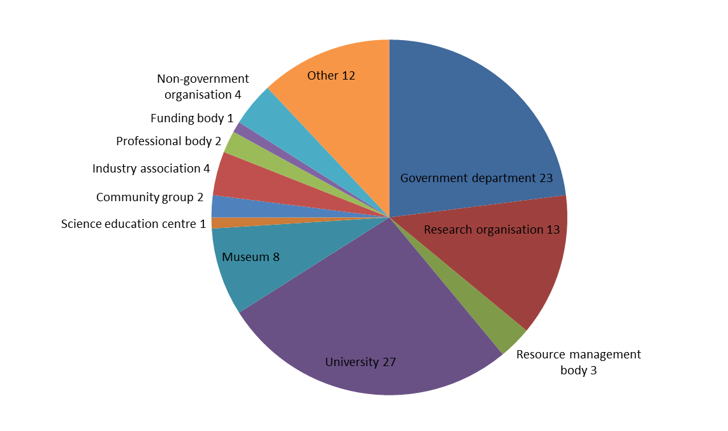
Figure A1 Number of organisations falling into the respective categories (n = 100)
Question 2: What relative priority is given to ocean/coastal communication by your organisation?
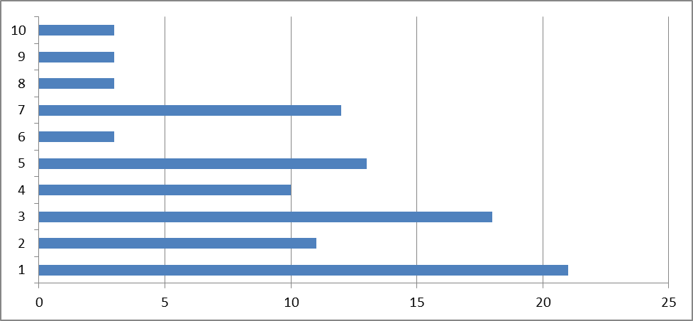
Figure A2 Relative priority of ocean/costal communication (n = 97, highest = 1, lowest = 10, average = 7.03)
Question 3: What proportion of that activity focuses on science (processes and scientific outputs) versus corporate (uptake and notional value) communication?
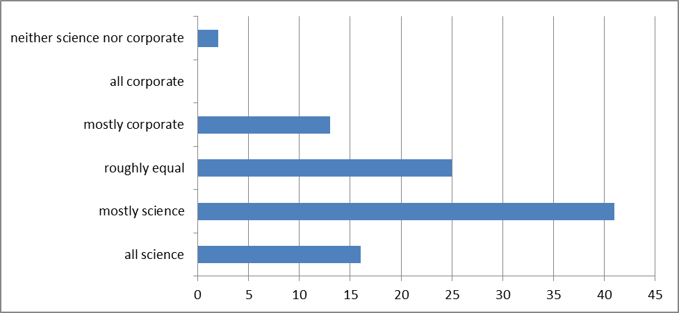
Figure A3 Proportion of activity focused on science versus corporate communication (n = 97)
Question 4: Which ocean or coastal issues are relevant to your organisation?
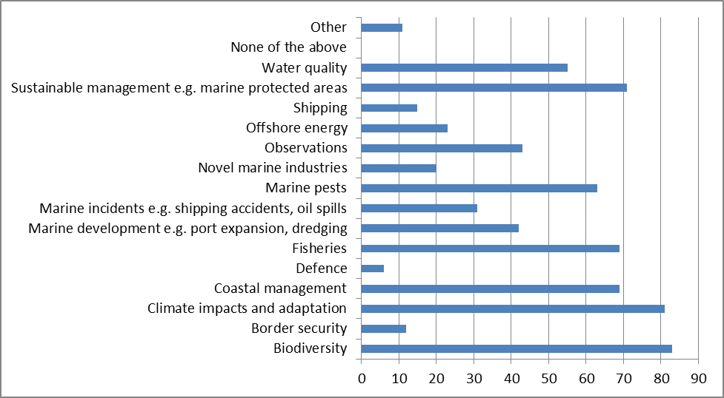
Figure A4 Issues of relevance (n = 97)
Question 5: Please rank the following audiences in order of priority for your organisation
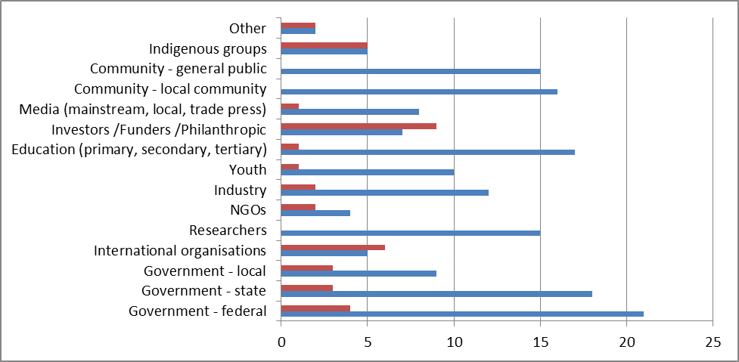
Figure A5 Highest and lowest priority audiences per organisation (n = 83, red = ranked lowest, blue = ranked highest)
Question 6: What proportion of your communication activities are focused on people living in rural, remote and regional areas?
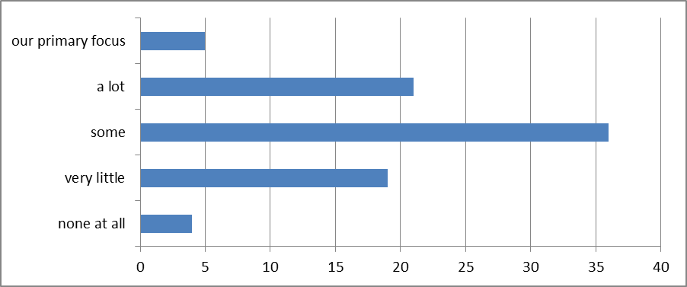
Figure A6 Proportion of communication activities are focused on people living in rural, remote and regional areas (n = 85)
Question 7: Which mechanisms do you use to communicate with your various audiences?
Table A1 Communication methods used per audience (n = 76)
Audience | Website | Direct contact | Networking | Mass media | Conference | Newsletters | Education materials | Displays | Lectures | Direct mail | Open Days | Social media | Product launches | Web/mobile launches | Trade media
Fed govt | 32 | 42 | 37 | 19 | 25 | 19 | 4 | 7 | 8 | 16 | 8 | 5 | 6 | 6 | 4
State govt | 43 | 46 | 40 | 24 | 31 | 27 | 14 | 13 | 14 | 22 | 9 | 10 | 13 | 7 | 7
Local govt | 50 | 35 | 29 | 23 | 16 | 20 | 13 | 14 | 10 | 18 | 13 | 12 | 8 | 3 | 2
International | 44 | 29 | 24 | 12 | 31 | 16 | 5 | 3 | 11 | 15 | 2 | 11 | 3 | 5 | 2
Researchers | 47 | 52 | 48 | 18 | 46 | 22 | 13 | 13 | 29 | 27 | 10 | 10 | 12 | 6 | 5
NGOs | 46 | 35 | 31 | 20 | 25 | 23 | 15 | 15 | 13 | 17 | 18 | 10 | 7 | 5 | 3
Industry | 48 | 46 | 45 | 24 | 35 | 23 | 13 | 23 | 14 | 26 | 18 | 12 | 14 | 6 | 11
Youth | 49 | 24 | 13 | 22 | 7 | 10 | 41 | 24 | 25 | 7 | 32 | 30 | 5 | 5 | 2
Education | 65 | 36 | 26 | 21 | 32 | 27 | 51 | 30 | 40 | 15 | 33 | 21 | 7 | 9 | 5
Funders | 31 | 43 | 25 | 15 | 15 | 21 | 4 | 7 | 10 | 20 | 7 | 5 | 7 | 4 | 5
Media | 45 | 39 | 22 | 32 | 12 | 16 | 12 | 13 | 10 | 18 | 17 | 19 | 11 | 7 | 4
Local community | 56 | 28 | 16 | 29 | 8 | 25 | 27 | 36 | 27 | 16 | 32 | 28 | 3 | 6 | 1
General public | 60 | 25 | 15 | 38 | 10 | 26 | 38 | 44 | 31 | 19 | 38 | 35 | 4 | 6 | 3
Indigenous | 38 | 28 | 19 | 18 | 9 | 16 | 19 | 15 | 12 | 16 | 13 | 14 | 1 | 2 | 1
Note: number of respondents—the most important mechanisms for particular audiences are in bold.
Question 8: Which social networks, if any, does your organisation use as a communication tool?
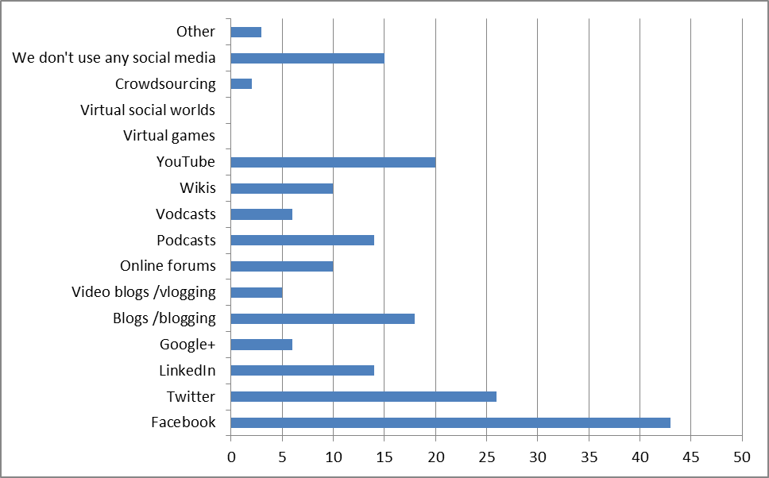
Figure A7 Social media usage by type (n = 76)
Question 9: What is the one big communication activity you’ve always wanted to initiate, but have never had access to the resources to make it happen? (n = 54)
Question 10: You mentioned that... [answer Q9] ...would be a great idea for a communication activity in the future. Can you provide us with several examples of particularly successful communication activities that you have helped deliver in the past e.g. public events, online interactives, communication strategies, etc? (n = 56)
Question 11: In order to help meet its objectives, the Expert Working Group may conduct a more detailed ‘activity audit’ aimed at building a more complete picture of projects currently under way or planned for the foreseeable future. Would you, or another member of your organisation, be interested in providing such information if we were to contact you directly? We envisage a 15 minute phone call at a time convenient to you. (n = 68)
Question 12: Do you evaluate the effectiveness of your communication activities?
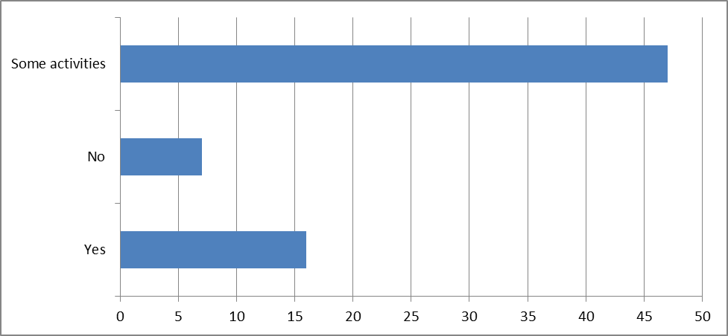
Figure A8 Evaluation of communication activities (n = 70)
Question 13: If you answered yes to the previous question, which evaluation tools do you use?
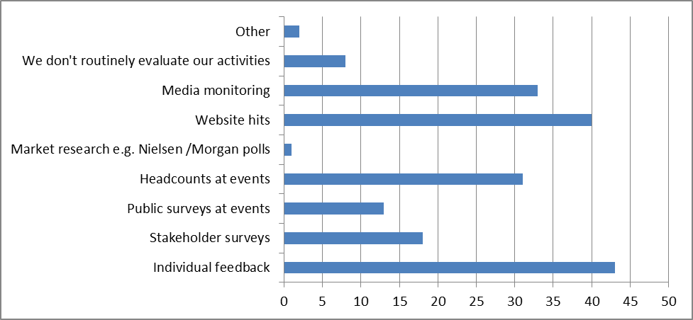
Figure A9 Evaluation tool usage by type (n = 61)
Question 14: Personal details
Question 15: How many staff in your organisation?
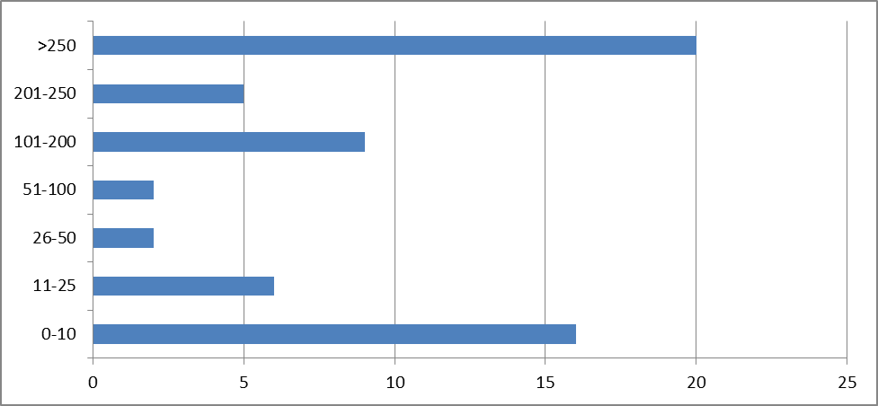
Figure A10 Number of staff in organisation (n = 60)
Question 16: Number of staff formally engaged, either full- or part-time, in oceans/coastal communication?
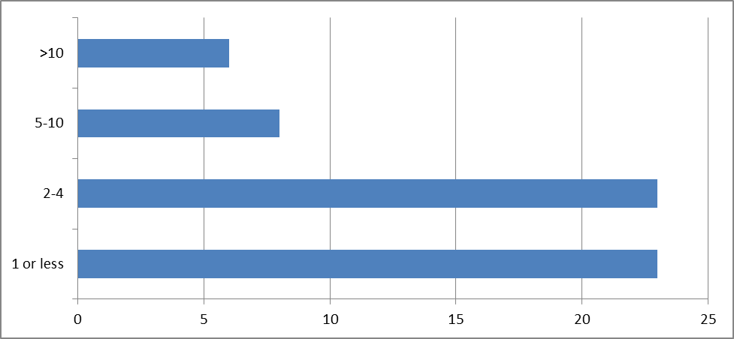
Figure A11 Number of staff engaged in ocean/coastal communication per organisation (n = 60)
Question 17: Do others in your organisation informally undertake ocean/coastal communication activities?
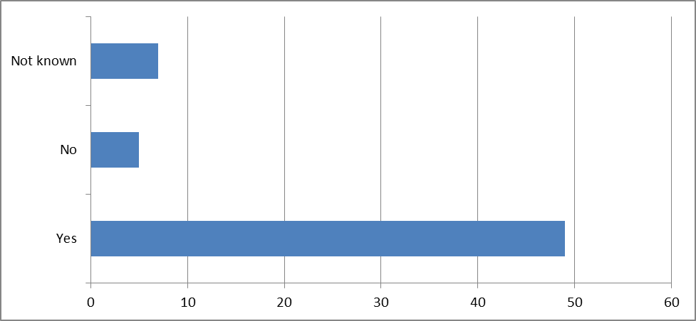
Figure A12 Number of organisations with staff informally engaged in ocean/coastal communication (n = 61)
Question 18: If so, what do you estimate to be the total annual contribution, in person days, made by those individuals?
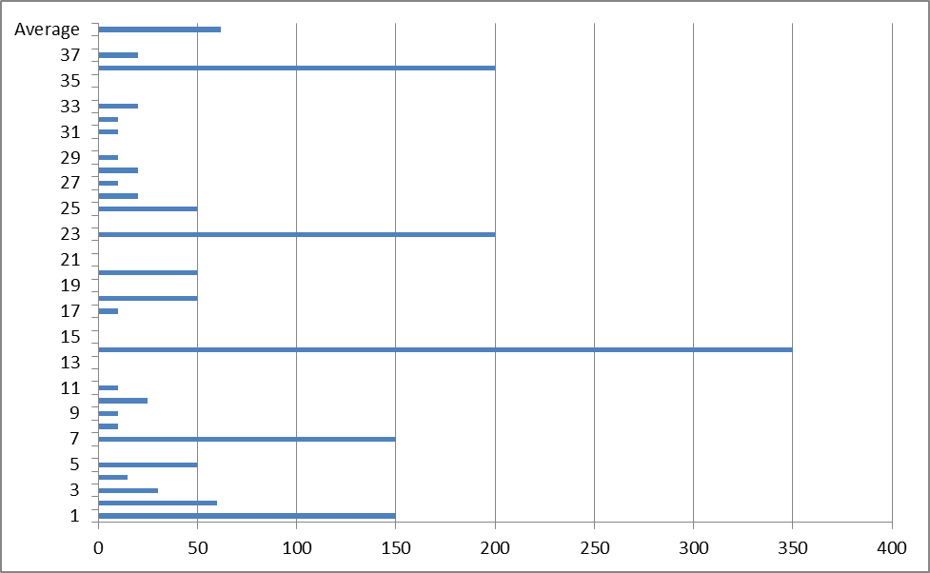
Figure A13 Informal contribution to ocean/coastal communication activity in person days per organisation (n = 38, average = 61.6)
Question 19: Does your organisation use the services of volunteers such as tour guides, community ‘champions’, event marshals, etc when undertaking ocean/coastal communication activities?
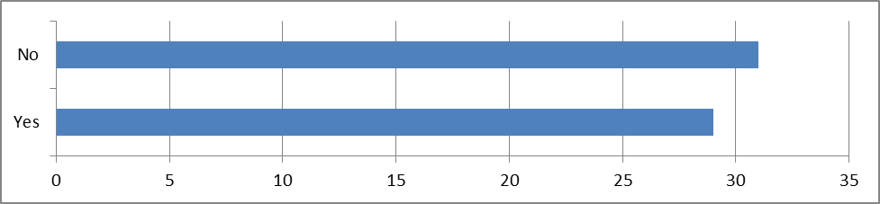
Figure A14 Use of volunteers in ocean/coastal communication activities (n = 60)
Question 20: Source of funding: Which, if any, of the following sources contribute to your communication budget?
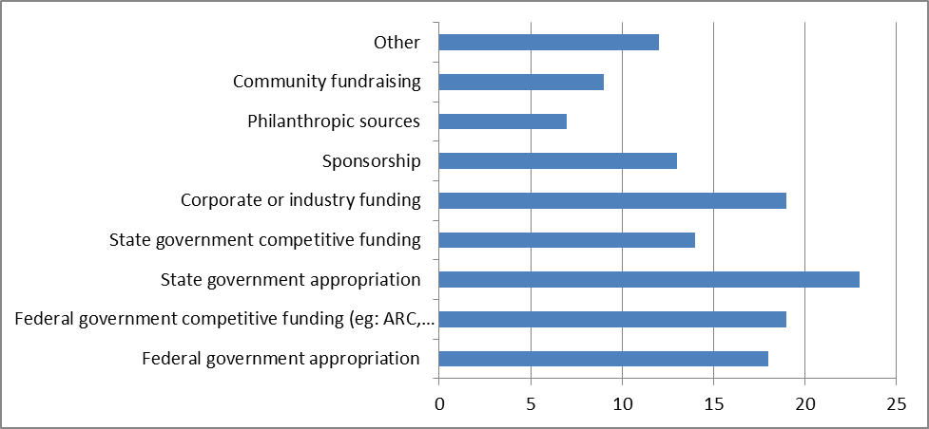
Figure A15 Source of funding (n = 56—note that respondents could select more than one funding source)

Appendix 5 Organisations associated with marine science
ARC Network for Earth System Science
Antarctic Climate and Ecosystems CRC
Australian Antarctic Division
Australian Biological Resources Study
Australian Coral Reef Society
Australian Fisheries Management Authority
Australian Fisheries Management Forum (AFMF)
Australian Institute of Marine Science
Australian Marine Sciences Association
Australian Maritime Safety Authority
Australian Museum
Australian National Maritime Museum
Australian National University—Research School of Earth Sciences
Australian Nuclear Science and Technology Organisation
Australian Petroleum Production & Exploration Association
Bureau of Meteorology
Bureau of Rural Sciences
Central Queensland University
Centre for Australian Climate and Weather Research
CERF Marine Biodiversity Hub
Charles Darwin University
Commonwealth Scientific and Industrial Research Organisation (CSIRO)
Council of Australasian Museum Directors
CRC for Greenhouse Gas Technologies
CSIRO Marine and Atmospheric Research
CSIRO Wealth from Oceans National Research Flagship
Curtin University of Technology
Deakin University
Defence Science and Technology Organisation
Department of Innovation, Industry, Science and Research
Department of the Environment, Water, Heritage and the Arts
Edith Cowan University
Fisheries Research & Development Corporation
Fisheries Victoria
Flinders University
Geoscience Australia
Great Barrier Reef Marine Park Authority
Griffith University
Integrated Marine Observing System
James Cook University
Macquarie University
Marine Geoscience Office (MARGO)
Marine Innovation South Australia
Monash University
Murdoch University
Museum and Art Gallery of the Northern Territory
Museum Victoria
National Climate Change Adaptation Research Facility/Griffith University
Northern Australia Marine Research Alliance
NSW Department of Primary Industries
NSW Department of Environment and Climate Change
NT Department of Regional Development, Primary Industry, Fisheries and Resources
Ports Australia
Queensland Department of Agriculture, Fisheries and Forestry
Queensland Department of Environment and Heritage Protection
Queensland Department of Science, Information Technology, Innovation and the Arts
Queensland Museum
Queensland University of Technology
RAN Australian Hydrographic Service
RAN Directorate of Oceanography and Meteorology
Reef and Rainforest Research Centre/MTSRF
RMIT University
Southern Cross University
Sustainable Tourism CRC
South Australian Museum
Sydney Institute of Marine Science
Tasmanian Museum and Art Gallery
University of Adelaide
University of Melbourne
University of Newcastle
University of New England
University of New South Wales
University of Queensland
University of Sydney
University of the Sunshine Coast
University of Tasmania
University of Technology Sydney
University of Western Australia
University of Wollongong
Victoria University
WA Department of Fisheries/WA Fisheries and Marine Research Laboratories
Western Australian Energy Research Alliance
Western Australian Marine Science Institution
Western Australian Museum

AIMS (Australian Institute of Marine Science) (2011). AIMS Index of Marine Industry, AIMS, Townsville.
Lamberts, R, Grant, W & Martin, A (2010). Public Opinion About Science. ANUpoll: The Australian National University, Canberra.
OPSAG (Oceans Policy Science Advisory Group) (2009). A Marine Nation: National Framework for Marine Research and Innovation, OPSAG, Melbourne.
DIISR (Australian Government Department of Innovation, Industry, Science and Research) (2010). Inspiring Australia: A National Strategy for Engagement with the Sciences, DIISR, Canberra.
Lamberts, R, Grant, W & Martin, A (2010). Public opinion about science. ANUpoll: The Australian National University.
AMSA (Australian Marine Sciences Association) (1997). Toward a Marine Science Policy for Australia: Recommendations for a National Marine Science Policy for Australia. AMSA, Canberra.
DISR (Australian Government Department of Industry, Science and Resources) (1999). Australia’s Marine Science and Technology Plan: An Overview. DISR, Canberra.
Symonds P, Alcock, M & French, C (2009). Setting Australia’s limits: understanding Australia’s marine jurisdiction. AusGeo News 93:1–8. Available at www.ga.gov.au/ausgeonews/ausgeonews200903/index.jsp (accessed 12 April 2012).
Moseley, HN (1879) Notes by a Naturalist on the ‘Challenger’, being an Account of Various Observations made during the Voyage of H.M.S. ‘Challenger’ Round the World, in the Years 1872–1876, Macmillan and Co., London.
Hugo, G (2011). Is decentralisation the answer? In: A ‘Sustainable’ Population? Key Policy Issues, Productivity Commission, Canberra, 133–170.
Butler, AJ, Rees, T, Beesley P, & Bax, NJ (2010). Marine biodiversity in the Australian region. PLoS ONE 5(8):e11831.
Bateman, S & Bergin, A (2009). Sea Change: Advancing Australia’s Ocean Interests, Australian Strategic Policy Institute, Canberra.
ARC (Australian Research Council) (2011). Excellence in Research for Australia 2010 National Report, ARC, Canberra.
Office of the Chief Scientist (2012), Health of Australian Science. Australian Government, Canberra. Available at www.chiefscientist.gov.au
www.amsa.asn.au
www.mesa.edu.au
www.mdca.org.au
www.whitetag.com.au
DIISR (Australian Government Department of Innovation, Industry, Science and Research) (2008). Australian Government and the Review of the National Innovation System: Venturous Australia—building strength in innovation. DIISR, Canberra.
Boddington, A & Coe, T (1996). So Did it Work? Evaluating public understanding of science events. London: COPUS.
DEST (2006). Literature Review of Science, Engineering and Technology (SET) Awareness Raising Activities. Available at http://www.deewr.gov.au/Skills/Resources/Documents/LitRevSciEnginTechAwarenessAct.pdf (accessed 14 September 2012)
Metcalfe, J & Perry, D (2001). The evaluation of science-based organisations’ communication programs. Presentation to Australian Science Communicators Conference, Sydney, 2001.
Oxford Dictionaries Online, http://oxforddictionaries.com/definition/english/scientific%2Bmethod?q=scientific+method
Dickinson, JL, Zuckerberg, B & Bonter, DN (2010). ‘Citizen science as an ecological research tool: challenges and benefits’. In: Futuyma, DJ, Shafer, HB & Simberloff, D (eds), Annual Review of Ecology, Evolution and Systematics, vol 41, pp 149–172.
www.redmap.org.au
www.reefwatch.asn.au
www.reefcheckaustralia.org
www.reefwatch.asn.au/feralInPeril.html
www.seagrasswatch.org.au
www.coralwatch.org
www.ala.org.au
www.bionet.nsw.gov.au
www.ala.org.au/get-involved/citizen-science/fielddata-software/teachwild/
www.ghostnets.com.au
www.reefed.edu.au/home/guardians
Odd Askel Bergstad, Leader of the Census of Marine Life Mid-ocean Ridges project, quoted in The Census of Marine Life and the Arts, Census Education and Outreach, 2012.
www.antarcticanimation.com
www.livingdata.net.au
www.antarctica.gov.au/about-antarctica/antarctic-arts-fellowship
www.ghostnets.com.au/projects.html?cat=Art
www.coml.org/media-resources/arts
www.capefarewell.com
www.seaweedartmeetsscience.com/index.php
www.curriculum.wa.edu.au/internet/Senior_Secondary/Courses/WACE_Courses/Marine_and_Maritime_Studies
www.boardofstudies.nsw.edu.au/syllabus_hsc/pdf_doc/marinestudies_cec_syl.pdf
www.qsa.qld.edu.au/1941.html
www.qsa.qld.edu.au/downloads/senior/snr_marine_studies_13_syll_draft.pdf
www.australiancurriculum.edu.au/Science/Rationale
teacheratsea.noaa.gov
Pielke, R (2007). The Honest Broker: making sense of science in policy and politics. Cambridge University Press, Cambridge.
www.philanthropy.org.au
www.innovation.gov.au/Science/InspiringAustralia/ExpertWorkingGroup/Documents/ScienceandtheMedia-FromIdeastoAction.pdf
Audit Bureau of Circulations (ABC) figures sourced from australianonlinejournalist.com
FreeTV Australia Consolidated Ratings Report for Week 10, 2012.
whc.unesco.org/en/documents/117104

